9. Hospital Orientation
Hospital orientation occurs at the beginning of each term. Attendance is mandatory and paid non-clinical time.
This is separate to the unit orientation. Follow the link for details, password: NorthernDoctors
Location | NCHER, Northern Hospital – Epping | 185 Cooper Street, Epping 3076
Facilitator | Medical Education Unit | Email: MedicalEducationUnit@nh.org.au
Date | First day of each term
Start | 08:00

10. Unit Orientation
Unit Orientation occurs at the beginning of each term. Attendance is mandatory and paid time.
Orientation that occurs outside of your rostered hours should be submitted as overtime on the overtime reporting portal
Location | Ward 18
Facilitator | Dr Bibhusal Thapa
Date | First week of rotation
Start | Returning resident 08:00, New to Northern - After hospital orientation session

11. Unit Overview
Department | Thoracic Surgical services- Department of Surgery
Location | Department of Surgery/ ward 18
Inpatient Beds | Ward 18
Outpatients Clinics | Thursdays alternating between PM (weeks 1 and 3), AM (weeks 2 and 4). Consultant led with active participation of the JMO
Day Procedures | Diagnostic and therapeutic bronchoscopies.
Virtual Unit | NA

12. Safety
Unit Specific Risks
Chest drain management is key in caring for the thoracic surgical patient.
- Ability to identify, flag and manage chest drain issues is paramount to the safe care of the patients in this unit.
Pain management is another key component post-operatively and in patients admitted after chest trauma.
- Assessing and adjusting medications according to patient’s analgesic needs helps avoid post-op complications especially pneumonias.
- Early identification of inadequate pain control or excessive sedation due to analgesia. This needs to be promptly flagged with the Acute pain services team.
VTE prophylaxis and early mobilization
- Patient mobilization needs to be encouraged as soon as possible – enlist help of physiotherapists
- VTE prophylaxis is a must unless specific contra-indications exist.

13. Communication
Medtasker | Inpatients role
WhatsApp
Pager
MS Teams

14. Handover Process
Morning | Monday morning 8:00 am- receive handover from the SPEC surgery weekend cover
Afternoon | N/A
Night | @ 16:30 – 17:00 – hand over to the evening cover  Friday – contact and handover to the weekend cover  Contact and send an updated list of inpatients and consults under the unit to general surgery unit 3/4 covering weekend.
Weekend

15. Shift Structure
 | Registrar
Day | 08:00 start- Finish times vary- see above roster
Afternoon | No PM shifts
Night | No Night shifts
Weekend | No weekend shifts

16. Shift Roles & Responsibilities
 | Registrar
Day | Login to Medtasker  Ward rounds (independently + with consultant) update ward and consult lists  Receive referrals  Contribute in the pre-operative preparation of patients on elective and emergency lists  Thursdays – actively participate in the lung cancer MDM  actively participate in the clinics  Theatre time- assist in procedures and participate in the completion of post-operative documentation  ensure optimum documentation of post-operative orders and investigations  Ensure timely completion of discharge documentation including referrals for subsequent clinic appointments  Ensure adequate handover to PM cover (weekdays) and weekend covers (Friday)
Afternoon
Night | N/A
Weekend | N/A

17. Common Conditions
Common clinical conditions treated in the unit are:
- Chest trauma – rib fractures with/without hemo-pneumothorax
- Spontaneous pneumothorax
- Lung cancer
- Pleural effusions
- Empyema Thoracis
- Mediastinal tumours/cysts
- Esophageal foreign bodies
- Chest wall deformities and corrections

Common problems in thoracic surgical patients that may require trouble shooting are:
- Blocked intercostal catheter (ICC)
- Displaced/ leaking ICC
- Uncontrolled post-operative/ post-traumatic pain
- Drowsiness, ineffective breathing and coughing due to analgesia – sputum retention and hypoxia
- Post-op urinary retention
- Post-operative delirium
- Nutritional depletion post-operative
- Prolonged air leak
- Subcutaneous emphysema
- Superficial/deep wound site infection
- Dyselectrolylemia
- Cardiac arrythmias – especially atrial fibrillation

18. Common Procedures
Common procedures done in the unit are:
- Intercostal catheter (chest tube) insertion and removal
- Radiological guided drainage of pleural gas/fluid
- Anatomical lung resection (pneumonectomy, lobectomy, segmentectomy)
- Non anatomical lung resection (wedge resection, lung biopsies)
- Pleural biopsies and pleurodesis
- Deloculation/ decortication for empyemas
- Biopsies and excision of mediastinal tumours.
- Diagnostic and therapeutic bronchoscopies
- Therapeutic esophagoscopies
Most major thoracic operations are done via the Video-assisted thoracoscopic surgical (VATS) approach

19. Clinical Guidelines
The My Favourite Links page on the intranet contains the links to a number of useful clinical guidelines https://intranet.nh.org.au/applications/
ETG- Electronic Therapeutic Guidelines
AMH- Australian Medicines Handbook
Up to Date
PROMPT- This site contains the hospital policy and procedure manuals. It can only be accessed from the intranet - https://intranet.nh.org.au/departments-and-services/prompt-policy-procedures-guidelines/prompt-policies-procedures-and-forms/
Important Thoracic surgery related documents found on prompt are:
- Rib fracture management: Code Trauma - Adult Trauma Management
- Insertion, management and removal of ICCs: Pleural Medicine Unit - Procedural Diagnosis & Management

20. Routine Orders
Pathology | - Ensure orders for relevant histopathology, cytology and cultures have been made after each surgical procedure  - Post-operative patients need FBE, U+E, LFT, CRP on day 1 and subsequent days depending upon the clinical course of the patients
Radiology | - Make sure each patient who underwent thoracic procedures including rigid bronchoscopy and mediastinoscopy have a chest x-ray post-op and that these are reviewed before the patient is transferred to the ward/ICU.  - Patients who have had major procedures (lung resection/decortication etc) need a CXR early next morning. Need for subsequent radiology will depend on patient’s clinical course.  - All patients who have had ICC removal need to have a CXR in 3-4 hours. They can only be discharged after that CXR has been reviewed and found to be satisfactory.  - CT scans are only to be ordered at the order of the treating consultant.
Pharmacology | - Prophylactic antibiotics – usually Cephazolin is not to be continued beyond 24 hours unless specific indications exist  - Antibiotic coverage for specific infective episodes is to be guided by ID and cultures where available.  - Post-operative analgesia needs to be co-ordinated with the acute pain team (APS). Analgesic de-escalation plan to be included in the discharge summary, explained to the patient and followed after discharge. It can be found in the unit handbook (rover).  - Optimum laxative to be co-prescribed with opioid analgesia

21. IT Programs
EMR | The EMR is in use for documentation, medication ordering and radiology/pathology requests.  It is being used for all inpatients, as well as maternity clinics and pre-anaesthetic clinics.  Located in the intranet > My Favourite Links > EMR Live Environment  EMR Training courses are located on the LMS- https://mylearning.nh.org.au/login/start.php  Training is compulsory; you will need to complete the elearning within the first week of commencing.  Please contact medical workforce, or check the EMR website for more information on how to complete EMR training https://emr.nh.org.au/  When starting a new rotation, please reach out to Term Supervisor to ensure you are oriented to the EMR specific workflows for that unit as well.  EMR is NOT a primary communication system. Please use Medtasker and phones for referrals and communication.
CPF | The source of information for all outpatients’ clinics, investigations, GP referrals and scanned admission notes prior to September 2023.  Located in the intranet > My Favourite Links > CPF https://cpf.nh.org.au/udr/
PACS | XERO Viewer Pacs- https://nivimages.ssg.org.au/ or located in My Favourite Links, look for the CXR icon  This is where you can find radiology images
My Health Record | Centralised health record https://shrdhipsviewer.prod.services/nhcn
Safe Script | Monitoring system for restricted prescription medications https://www.safescript.vic.gov.au/

22. Documentation
Admission | Most admissions are elective operative patients. Chest trauma patients can be admitted either directly from the NH ED or via the AGSU unit.  There might occasionally be admissions from other acute hospitals (public and private)  The quality of referral and information sent with each patient can vary!! Often need to fax GP or hospital from which they came to get latest pathology and imaging results.  Use the admission workflow on EMR
Ward Rounds | Use the ward round workflow on EMR
Discharge Summary | Use the discharge workflow on EMR  Signing and submitting will send an electronic copy to the GP and upload to My health record
Outpatient Clinics | Outpatient clinics, prescriptions and investigations remain on CPF
CDI Queries | Medtasker
Death Certificates | Death certificates are completed online. Hard copies are to be printed out for the patient file/funeral director, in addition to the electronic submission.  https://www.bdm.vic.gov.au/medical-practitioners
Coroners | Reportable deaths: Death certificates should not be completed if it is a Coroner’s case. This will require a phone call to the Coroner’s office followed by an e-medical deposition. It is important that the medical team identifies patients who will be reported to the Coroner ahead of time. Patients’ whose death is reportable will need to have a statement of identification completed by the next of kin, and attachments such as butterfly cannulas etc are left in situ. Any uncertainty about whether a death is reportable should be escalated to the consultant  https://www.coronerscourt.vic.gov.au/report-death-or-fire/reportable-deaths

23. Referrals
Internal | Clinic: Referrals to this clinic are made electronically via e-referrals on CPF. If you think referral to the clinic is indicated, please discuss with your supervising consultant prior.  The registrar is responsible for receiving and reviewing inpatient referrals. All referrals need to be discussed with the on-call consultant in a reasonable time frame. Any requested transfer of care can only be actioned with approval from the concerned consultant.
External | External referrals to clinic are made electronically via e-referrals on CPF.  In hours referrals from external sources for inpatient services will go to the registrar. All referrals need to be discussed with the on-call consultant in a reasonable time frame. Any requested transfer of care can only be actioned with approval from the concerned consultant.  Out of hours these referrals will go directly to the consultant

24. Clinical Deterioration
Escalation Process | Check GOPC
PreMet | Registrar review
Code | Registrar to follow standard procedures and discuss with consultant about transfer to Intensive care unit

25. Night Shift Support
Unit | N/A
Periop | Via Medtasker or peri-op phone
Take 2 @ 2 | N/A

26. Assessments: PGY1 & PGY2
All forms are located on the Northern Doctors website under the Assessments tab
Beginning of Term | Meet with Term Supervisor to set learning goals for the term using the Term Description Learning Objectives as a basis for the discussion
Mid-Term & End of Term | To be completed at the mid and end of term meetings
EPAs | Minimum of x2 EPA assessments to be completed per term

27. Mandatory Training
- Mandatory Training is located on the LMS- https://mylearning.nh.org.au/login/start.php
- Mandatory training is compulsory and part of your contract with Northern Health and needs to be completed by the first month of your start date. If not completed you will come of the floor to complete.
- Hand Hygiene needs to be completed by the end of your first week.
- If you have completed the mandatory training elsewhere you may be able to apply for recognition of prior learning

28. Unit Education
Thoracic surgery journal club to be held on a monthly basis first Monday of each month.
Chest tube insertion and management workshop – two sessions every year. Dates advised at beginning of term

29. Unit Meetings
Registrars are expected to be actively involved and contribute to the Lung MDM at 8-9am every Thursday
Registrars are encouraged to be involved in the radiology meeting along with respiratory team on alternating Thursday and Friday 12-1 pm.

30. Research and Quality Improvement
Thoracic surgery unit – Northern health contributes to the Thoracic surgery database maintained by Mr Simon Knight and also since 2023 Jan to the ANZTHOR.
The registrar is expected to contribute to the collection of data requestioning appropriate consent from patients for data collection. A bradma of each operated patient needs to be put on the data collection “blue forms” located in the Thoracic surgery database folder housed in the consultant/fellow room. (Ask Dr Thapa for location)

31. Career Support
Discuss with HoU Dr Bibhusal Thapa

32. Medical Students on the Unit
To follow unit registrar

33. Rostering
Shift Swap | The doctor initiating the roster swap is responsible for arranging with an appropriate colleague.  Once you have arranged a colleague to perform the swap, please email your MWU coordinator and cc in the colleague.  All swaps should be kept to within the pay period fortnight where possible. In exceptional circumstances where this cannot be achieved, please discuss with the MWU coordinator prior.  All shift swaps should be like hours for like hours.  Proposed shift swaps must be emailed to your MWU coordinator for approval.
Unplanned Leave- Notification and documentation process | Personal Leave documentation required:  For 3 single absences per year, the doctor will not be required to provide any supporting evidence to substantiate their personal leave.  For other days absent due to personal illness or injury the doctor is required to provide evidence of illness.  To be eligible for payment, the doctor is required to notify the Health Service two hours before the start of their shift, or as soon as practicable.  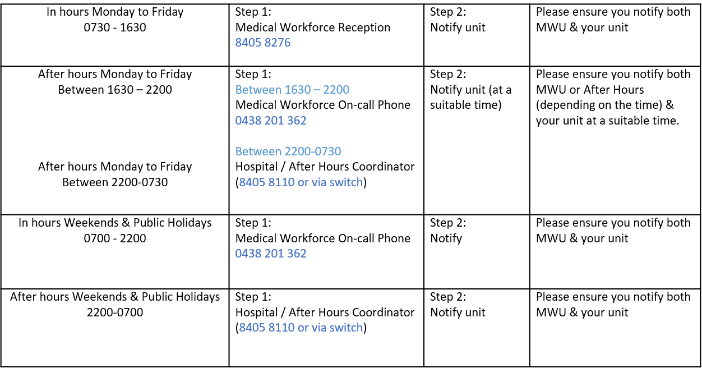
Overtime | All overtime should be submitted into the Overtime Portal  This can be accessed via the intranet whilst onsite at Northern Health  Please include the reason for your overtime- i.e. ward workload, delayed handover, include UR where relevant.

