ENDOCRINOLOGY HMO HANDOVER
GENERAL
- Print the Endo in-patient ward list daily from EMR
- You also need to maintain the EMR list: “Endocrinology | Endocrinology Consults” Care Team List – you need to manually add and remove inpatients/consults to this list
- Assist the ward Registrar/Consultant with daily ward rounds. Consultants normally do a ward round 1-2 times per week. Registrar ward rounds happens daily
- Remember to request blood tests for the weekend (including Monday) if needed.
- Depending on consults load and level of comfort, you’ll either see consults with your Registrar or see them solo and discuss them with your Registrar later.
- Referrals to endocrine come:
  - To the registrar via medtasker from other inpatient teams
  - from diabetes nurse educators via the Microsoft teams (ask the reg to add you)
  - occasionally to you directly by a consultant or registrar
- Check your emails daily as consultants from the clinics will get you to organize outpatient pathology/tests from time to time. Liaise with outpatient registrar to see if any of them need actioning as very often you both will be cc’ed in the emails.
- There will be elective admissions from time to time; Patient flow coordinator is helpful with organizing booking dates – try to avoid clinic days.

ENDO AUDIT LIST
- Remember to add discharged in-patients and consults to the appropriate audit tabs in the excel spread sheet (S drive: Endocrinology/Audit & Presentations/Audits). Don’t worry about the other tabs. T1DM and T2DM consults will both go under the DC Diabetes Ref tab.
- The registrars will present the audit data based on your inputs at the Monday Unit meetings.
GENERAL SCHEDULE (No weekends!)
Monday:
8 am – 9 am: Registrar WR
9 am – 12.30 pm: Obs Endo Clinic (You will need to attend. You and the in-patient Registrar will be attached to a consultant)
12.45 to 2 pm: Unit Meeting (there is usually free lunch tab at Henry’s)
2 pm – 5 pm: on the wards seeing consults/in-patients.

Tuesday:
8 am – 5 pm: No clinics. Just ward round. The inpatient registrar is usually on their half-day. So, you’ll get to step-up and take referrals in the PM once comfortable doing so later in the rotation (the outpatients registrar usually holds the medtasker role / phone in the first few weeks). The outpatients registrar is around in clinic, but can always ask them questions.

Wednesday:
8 am – 9 am: Registrar WR
9 am – 12.30 pm: General Endo Clinic (Technically not meant to go if you have rapid access clinic in the arvo but it is always really busy). Otherwise you will continue with ward duties/consults.
1.30 pm – 5 pm: Complete ward round and review consults.

Thursday:
8 am – 12 pm: No clinics. Just ward round. Take your half-day!

Friday:
8 am – 5 pm: Ward rounds. The registrar usually dials into Austin Health teaching from 12-1330 hrs.

USEFUL RESOURCES
- Harmonization of Endocrine Dynamic Testing -Adult (HEDTA) guidelines are a great resource for Endo dynamic tests info. See: https://www.endocrinesociety.org.au/guidelines.asp
- Consider printing the guidelines and leave them in the patient’s folders as it helps the nursing staff carry out the testing. We commonly do dynamic tests such as Salt Suppression tests, Dexamethasone suppression testing, Mixed meal testing and Short Synacthen testing.
- Also, if you want to read up on Registrar level management/workup of key endocrine problems; Go to Shared S: drive → Endocrinology → Useful guidelines → Endo Reg Useful Info 2022

USEFUL TIPS
Endo Investigations:
- Routine initial HypoNa work-up must include Paired Serum and Urine Osmolarity and Urine Na + TSH and AM cortisol. There is a useful HypoNa work-up chart in the office bulletin board.
- T1/LADA antibody testing consists of ZnT8, IA2 and GAD antibodies.
- Thyroid autoantibodies: anti-TPO, anti-Tg and TSH receptor antibodies
- When ordering C-peptide levels, always pair with a glucose level. It is traditionally fasting but doesn’t technically have to be fasting, but you need the glucose to compare
- T1DM screening tests (if not done) includes: TFTs, Coeliac serology, B12

General DM/pregnancy targets:
- Fasting BGLs target 4-8 mmol/L and Post-prandial 4-10 mmol/L. For in-patients, 5-10 mmol/L is usually tolerated (up to 15 if at risk of hypoglycemia or having relaxed HbA1c target)
- For GDM, fasting BGLs should be below ≤5.0 mmol/L and post-prandial ≤ 6.7 mmol/L. For pregnant ladies who have pre-existing T1DM/T2DM, fasting BGLs should be below ≤5.2 mmol/L and post-prandial ≤ 6.7 mmol/L.
- For hypothyroidism/SC hypothyroidism in pregnancy, we commence replacement when TSH >4.00 and we aim TSH < 2.5 for patients who are on replacement (This is only a general rule and is often assay dependent).

Pathology Book:
- During clinics, Dr Suresh (or other people) may ask you “where is the pathology book?” or “do you have the pathology book with you?”
- This is the hardcopy calendar diary with details of patients with investigation results to be chased.
- This book is held by the outpatient registrar who should bring it to clinic. The outpatient registrar is in charge of the pathology book, but you may need to assist from time to time with adding patients to the book or chasing results.
- There is a list of log-in details for some external pathology providers at the front of the book. This can be handy when chasing bloods for outpatients.

Outpatient Matters:
- The old hardcopy pathology forms & scripts can still used for outpatient requests
- Ask a patient which pathology service they will attend for their blood tests (makes life a lot easier when chasing tests)
- The quickest way to send path slips or scripts for a patient is via email
  - For path, send to the patient’s email for them to print out. Make sure you put in a name and provider number
  - For scripts, you can email it to the pharmacy the patient will pick the meds up from. You will still need to mail the original script to the pharmacy for their records (but keep the red medical records copy for our scanning)
- To mail anything, you just need to leave your envelope with name and address in one of the trays in the outpatients department, or bring it directly to the mailroom near front reception
- If you need to print a clinic letter to send to the GP, just click ‘Print Letter’ on CPF. After printing, you can give the letters to the clinic reception staff or leave in the trays at the front.
- Outpatient notes for obstetric patients are usually on EMR, but we also leave our Obs Endo clinic notes on CPF as well.
- Other Endo clinic notes and outpatients notes are solely on CPF.

Q flow :
- This is the software used in outpatient clinics with patient lists etc.
- Update your details in the User tab for each clinic

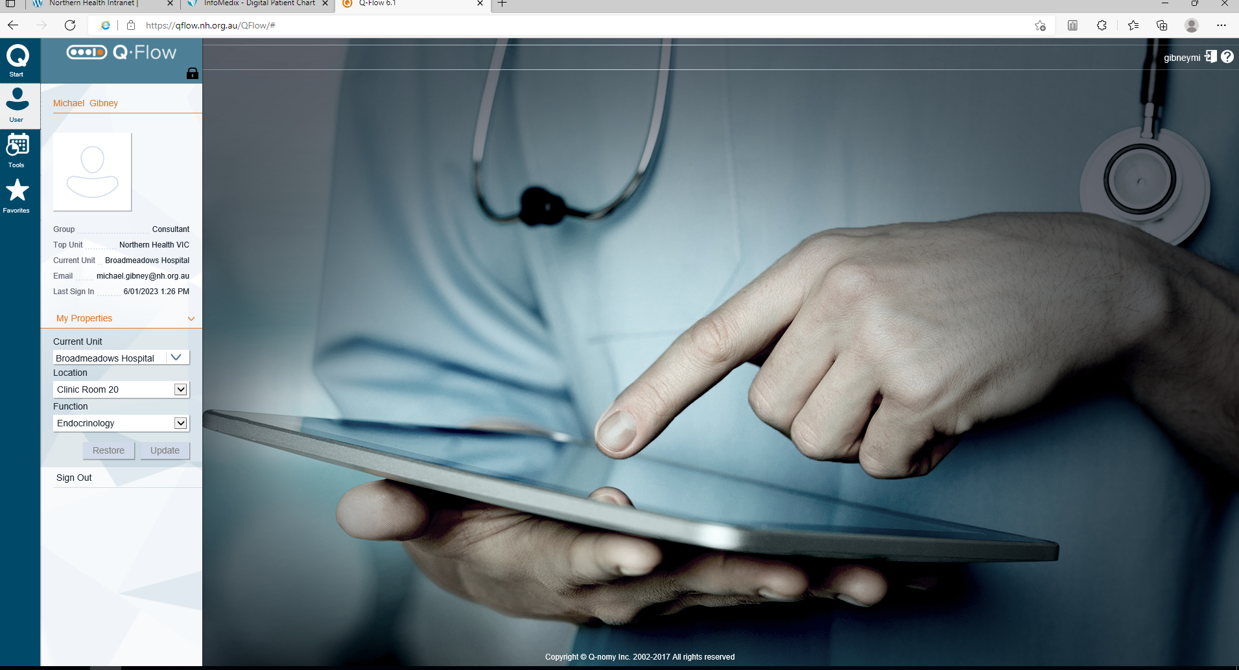

- Click on service console in the tools tab. Then select which clinic you are on and the patients will appear in this screen

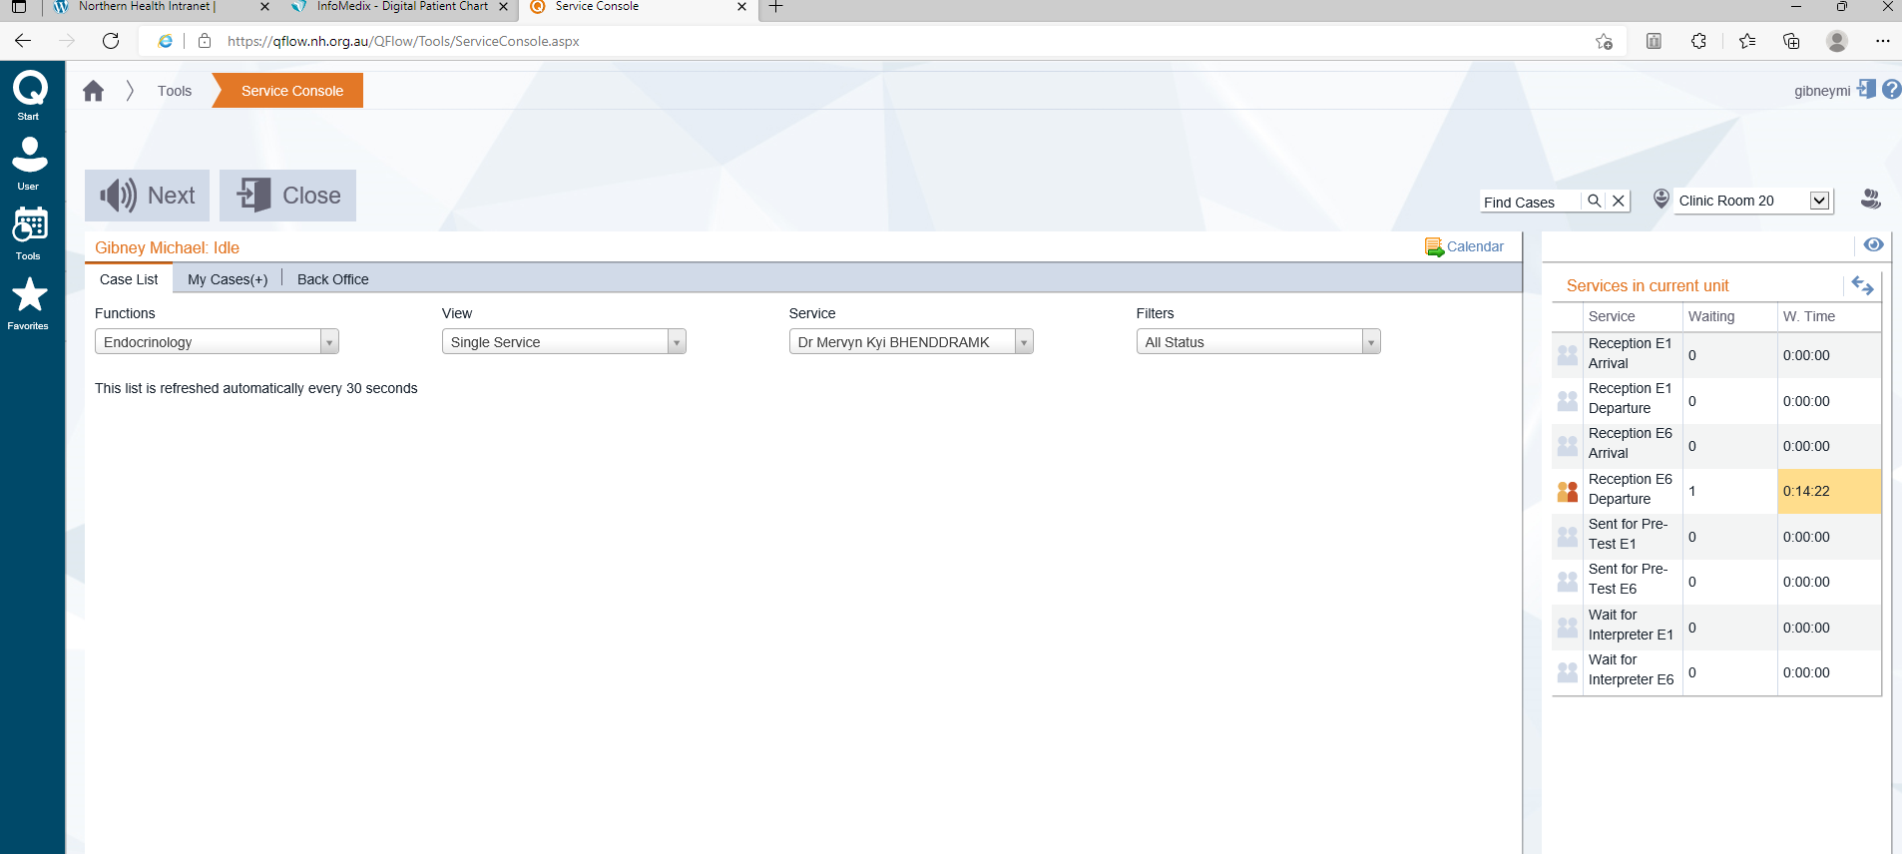

Select a patient and click ‘silent call’ which will signal that you are seeing them, then use ‘call patient’ when you are ready to actually see them (you don’t have to do this if it’s a telephone call).

I also write my name in the “qflow comments” which makes it easy to see later I have seen that patient.

Once you have finished seeing the patient + discussed with consultant, click on outcome form which will prompt you to discharge or book in a follow up appointment. Remember to put in as “time critical appointment” if needed – this will bump other appointments further back the waiting

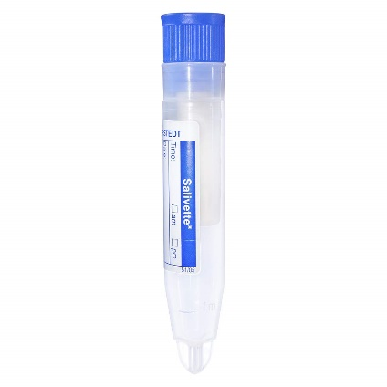
Midnight salivary cortisol testing (outpatient or in-patient):
- You can obtain the Cortisol Salivette from Pathology (See image to the right)

Short synacthen tests:
- Probably the most common outpatient test to organize
- Refer to the Adult (HEDTA) guidelines for the process
- Contact the patient to come to hospital (on a Tuesday, Thursday or Friday) between 8-930am
  - The patient should be told to present to pharmacy to collect the synacthen
  - It is free for them
  - Then they will go to pathology for the injection and blood tests.
- Write the script (synacthen 250mcg IM) to pharmacy
- On the day
  - Pathology should contact you to let you know they are waiting
  - They will get their baseline cortisol and ACTH
  - You will inject the synacthen IM. It does not need to be diluted or slow pushed. Just IM stat.
  - That is it for you, the patient will get 2 more blood tests after the IM injection then go

Zoledronic Acid infusions:
- You may be asked to organize zoledronic acid infusions for outpatients at Day Oncology
- There is a prompt guideline on how to do this, basically you will need to:
  - Write a script for zoledronic acid
  - Write the zoledronic acid order on an IV fluid order (4mg IV for hypercalcemia or 5mg IV for osteoporosis, in 100mls NS 0.9%, over 15 mins)
  - Write a medication chart with anaphylaxis/allergy PRNs (hydrocortisone 100mg IV, adrenaline 0.5mg IM, promethazine PO 25-75mg)
  - Fill out the Day Oncology Referral form and liaise with Day Oncology ANUM

Mixed Meal Tests:
- Usually will be an elective admission for this. Refer to the HEDTA guidelines for the protocol
- Will need to liaise with Kitchen services the day before to arrange for the required breakfast items to be provided on the morning of the test (usually involves nursing staff making a special meal request)

