9. Hospital Orientation
Hospital orientation occurs at the beginning of each term. Attendance is mandatory and paid non-clinical time.
This is separate to the unit orientation. Follow the link for details, password: NorthernDoctors
Location | NCHER, Northern Hospital – Epping | 185 Cooper Street, Epping 3076
Facilitator | Medical Education Unit | Email: MedicalEducationUnit@nh.org.au
Date | First day of each term
Start | 08:00

10. Unit Orientation
Unit Orientation occurs at the beginning of each term. Attendance is mandatory and paid time.
Orientation that occurs outside of your rostered hours should be submitted as overtime on the overtime reporting portal.
Location | Residents Quarters
Facilitator | Sarah Condron
Date | Tuesday of the first week of each term
Time | 2pm - 3pm

11. Unit Overview
Department | There are 2 HMO Roles in this term that are divided into general and specialty units  1. Gen Surg Night HMO- AGSU and General Surgery Units 1-4, Urology  2. Spec Surg Night HMO- Plastics, Orthopaedics, Paeds Surg, Thoracics, Vascular, ENT
Location | Northern Hospital, Epping Campus  Ward 2- Paeds Surg  Ward 13- AGSU  Ward 16- Gen Surg, Urology  Ward 18- Thoracics, Vascular  Ward 19- Ortho, Plastics
Inpatient Beds | ~ 108
Outpatients Clinics | No
Day Procedures | No
Virtual Unit | No

12. Safety
Unit Specific Risks- see relevant handbooks for unit specific issues
- Multiple units cross cover requiring good communication and handover between staff
- Distance between wards, consider travel time between various wards, especially with multiple unwell patients
- Wear good supportive shoes!

13. Communication
Medtasker | There are 2 night roles. Sign in at the start of your shift and sign out at the end of your shift.  1. Gen Surg Night HMO (AGSU, Gen Surg Units 1-4, Urology)  2. Spec Surg Night HMO (Ortho, Plastics, Vasc, Paeds Surg, Thoracics, ENT)
WhatsApp | N/A
Pager | Pagers are located at reception. Please sign them out at the start of your shift and sign them in at the end of your shift.  1. General Surgery - 090  2. Specialty surgery - 160
MS Teams | N/A

14. Handover Process
To find out which Doctor is covering a role- Check the portal on the intranet. Go to the intranet > Favourite Links > Reporting Portal > +Add more reports to my profile> scroll to find Workforce WOR303 > Add to favourites > Refresh> Done
 | Weekday | Weekend
Morning | At the end of shift handover:  1. Gen Surg Night HMO  - 07:00 Handover to AGSU, Gen Surg 1/2/3/4, Urology HMOs  2. Spec Surg Night HMO  - 07:00 Handover to Plastics, Orthopaedics, Paeds Surg, Thoracics, Vascular HMOs & ENT Reg | At the end of shift handover:  1. Gen Surg Night HMO  - 07:00 Handover to AGSU HMO, Gen Surg 1-2 Intern, Gen Surg 3-4 HMO and Spec Surg Weekend HMO for Urology in ressies  2. Specialty Surg Night HMO  - 07:00 Handover to Spec Surg Weekend HMO for Paeds surg/Thoracics/ENT,  Orthopaedics HMO, Plastics HMO, Vascular HMO & OrthoPlastics HMO
Afternoon | N/A | N/A
Night | At start of shift receive handover:  1. 20:30 Gen Surg Night HMO  - Receive handover from AGSU Intern and Gen Surg Units 1-4 Intern, Urology HMO in ressies  2. 20:30 Spec Surg Night HMO  - Receive handover from OrthoPlastics HMO, Vascular HMO, Spec Surg PM HMO in ressies | At start of shift receive handover:  1. Gen Surg Night HMO  - 20:30 Receive handover from AGSU Intern, Gen Surg 1-2 Intern, Gen Surg 3-4 HMO, Spec Surg Weekend HMO for Urology in ressies  2. Spec Surg Night HMO  - 20:30 Receive handover from Spec Surg Weekend HMO and Orthoplastics HMO

15. Shift Structure
 | 1. Gen Surg Night HMO | 2. Spec Surg Night HMO
Day | N/A | N/A
Afternoon | N/A | N/A
Night | 20:30 – 07:30 | 20:30 – 07:30
Weekend | 20:30 – 07:30 | 20:30 – 07:30

16. Shift Responsibilities and Tasks
 | 1. Gen Surg Night HMO | 2. Spec Surg Night HMO
Day | N/A | N/A
Afternoon | Sleep, study, exercise, eat | Sleep, study, exercise, eat
Night | Collect pager from reception and log onto Medtasker  Get handover from day teams as above  Attend 2 @2 meeting in ICU conference room at 0200  Repond to pager calls and Medtaskers- review patients for deviations in observations or concerns, MET calls, write admission notes for patients from ED, escalate to consultants or registrars  - Ward cover for AGSU, Gen Surg 1-4  - Ward cover and admissions for Urology | Collect pager from reception and log onto Medtasker  Get handover from day teams as above  Attend 2 @2 meeting in ICU conference room at 0200  Repond to pager calls and Medtaskers- review patients for deviations in observations or concerns, MET calls, write admission notes for patients from ED, escalate to consultants or registrars  - Ward cover for paeds surg (AGSU do admissions)  - Ward cover and admissions for ortho, plastics, vasc, thoracics, ENT
Weekend | Same as above | Same as above

17. Common Conditions
See specific unit handbook

18. Common Procedures
List specific unit handbook

19. Clinical Guidelines
PROMPT- This site contains the hospital policy and procedure manuals. It can only be accessed from the intranet - https://intranet.nh.org.au/departments-and-services/prompt-policy-procedures-guidelines/prompt-policies-procedures-and-forms/
See unit handbooks for respective units Northern Doctors wesite: https://www.northerndoctors.org.au/handbook_rover/

20. Routine Orders
Pathology | Nil
Radiology | Nil
Pharmacology | Nil

21. IT Programs
EMR | The EMR is in use for documentation, medication ordering and radiology/pathology requests.  It is being used for all inpatients, as well as maternity clinics and pre-anaesthetic clinics.  Located in the intranet > My Favourite Links > EMR Live Environment  EMR Training courses are located on the LMS- https://mylearning.nh.org.au/login/start.php  Training is compulsory; you will need to complete the elearning within the first week of commencing.  Please contact medical workforce, or check the EMR website for more information on how to complete EMR training https://emr.nh.org.au/  When starting a new rotation, please reach out to Term Supervisor to ensure you are oriented to the EMR specific workflows for that unit as well.  EMR is NOT a primary communication system. Please use Medtasker and phones for referrals and communication.
CPF | The source of information for all outpatients’ clinics, investigations, GP referrals and scanned admission notes prior to September 2023.  Located in the intranet > My Favourite Links > CPF https://cpf.nh.org.au/udr/
PACS | XERO Viewer Pacs- https://nivimages.ssg.org.au/ or located in My Favourite Links, look for the CXR icon  This is where you can find radiology images
My Health Record | Centralised health record https://shrdhipsviewer.prod.services/nhcn
Safe Script | Monitoring system for restricted prescription medications https://www.safescript.vic.gov.au/

22. Documentation
Admission | Use admission workflow on EMR
Ward Rounds | Use ward round workflow on EMR
Discharge Summary | Use discharge workflow on EMR
Outpatient Clinics | On CPF
CDI Queries | Medtasker
Death Certificates | https://www.bdm.vic.gov.au/medical-practitioners
Coroners | Guide to making a corners report  https://coronerscourt.vic.gov.au/report-death-or-fire/how-report-death

23. Referrals
Internal | The cover HMO does not receive referrals for patients
External | N/A

24. Clinical Deterioration
Escalation Process | Within the hospital at all times help is available from:  AGSU registrar - x52628  Periop medical registrar – 0418428781 and  ICU registrar - x88230  All specialty units have someone that can be contacted if there is concern  Urology – registrars alternating roster – contact via switch  Paediatric Surgery – consultant alternating roster – contact via switch  Thoracic Surgery – consultant alternating roster – contact via switch  ENT – no after hours cover – contact AGSU/ anaesthetics, Austin ENT  Vascular Surgery – Registrar alternating roster – contact x58984  Plastic Surgery – Registrar alternating roster – contact x52356  Orthopaedic Surgery – Registrar alternating roster – contact x58461
PreMet | Respond to Med tasker physically within 15 minutes
Code | Surgical units need to be advised if their patient has a code  Urology – registrars alternating roster – contact via switch  Paediatric Surgery – consultant alternating roster – contact via switch  Thoracic Surgery – consultant alternating roster – contact via switch  ENT – no after hours cover – contact AGSU/ anaesthetics, Austin ENT  Vascular Surgery – Registrar alternating roster – contact x58984  Plastic Surgery – Registrar alternating roster – contact x52356  Orthopaedic Surgery – Registrar alternating roster – contact x58461

25. Night Shift Support
Unit | 1. AGSU registrar  2. Unit registrar or fellow  3. Consultant
Periop | Periop medical registrar
Take 2 @ 2 | All night staff attend this meeting in ICU conference room

26. Assessments
All forms are located on the Northern Doctors website under the Assessments tab
Beginning of Term | Meet with Term Supervisor to set learning goals for the term using the Term Description Learning Objectives as a basis for the discussion
Mid-Term & End of Term | To be completed at the mid and end of term meetings
EPAs | Minimum of x2 EPA assessments to be completed per term

27. Mandatory Training
- Mandatory Training is located on the LMS- https://mylearning.nh.org.au/login/start.php
- Mandatory training is compulsory and part of your contract with Northern Health and needs to be completed by the first month of your start date. If not completed you will come of the floor to complete.
- Hand Hygiene needs to be completed by the end of your first week.
- If you have completed the mandatory training elsewhere you may be able to apply for recognition of prior learning

28. Unit Education
TBC

29. Unit Meetings
TBC

30. Research and Quality Improvement
TBC

31. Career Support
Discuss with Unit Consultant

32. Medical Students on the Unit
N/A

33. Rostering
Shift Swap | The doctor initiating the roster swap is responsible for arranging with an appropriate colleague.  Once you have arranged a colleague to perform the swap, please email your MWU coordinator and cc in the colleague.  All swaps should be kept to within the pay period fortnight where possible. In exceptional circumstances where this cannot be achieved, please discuss with the MWU coordinator prior.  All shift swaps should be like hours for like hours.  Proposed shift swaps must be emailed to your MWU coordinator for approval.
Unplanned Leave- Notification and documentation process | Personal Leave documentation required:  For 3 single absences per year, the doctor will not be required to provide any supporting evidence to substantiate their personal leave.  For other days absent due to personal illness or injury the doctor is required to provide evidence of illness.  To be eligible for payment, the doctor is required to notify the Health Service two hours before the start of their shift, or as soon as practicable.  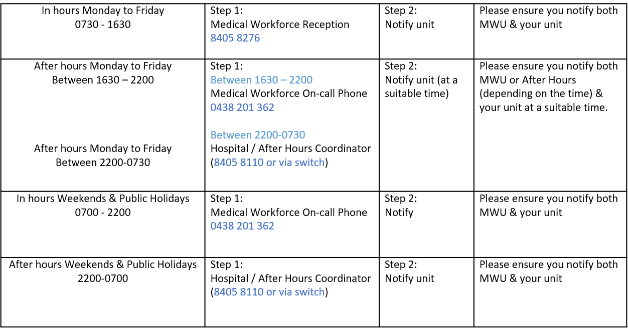
Overtime | All overtime should be submitted into the Overtime Portal  This can be accessed via the intranet whilst onsite at Northern Health  Please include the reason for your overtime- i.e. ward workload, delayed handover, include UR where relevant.

