9. Hospital Orientation
Hospital orientation occurs at the beginning of each term. Attendance is mandatory and paid non-clinical time.
This is separate to the unit orientation. Follow the link for details, password: NorthernDoctors
Location | NCHER, Northern Hospital – Epping | 185 Cooper Street, Epping 3076
Facilitator | Medical Education Unit | Email: MedicalEducationUnit@nh.org.au
Date | First day of each term
Start | 08:00

10. Unit Orientation
Unit Orientation occurs at the beginning of each term. Attendance is mandatory and paid time.
Orientation that occurs outside of your rostered hours should be submitted as overtime on the overtime reporting portal.
Location | Residents Quarters
Facilitator | Sarah Condron
Date | Tuesday of the first week of each term
Time | 2pm – 3pm

11. Unit Overview
Department | There are 3 weekday HMO Roles  1. Spec Surg PM HMO (Paeds surg, Thoracics, ENT)  2. OrthoPlastics HMO  3. Gen Surg Units 1-4 Intern  There are 4 weekend HMO Roles  1. Spec Surg Weekend HMO (Paeds surg, Thoracics, Urology, ENT), after 17:00 Vascular ward cover  2. OrthoPlastics HMO  3. Gen Surg 1-2 Intern  4. Gen Surg 3-4 HMO
Location | Northern Hospital, Epping Campus  Ward 2- Paeds Surg  Ward 13- AGSU  Ward 16- Gen Surg, Urology  Ward 18- Thoracics, Vascular  Ward 19- Ortho, Plastics
Inpatient Beds | ~108
Outpatients Clinics | No
Day Procedures | No
Virtual Unit | No

12. Safety
Unit Specific Risks- see relevant handbooks for unit specific issues
- Multiple units cross cover requiring good communication and handover between staff
- Distance between wards, consider travel time between various wards, especially with multiple unwell patients
- Wear good supportive shoes!

13. Communication
Medtasker | Sign in at the start of your shift and sign out at the end of your shift  There are 3 weekday HMO Roles  1. Spec Surg PM HMO (Paeds surg, Thoracics, ENT)  2. OrthoPlastics HMO  3. Gen Surg Units 1-4 Intern  There are 4 weekend HMO Roles  1. Spec Surg Weekend HMO (Paeds surg, Thoracics, Urology, ENT), after 17:00 Vascular ward cover  2. OrthoPlastics HMO  3. Gen Surg 1-2 Intern  4. Gen Surg 3-4 HMO
WhatsApp | N/A
Pager | Pagers are located at reception. Please sign them out at the start of your shift and sign them in at the end of your shift.  Paeds Surg #193  Thoracics #1111  Orthopaedics # 462  Plastics #185  Vascular #037  Urology #041  ENT- no pager  Surg 1 # 092  Surg 2 # 057  Surg 3 # 096  Surg 4 # 282/ #280
MS Teams | N/A

14. Handover Process
To find out which Doctor is covering a role- Check the portal on the intranet. Go to the intranet > Favourite Links > Reporting Portal > +Add more reports to my profile> scroll to find Workforce WOR303 > Add to favourites > Refresh> Done
 | Weekday Role | Weekend Role
Morning |  | At start of shift receive handover:  1. Spec Surg Weeknd HMO  - 07:00 Receives handover from Spec Surg Night HMO, Gen Surg Night HMO & AGSU Reg in ressies for Paeds surg, Thoracics, Urology, ENT  2. OrthoPlastics HMO  - 07:00 Receives handover from Spec Surg Night HMO in ressies for Orthopaedics and Plastics  3. Gen Surg 1-2 Intern  - 07:00 Receives handover from Gen Surg Night HMO in ressies for Gen Surg 1-2  4. Gen Surg 3-4 HMO  - 07:00 Receives handover from Gen Surg Night HMO in ressies for Gen Surg 3-4
Afternoon | At start of shift receive handover:  1. Spec Surg PM HMO (Paeds surg, Thoracics, ENT)  - 16:00 Receive handover from ENT Reg via phone  - 16:30 Receive handover from Paeds Surg, Thoracics  HMO via medtasker  2. OrthoPlastics HMO  - 16:00 Receive handover from orthopaedics and plastics on ward 18  3. Gen Surg Units 1-4 Intern  - 16:00 Receive handover from Gen Surg 2/3/4 HMO & Interns on ward 16 | 1. Spec Surg Weekend HMO  - 16:00 receives handover from Vascular HMO in ressies/medtasker
Night | At the end of shift handover:  1. Spec Surg PM HMO (Paeds surg, Thoracics, ENT)  - 20:30 Handover to Spec Surg Night HMO in ressies  2. OrthoPlastics HMO  - 20:30 Handover to Spec Surg Night HMO in ressies  3. Gen Surg Units 1-4 Intern  - 20:30 Handover to Spec Surg Night HMO in ressies | At the end of shift handover:  1. Spec Surg Weekend HMO  - 20:30 Handover Paeds, Thoracics, ENT, Vascular to Spec Surg Night HMO in ressies  - Handover Urology to Gen Surg Night HMO in ressies  2. OrthoPlastics HMO  - 20:30 Handover to Spec Surg Night HMO in ressies  3. Gen Surg 1-2 Intern  - 20:30 Handover to Gen Surg Night HMO in ressies  4. Gen Surg 3-4 HMO  - 20:30 Handover to Gen Surg Night HMO in ressies

15. Shift Structure | Weekday Role | Weekend Role
Day | N/A | 07:00 – 21:00
Afternoon | 16:00 – 21:00 | N/A
Night | N/A | N/A

16. Shift Responsibilities and Tasks
Weekday | Weekend
1. Spec Surg PM HMO  Ward cover for Paeds surg, Thoracics, ENT | 1. Spec Surg Weekend HMO  Post-handover make contact with Urology, Surg 1&2, Surg 3&4 regs to co-ordinate start time for ward rounds  07:30 Urology ward round with Urology Reg, ward cover, admissions  Paeds surg ward round with Surg 1-2 Reg and ward cover (AGSU does admissions)  Thoracics ward round with Surg 3-4 Reg and ward cover and admissions  ENT ward round, then call ENT Reg to discuss, ward cover  After 17:00 Vascular ward cover
2. OrthoPlastics  Ward cover for orthopaedics and plastics | 2. OrthoPlastics  Orthopaedics ward round and ward cover on Saturday, cover Plastics after 17:00, including admissions  Plastics ward round and ward cover on Sunday, cover Orthopaedics after 17:00, including admissions
3. Gen Surg Units 1-4  Ward cover for Gen Surg units 1-4 | 3. Gen Surg 1-2  Gen Surg Units 1-2 ward round with Surg 1-2 Reg and ward cover
4. Gen Surg 3-4
Gen Surg 3-4 ward round with Surg 3-4 Reg and ward cover

17. Common Conditions
See specific unit handbook

18. Common Procedures
See specific unit handbook

19. Clinical Guidelines
PROMPT- This site contains the hospital policy and procedure manuals. It can only be accessed from the intranet -
See unit handbooks for respective units Northern Doctors wesite: https://www.northerndoctors.org.au/handbook_rover/

20. Routine Orders
Pathology | Nil
Radiology | Nil
Pharmacology | Nil

21. IT Programs
EMR | The EMR is in use for documentation, medication ordering and radiology/pathology requests.  It is being used for all inpatients, as well as maternity clinics and pre-anaesthetic clinics.  Located in the intranet > My Favourite Links > EMR Live Environment  EMR Training courses are located on the LMS- https://mylearning.nh.org.au/login/start.php  Training is compulsory; you will need to complete the elearning within the first week of commencing.  Please contact medical workforce, or check the EMR website for more information on how to complete EMR training https://emr.nh.org.au/  When starting a new rotation, please reach out to Term Supervisor to ensure you are oriented to the EMR specific workflows for that unit as well.  EMR is NOT a primary communication system. Please use Medtasker and phones for referrals and communication.
CPF | The source of information for all outpatients’ clinics, investigations, GP referrals and scanned admission notes prior to September 2023.  Located in the intranet > My Favourite Links > CPF https://cpf.nh.org.au/udr/
PACS | XERO Viewer Pacs- https://nivimages.ssg.org.au/ or located in My Favourite Links, look for the CXR icon  This is where you can find radiology images
My Health Record | Centralised health record https://shrdhipsviewer.prod.services/nhcn
Safe Script | Monitoring system for restricted prescription medications https://www.safescript.vic.gov.au/

22. Documentation
Admission | Use admission workflow on EMR
Ward Rounds | Use ward round workflow on EMR
Discharge Summary | Use discharge workflow on EMR
Outpatient Clinics | On CPF
CDI Queries | Medtasker
Death Certificates | https://www.bdm.vic.gov.au/medical-practitioners
Coroners | Guide to making a corners report  https://coronerscourt.vic.gov.au/report-death-or-fire/how-report-death

23. Referrals
Internal | The cover HMO does not receive referrals for patients
External | N/A

24. Clinical Deterioration
Escalation Process | Within the hospital at all times help is available from:  AGSU registrar - x52628  Periop medical registrar – 0418428781 and  ICU registrar - x88230  All specialty units have someone that can be contacted if there is concern  Urology – registrars alternating roster – contact via switch  Paediatric Surgery – consultant alternating roster – contact via switch  Thoracic Surgery – consultant alternating roster – contact via switch  ENT –via switch – if no cover- contact AGSU/ anaesthetics, Austin ENT  Vascular Surgery – Registrar alternating roster – contact x58984  Plastic Surgery – Registrar alternating roster – contact x52356  Orthopaedic Surgery – Registrar alternating roster – contact x58461
PreMet | Respond to Med tasker physically within 15 minutes
Code | Surgical units need to be advised if their patient has a code  Urology – registrars alternating roster – contact via switch  Paediatric Surgery – consultant alternating roster – contact via switch  Thoracic Surgery – consultant alternating roster – contact via switch  ENT – no after hours cover – contact AGSU/ anaesthetics, Austin ENT  Vascular Surgery – Registrar alternating roster – contact x58984  Plastic Surgery – Registrar alternating roster – contact x52356  Orthopaedic Surgery – Registrar alternating roster – contact x58461

25. Night Shift Support
Unit | 1. AGSU registrar  2. Unit registrar or fellow  3. Consultant
Periop | Contact the peri-op registrar for any acute medical concerns
Take 2 @ 2 | N/A

26. Assessments
All forms are located on the Northern Doctors website under the Assessments tab
Beginning of Term | Meet with Term Supervisor to set learning goals for the term using the Term Description Learning Objectives as a basis for the discussion
Mid-Term & End of Term | To be completed at the mid and end of term meetings
EPAs | Minimum of x2 EPA assessments to be completed per term

27. Mandatory Training
- Mandatory Training is located on the LMS- https://mylearning.nh.org.au/login/start.php
- Mandatory training is compulsory and part of your contract with Northern Health and needs to be completed by the first month of your start date. If not completed you will come of the floor to complete.
- Hand Hygiene needs to be completed by the end of your first week.
- If you have completed the mandatory training elsewhere you may be able to apply for recognition of prior learning

28. Unit Education
TBC

29. Unit Meetings
TBC

30. Research and Quality Improvement
TBC

31. Career Support
Contact Consultant on Unit

32. Medical Students on the Unit
N/A

33. Rostering
Shift Swap | The doctor initiating the roster swap is responsible for arranging with an appropriate colleague.  Once you have arranged a colleague to perform the swap, please email your MWU coordinator and cc in the colleague.  All swaps should be kept to within the pay period fortnight where possible. In exceptional circumstances where this cannot be achieved, please discuss with the MWU coordinator prior.  All shift swaps should be like hours for like hours.  Proposed shift swaps must be emailed to your MWU coordinator for approval.
Unplanned Leave- Notification and documentation process | Personal Leave documentation required:  For 3 single absences per year, the doctor will not be required to provide any supporting evidence to substantiate their personal leave.  For other days absent due to personal illness or injury the doctor is required to provide evidence of illness.  To be eligible for payment, the doctor is required to notify the Health Service two hours before the start of their shift, or as soon as practicable.  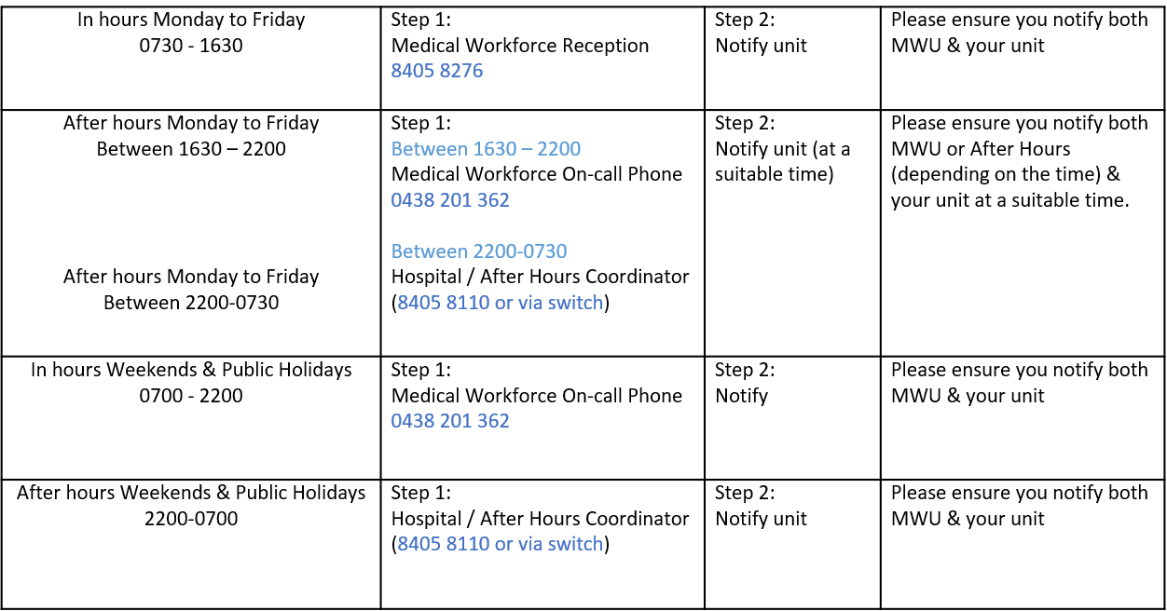
Overtime | All overtime should be submitted into the Overtime Portal  This can be accessed via the intranet whilst onsite at Northern Health  Please include the reason for your overtime- i.e. ward workload, delayed handover, include UR where relevant.

34. JMO Rover

