
ROVER (Rolling handOVER) – I am a ‘living document’ that needs your care and attention

ROTATION: SURGICAL 4 HEPATOBILARY SURGERY
UPDATED BY: Antonia Rigopoulos CONTACT: antonia.rigopoulos@nh.org.au DATE: 15/1/23
REVIEWED BY: CONTACT: DATE:
! Please update me as required and send me to fathimaijaza.lafeer@nh.org.au in week 8 of this rotation
TOP TIPS!
- Mondays are busy! MDM fortnightly (0745), consultant ward round 1230, radiology meeting 1300, outpatient clinic from 1400 (Clinic A) (usually overrun, aim to get a head start on clinic early in the day)
- There is a lot of outpatient stuff to do, get onto it early and personally book in dates / times for scans
- Be prepared to admit patients from clinic, speak to Carotina in bookings she will help you
- Will often paper round/debrief (usually with Reg/HMO/full day intern) at the end of the day even if finishing late in theatre/clinic so be prepared to do some overtime

STAFF
UNIT STAFF & KEY CONTACTS | CONTACT DETAILS
Head of Unit: Mr. David Bird | Via switch
Consultants:  Nezor Houli  Tuck Yong  Binh Nguyen  Russell Hodgson  Yahya Al-Habbal/Mohamed Ashour (covering for Mr Bird’s leave) | Via switch
Fellow: Hassan Malik | x52899
Reg: Victoria Jenkins (will change to Tess Howard soon) | Mobile
Unit 18 NUM / NIC: Rotating | x58299
Carotina (Theatre bookings/NOA’s) | x52036
Carmelita (Outpatients appointments) | x58729
Bec (Endoscopy/EUS bookings)

GEOGRAPHY
ITEM | LOCATION
Home ward | W18
Morning meeting point | W18 write up room
Your pager lives here | W18 write up room in one of cupboards or next to computer (#282, carried by full day intern)
Patient list | On S:\Medicine\Surg 4\Surg 4 ward round\2023\[Month]
Handover | W16 write up room (to handover to surg 1 cover intern)
Outpatient clinic | Outpatients A

TIMETABLE: 1 week 6.30am-5pm + Friday off / 1 week 7am-3pm (shift end times vary so check RosterOn)
Note: WR time can vary, ask Reg night before; half day intern won’t get their half day on Mondays, put in your overtime!
Mon | Tue | Wed | Thu | Fri
0700  Rounds  (Start W18)  7:45 MDM (every 2nd week)  1230  Consultant ward round  1300  Radiology meeting  Via Teams  1400  Clinic  Outpatients A | 0700  Rounds  (Start W18)  0830  Usually OT (Houli)  AM +/- PM  1230-1330  Intern Teaching  Lecture Theatre  Mandatory for Interns | 0700  Rounds  (Start W18)  Usually OT (Bird/Hodgson/Nguyen)  Endoscopy  HMO rostered to half day but usually stay til 5 pm (1100) | 0700  Rounds  (Start W18)  0830  Usually OT (Yong)  AM +/- PM  Endoscopy  12:30-13:30  HMO2&3 Teaching  Lecture Theatre  Mandatory for HMOs  (Interns welcome)  HMO rostered to half day but usually stay til 5 pm (1100) | 0700  Rounds  (Start W18)  DAY OFF fortnightly (NB: can rotate day off depending on patient load/theatre list/post-take days, just run it past Registrar and update workforce to ensure overtime coincides with correct days)

Radiology meeting – usually HMO in charge of this
Preparation: Consultants/ Reg will flag pts throughout the week, add them on as you are made aware of them, ask the consultants after clinic/theatre if they have any patients they want to add. Max down in Radiology can import external images for you. Radiology meeting folder can be found in synapse: conferences\SURG4\(date of meeting) – you may need to create a new folder if there isn’t one already. On Friday, email the list to the radiologist, your fellow and your reg.
During: take notes and upload on CPF (Radiology Meeting Progress notes), on note state which consultant the patient is under
After: put in further imaging requests / OPD referrals
MDM – usually HMO in charge of this
- At the start of your rotation, send an email to northern.health@cancermdm.com.au
- Tell them you are the new surg 4 intern, and they will create a MDM account for you
- You can access MDMs at: https://www.cancermdm.com.au/northern/Pub/pSplash.asp
- Log in with the details they provide you with.
- Preparation: Similar to radiology meeting, consultant/fellow/reg will flag patient to put on the various MDM meetings. Choose the appropriate MDM to add patient to, fill in the details, list any investigations, histology and put in the HIN number. You may need to call anatomical pathology at Alfred to obtain it if it’s close to the MDM submission timeline. (Thursday 8am before the MDM)
- Due to submission deadline (8am Thursday), finalise all imaging, pathology, and patient notes on Wednesday as you won’t have time Thursday morning to add more information. If you need to add more imaging or pathology, inform the radiologist/pathologist so they can add it to their list and prepare for the meeting.
- On day of MDM: Usually HMO will be scribing, find a computer that has MS teams (you can bring your own) and ensure you can share your screen. Fill in the details as it’s discussed. Most important is the plan. At the end of discussion, share the screen so everyone can view and agree with the plan.
- Keep a track of jobs as you go through it.
Consultant ward round
Formally on Monday at 1230, reg/interns/med students will present the patients. Meet at Ward 18 office 5 mins beforehand, as consultants will also gather here. Depending on the list, only some patients will be seen during consultant ward round (prep notes prior, template on S: drive, ask Reg which pts likely to present)

Outpatient Clinic (Monday @ 1400)
- HMO usually runs Reg Phone Clinic, Reg/Fellow usually run Fellow clinic + help with consultant clinics
- Usually half day intern assists HMO with Reg Clinic (usually will see simple post discharge lap choles, lap appendixes, hernia repairs)
- Things to ask the patients (see template below, appendix 1):
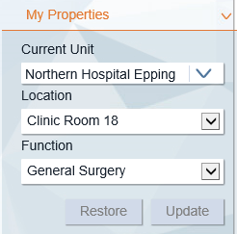
  - Easiest way to approach follow-up is to run through the plan in the discharge summary and ensure everything has happened. Can also check the operation note.
  - Pain control.
  - Wound.
  - Bowels.
  - Review the histology and sign it on CPF.
- Settings for Q-flow: User -> My Properties -> as per image ->
- Settings for CPF to see Reg clinic list: Patient List -> Outpatients -> Clinic code: NPSURG4PDREG
- After seeing a pt, complete the outcome form on q-flow and write a note on CPF (appendix 1)
  - Outcome form:
    - Click the smiley face -> outcome form
    - Usual outcomes: discharge to GP/rebook (specify timeframe)/Fail to attend (FTA).
  - CPF note:
    - CPF -> outpatients -> Surgical Outpatient progress note (MBBS: Standard review)
  - For FTAs:
    - Call a patient 3x, if no answer can classify as FTA.
    - You cannot FTA unless you have called at OR after the pts appointment time
    - If the pt had a simple procedure such as a lap appendix or chole, they can be d/c to GP, if there is something more important to discuss you can rebook for 2 weeks.
    - Discuss this with the reg.
- If you are unsure about anything that comes, feel free to discuss with the reg/HMO/Fellow
- Outpatient Jobs:
  - Consultants will often give the reg a list of ad hoc jobs that have come up during clinic.
  - Common jobs:
    - Chase radiology.
    - Chase bloods.
    - Add patients to radiology meeting.
    - Call patients to update them on results.
  - Can add these to the bottom of the ward round list or make an excel sheet to keep track of jobs and tick off as they have been completed.
- Chasing images:
  - To chase any image, you need to know 3 things:
    - Imaging modality i.e. CTCAP, US neck etc
    - Date of imaging.
    - Where the images were taken.
  - Images from other hospitals:
    - You need to hub and spoke these images to get them across.
  - Images from private companies i.e. IMED, Capital, Health imaging etc
    - Once you have the core info, you can ask Max from PACs to transfer the images to synapse via phone (x59682) or email (nh.hispacs@healthcareimaging.com.au)
    - In subject line: Re: image transfer PATIENT LASTNAME
    - In email body include: patient name, UNRO, DOB, imaging site, images to transfer (type + date) and consultant the patient is under

JMO ROLE & RESPONSIBILITIES
Lists/bloods
- For each week, the intern on long/full days prepares/updates the list and puts in bloods for the next morning (on Friday put in bloods for whole weekend incl. Monday to help cover HMO). Usually we alternate days for intern writing ward round notes but do what works for you! (Print WR template in S: drive and fill out notes as much as you can prior to ward round to save time)

Rostered hours, realistic hours, half-days, cover shifts, weekend shifts:
- If there are 2 lists in theatre, usually need both interns at work. One on the wards and 1 in theatre. Try to swap days off for other days
- For overtime put down Head of Unit to sign off i.e. Mr Houli (or Mr Bird when back from leave)
Who to hand over to at end of each shift:
- The person on the afternoon / cover shift (from 5pm), this will be one of the Surg 1 interns (W16)
Discharge summaries:
- Prepare in advance for those likely to go home in a few days, on quiet days get a head start, particularly for patients who have been admitted for a long time
- Most bosses have clinics at BHS and CHS as well as TNH, ask patient what is best for them
- If the boss is going to follow up with the patient privately, fax a referral +/- discharge summary to their rooms
Ordering of investigations, chasing results:
- Discuss with reg about who needs daily bloods / who does not need bloods. Simple post-ops who are well do not need bloods. Do not order daily CRP or CRP D1-3 post op. Don’t follow lipase for pancreatitis, will follow CRP (usually done every second day). Incl. freq of bloods on handover list.
- If you are planning a radiology guided procedure, will need recent coags (usually within 12-14 hrs) and to be fasted from midnight (FFMN) for planned procedure. You will book a lot of these, so order the bloods asap, document FFMN and chart IVT. The bookings nurses are lovely and can make anything happen if you’re nice; they don’t start until 0930. Reg/HMO needs to consent the patient for the procedure, will need a consent form + radiology form, and MUST discuss and get the signature of the Interventional Radiologist on that day for it to be approved BEFORE d/w bookings.
- No CRPs for Mr Yong’s patients! Make sure to run ALL investigations by the reg before ordering bloods for Mr Yong’s patients to ensure that they are the ones he actually wants, including bloods and drain tube fluid (usually only lipase/amylase, NOT MCS)
  - Also, do not refer to other inpatient teams without direct instruction from Mr Yong/Registrar, includes allied health referrals.
Referrals/ bookings on discharge specific to rotation:
- Most simple post op pts -> refer to Surg 4 Reg Phone Clinic on discharge. Clarify time frame, reg/fellow/consultant clinic, and phone/F2F in the AM round when the pt is to be discharged.
Outpatient clinics, preadmission clinic:
- OPC (Monday PM): HMO to be in the clinic. Half day intern usually helps out with simple post-ops.
- You will be given many outpatient jobs, from clinic, xray meetings, MDMs etc. We keep track of these using a section at the bottom of the list.
Theatre:
- May need to help out, especially if 2 lists on in theatre +/- scopes. Fellow/reg will let you know
- Team are very happy for you to get involved if you are keen
- Usually work out theatre schedule between interns week by week as theatre lists can change

Admissions:
- Often have to admit pts from clinic and endoscopy. Get onto bed manager early.
- Need to call the AO (admissions officer – ask switch to put you through) to request an admission/bed. Fill out an NOA (notice of admission) form and take it to the bookings office.
- If no beds, then may have to admit through ED, if so then let the ED NIC + Purple consultant know to put them down as an expected admission, do the admission paperwork, drug chart and relevant bloods, imaging requests etc. so they really don’t have to do anything other than babysit until a bed is available.
Clinical documentation queries in Medtasker
- Good documentation is critical to provide an accurate record of the patient’s stay in hospital, decision making processes and rationale and handover between the multiple clinicians engaged in the patient’s care. Remember - “if it is not documented, it didn’t happen”. Your documentation is also vital for ‘clinical coding’, which is necessary for Department of Health data reporting and hospital financial reimbursement.

- To ensure accurate and comprehensive documentation in real-time, the Clinical Documentation Specialist (CDS) will identify any deficiencies in documentation in the healthcare record and will query these via Medtasker. These will show up as “CDI Query”. Please action these queries by documenting in the healthcare record. This can be done by documenting:
• on the next progress note (paper format), or
• on an electronic progress note in CPF by noting “CDI query response”, and/or
• on the discharge summary in CPF

COMMON CONDITIONS MANAGED BY UNIT
- Pancreatitis
- Cholangitis
- Post ERCP +/- CBD stenting or EUS
- Cholecystitis / choledocholithiasis / CBD reconstruction
- Post elective Whipple’s / liver resections / pancreatectomy +/- splenectomy

COMMON MEDICATIONS SPECIFIC TO UNIT
MEDICATION | INDICATION | ROUTE | DOSE | FREQUENCY
Started anti emetics + analgesia
Creon | Post pancreatectomy | PO | 25,000 Units minimum | TDS * Boss dependent
Octreotide | Post pancreatectomy |  |  | *Boss dependent*
Erythromycin | Post HJ + GJ bypass as a prokinetic | PO | 50mg | TDS
Metoclopramide | Prokinetic | PO | 10mg | TDS

COMMON ISSUES
- Protocols – Know the protocols for each surgeon post op. E.g. clexane for 4/52 post major ops for Houli/Hodgson. Patient needs to be educated on administration (by nurse)
- Mr Hodgson has printed protocols for his major post-ops
- Post major ops: Daily weights, strict fluid balance – check drain tube and NG outputs!
- Post op liver resections often require QID BSLs and daily coags for a few days.
- Post op splenectomy patients should be added to the spleen registry, started on prophylactic amoxicillin and send home with rescue amoxicillin script (appendix 3), ensure spleen vaccines up to date otherwise ensure there is a plan for GP to follow-up on DC (easier to do prior to discharge).
  - Spleen Australia guidelines - https://spleen.org.au/wp-content/uploads/2020/03/202110-Spleen-Australia-ADULT-medical-recommendations-asplenia-hyposplenism-v41.pdf)
  - See appendix 2 for a post-whipple’s discharge plan in addition to standard DC instructions
- Electrolyte replacement – be proactive!

PROCEDURES COMMONLY ENCOUNTERED
- CT intravenous cholangiogram - patient needs to fast for 6 hours, chart biliscopin as stat order
- Clarify CT protocol with reg/fellow/consultant (e.g. Pancreas, liver, quad phase, triple phase)
- MRCP – needs to fast for four hours prior
- MRI with gadolinium contrast – prefer blue cannula
- CT with IV contrast – prefer green cannula (but pink will do if necessary)
- PET scan with FDG – clarify whether patient is diabetic, need to withhold metformin beforehand
- HIDA scan – no opioids usually for 24H, fast for 4-8 hours prior. Confirm with nuclear medicine.

INSIDER INFORMATION & MISCELLANEOUS TIPS
For any of Mr Yong's patients, do not test ANY drain tube fluids / order ANY imaging without him knowing or asking you to. Do not order a CRP. Discuss all referrals with Mr Yong.

Post Whipple’s pts will need a drain tube amylase/lipase/bilirubin ordered on specific days from each drain. Be absolutely certain they are done on the correct days and the samples are correctly labelled. Order different drains for different times of the day (i.e. 0900 R DT, 1200 L DT) and only leave one slip in the patient’s folder, to ensure correct sample is taken ( or take it yourself!)

Do not pull any drains or tubes from a pt without being told to do so by a consultant /fellow/ reg, and if you are told to pull a drain, ensure it has been removed (just because you document it, doesn’t mean it will be done, always CHECK).

Post op Whipple’s pts are in a persistent SIRS state for about a week post op, be careful of overzealous IVT boluses as it generally does not help tachycardia and will often result in APO. They are also known to have a “day 3 crash” post op. Keep in mind that post Whipple’s, you have pretty much made the pt a surgical diabetic, they require strict BGL monitoring and tight control, get Endo involvement early if required. All nursing staff / ICU staff etc are uneasy when there is a post op Whipple’s around, it’s good to let the night cover / night surg reg know there is one around and how they are going.

Some patients post whipple’s may need somatostatin analogue to suppress pancreatic secretions. If you are asked to give the patients a 4 week depot, you will have less resistance prescribing lanreotide rather than octreotide.

The most important thing to look out for in post op Whipple’s is for a “sentinel bleed”; i.e. blood in one of the DT’s -> this requires urgent reg / consultant review as it can signify pancreatic fluid eroding the gastroduodenal artery and the pt is about to be (or already) exsanguinating internally.

Learn what pancreatic juice looks like and document. Pancreatectomy patients often have a drain tube in for weeks and HITH will manage this (usually Mr Yong patient’s will be taught to self-manage their drains). HITH need to know when to notify the team re: DT (upper and lower limits of discharge).

Make sure nurses are doing daily / progressive totals on fluid balance – NGT output and volume of PO intake particularly for patients with ileus or obstruction, and of course drain tube outputs. Document colour/consistency of any outputs.

Generic post op instructions: no heavy lifting >5kg for 4-6 weeks. No driving for 1 week or until abdominal pain under control. Dressings waterproof so patient able to shower (no baths) + pat dry afterwards, dressings can come off in 7-10 days (with GP wound review at this time).
- Can find discharge templates for common procedures on S: Drive -> Medicine -> AGSU handover -> Templates -> POST OP DC templates

Appendix 1: Example CPF note template for outpatient clinic (simple lap chole/lap appendix/hernias)
FIRSTNAME LASTNAME (Surg 4 Intern) | Telehealth R/V post discharge
AGE(M/F) post-PROCEDURE for INDICATION (DATE OF PROCEDURE, CONSULTANT SURGEON)
(E.g., 29F post laparoscopic cholecystectomy + IOC for biliary colic (21/1/22, Mr B. Nguyen))

On R/V:
- Wound healed well – denies redness, pus, swelling
- F/U with GP for wound review – nil concerns
- Pain well controlled on simple analgaesia
- Bowels opening, passing urine
- Tolerating E+D, denies any N&V
- Adherence to no lifting restrictions? When patient able to resume normal activities? (usually 4-6 weeks)
- [If a hernia: ?recurrence of hernia]
- Nil other concerns

- Discussed histology results: XXX
- All questions answered

Plan:
1. Discharge to care of GP (most often outcome)

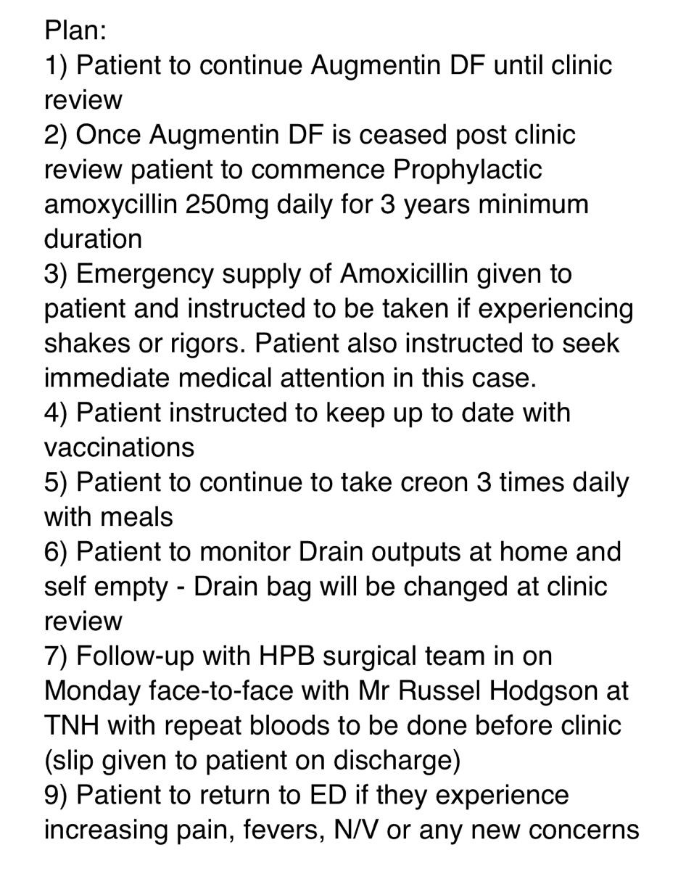
Appendix 2: Whipple’s discharge plan (total splenectomy)

Note: Drain tube management can either be self-managed by patient OR managed by HITH (consultant dependent, you will be told!)
- Also, surgical OPC follow-up will depend on boss, always ask Reg to clarify who will review the patient in OPC and timeframe of this!

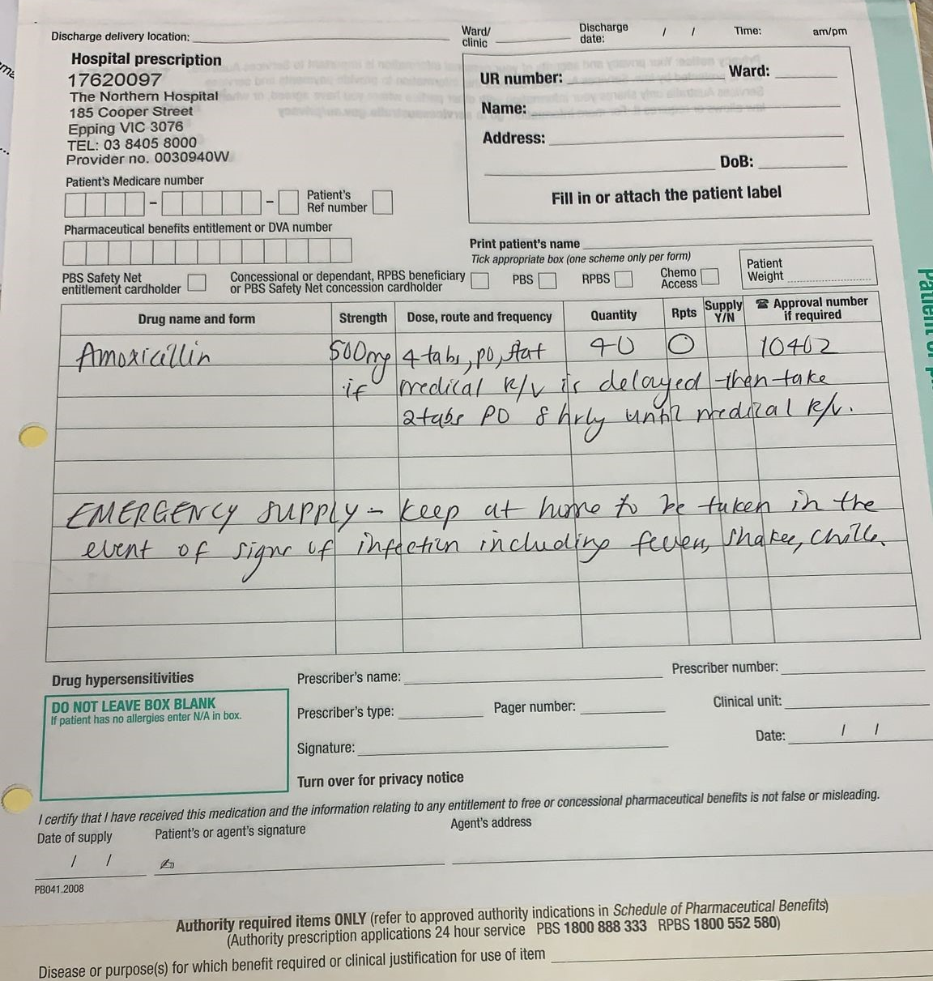
Appendix 3: Example of emergency amoxicillin script for Whipple’s patients

