
ROVER (Rolling handOVER) – I am a ‘living document’ that needs your care and attention

ROTATION: SURGICAL 3 – UPPER GI & ENDOCRINOLOGY
UPDATED DATE: 05/04/2024
! Please update me as required and send me to fathimaijaza.lafeer@nh.org.au in week 8 of this rotation
CHECKLIST FOR NEW STARTERS
- read through this ROVER
- receive comprehensive unit orientation from term supervisor/registrar within week 1
- obtain username and login for Cancer MDM and iPM
TOP TIPS!
- Procedures relating to oesophagus may require a gastrograffin swallow booked ahead of time, check with the registrar to be sure ! GG challenge is 4-6 hrs post gastrografin ingestin, whereas GG swallow occurs in real-time (“on the table”). Swallow does not require GG to be ordered in EMR before procedure
- HMO - Mail out the agenda for the radiology meetings before Wednesday evening the week of the meeting.
- Always have one intern ready to scrub into theatre as needed
- HMO - Arrive at radiology meeting 5-10 minutes early to set up CPF and prepare for busy note taking
- When adjusting internal referrals for patients known to Surg3 Clinic (e.g. bringing forward clinic appointments as per plans from the radiology meeting) email Ally at NH-SpecialtyPracticeGroup5@nh.org.au and making a new referral as it easier for the clinic team.

STAFF
UNIT STAFF & KEY CONTACTS | CONTACT DETAILS
Head of Unit: Mr Steve Manolas
Consultants:  Steve Manolas  Chek Tog  Betty Lai (on sabbatical)  Ben Keong  Andrew Chong (on sabbatical)  Krinal Mori (on leave)  Zeng Yap  Yi Sia  Ernest Lim | Via switch
Fellow:
Michael Reeves
Registrar:
Alex Kuzminov/ Pearl Momoh
HMO/Resident: Lily Owens | Intern pager 184 (Intern A), 096 (Intern B)

GEOGRAPHY
ITEM | LOCATION
Home ward & AM meeting point | Ward 18, back office
Consultant Rounds | Thursdays at 12:30pm outside of ward 13 by operating theatre doors
Your pager lives here | Ward 18 somewhere on the desks
Patient list | EMR > Doctor Worklist > List: Care Team List > General Surgery 3 (Upper GI/Endocrine Su
Handover | Via medtaskers (night HMO/intern cover) or AGSU junior surg group whatsapp

WEEKLY TIMETABLE
Mon | Tue | Wed | Thu | Fri
0745  MDM meeting (UGI fortnightly,  12:45pm  MDM meeting (Endocrine monthly) | 1230-1330  Intern Teaching  Lecture Theatre |  | 1230  Consultant Ward Round  1300-1330  Radiology meeting (weekly, MSteams)  1400+  Surg 3 Clinic  Liaise with Reg after clinics to gather list of outpatient jobs

Radiology meeting (1pm Thursdays, radiology meeting room)
The regs will add you to a whatsapp group specifically for XRM. They will post everyone that needs to be added to the meeting there. Generally an HMO job.
Interesting radiology from preceding week + upcoming surgery + patients attending OPC that day for review Consultants will commonly add late cases or add external patients
- Prepare agenda: My Computer> S Drive > Medicine > Surg 3 > Radiology Meetings
  - See previous meetings for examples.
  - You may need to chase external images, ensure this is done early (see below in outpatient clinic “Chasing Images” for instructions)
- Create synapse folder
- Synapse > Conferences > SURG 3 2018 > scroll to bottom of list, right click, new > conference
  - Open a second synapse window, search your patient then drag the appropriate imaging file into the conference folder
- Email out the agenda to the meeting before Wednesday evening of that week. Make sure to CC all consultants and radiologists
- During meeting
- Plan is the most important aspect, it is ok to ask for clarification from the fellow or in the MS teams meeting.
- Can take notes in the word doc agenda but after the meeting you must copy and paste the notes into each patient’s file in CPF.
- Record notes in CPF > Outpatients tab > add> Radiology Meeting Note
- After: Liaise with team for outpatient follow up – i.e. needs a repeat PET or CT etc

Consultant ward round
Consultant Ward Round occurs at 12:30 every Thursday
- Meeting place is outside theatre entrance near ward 13
- Be there at 12:25 with up to date list printed. Print around 10-15 as you never know exactly how many consultants are coming
- Prepare to present patients to consultants – this will be good exposure to meet consultants
- Be prepared for jobs to crop up as a result of the ward round
- Occasionally will be required to present patients to the consultants.
JMO ROLE & RESPONSIBILITIES
Ward round:
  - Start time is usually 7am unless registrar states otherwise (often 8am when there is no theatre list for the day).
  - Interns arrive 30 mins before to prep the list (see appendix for accessing List) and ward round notes.
  - During the ward round, divide jobs amongst the two interns, 1 intern writes notes the other does tasks and answers the medtasker

- Theatre list (Accessible via the following links)
  - ETBS: http://etbs.nh.org.au/
  - Electives: http://dsuselfrequest.nh.org.au/internal/SessionSchedule/index.php
    - This PC > Shared on TNHOffice (S:) > Medicine > Surg 3 >
  - Theatre List available inside theatre on hospital tower side entrance
  - Names of consultant will be written on whiteboard outside each theatre
- Although the HMO goes to clinic, interns can assist with Surg 3 resident (resident) or registrar (in-person) clinic every week when busy(Thursday afternoon)
- Theatre bookings for Surg 3: next to Day Procedure Unit entrance
- Endoscopy/NoA booking: must be consented by HMO (not intern)
- Intern orders bloods for the next day (and weekend + Monday if on Friday)
- Make sure to writeup a list (best around ~4:30pm) and handover to the surg 1 cover Intern before you leave.
Outpatient Clinic
- On Thursdays after radiology meeting.
- 1 intern can help with the reg/HMO clinic
- The reg will usually screen patients appropriate for the intern to call (usually simple post discharge lap choles and appendixes)
- Things to ask the patients:
  - Easiest way to approach follow up is to run through the plan in the discharge summary and ensure everything has happened.
  - Pain control.
  - Wound.
  - Bowels.
  - Review the histology and sign it on CPF.
  - Work.
- After seeing a patient, complete the outcome form on q-flow and write a note on CPF
  - Outcome form:
    - Click the smiley face ➔ outcome form.
    - Usual outcomes are discharge to GP/rebook (specify timeframe)/Fail to attend (FTA).
  - CPF note:
    - CPF ➔ outpatients ➔ Surgical Outpatient progress note
    - Contents:
      - Identity | Post discharge review.
      - Background
      - Discussion points.
      - Plan.
  - For FTAs:
    - Call a patient 3x, if no answer can classify as FTA.
    - You cannot FTA unless you have called at the time or after the patient’s appointment time.
    - If the patient had a simple procedure such as a lap appendix or chole, they can be d/c to GP, if there is something more important to discuss you can rebook for 2 weeks.
    - Discuss this with the reg.
- If you are unsure about anything that comes up during an OPC, feel free to discuss the condition with the reg.
- Outpatient Jobs:
  - Consultants will often give the reg a list of ad hoc jobs that have come up during clinic.
  - Common jobs:
    - Chase radiology.
    - Chase bloods.
    - Add patients to radiology meeting.
    - Call patients to update them on results.
- Chasing images:
  - To chase any image, you need to know 3 things:
    - Imaging modality i.e. CTCAP, US neck etc
    - Date of imaging.
    - Where the images were taken.
  - Images from other hospitals:
    - You need to hub and spoke these images to get them across.
  - Images from private companies i.e. IMED, Capital, Health imaging etc
    - Once you have the core information, you can ask Max from PACs to transfer the images to synapse via email.
    - Email a request to nh.hispacs@healthcareimaging.com.au
    - In subject line: Re: image transfer PATIENT LASTNAME
    - In email body:
      - Pt name
      - URNO:
      - DOB:
      - Imaging site:
      - Images to transfer (Type and date)
      - Consultant:

MDM Upper GI (0745 Mondays, fortnightly) Endocrine (1245 Mondays, monthly)
- Preparation
- cancermdm.com.au
  - Request a login by emailing cancermdm@nh.org.au
- Please ask the registrar who needs to be added to the meeting agenda
- The list needs to be finalised the Thursday before the meeting at the latest to ensure that the pathologist has enough time to see the slides
- Filling out the MDM:
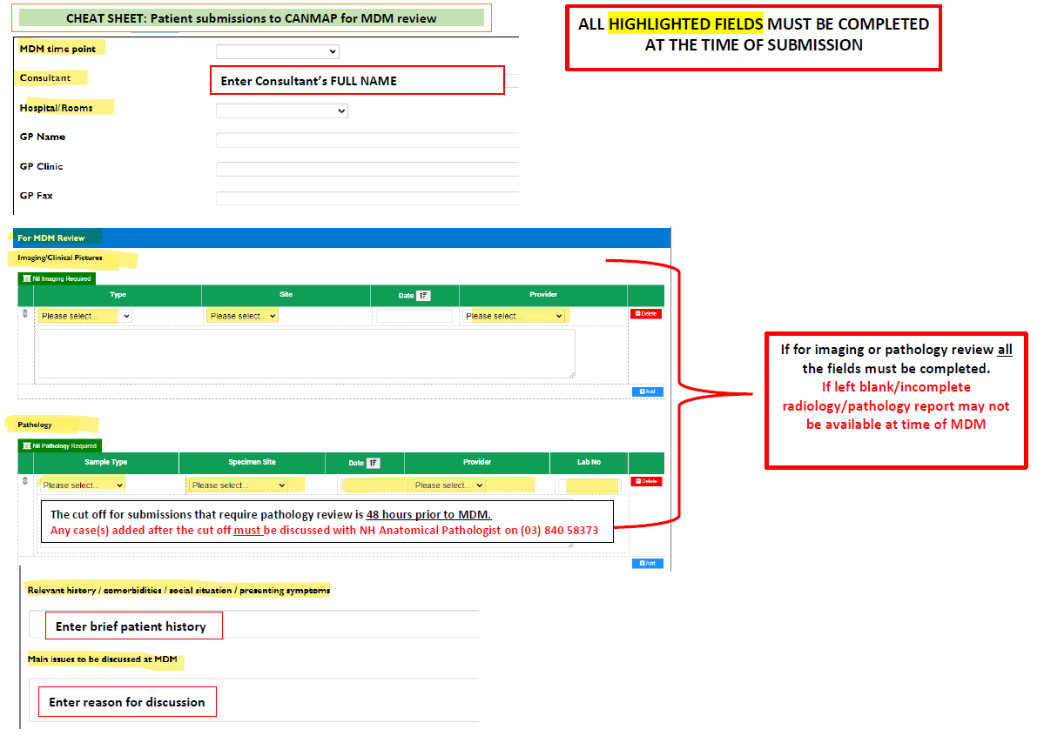
- During the meeting
- Registrar fills out the MDM form (co-ordinator will give to you during meeting)
- After the meeting
- If any referrals or radiology imaging for patients is required, please check to see they have been booked and if not make the appropriate referrals

POST TAKE
Each surgeon rotates through the on take roster for AGSU. The new patients will be under our care the following day.
- Take a photo of the take roster printout in the AGSU handover room (entrance to wards 13/14/15)
- This PC > Shared on TNHOffice (S:) > Medicine > Surg 3 > SURGICAL & O&G ONCALL ROSTERS
AGSU will let you know how many patients are transferred in your rotation’s whatsapp group.
- If AGSU has not added to the care list, Add Patient + Establish Relationships in Doctor’s Worklist
- AGSU Reg should hand over to your Reg too. (AGSU phone x52628)

ONE NOTE
https://onedrive.live.com/view.aspx?resid=AEE9DB332E48657D!23400&ithint=onenote&authkey=!ArSzwuyihr7nRY0
- Outdated as of 05/03/2024

DISCHARGE SUMMARIES:
Tip: Find an outgoing intern and copy their autotexts!
.GPxxxx or .advicexxxxx
Sample plan (adapted from Surg 1 template):
Dear Doctor,

Thank you for the ongoing management of XXX. She/He underwent an XXXXX for a XXXXXXX (details above).

Please see the following plan upon discharge:
1. Discharge home
2. Continue using analgesia as required.
3. Remove dressings in 7-10 days.
4. GP to review wound in 1 week.
5. Follow up in Surg 3 reg phone outpatient clinic in XX weeks. (usually 2 weeks, 4 weeks for lap choles)
*Usually book reg phone clinic unless otherwise specified (i.e F2F Consultant clinic)
6. No heavy lifting (>5kgs) for XX weeks. (usually 4 weeks, 6-8 weeks for post hernia repairs)
7. No driving for 2 weeks or until pain well controlled without use of opioid analgesia

Kind Regards,
General Surgical Unit 3 | Northern Health

Instructions for Patient:
No heavy lifting (>5 kg) or strenuous activity for 4 weeks.
You may start driving when you feel the abdominal pain is under control (we generally say no driving for about 2 weeks).
Dressings can be removed after 5 days. You can shower in them, just pat dry afterwards.
Please take your medications as instructed by your pharmacist.
Please attend your follow-up outpatient appointment with Surg 3 in 2 weeks (appointment letter will be sent out to you).
If you experience increasing pain, fevers/chills, nausea/vomiting, or any significant new concerns, please return to the ED.

More discharge summary templates can be found in the Surg 3 folder on the S drive

GEN SURG CONDITIONS AND PROCEDURES COMMONLY ENCOUNTERED
- Acute cholecystitis/cholelithiasis → Laparoscopic cholecystectomy
- Appendicitis → Laparoscopic appendicectomy
- Abscess → Incision and drainage of perianal abscess/pilonidal sinus
- Adhesional SBO → Adhesiolysis vs conservative management
- Hernia – inguinal/periumbilical/incisional → laparoscopic repair +/- mesh
- Non-perforated/contained perforation diverticulitis, simple small bowel obstruction, mild pancreatitis → conservative management

ENDOCRINE SURG CONDITIONS AND PROCEDURES COMMONLY ENCOUNTERED
- Primary hyperparathyroidism (parathyroid adenoma) → parathyroidectomy and 4 gland exploration. Patients need CMP and PTH levels post-op and the following morning, if calcium low discharge on caltrate, counsel patient about symptoms of hypocalcaemia
- Secondary/Tertiary hyperparathyroidism (renal cause) → Removal of all four parathyroid glands or may remove 3 and a half. Patients will need a central line and ICU management, renal will be closely involved. These are rare.
- Thyroid nodule/nodules → hemithyroidectomy, patients discharged following day. TFTs 6 weeks post op, GP can review. Total/completion thyroidectomy – CMP and PTH 4 hours post-op (Monash protocol), if calcium low discharge on caltrate with repeat CMP in 2 weeks and clinic review where caltrate can be weaned.

- Hemithyroidectomy
  - PTH/TFTs prior
  - No clexane post, sleep head 30*; any neck swelling/difficulty breathing → CODE BLUE
  - No bloods required post op (unless otherwise specified)
  - Surg 3 clinic 1 week
  - TFTs 6 weeks with surg 3 clinic post
- Total (or completion) Thyroidectomy
  - PTH/TFTs prior
  - No clexane post, sleep head 30*; any neck swelling/difficulty breathing → CODE BLUE
  - Ca + PTH post op + 0600 next mane (slip often made in OT but double check)
  - Commence on Thyroxine daily (check dose based on op note, usually 100microg mane)
  - Commence on Caltrate (either regular or PRN → be guided by OT note/Monash protocol)
    - Caltrate PRN – utilize if any symptoms hypocalcemia (tingling mouth/fingertips)
  - Repeat CMP at 1 week + surg 3 clinic post
  - Repeat CMP at 4 weeks (may get cancelled in surg 3 clinic but provide slip just in case)
  - Repeat CMP + TFTs at 6 weeks with surg 3 clinic post
  - Consider Endocrine Outpatient referral to review thyroxine dose in 6-8 weeks
- Parathyroidectomy
  - PTH/TFTs prior
  - No clexane post, sleep head 30*; any neck swelling/difficulty breathing → CODE BLUE
  - Ca + PTH post op + 0600 next mane (slip often made in OT but double check)
  - Commence on Caltrate (either regular or PRN → be guided by OT note/Monash protocol)
    - Caltrate PRN – utilize if any symptoms hypocalcemia (tingling mouth/fingertips)
  - Repeat CMP at 2 weeks + surg 3 clinic post

UPPER GI SURG CONDITION AND PROCEDURES COMMONLY ENCOUNTERED
- Hiatus hernia → 360 degree/posterior wrap fundoplication or 180 degree/anterior wrap fundoplication. Patients will often need a gastrograffin swallow post-op to rule out early recurrence before commencing diet. These need to be requested a day or two beforehand
- Oesophageal cancer → Ivor Lewis oesophagectomy, ICU post-op, gastrograffin swallow D5 post-op
- Gastric cancer → mainly subtotal gastrectomy, also do total and proximal gastrectomies
- Perforated duodenal ulcer (emergency) → omental patch repair, ICU post-op
- Tenkhoff peritoneal dialysis catheter insertion

OTHER USEFUL INFORMATION
- Endobase: endobhs (both login & password)
  - Access via link on summary tab of CPF
  - Have endoscopy reports and images
- Useful forms to have in your folder
  - Endoscopy notice of admission, theatre notice of admission, consent for procedures
- S drive: post-operative orders
  - General information for patient post laparoscopic cholecystectomy & hernia repair
- Total/Completion Para/thyroidectomy: require calcium level checked post-op
  - Patients are usually placed on caltrate +/- calcitriol supplements (see Monash protocol)
  - Will be reviewed in outpatients 2 weeks post-discharge F2F with repeat bloods prior to appointment
  - All hemi or total thyroidectomy patients require TFTs in 6 weeks with surg 3 f/u psot
- Generally all patients get followed up in OPC in 2/52 post discharge/operation reg clinic telehealth
  - Sample referral:
    - F/U in Surg 3 reg OPC Telehealth in 2/52 w/ r/v of histopath

AUDITS

General surgical audit
- Monthly general surgery audit meeting Thurs evening
Data entry
- SINS: select ‘SURG3’ in drop down option
New admissions
- 3 sections, press the ‘Return’ button at the bottom right to navigate between these tabs
- Once all the 3 sections have been completed, press return & the number of patients displayed at the top of the screen should decrease by one
- Patient Details
  - Discharge plan (e.g. to home), organ selection, pathology selection
- Operation Details
  - Operation date (remember to change the date as default is the day you are accessing the program), supervisor, surgeon, assistant, operation time, operation category (elective, emergency etc), college class, ASA status (can be found on the anaesthetic notes from the operation)
  - Wound category
    - Clean: e.g. thyroidectomy, hernia
    - Clean-contaminated: e.g. cholecystectomy
    - Dirty: e.g. perforated bowel, perforated appendicitis
    - No wound
  - Organ selection, operation selection
- Complication details

Data analysis
- SINS
  - Press ‘Reports’
  - Enter the date range, then press ‘Workload’ → report generated
  - You will need to do the tally manually
- Update PowerPoint presentation ( S:\Medicine\Surg 3\Audit\2015)
  - Total workload
  - Individual surgeons
  - Operations
  - Non-operative cases
  - All other sections are completed by the registrar

Thyroid/endocrinology audit
- Excel file (S:\Medicine\Surg3\Audit\

Upper GI Cancer audit
- All patients with upper GI cancer will need an audit form filled out
  - ANZGOSA Audit Data Collection
- Fill form to the best of your ability
- Give to Mr Tog once completed
  - They belong in a folder above Mr Tog’s desk in the surgeons’ office (across from Medical Workforce Unit office)
- Not an intern expectation!

COMMON MEDICATIONS SPECIFIC TO UNIT
MEDICATION | INDICATION | ROUTE | DOSE | FREQUENCY
Gastrograffin Challenge | SBO/post op ileus  (AXR 4-6hrs post) | PO or NGT | 100ml | 4-6hr pre AXR
Gastrograffin Swallow | GOO, post HH repair, dysphagia | PO or NGT | 100ml | STAT in fluoroscopy (no need to chart on med chart, radiology will do it)
Augmentin Duo Forte | infection | PO | 875/125mg | BD for 5/7
Metronidazole | infection | PO/IV | 400mg TDS/500mg BD | BD for XX days
Targin | pain | PO | 10/5mg | BD
Endone | Pain | PO | 5-10mg | Q3H PRN (5-10 tablets)
Pantoprazole | PPI | PO/IV | 20-80mg | OD-BD
** Medication doses must be in accordance with the Pharmacy approved booklet
PROCEDURES COMMONLY ENCOUNTERED
- Bleeding incision sites – may require suture to be placed on the ward, alternatively can use steri-strips and packing to apply pressure to bleeding site, gauze soaked in adrenaline/lignocaine or directly infiltrating the wound with lignocaine/adrenaline to cease bleeding and achieve haemostasis
INSIDER INFORMATION & MISCELLANEOUS TIPS
- Patients with intercostal catheters (ICC’s) will require daily CXR
- It is encouraged that you scrub in and attend theatre as much as possible even if you are not surgically inclined. You gain valuable skills and are able to do basic things like retracting, manipulating the scope and suturing.
- Red Logins in the (S) Shared Drive will have general logins for Lumus, GV Health, Capitol Radiology, Goulburn Valley Imaging Group (private), Melbourne Pathology, Dorevich Pathology, Philip Island Radiology, Vision Radiology, Penninsula Health, Epworth Medical Imaging, Marina Imaging, Imed Regional Wodonga, Imed/MIA Victoria, Healthcare Imaging, Latrobe I-Med Regional Imaging, Future Medical Imaging Group, Bendigo (incl swan hill) Radiology

Surg 3 are a really welcoming and helpful team, if you are unsure about anything feel free to ask. The interns are amazing and really appreciate opportunities to learn so if you are unclear about something try and discuss with the reg when they are present so that they can benefit too. Enjoy it!

Appendix

Accessing List & Managing List
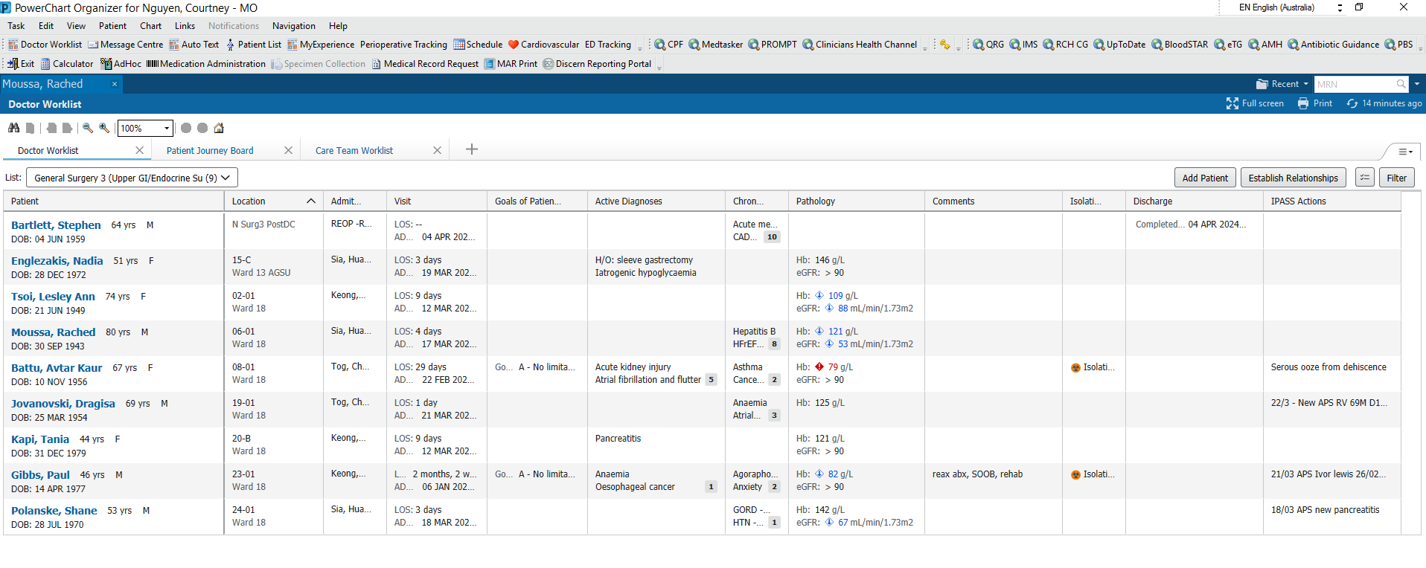
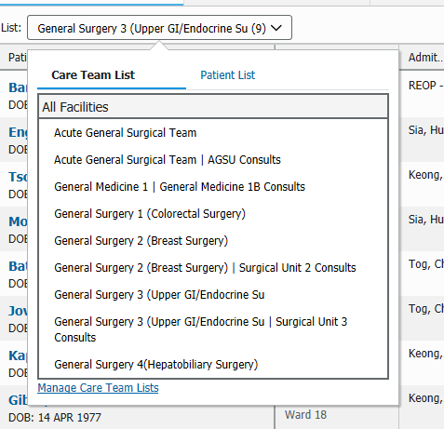
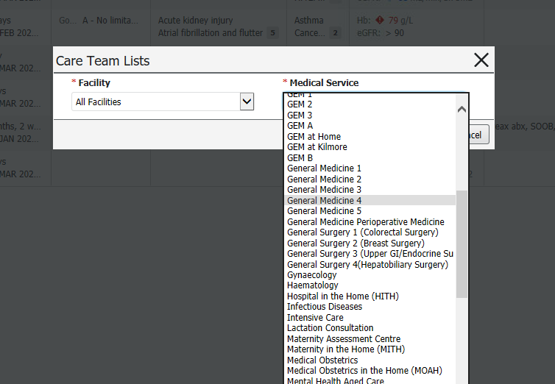
All General Surgery and AGSU will use this method of generating their list.
- Patients must be added to list by “Add Patient” → enter UR or name → select current/latest admission
- To access patient on list, must “Establish Relationship” with selected patients; all patient who are not ‘established’ will have grayed out information in their row
- Other teams can access your list and add/remove patients (esp AGSU)
- Patients must also be manually removed from the list when DC or TOC; patients who discharge on HITH don’t have a discharge date and may look like they are still inpatient when they have already went home
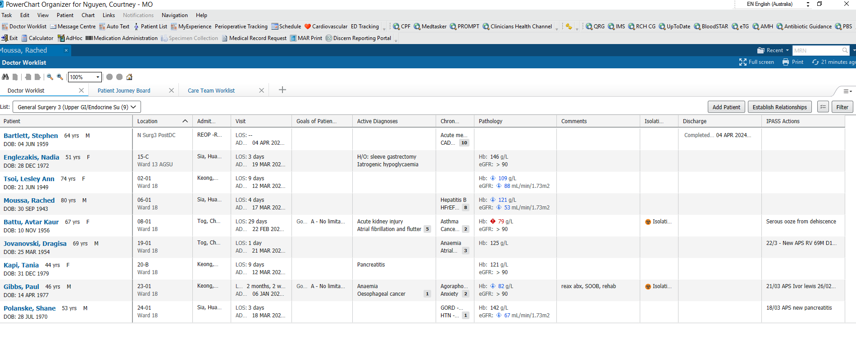
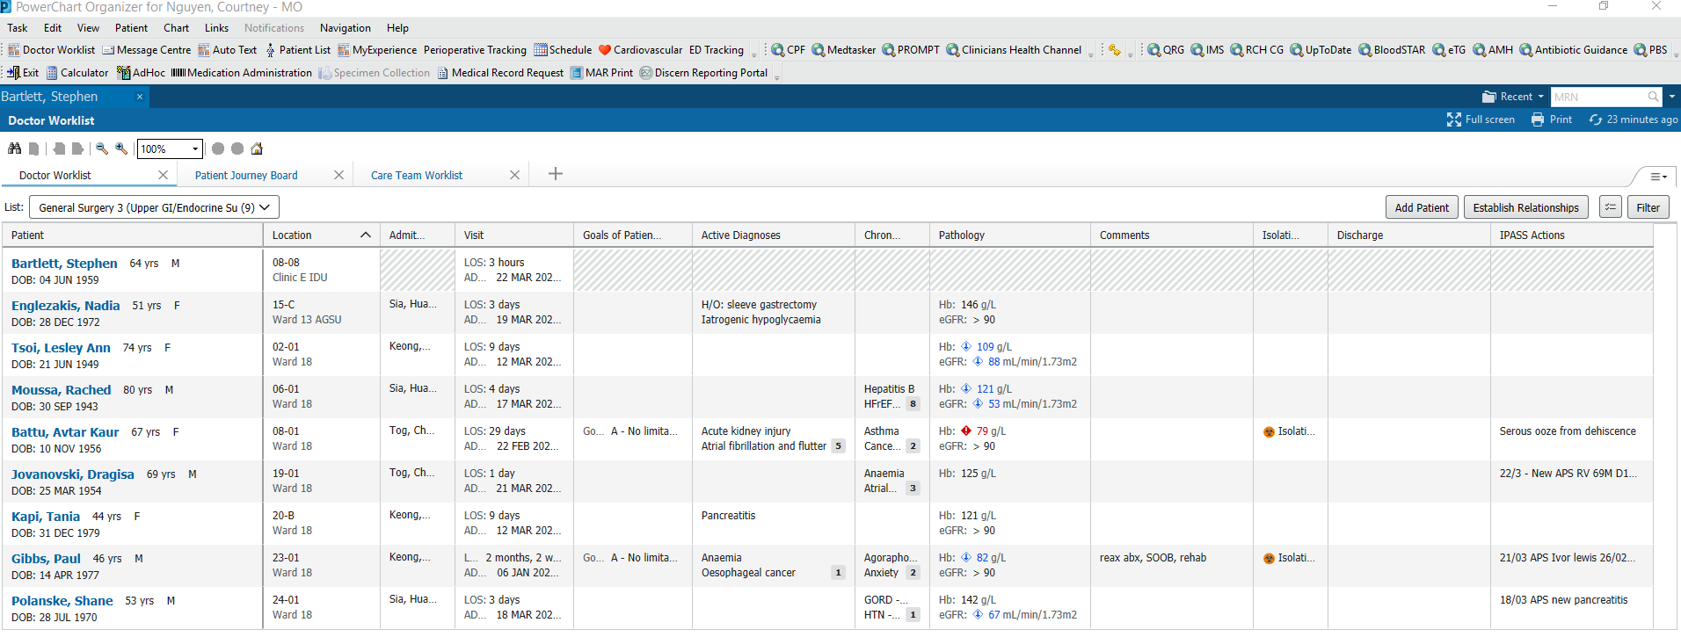
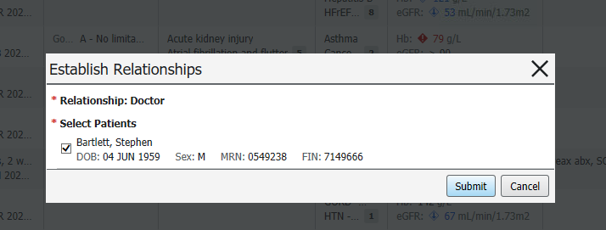

Monash Protocol
For Parathyroid patients with low calcium – calcium supplementation needed; they will also need to be weened of calcium. Will need to write this in the GP advice and advice to patient portion in the DCS

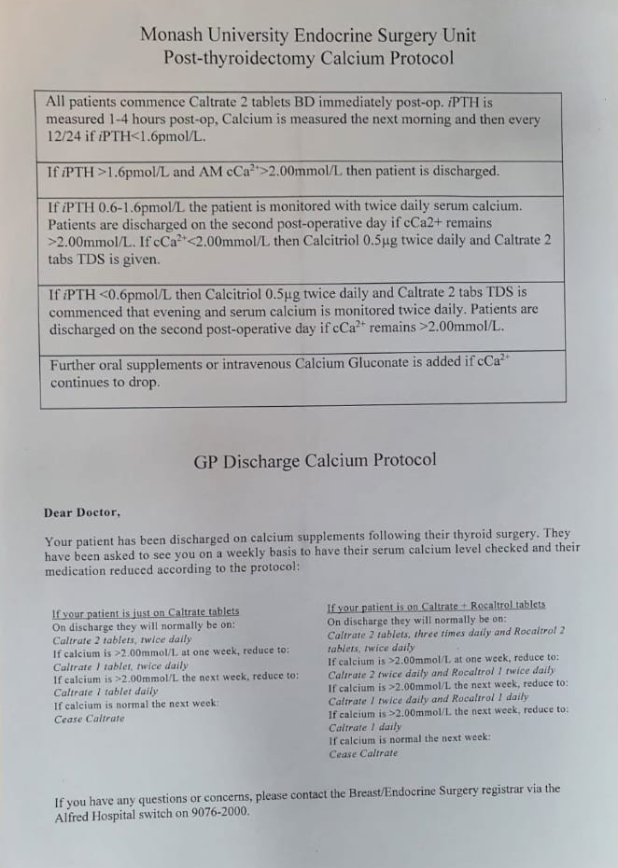

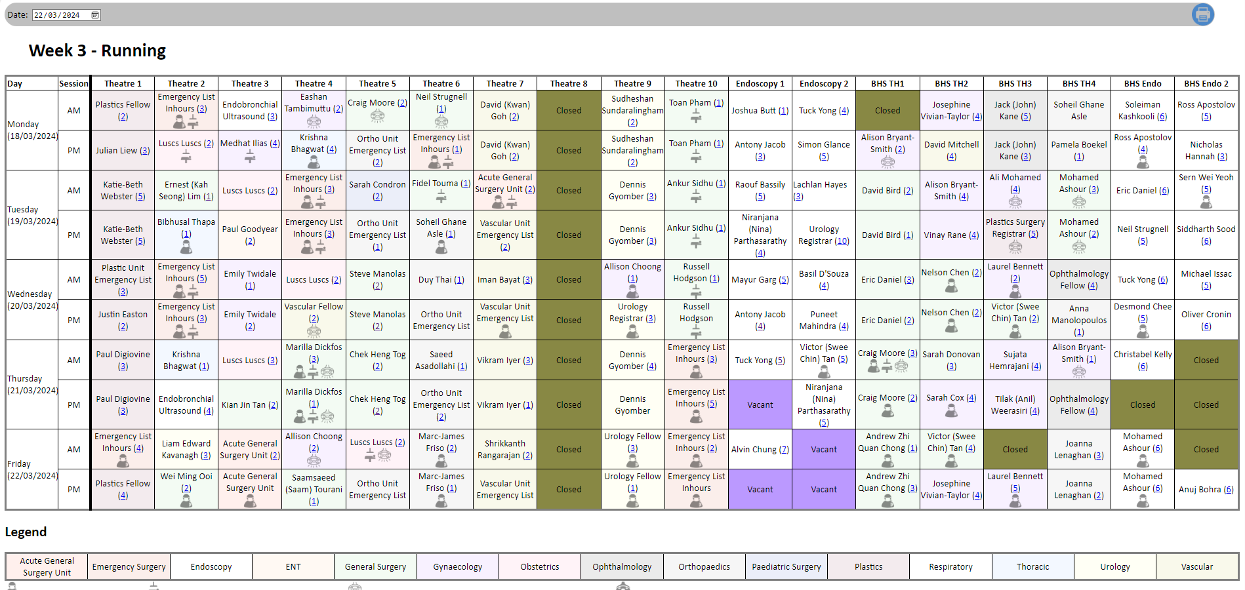
http://dsuselfrequest.nh.org.au/internal/SessionSchedule/index.php
^ Add to favorites

