9. Hospital Orientation
Hospital orientation occurs at the beginning of each term. Attendance is mandatory and paid non-clinical time.
This is separate to the unit orientation. Follow the link for details, password: NorthernDoctors
Location | NCHER, Northern Hospital – Epping | 185 Cooper Street, Epping 3076
Facilitator | Medical Education Unit | Email: MedicalEducationUnit@nh.org.au
Date | First day of each term
Start | 08:00

10. Unit Orientation
Unit Orientation occurs at the beginning of each term. Attendance is mandatory and paid time.
Orientation that occurs outside of your rostered hours should be submitted as overtime on the overtime reporting portal
Location | Rheumatology office – see JMO rover
Facilitator | Rheumatology Registrars
Date | First day of each rotation
Start | 08:00am

11. Unit Overview
Department | Rheumatology
Location | No inpatients; consults and outpatients only
Inpatient Beds | 0
Outpatients Clinics | HMOs attend 3 per week, Reg 1 attends 3 per week, Reg 2 attends 5 per week
Day Procedures | N/A
Virtual Unit | N/A

12. Safety
You will have the opportunity to undertake some procedures during this term if you are interested. Particularly knee aspirate/injection, but possibly other joint aspirates/injections if interested. Therefore, sharps are used. All procedures will be taught and supervised by the registrars and/or consultants.

13. Communication
Medtasker | Yes – Regs and HMO each have a MedTasker role
WhatsApp | Yes – WhatsApp group for the rheumatology team
Pager | No
MS Teams | No – only used for meetings

14. Handover Process
Morning | All team members arrive at the office at 8am and discuss new consults to be seen.
Afternoon | No specific handover as all team members work together during the day, but WhatsApp is used as required e.g on Friday when the HMO is leaving for their half day and may need to hand jobs or consults over to the registrar.
Night | N/A

15. Shift Structure
 | Intern | HMO | Registrar
Day | N/A | 08:00-17:00 daily except Friday half day | 08:00-17:00 daily except half day – Monday for Reg 1 and Friday for Reg 2
Afternoon | N/A | 08:00-17:00 daily except Friday half day
Night | N/A | N/A | N/A
Weekend | N/A | N/A | N/A

16. Shift Roles & Responsibilities
 | Intern | HMO | Registrar
Day | N/A | Document whilst seeing consults with registrars or consultants. Attend clinics on Wednesday and Thursday afternoon. | See inpatient consults, tend to outpatient jobs as required, attend clinics (Wed/Thurs PM, Fri AM for Reg 1; Tues all day, Wed/Thurs PM, Fri AM for Reg 2). Monitor & manage TNH Rheumatology gmail account.
Afternoon | N/A
Night | N/A | N/A | N/A
Weekend | N/A | N/A | N/A

17. Common Conditions
1. Gout / Calcium pyrophosphate deposition disease (pseudogout)
2. Rheumatoid arthritis
3. Spondyloarthritides (often HLA-B27 associated): ankylosing spondylitis, psoriatic arthritis, enteropathic arthritis, reactive arthritis
4. Polymyalgia rheumatica
5. Giant cell arteritis
6. Systemic lupus erythematosus
7. ANCA vasculitis
8. Idiopathic inflammatory myopathies (eg. dermatomyositis, antisynthetase syndrome, immune-mediated necrotising myopathy)
9. Systemic sclerosis
10. Sjogren’s syndrome
11. Sarcoidosis
12. MSK: osteoarthritis, greater trochanteric pain syndrome, rotator cuff pathology, adhesive capsulitis
13. Fibromyalgia/central pain sensitisation

18. Common Procedures
Joint aspiration – knee
Corticosteroid injections – knee, shoulder, wrist, trochanteric bursa etc

19. Clinical Guidelines
The My Favourite Links page on the intranet contains the links to a number of useful clinical guidelines https://intranet.nh.org.au/applications/
ETG- Electronic Therapeutic Guidelines
AMH- Australian Medicines Handbook
Up to Date
PROMPT- This site contains the hospital policy and procedure manuals. It can only be accessed from the intranet - https://intranet.nh.org.au/departments-and-services/prompt-policy-procedures-guidelines/prompt-policies-procedures-and-forms/

20. Routine Orders
Pathology | - FBE/UEC/LFT/CRP/ESR (Rheum Five)  - Other diagnostic investigations – RF, anti-CCP, ANA, ENA, dsDNA, ANCA, C3/C4, HLA B27 (spondyloarthritides), ACE / calcium (for sarcoidosis), APLS bloods (anticardiolipin, beta 2 glycoprotein, lupus anticoagulant), urine protein-creatinine ratio, urine MCS, haemolysis screen (haptoglobin, LDH, reticulocytes, blood film, DAT)  - SLE activity markers: dsDNA, C3, C4, urine protein-creatinine ratio, urine MCS (+/- red cell morphology)  - Pre-immunosuppression screening: hepatitis B sAg / sAb / core Ab, hepatitis C serology, HIV serology, QF gold +/- strongyloides serology
Radiology | - Plain x-rays: ?erosions, ?osteopenia, New York criteria for sacroiliitis  - Ultrasound  - MRI  - Extrapulmonary screening (systemic sclerosis, CTD-ILD etc): TTE, HRCT, RFTs
Pharmacology | - NSAIDs – meloxicam, naproxen, celecoxib  - Prednisolone (PNL)  - Common csDMARDs: methotrexate (MTX), hydroxychloroquine (HCQ), sulfasalazine (SSZ), mycophenolate mofetil (MMF), azathioprine (AZA)  - Biologics: adalimumab (eg Humira, Hyrimoz, Hadlima, Amgevita), etanercept (Enbrel, Brenzys), certolizumab (Cimzia), golimumab (Simponi), abatacept (Orencia), infliximab (Inflectra), tocilizumab (Actemra), rituximab, tofacitinib (Xeljanz), upadacitinib (Rinvoq), secukinumab (Cosentyx), ustekinumab (Stelera), ixekizumab (Taltz)  - Intravenous immunoglobulin (IVIg)

21. IT Programs
EMR | The EMR is in use for documentation, medication ordering and radiology/pathology requests.  It is being used for all inpatients, as well as maternity clinics and pre-anaesthetic clinics.  Located in the intranet > My Favourite Links > EMR Live Environment  EMR Training courses are located on the LMS- https://mylearning.nh.org.au/login/start.php  Training is compulsory; you will need to complete the elearning within the first week of commencing.  Please contact medical workforce, or check the EMR website for more information on how to complete EMR training https://emr.nh.org.au/  When starting a new rotation, please reach out to Term Supervisor to ensure you are oriented to the EMR specific workflows for that unit as well.  EMR is NOT a primary communication system. Please use Medtasker and phones for referrals and communication.
CPF | The source of information for all outpatients’ clinics, investigations, GP referrals and scanned admission notes prior to September 2023.  Located in the intranet > My Favourite Links > CPF https://cpf.nh.org.au/udr/
PACS | XERO Viewer Pacs- https://nivimages.ssg.org.au/ or located in My Favourite Links, look for the CXR icon  This is where you can find radiology images
My Health Record | Centralised health record https://shrdhipsviewer.prod.services/nhcn
Safe Script | Monitoring system for restricted prescription medications https://www.safescript.vic.gov.au/

22. Documentation
Admission | N/A – no Rheumatology bedcard
Ward Rounds | Documented on the EMR
Discharge Summary | N/A – no Rheumatology bedcard
Outpatient Clinics | - Favorite links > Qflow > update Room number & clinic list  - To call patients into your room & request any follow up appointments  - CPF > Outpatients > Add > Rheumatology Outpatient/Telehealth (phone) clinic  - Condition/Disease  - Duration of diagnosis  - Clinical manifestations of disease/joints usually affected  - Previous and current management (Why ceased? - intolerance, inefficacy)  - Last flare/stability of disease  - Current symptoms  - Infection risk – recent infections? Vaccine updates?  - Cardiovascular risk factors/management (autoimmune inflammatory disease associated with higher risk)  - Bone health/last DEXA scan (if significant glucocorticoid history)  - Examination  - Recent/last pathology results  - Scripts, including biologic reapplications  - Pens vs syringes  - How many left at home/pharmacy?  - For PBS applications, need current joint count (joints with synovitis) + CRP/ESR within last 4 weeks  - Plan for next review – routine vs time critical, F2F or phone
CDI Queries | N/A – no Rheumatology bedcard
Death Certificates | N/A – no Rheumatology bedcard
Coroners | N/A – no Rheumatology bedcard

23. Referrals
Internal | See JMO rover
External | See JMO rover

24. Clinical Deterioration
Escalation Process | No inpatients, but if concerned about clinical deterioration, escalation process is to the registrar initially and then to the Rheumatology consultant. The registrars will usually update the consultant daily, or more urgently if there is an unwell patient.
PreMet | N/A
Code | N/A

25. Night Shift Support
Unit | N/A (no night shifts 😊)
Periop | N/A
Take 2 @ 2 | N/A

26. Assessments: PGY1 & PGY2
All forms are located on the Northern Doctors website under the Assessments tab
Beginning of Term | Meet with Term Supervisor to set learning goals for the term using the Term Description Learning Objectives as a basis for the discussion
Mid-Term & End of Term | To be completed at the mid and end of term meetings
EPAs | Minimum of x2 EPA assessments to be completed per term

27. Mandatory Training
- Mandatory Training is located on the LMS- https://mylearning.nh.org.au/login/start.php
- Mandatory training is compulsory and part of your contract with Northern Health and needs to be completed by the first month of your start date. If not completed you will come of the floor to complete.
- Hand Hygiene needs to be completed by the end of your first week.
- If you have completed the mandatory training elsewhere you may be able to apply for recognition of prior learning

28. Unit Education
Wednesday morning: after weekly consultant ward round, before weekly unit meeting there is a teaching session with Dr Andrew Foote. Each week the team will choose a different topic to explore (e.g rheumatoid arthritis, myositis etc.) and Andrew will send some papers on the topic in advance. Andrew or one of the registrars will facilitate and the session typically goes for 30 minutes to an hour.

Many additional opportunities for informal education on the wards and in clinics.

29. Unit Meetings
Wednesday 12:45 – 13:30: weekly unit meeting online (Teams)
Rotating roster with registrars, consultants, and HMOs presenting. Each HMO will typically present once per rotation.

30. Research and Quality Improvement
No specific requirements for research or quality improvement. Consultants are very approachable and can assist with finding topics for research or ideas for quality improvement projects for HMOs interested in Rheumatology.

Challenging cases and those with poor outcomes are discussed in the weekly unit meeting to assist with both education/professional development and quality improvement.

31. Career Support
Consultants all approachable and happy to provide career advice and support. If interested in Rheumatology, speak with Dr Andrew Foote and arrange a time to meet with him.

32. Medical Students on the Unit
During the university semester there are two students attached to the unit at all times. Students work with the team for two weeks before rotating. Students are usually MD2, but occasionally there will be MD4 students assigned as well.

33. Rostering
Shift Swap | The doctor initiating the roster swap is responsible for arranging with an appropriate colleague.  Once you have arranged a colleague to perform the swap, please email your MWU coordinator and cc in the colleague.  All swaps should be kept to within the pay period fortnight where possible. In exceptional circumstances where this cannot be achieved, please discuss with the MWU coordinator prior.  All shift swaps should be like hours for like hours.  Proposed shift swaps must be emailed to your MWU coordinator for approval.
Unplanned Leave- Notification and documentation process | Personal Leave documentation required:  For 3 single absences per year, the doctor will not be required to provide any supporting evidence to substantiate their personal leave.  For other days absent due to personal illness or injury the doctor is required to provide evidence of illness.  To be eligible for payment, the doctor is required to notify the Health Service two hours before the start of their shift, or as soon as practicable.  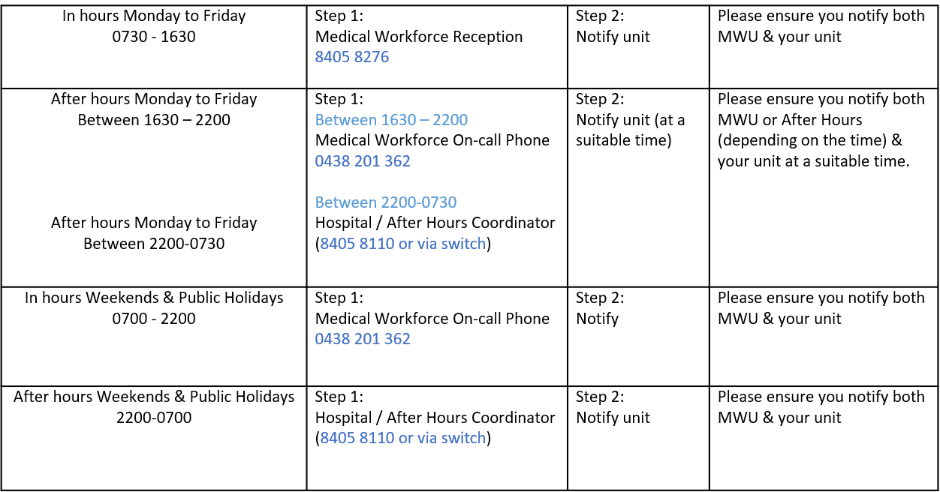
Overtime | All overtime should be submitted into the Overtime Portal  This can be accessed via the intranet whilst onsite at Northern Health  Please include the reason for your overtime- i.e. ward workload, delayed handover, include UR where relevant.

