9. Hospital Orientation
Hospital orientation occurs at the beginning of each term. Attendance is mandatory and paid non-clinical time.
This is separate to the unit orientation. Follow the link for details, password: NorthernDoctors
Location | NCHER, Northern Hospital – Epping | 185 Cooper Street, Epping 3076
Facilitator | Medical Education Unit | Email: MedicalEducationUnit@nh.org.au
Date | First day of each term
Start | 08:00

10. Unit Orientation
Unit Orientation occurs at the beginning of each term. Attendance is mandatory and paid time.
Orientation that occurs outside of your rostered hours should be submitted as overtime on the overtime reporting portal.
Location | Ward 20 and Respiratory Lab
Facilitator | Ward Consultant/registrar and NUM  Pleural team will arrange practical pleural procedure training.
Date | First week of rotation
Start | 08:00

11. Unit Overview
Department | Respiratory
Location | Ward 20 and Respiratory Function/Fit Testing Lab
Inpatient Beds | 4 RCU (Respiratory Care Unit) Beds and remainder Ward 20
Outpatients Clinics | Nil mandatory. Monday AM/PM, Tuesday AM, Thursday AM/PM, Friday PM
Day Procedures | SURC (Transit Lounge B) for day pleural procedures. Theatre for bronchoscopy/EBUS.
Virtual Unit | Ambulatory Pleural Service

12. Safety
Unit Specific Safety & Risks
- Safe medication prescribing
  - Minimise aerosol generating procedures. MDI inhalers, rarely if ever use nebulisers.
- Respiratory failure- Type 2 respiratory failure patient predominantly in RCU. Type 1 respiratory failure patients only if there is a clear limit of care/plan for escalation.
  - Non invasive ventilation (BiPAP, CPAP), HFNP
- COVID screening. All community referrals require COVID clearance to be completed by Reg/Resident prior to accepting admission.
- TB precautions. To be discussed with ward registrar/consultant and infection control as required.
- Falls
- Pressure injuries
- Delirium
- DVT prophylaxis
- Standardised documentation
  - Autotext proformas- respiratory and pleural
  - RCU care plans
- Intravenous lines
- Procedural safety
  - All procedures performed under ultrasound
  - Procedure matching
  - Anticoagulation status

13. Communication
Medtasker | Residents, Inpatient Registrar, Pleural Registrar, Consults Registrar
WhatsApp | N/A
Pager | Residents only
MS Teams | Respiratory Junior Doctors, Pleural Medicine Unit, Respiratory Unit Meeting, Respiratory Radiology Meeting

14. Handover Process
Morning | Respiratory Office (behind RCU Ward 20)
Afternoon | Respiratory Office (behind RCU Ward 20)/ MS Teams  Pleural Handover to Respiratory team for after hours cover.
Night | Tuesday and Sunday- Handover Neurology Resident  Wednesday and Saturday- Handover from Neurology Resident  Handover RCU patients to on call registrar.  All other days handover to night cover

15. Shift Structure
 | Intern | HMO | Registrar
Day | N/A | 0800-2030 (week on week off) | 0800-1700  On call 1 in 4.  1x half day per week
Afternoon | N/A | Handover to evening resident 2000  Handover to Neurology resident at 1700 on Tuesday.  Covering Neurology from 1700-2000 Wednesday. | 0800-1700  On call 1 in 4.  1x half day per week
Night | N/A | N/A | 0800-1700  On call 1 in 4.  1x half day per week
Weekend | N/A | 0800 – 2030 on Saturday (covering neuro/stroke from 1600)  0800 – 1600 on Sunday (handover to neuro/stroke HMO)  Handover to N Tower HMO covering resp/neuro/stroke via MedTasker at end of evening shift | 0800-1700  On call 1 in 4.  1x half day per week

16. Shift Roles & Responsibilities
 | Intern | HMO | Registrar
Day | N/A | Login to medtasker.  Respiratory and Pleural.  Receive handover from night resident.  Print EMR lists.  Confirm CLDs.  Ward Rounds (RWR/CWR)  - Respiratory  Assist with pleural procedures (as required)  Wednesday 10am- Long stay meeting (Ward 20) | As per individual registrar role ROVER.  Inpatient  Consult  EBUS  Pleural
Afternoon | N/A | Chase bloods  Ward round jobs  Prepare discharges  Ward MDT meeting daily- 3pm  Assist with admissions  Update EMR lists.  Cover Neuro- Wednesday PM
Night | N/A | Handover to evening resident- 8pm.
Weekend | N/A | Login to medtasker.  Receive handover from night resident.  Print EMR lists.  Confirm CLDs.  CLDs for Sunday and Monday are almost impossible with limited pharmacists  All scripts to be completed before 12 pm  Ward Rounds (RWR/CWR)  - Respiratory and pleural.  Assist with consults as required.  Cover Neuro- Saturday PM

17. Common Conditions
Guidelines available for admission and management of:
Asthma exacerbation
COPD exacerbation
Bronchiectasis exacerbation
Community acquired pneumonia
IPF exacerbation
Lung masses
Pleural effusions
Pneumothorax

18. Common Procedures
NGT insertion
IDC insertion
IVC insertion +/- venesection
Arterial bloods gas
Pleural aspirate
Pleural catheter insertion

19. Clinical Guidelines
The My Favourite Links page on the intranet contains the links to a number of useful clinical guidelines https://intranet.nh.org.au/applications/
ETG- Electronic Therapeutic Guidelines
AMH- Australian Medicines Handbook
Up to Date
PROMPT- This site contains the hospital policy and procedure manuals. It can only be accessed from the intranet - https://intranet.nh.org.au/departments-and-services/prompt-policy-procedures-guidelines/prompt-policies-procedures-and-forms/
S: Drive
S:\Respiratory Medicine\Registrar Education\NH guidelines for Respiratory\Respiratory
Access can be granted by respiratory lab staff.

Pleural medicine handbook- Please contact Kirstin (Pleural CNC). Will be available on S: Drive

20. Routine Orders
Pathology | EMR order sets exist for common respiratory presentations.  FBE, UEC, CRP, LFT  ABG, VBG  Sputum MCS  Extended viral PCR  Urinary streptococcal antigen, urinary legionella antigen  LDH and Coagulation profile (prior to pleural procedures)
Radiology | CXR, CT Chest
Pharmacology | Short acting bronchodilators: Salbutamol, Ipratropium  Long-acting bronchodilators  - LAMA: Tiotropium (e.g. Spiriva)  - LAMA/LABA: Tiotropium/Oladaterol (e.g. Spiolto)  - LABA/ICS: Budesonide/Formoterol (e.g. Symbicort)  - ICS/LABA/LAMA: Budesonide/Formoterol/Glycopyrrolate (E.g. Breztri), Beclometasone/Formoterol/Glycopyrronium (E.g. Trimbow)  Prednisolone  Anxiolytics: Ordine, Lorazepam  Mucolytics: Bromhexine  Antibiotics: Ceftriaxone, Amoxycillin, Augmentin, Cefuroxime, Metronidazole, Azithromycin, Doxycycline, Moxifloxacin (Penicillin allergy only)

21. IT Programs
EMR | The EMR is in use for documentation, medication ordering and radiology/pathology requests.  It is being used for all inpatients, as well as maternity clinics and pre-anaesthetic clinics.  Located in the intranet > My Favourite Links > EMR Live Environment  EMR Training courses are located on the LMS- https://mylearning.nh.org.au/login/start.php  Training is compulsory; you will need to complete the elearning within the first week of commencing.  Please contact medical workforce, or check the EMR website for more information on how to complete EMR training https://emr.nh.org.au/  When starting a new rotation, please reach out to Term Supervisor to ensure you are oriented to the EMR specific workflows for that unit as well.  EMR is NOT a primary communication system. Please use Medtasker and phones for referrals and communication.
CPF | The source of information for all outpatients’ clinics, investigations, GP referrals and scanned admission notes prior to September 2023.  Located in the intranet > My Favourite Links > CPF https://cpf.nh.org.au/udr/
PACS | XERO Viewer Pacs- https://nivimages.ssg.org.au/ or located in My Favourite Links, look for the CXR icon  This is where you can find radiology images
My Health Record | Centralised health record https://shrdhipsviewer.prod.services/nhcn
Safe Script | Monitoring system for restricted prescription medications https://www.safescript.vic.gov.au/

22. Documentation
Admission | Admission workflow on EMR.  Every RCU patient requires a daily RCU care plan, complete during the ward round as they expire in the morning.  NIV/CPAP/High flow order (always d/w reg).  Mandatory documentation.  GOPC  VTE prophylaxis  SpO2 target range  - Either 88-92% or 92-96%  Regular puffer (type and dose)  Tips  Cautious use of ordine (1-2mg q2h PRN) for managing breathlessness – only give to people in whom you are comfortable supressing their respiratory drive.  Bromhexine for sputum clearance problems. Pholcodine for bothersome cough.  Pneumonia – SMART-COP score, sputum MCS, consider urine strep/legionella antigens. IV antibiotics as per Northern Guidelines or eTG. Some need repeat CXR 6 weeks post discharge to assess for underlying mass.  Asthma exacerbations – usually viral, smoking, or puffer technique/non-compliance. Pred 50mg, usually no antibiotics, PRN bronchodilators +/- regular.  COPD exacerbations – non-infectious vs infectious (2 of 3: fevers, ∆sputum colour, ∆sputum volume). Prednisolone 25–37.5 mg daily (~0.5mg/kg), regular preventers +/- bronchodilators. Antibiotics if infectious.  Patients for bronchoscopy +/- lavage +/- biopsy: fast from midnight, check for blood thinners, coags, consent (risks include anaesthetic, bleeding, infection, pneumothorax, non-diagnostic sample).  Patients for radiological biopsy: must be discussed with radiologist and approved on request form, consent, check for blood thinners and withhold accordingly, drop off forms to procedure booking office and take the yellow checklist with you back to the ward and ensure the nurse is aware.
Ward Rounds | Prior to round  - Receive handover from night HMO, note issues requiring early flag to registrar/consultant  - Ensure list updated with new admissions; include on the list patients who are admitted under other teams but are in RCU beds for ventilatory support (e.g. HFNP, NIV) as the inpatient respiratory team sees these patients as part of the round.  - Ensure WOWs battery fully charged  - Check with NIC if any issues with the planned CLDs for that morning  During round  - HMOs are encouraged to present patients on ward rounds.  - Use ward round workflow on EMR.  - Order of round: sick patients -> Discharges and RCU patients -> other  - Every RCU patient requires a daily RCU care plan (as they expire each morning) as an additional documentation to the ward round note – can be completed from EMR shortcut  - Update Resp CNCs on patients that need their input: RCU patients, ABGs, puffer education, COPD/asthma/dyspnoea action plans, home oxygen, CPAP initiation.
Discharge Summary | Use the discharge workflow on EMR  Signing and submitting will send an electronic copy to the GP and upload to My health record  Please ensure private physicians are also receiving a copy.  Phone handovers to GPs for complex patients.  Tips  On the round, confirm the following: duration of antibiotics/steroids, follow-up plan, outpatient investigations, planned date of discharge and are they a CLD?  Ensure discharge summaries are copied to any private physicians’ rooms (explicitly request this under the discharge plan and provide the details of the rooms).  ARC referrals are through MedTasker + complete the top part of the ARC referral form. Inform the NIC as the back will need to be filled out. DC summary needed.  Respiratory function tests: most will need spirometry + TLCO, lung volumes if restrictive pathology, some asthmatics need FeNO + skin prick testing. Test off inhalers where possible. Can email through to Resp lab or dropped off in person.  OPC referrals through CPF. Please clarify which clinic with ward registrar if unsure. Urgent referrals (<4 weeks) can be facilitated by ward registrar (e.g. lung mass follow up, ILD)  Pulmonary rehab is ‘Community Access > SACS > Pulm Rehab.’  Elective bronchoscopy – notice for admission form to be completed, consented and given to office near anaesthetics department. Ensure they have recent coags prior.  Home O2: Need ABG off O2 for 15 min – as per home oxygen referral form on PROMPT. Takes time to organise so pre-empt patients that will need this prior to discharge. Follow-up at oxygen clinic in >30 days with repeat ABG off oxygen and/or 6MWT prior to appointment (both of these can be requested on the RFT forms and faxed through in addition to giving the patient an ABG path slip).
Outpatient Clinics | Outpatient clinics, prescriptions and investigations remain on CPF
CDI Queries | Good documentation is critical to provide an accurate record of the patient’s stay in hospital, decision making processes and rationale and handover between the multiple clinicians engaged in the patient’s care. Remember - “if it is not documented, it didn’t happen”. Your documentation is also vital for ‘clinical coding’, which is necessary for Department of Health data reporting and hospital financial reimbursement.  To ensure accurate and comprehensive documentation in real-time, the Clinical Documentation Specialist (CDS) will identify any deficiencies in documentation in the healthcare record and will query these via Medtasker. These will show up as “CDI Query”. Please action these queries by documenting in the healthcare record. This can be done by documenting:  • on the next progress note (paper format), or  • on an electronic progress note in CPF by noting “CDI query response”, and/or  • on the discharge summary in CPF
Death Certificates | Print 2 copies, sign them and put them in the file.  The discharge summary should still be completed in a timely fashion, as should any communication required with outside providers. Death certificates are completed online. https://www.bdm.vic.gov.au/medical-practitioners  Hard copies are to be printed out for the patient file/funeral director, in addition to the electronic submission.
Coroners | Reportable deaths: Death certificates should not be completed if it is a Coroner’s case. This will require a phone call to the Coroner’s office followed by an e-medical deposition. It is important that the medical team identifies patients who will be reported to the Coroner ahead of time. Patients’ whose death is reportable will need to have a statement of identification completed by the next of kin, and attachments such as butterfly cannulas etc are left in situ. Any uncertainty about whether a death is reportable should be escalated to the consultant  https://www.coronerscourt.vic.gov.au/report-death-or-fire/reportable-deaths

23. Referrals
Internal | Clinic: Referrals to clinic are made electronically via e-referrals on CPF. If you think referral to the clinic is indicated, please discuss with your supervising consultant/registrar prior, as availability is limited.  Inpatient: Referrals for admission go through the inpatient registrar via Medtasker or phone.  Referrals made from external or other teams go through the consults registrar via Medtasker or phone via switch.  Pleural referrals are made electronically via e-referrals on CPF. Please confirm with the pleural team on the Pleural Medicine Unit MS teams application on timing and discharge plan.
External | External clinic referrals are made electronically through the northern e-referrals.  Urgent external referrals can be made by contacting the consults or pleural registrar directly through switch.

24. Clinical Deterioration
Escalation Process | Check GOPC and contact registrar
PreMet | Resident and registrar review
Code | Resident and registrar review

25. Night Shift Support
Unit | On call registrar
RCU | All changes to NIV/HFNP or other settings must be approved by on call Respiratory registrar/consultant
Take 2 @ 2 | N/A

26. Assessments: PGY1 & PGY2
All forms are located on the Northern Doctors website under the Assessments tab
Beginning of Term | Meet with Term Supervisor to set learning goals for the term using the Term Description Learning Objectives as a basis for the discussion
Mid-Term & End of Term | To be completed at the mid and end of term meetings
EPAs | Minimum of x2 EPA assessments to be completed per term

27. Mandatory Training
- Mandatory Training is located on the LMS- https://mylearning.nh.org.au/login/start.php
- Mandatory training is compulsory and part of your contract with Northern Health and needs to be completed by the first month of your start date. If not completed you will come of the floor to complete.
- Hand Hygiene needs to be completed by the end of your first week.
- If you have completed the mandatory training elsewhere you may be able to apply for recognition of prior learning.
- Credentialing for pleural procedures will be based upon completion of the pleural practical session and performance of procedures under supervision. There are defined requirements listed within the pleural unit handbook.

28. Unit Education
Topic presentations- Fortnightly on Thursday meeting. Either long or short depending on radiology meeting.
Journal club- Fortnightly following on from weekly audit at Friday meeting.
Ward consultant teaching- Wednesday post round on second week of consultant ward service.

Pleural education and practical session- start of rotation.

29. Unit Meetings
Lung Mass MDM – Thursdays 8-9am, prior to lung mass clinic that afternoon
- Can sometimes expect direct admits for patients discussed at MDM if a decision was made for inpatient management

Audit Meeting – Fridays 12-12:30pm
- HMO to present the discharge audit spreadsheet from previous week (details later in document) and whether KPIs were met.
- Registrars to present any prolonged admissions (>5 days) or readmissions.

Radiology Meeting – Thurs/Fri 12:30-1pm
- Document impressions/plans from meeting.
- Have patient URNs ready if presenting a case
- To add pts: Team chat and add to excel document uploaded by Registrar each week.

Journal Club/Topic Presentations – Thursday 12-1pm/Friday 12.30-1pm
- Roster made at the start of the year. Journal club for shorter ½ hour sessions. Larger topics for full 1 hour sessions.
- Maximum 1 presentation per resident per rotation.

CUSP Meeting – 4th Tuesday every month 2-3pm (check emails)
- Use discharge audits to tally readmissions over the previous calendar month and reasons why - into 1 slide. You talk to the readmissions slide. Registrars talk about reasons why.
- For reference: S:\Respiratory Medicine\Respiratory CUSP\Presentations

30. Research and Quality Improvement
Research Meeting Wednesday 11am (monthly) – run by Dr Sanjeevan Muruganandan
- Opportunity to get involved with research as required.

Pleural research – please contact the pleural team in regards to ongoing research projects.

DISCHARGE AUDIT
Every Friday at the discharge audit meeting, you are to present the spreadsheet from the week prior (Mon-Sun). While you are on ward duty you should update the discharge spreadsheet with details of patients you discharged for your week.

S:\\Respiratory Medicine\Discharge Audits\Discharge Audits 2023\...\
Copy the spreadsheet from the week prior and change the dates
Note there are now two separate tabs for gen resp and pleural patients!
Fill in patient details according to columns and the stats at the bottom should automatically complete. Double check the formula fields include all patients.
For readmissions within 28 days, include the team they were previously admitted under, and a brief reason why they were readmitted.
Ensure that discharge time is counted as time leaving the ward, not time leaving transit lounge.

This information can be found in iPM > search patient > Inpatients > Inpatient history > then see all bed updates for relevant encounter

Data can be collected from iPM > Reports > Inpatient Reports > Discharge Reports >> Parameters > Health organisation (1280 for TNH) > Start date/End date as per Audit dates >

Group by “S” >> Jump to “N Respiratory” and “Pleural Medicine Unit” to gather data for: Patient name/URN, LOS, time of discharge, destination, transit lounge or not. NOTE that day bronchoscopies also come on this list – DO NOT include them in the audit.

NOTE that CLD/RCU LOS/ICU LOS can’t easily be found after discharge and it takes a long time for notes to be uploaded to CPF, so keep track of these things prior to d/c.
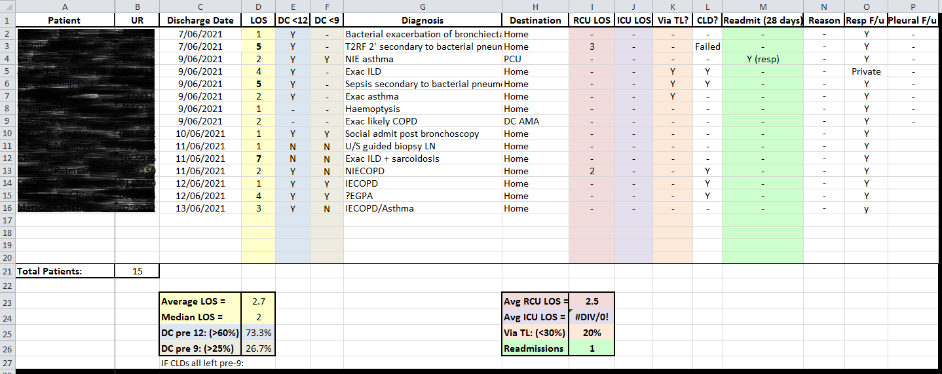
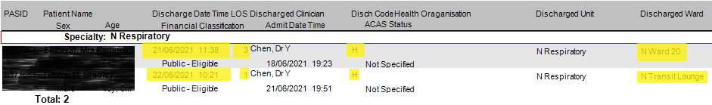

CUSP Audit Slide
Cumulative data for the CALENDAR month (1st to last day of each month).
Collate the data in excel then put the data in the slide proforma (S:\\Respiratory Medicine\Respiratory CUSP\Pro forma slides)– tell the registrar when you’ve completed it so they can add it into the slideshow. You can save the slide to the respective Discharge audit folder for that month.

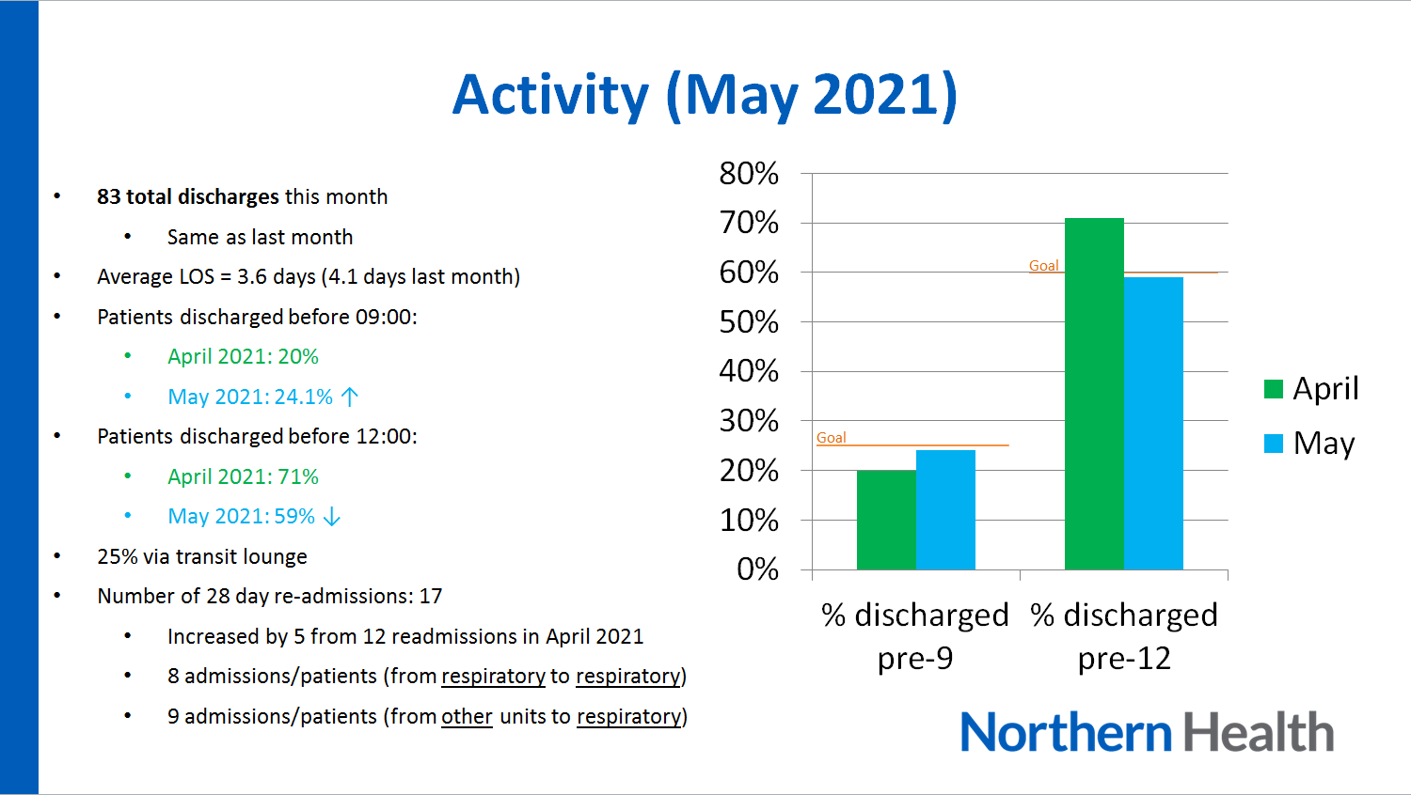

31. Career Support
Discuss with
Head of Unit - Katharine See
Deputy Head of Unit- Liam Hannan
Ward Consultant

Research
Pleural/Research Lead- Sanjeevan Muruganandan

32. Medical Students on the Unit
MD2 and 4: Follow resident and registrar. Can be divided between registrars.

33. Rostering
Shift Swap | The doctor initiating the roster swap is responsible for arranging with an appropriate colleague.  Once you have arranged a colleague to perform the swap, please email your MWU coordinator and cc in the colleague.  All swaps should be kept to within the pay period fortnight where possible. In exceptional circumstances where this cannot be achieved, please discuss with the MWU coordinator prior.  All shift swaps should be like hours for like hours.  Proposed shift swaps must be emailed to your MWU coordinator for approval.
Unplanned Leave- Notification and documentation process | Personal Leave documentation required:  For 3 single absences per year, the doctor will not be required to provide any supporting evidence to substantiate their personal leave.  For other days absent due to personal illness or injury the doctor is required to provide evidence of illness.  To be eligible for payment, the doctor is required to notify the Health Service two hours before the start of their shift, or as soon as practicable.  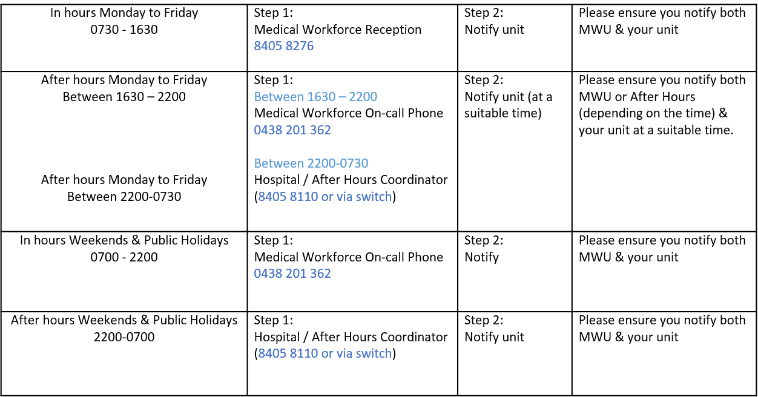
Overtime | All overtime should be submitted into the Overtime Portal  This can be accessed via the intranet whilst onsite at Northern Health  Please include the reason for your overtime- i.e. ward workload, delayed handover, include UR where relevant.  Overtime is approved by consultant on ward service.

