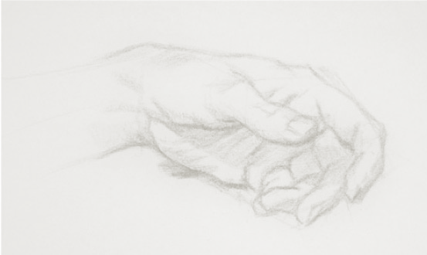
Dear Doctor,
Welcome to The Northern Health Plastic and Reconstructive surgery unit. The aim of this handbook is to introduce you to:
- The unit and how is structured
- The learning objectives
- Important and basic concepts in plastic surgery
We hope you enjoy your term and this term provides you with the skills for you to excel in the field of medicine.

“Observation is the basis of surgical diagnosis. Diagnose before you treat. Make a plan. Keep records. Always have a backup plan. Your brand is dexterity and care with tissue. Reconstruct what is normal and hold it there. Treat the primary defect first. Borrow with Peter to pay Paul only if Peter can afford it. Losses should be replaced with similar tissue. Consult the experts. Never do today what can hold till tomorrow – when in doubt do not operate. Despite being its biggest critic, time is a plastic surgeon’s biggest friend. Never allow routine to become your master but master your routine.”
Table of Contents:

Table of Contents
THE NORTHERN HEALTH PLASTIC AND RECONSTRUCTIVE TEAM 7
Objectives in this unit 8
Basic Weekly Template 9
WARD ROUNDS: 10
CLINICS: 10
THEATRE: 11
BASIC FUNDAMENTALS OF PLASTIC SURGERY 13
Skin 14
Skin Cancers 15
Wounds 17
Management of Complex wounds 19
Wound repair 20
Basic Hand Anatomy 24
Basic Hand History 26
Specific examination techniques 28
Common Hand traumas: 29
Common hand infections 31
Recommended Readings: 32
Appendix A: How to prepare the audit 33
Appendix B: Useful tips from previous HMOs 36
Appendix C: Contacts 37

THE NORTHERN HEALTH PLASTIC AND RECONSTRUCTIVE TEAM

Head of the Department and Research Supervisor:
Dr. Rodrigo Teixeira rodrigo.teixeira@nh.org.au
Term Supervisor (HMO)
Dr. Nigel Mann nmann150@gmail.com
Supervisor of Training (Accredited Registrar):
Dr. Julian Liew julianliew@me.com
Plastic Surgery Consultants:

Dr. Julian Liew
Dr. Katie-Beth Webster
Dr. Paul Di Giovine
Dr. Justin Easton
Dr. Rob Capstick
Dr. George Miller
Dr. Kim Hughes

Plastic Surgery Nurse Practitioner
Vicki Malamatinas
There are 4 registrars and 4 residents:
1 Accredited Registrar
3 Unaccredited Registrars
4 HMOs

Objectives in this unit

Active participation in Ward Rounds
Documentation of date, time, attendance and plans
Check relevant results in advance
Prepare patients that may need change of dressings for examination (analgesia, pre-round dressings removed and covered with sterile towel, need for nursing staff involvement, call each ward and ask for dressings down PRIOR to round)
Implement and follow-up plans discussed
Attend all clinics
(At least one resident and senior resident should attend on time and the ward resident to join clinic once ward jobs and discharges are completed)
See patients and discuss with registrars / consultants
Join registrars / consultants when interesting cases are seen
Shadow a consultant when they are present for one ‘new’ case
Present patients to consultants
Clinical documentation queries in Medtasker
- Good documentation is critical to provide an accurate record of the patient’s stay in hospital, decision making processes and rationale and handover between the multiple clinicians engaged in the patient’s care. Remember - “if it is not documented, it didn’t happen”. Your documentation is also vital for ‘clinical coding’, which is necessary for Department of Health data reporting and hospital financial reimbursement.

- To ensure accurate and comprehensive documentation in real-time, the Clinical Documentation Specialist (CDS) will identify any deficiencies in documentation in the healthcare record and will query these via Medtasker. These will show up as “CDI Query”. Please action these queries by documenting in the healthcare record. This can be done by documenting:
• on the next progress note (paper format), or
• on an electronic progress note in CPF by noting “CDI query response”, and/or
• on the discharge summary in CPF

Attend theatre sessions after completing ward round and clinic
Learn basic plastic surgical skins including how to excise simple skin cancers, to harvest skin graft and debride simple wounds.
Assist with documentation
Perform minor tasks such as preparing splints, help with dressings, etc.
Perform minor complexity procedures under registrar/consultant supervision
Develop an understanding on how hand traumas are managed

Basic Weekly Template

Day | Mon | Tues | Wed | Thurs | Fri | Weekend
AM | 0700  Ward round  (Ward 13/14 Doctors Room)  0815  Clinic / Theatre  (PRS Reg clinic) | 0700  Ward round  (Ward 13/14 Doctors Room)  0815  Clinic / Theatre  (PRS Reg clinic) | 0700  Ward round  (Ward 13/14 Doctors Room)  0815  Clinic / Theatre | 0700  Ward round  (Ward 13/14 Doctors Room)  0815  Clinic / Theatre  (PRS Reg clinic) | 0700  Ward round  (Ward 13/14 Doctors Room  0815-0900 Audit meeting (Unit A/B Tute Room)  0900 Consultant Clinic | Trauma List (either Sat or Sun)
PM | 1315  Elective theatre list | 1315  Elective theatre list | 1315  Elective theatre list | 1315  Elective theatre list | 1315  Elective theatre list
PM | 1730  Twilight Theatre list | 1800 Emergency Theatre List | 1730  Twilight Theatre list | 1730  Twilight Theatre list | 1800 Emergency Theatre List

WARD ROUNDS:
The main plastic surgery wards are Ward 13 and 14
- The ward round usually starts at 0700 am
- It is useful to come early to update the patient list including the list of all the inpatients, their locations, relevant investigations and plans.
- The ward list also includes the outstanding trauma cases
- A paper round is done at the end of the day with the registrar on call.

CLINICS:
All Clinics are held in Wound Clinic (Behind clinic D)
- Acute Plastic Surgery + Review Clinics
When: Mon, Tues, Thurs 8.30am & Fri 9 am
Where: Wound clinic
- New referrals from GP and Emergency Department
- Post operative and discharge reviews
- Plastic Surgery Clinic (Consultant Clinic)
When: Friday 9am
- Registrar Clinic shared patients
- Consultant allocated clinics (most consultants have a clinic on fortnightly basis. There is a consultant timetable in clinic for reference)
- Senior registrar will have new patient and/or assist consultants
- Nurse Led Plastic Surgery Clinic
When: Wednesday 830am and Mon/Tues/Thurs/Frid PM
- Nurse run wound clinic, doctors do not attend
- Nurses may call with questions or if concerned for review

THEATRE:
- TNH Operating Lists
Am list – 0815 -1230
Pm list – 1315 – 1700
Twilight list 1700-2100 (Monday, Wednesday and Thursday)
* If twilight is not following on a PM list start time will be 1730
- Twilight Lists
- Monday, Wednesday and Thursday
- On days of twilight lists there is a 1230 meeting at the theatre main desk with Theatre IC, Anaesthetist IC & bed Manager to ensure correct plan for all twilight cases. The Plastic Surgery Registrar on-call that day for the twilight must attend.
- Registrar on-call and Senior HMO (or Plastics/Ortho HMO) stay for Twilight lists
- Emergency List
- 1830 start for non-twilight specialties
- Shared between all non-twilight specialties
- Continues as sole theatre after twilight completed
- Weekend Operating Lists
- 0830-1700 list Sat & Sun shared between orthopaedics and plastic teams
- Allocation of times for the weekend sessions negotiated between registrars/consultants on-call for the weekend
- HMO works 0700-1700 on operating days and 0800-1200 on non-operating day over weekend
  - Holds phone and sees/admits referrals
- If half day sessions negotiated:
Am 0830-1230
Pm 0130-1700
Plastic Surgery Audit Meeting
Where: MS Teams
When: Weekly Friday 815 am
- Plastic surgery staff attend
- Fortnightly audit of activity – emergency and elective cases
- Audit of all pathology results for period (presented by HMO)
- Cases for discussion and complications presented (registrars will confirm cases to be discussed)
Support and escalation process
Your welfare is important to us. If you have any concerns, we encourage you to discuss this with any member of the unit including registrars, consultants, medical workforce or the director of surgery or CMO.

BASIC FUNDAMENTALS OF PLASTIC SURGERY

Skin
- The skin is the largest organ of the body.
- It has three structural layers, the epidermis, the dermis and hypodermis
- Hair, nails, sebaceous glands and apocrine glands are derivatives of skin.
- The skin acts as a physical barrier to the environment, allowing and limiting the inward and outward passage of water, electrolytes and various substances.
- It provides protection against microorganisms, ultraviolet radiation (UVR), toxic agents and mechanical insults.
- It is involved in thermoregulation.

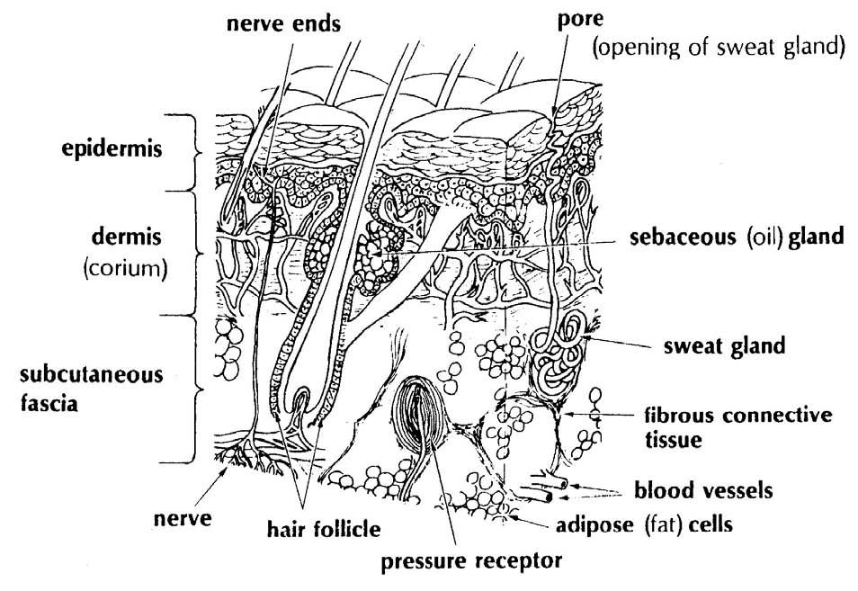
Figure 1: Layers of the skin

Skin Cancers

One of the most common cancers that cause a significant burden on the Australian healthcare system. The 3 most common types are basal cell carcinoma, squamous cell carcinoma and Melanoma.

Basal Cell Cancer (BCC)
Most common skin cancer
Usually occurs between the age of 40-80
Most occur in the head and neck, and sun exposed areas
Risk factors include Fitzpatrick skin types, sun exposure, increasing age and certain exposures including UV and ionising radiation
Multiple subtypes (including superficial, nodular, infiltrating and sclerosing)
Biopsy required for diagnosis
Treated with surgical excision
Superficial basal cell carcinoma can be treated with topical cream (Imiquimod 5%) depending on location

Squamous cell Carcinoma (SCC)
Second most common skin cancer
Usually occurs in sun exposure areas including face and limbs
Risk factors include sun exposure, fair skin, viral exposure (HPV and HIV), carcinogenic exposure (pesticides, arsenic etc.), radiation, chronic wounds
Local and distant metastasis can occur
Biopsy required for diagnosis
Poor prognostic factors include perineural and lymphovascular invasion, thickness greater than 4mm and poorly differentiated type.
Treatment include topical cream (5-fluorouracil), surgical resection and radiation
(Hint: Lymph nodes should always be examined in patients with SCC)

Melanoma
Any pigmented lesion should raise the suspicious of melanoma
More common in males
>70% present with localised disease
Risk factors include age, UV exposure, history of melanoma, Skin Fitzpatrick Type I and II, family history of melanoma and certain types of naevus including (dysplastic naevus, congenital naevus)
General assessment include ABCDs; Asymmetry, Border irregularity, Colour variation and Diameter >6mm
Excisional biopsy is the gold standard
Staging is important (TNM classification)
(Hint: Melanoma cases are referred to Peter Mac Cancer Institute for discussion in the MDT meeting - the registrar would inform you if this is required)

Wounds
- Wounds can be caused by trauma, burns, chemicals, heat/cold, friction/sheer force or surgically created.
- Certain systemic diseases such as diabetes mellitus, peripheral vascular disease and connective tissue disorders are risk factors for wounds.
- Wound healing after a skin injury is an important part of homeostasis
- Wounds can heal through primary or secondary intention, or they can be surgically repaired.
.

There are three overlapping but biologically distinct phases of wound healing: inflammatory phase, proliferative phase and the remodelling phase.

Inflammatory phase (Day 1-6):
Platelet plug formation and activation of inflammatory cascade.
Proliferative Phase (Day 4- week3):
Keratinocytes in the epidermis proliferative and migrate. Fibroblasts proliferate to become the dominant cell type. They produce collagen and replace the fibronectin-fibrin matrix. Eschar: scab.
Remodelling Phase (Week 3 to 1 year):
Note the scar formed does not have the same composition as “normal skin”
Figure 2: Phases of cutaneous wound healing (Darby et al, 2014)

Management of Complex wounds
The treatment of complex wounds requires a multi-disciplinary team approach, which includes plastic surgeons, physicians, wound nurses, allied health team (dietician and physiotherapist) and most importantly the patient and their family.
History
Age
PMHX: including Diabetes Mellitus, Kidney disease, peripheral vascular disease, connective tissue disease and blood disorders
Medications including immunosuppressive drugs including steroids.
Malnutrition.
Smoking and alcohol history
Wound history should include: mechanism, duration, past and current treatment
Physical Examination
General observations
Wound: size and depth, signs of infection, status of surrounding tissue
Sensation, capillary refill and presence of pulses
Investigations
Wound: wound swab, tissue sample for MCS/Fungal/Histology to exclude cancer
Bloods including FBE, UEC, CRP and albumin
Imaging (X-ray, bone scan, CT/MRI – to exclude fractures, foreign body, osteomyelitis or deep collections)

Wound repair
The reconstructive ladder is a good framework to use when treating wounds. This is used as an aid and each wound should be treated bearing in mind the type of wound, mechanism and patient’s overall history.

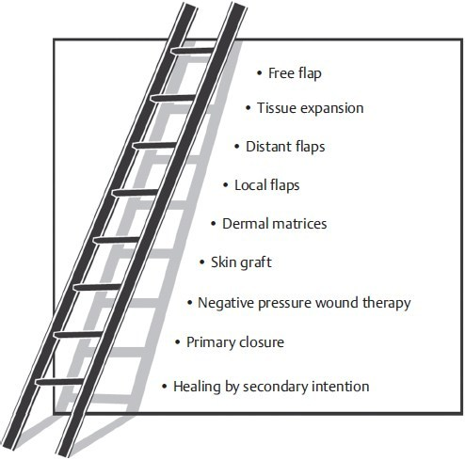

Figure 3: The reconstructive ladder. (Reproduced from Janis, Essentials of Plastic Surgery, 2nd edition, ©2014, Thieme Publishers, New York.)

Primary and secondary repair
- A wound defect can heal by primary or secondary intention.
- Primary intention is when the edges of the wound are approximated together by sutures. This is possible with small and clean wounds.
- In large wounds where there is extensive tissue loss, the wound can be allowed to heal by secondary intention. Clinically this method is used when treating ulcers or abscesses. The wound is left open and it slowly heals from the bottom towards the surface by the processes of epithelialization and contraction.

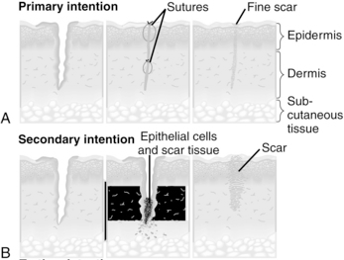
Figure 4: Wound healing by primary and secondary intention

Skin grafts
Skin grafts can be split or full thickness.
Split skin graft (SSG):

contains epidermis and part of the dermis
Used when large surface area is required
Common donor sites are the abdomen, thigh, arm and buttock.
Can be harvested with a dermatome.
Graft is placed onto wound bed and a dressing is applied to keep the graft Immobile and adherent to the wound
Donor sites heals spontaneously and is treated with dressings only
Full thickness skin graft (FTSG)

Consists of epidermis and entire dermis
Donor site needs to be surgically closed
Limited to small defects due to donor site limitation
“Take is longer” but better overall result when compared to split skin grafts

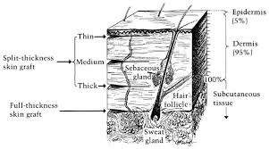
Figure 5: Layers of skin in skin graft
“The take process”

Imbibition – Day 0 - 3: fibrin formation that supply nutrients from the bed
Revascularization – Day 3 - 7 – outgrowth of capillaries from recipient bed to graft
Regeneration – Day 4 - onwards Fibroblast proliferation, replacement of fibrin and deposition of collagen
Common causes of graft failure

Shearing
Infection
Seroma
Hematoma
Flaps
A flap is a unit of tissue that has its own blood supply (an artery and a vein referred to as the ‘vascular pedicle’)
Flaps can be described by a number of ways:
Location (local, regional, distal, free)
Geometry (Rotation, transposition)
Content (Cutaneous, fasciocutaneous, myocutaneous)
Blood supply (Random and axial pattern)
(Hint: Management of patients who have flap reconstruction also includes adequate assessment and treatment of fluid status, DVT prophylaxis and antibiotics. Any concerns should always be directed to the registrar.)

Basic Hand Anatomy
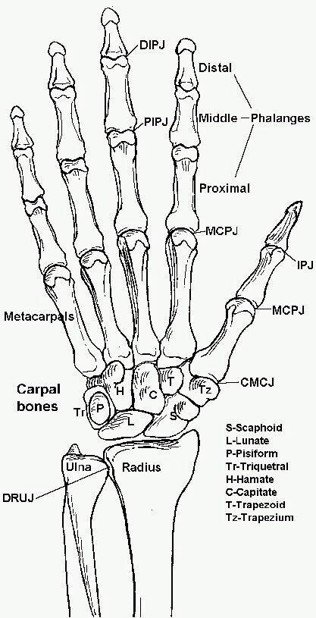

Bones
- 5 metacarpals
- Thumb: 2 phalanges
- Other fingers: 3 phalanges
(proximal, middle, distal)
- Carpal bones: 7 bones that lie in
2 rows (proximal and distal – 4 in each row)

Tendons

Flexor Tendons
- Muscle bellies lie in the forearm
- Flexor tendons flex the wrist, fingers and thumb
- FDS inserts on the base of the phalanx and flex the PIPJ
- FDP inserts on the base distal phalanx and flex the DIPJ
- Innervated by the median and ulna nerve
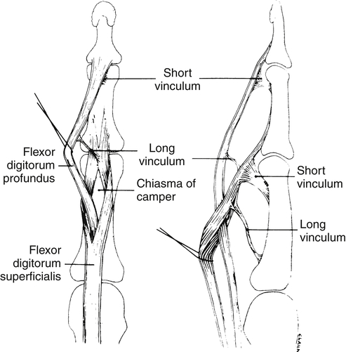
Figure 7 shows the flexor tnedons in the digit

Extensor Tendons
- Muscle bellies lie in the forearm
- Extensor tendons extend the wrist, and the fingers
- Innervated by radial nerve
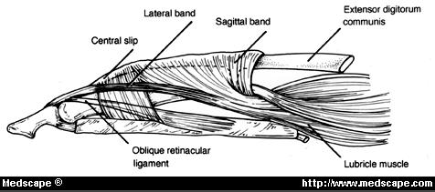
Figure 8: Extensor mechanism of the digit

Fingertip

Involves the nail bed, plate, pulp
Distal phalanx
(Hint: Most common injury of the hand)
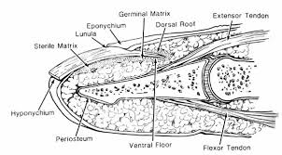
Figure 9: Structures of the finger tip

Basic Hand History
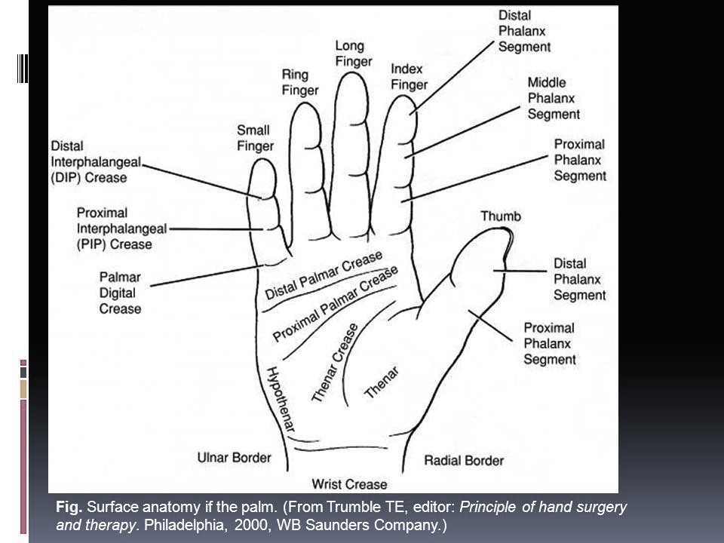

- Age
- Dominant hand
- History of Presenting Complaint:
- Trauma – time of injury, type of injury (sharp,
Blunt/crush, avulsion), where did the injury occur.
- Other digits/ areas involved
Fiigure 10: Surface anatomy of the hand
- Acute or chronic onset, pain, swelling, altered sensation
- Restriction in movement
- How the symptom is impairing the patient’s function
- PMHX: DM, connective tissue disorders, peripheral vascular disease
- Previous surgeries
- Medications (including any blood thinners)
- Occupational history
- Smoking history
(★★ Its important to use the correct hand surface anatomy terminology)

Basic Hand Examination

Look
Location
Skin (colour, swelling, erythema, assessment of the defect)
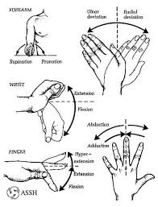
Muscle atrophy
Cascade of the fingers
Previous scars

Feel
Swelling, tenderness
Deformity
Capillary refill and pulses
Sensation
Figure 11: Movement of the hand

Move (active and passive)

Range of movement
(★★ Think of what structures can be affected including skin, tendon, nerves, arteries, bones and joints and assess each. An understanding of the anatomy of the hand is important)

Specific examination techniques

Testing for Flexor Digitorum Profundus
“Ask the patient to bend the tip of their finger”
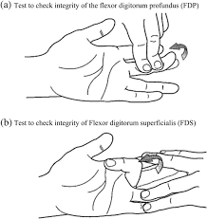
Figure 12: Testing the FDP tendon
Testing for flexor digitorum superficialis
“Ask the patient to bend their finger at their middle joint”
Allen’s test
Ask the patient to elevate their hand and make a fist. Apply pressure over the radial and the ulnar artery. Ask them to open their fist. Their hand should be pale and blanched. Then release the ulnar pressure and if the hand returns to normal pink colour the Allen’s test is positive:
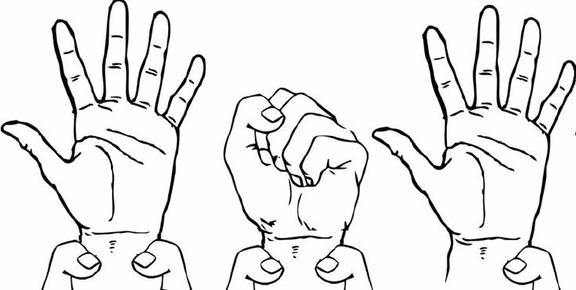
Figure 13: Allen’s test

Common Hand traumas:

- Fingertip injuries
- The fingertip is one of the most common hand injuries
- The middle finger is most commonly affected
- Usually involved the nail bed and the soft tissue of the finger tip
- Describing the geometry of the injury is important:
- Volar oblique
- Transverse
- Volar oblique with bone exposed
- Dorsal oblique

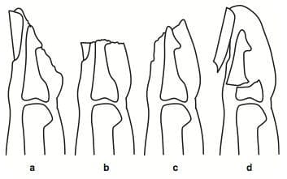
Figure 14: Types of finger tip injuries

- Fractures
- Metacarpal and phalangeal fractures are common
- History: includes mechanism, hand dominance, occupation
- Physical examination should include location, deformities, open vs. closed, soft tissue involvement
- Common terms used in describing a fracture
Closed vs. open
Simple, comminuted
Transverse, oblique, spiral
Intraarticular vs. extraarticular
- X-rays are the first line of investigation and should include AP/lateral/oblique views
- Can be managed conservatively with splint or surgically (closed reduction (GAMP) or open fixation.
- All open fractures need a washout in theatre to avoid infection
(The hand therapy handbook is very helpful)

- Revascularization and Replantation
Revascularization is needed the vascular supply of the digit is compromised but the distal end of digital is still attached
Replantation is required when the distal part of the digit is completely detached.
(Hint: Any issues with a revascularized or replanted digit should be directly to the registrar immediately)

Common hand infections

- Flexor tenosynovitis
An abscess within the flexor sheath
Staphylococcus aureus is the common cause and Streptococcus infections can quite aggressive.
The 4 cardinal signs are: Pain on passive extension of the finger, fusiform swelling, tenderness over the flexor sheath and finger in a partially flexed position
Treatment includes strict elevation, splinting, washout and intravenous antibiotics

- Bite wounds
Dog and cat bite bites are highly common
Most common organisms include staphylococcus spp, Pasteurella multicida and streptococcus spp.
Treatment includes washout and intravenous antibiotics (usually tazocin)

Recommended Readings:
- Last anatomy
Regional and applied Anatomy
R.M.H Mc. Minn
- Fundamentals Techniques of Plastic Surgery and their surgical applications
Alan D. McGregor
- Hand Therapy Red Book
(There is a copy located in the Unit H/I Doctors’ Room or visit the Hand Therapy clinic for a copy)

Appendix A: How to prepare the audit
Audit meeting
Audit date is Thurs-Wed of each week and is 1 week behind i.e. ends the Wed of the PREVIOUS week.
For every 2-week period, there is a minor and a major audit. The first week it will be a minor audit, the second week it will be a major. Each audit covers the same material however the major audit contains theatre statistics covering the 2 week period.
The resident presents the Audit
Preparation:
- Histology Discussion - any histology from operations (Theatre histology) and Punch biopsies in the previous week (Biopsy Book, use this to see which biopsies to include in the audit. It is in the wound clinic on a shelf) and any pending histology from the week before (Go through last week audit presentation to check)
- Interesting cases / Major cases – ask the registrars for these and photos – note you may need to take photos yourself of patients, remember to always get consent and never store these on your personal phone.
- Complications Please categorise according to Clavien
- Adverse events, including treatment delay, cancellations etc…
- Hand fractures audit
- Every second week is a MAJOR audit which requires numbers of operations elective vs. emergency plus total – use iPM for this data (See below)

Getting TNH theatre histology and numbers from iPM:
GET A LOGIN FOR iPM.
If you are awaiting a login use: User: NHSorthres Password: Orthopaedic27
- Log into iPM. You can find it by searching “iPM” in the start search bar.
- Click through the following from the main tab: Context >> Theatre Overview >> Main Theatre Suite >> (Adjust the date for the first day of the audit period) >> Filter by Consultant >> Press F2 >> Export to Excel (you need to do this for each day, delete cases that aren’t plastics)
- Keep the ‘Emergency list’. ‘Emergency’ , ‘Plastics’ , sometimes even ‘AGSU’!!! Delete all other specialties
- Don’t forget the Breast combined cases with General Surgery (sometimes don’t come up on our list. TIP: Ask the Regs if any breast cases were done during the audit period, they will probably know)
- Search patient UR on CPF to review type of surgery (You only need to do this if you are unsure whether the case was Plastics or not – if plastics keep, if not delete.
- After filtering out the non-Plastics cases, save this excel file (I usually label it as e.g. “TNH Theatre Data April 2-9th”). Repeat the steps above for every day of the 1 week period and add them to the first excel file so that all the cases for the week are in one file and read in chronological order. Now you should have a single excel file that lists all the theatre cases for that week.
- Once done, save the excel file in S: Drive folder (S: Plastics\Audit\#Plastics Audit\Datasheet 2020. (I advise to keep each week separate; it makes counting the numbers easier. Also keep BHS numbers separate, otherwise it can be confusing)
- Repeat the steps above for the 2nd week of the audit period
- Firstly, start with the Northern theatre data and mark out the Paediatric Cases with a highlighted colour (See old Theatre Data excel documents to see example). Fill these numbers into the worksheet
- Second, mark out the Elective cases with a highlighted colour
Go to the comments column next to operation description column. Use this column to label cases based on anatomical region (ABDO=Abdomen, BR=Breast, GP=General Plastics, MF= MaxFax, UL=Upper limb, LL=lower limb, BURN=Burns)
Once labelled, filter this column A to Z (BUT DO NOT SAVE FILE IN THIS FORMAT AS IT WILL JUMBLE EVERYTHING!!)
Click and drag the pointer to select cases by each region and excel will count these for you in the bottom right corner). NO NEED TO COUNT MANUALLY! Fill these into the WORKSHEET mentioned above. NOTE As you will see from the worksheet, initially when you count the complete numbers by region it will include adult and paediatric cases. Don’t forget to subtract the Paeds cases from the total cases to get the adult cases. Once you have counted all the cases, click the undo button so the list returns to chronological order.

Open the Excel file for Theatre Data Graphs (S: Plastics\Audit\#Plastics Audit\Datasheet 2020 \Theatre Data for Audit Graphs 2020)
- Add your numbers to elective and emergency data columns for this year
- Click on one of the graphs for the previous major audit. Click on the graph column for the last audits numbers. This will show up a box over the excel data sheet, which uses the data within it to generate the graphs. Drag this box to include the new audit numbers and the chart will generate a new column for it.
- Save this file and update it for every Major audit. Then simply copy the graph as an image and paste it into the audit PowerPoint.

Appendix B: Useful tips from previous HMOs
- This is a high turnover, busy rotation but if you manage your time well you still get a lot of theatre time and practical experience.
- Most ward rounds start at 7am. Residents should come a bit earlier, around 6:30 to update the list and take down dressings for patients. Ward person carries pager + logs onto Medtasker for the day
- Ensure selected dressings are down PRIOR to round. Document in the notes the evening before ‘dressings down 7am’, to save you rushing to take down dressings in the morning when you arrive. All pre-op patients need their dressings down unless told otherwise. Lots of patients will have their operations delayed/pushed back depending on how the wound looks, and their dressings should be down so the registrar operating that day has seen the wounds.
- Carry a bag with bits and pieces for ease of ward rounds (Huck towels++, blueys, saline, chlorhex, scissors, local, plastics instrument tray, medium gloves, syringes, 23G needles etc.)
- There is a lot of opportunity to go to theatre. Try to arrange amongst yourself a designated person who will go to theatre that day
- After the ward round we do a group handover where we run through all the plans of patients. Please make sure you are clear on the plans
- Admissions – you are expected to help with admissions including writing notes, getting the consent ready, putting the patient on ETBS. On Twilight days and weekends the Plastics HMO may hold the referral phone
- You will be working every 4th weekend, divided amongst the 4 residents. 1 day will usually be quite busy, as it is a protected operating day for plastics (Saturday), whereas the other will just be a half day (usually just ward jobs).
- Audit – protect the time of the person doing Audit. Assign someone at the start of the week to do it. This will make your life a lot easier. Rotate it each week.

Appendix C: Contacts
Ward: Unit 13 | Consultants: (Via Switch)
NUM: x58140  Registrar on call phone: 52356  HMO Pager: pager number185 | Dr. Rodrigo Teixeira  Dr. Nigel Mann  Dr. Julian Liew  Dr. Katie-Beth Webster  Dr. Paul Di Giovine  Dr. Justin Easton  Dr. Rob Capstick  Dr. George Miller  Dr. Kim Hughes
Ward Numbers/ Helpful contacts:
TNH Bed Manager x58110 | Manager Clinical Services Operating Theatre:  Carolyn Downing: 58178
TNH Theatre NIC: 58990 | TNH Anaesthetics IC: 58993
TNH Theatre bookings  Plastics Manager: 52036 | Ortho Reg: 58461
Hand Therapy Department  Fiona Moate: 58719  Wound clinic: 8851 | All useful numbers can be found on top of daily ward lists
Emergency / MET Call | 2222
Switchboard | 9
ITEM | LOCATION
Home ward | Ward 13
Morning meeting point | Ward 13/14 Doctors write up room
Your pager lives here | Plastics box in Unit 13/14 doctors write up room
Patient list | S: \Plastics\Ward Lists
Audit | S:\Plastics\Audit\#Plastics Audit
Outpatient clinic | Wound clinic (Clinic D, Room 57)

