9. Hospital Orientation
Hospital orientation occurs at the beginning of each term. Attendance is mandatory and paid non-clinical time.
This is separate to the unit orientation. Follow the link for details, password: NorthernDoctors
Location | NCHER, Northern Hospital – Epping | 185 Cooper Street, Epping 3076
Facilitator | Medical Education Unit | Email: MedicalEducationUnit@nh.org.au
Date | First day of each term
Start | 08:00

10. Unit Orientation
Unit Orientation occurs at the beginning of each term. Attendance is mandatory and paid time.
Orientation that occurs outside of your rostered hours should be submitted as overtime on the overtime reporting portal
Location | Ward 5 Haematology and Oncology Ward
Facilitator | Ward Registrar and NUM
Date | First day of rotation
Start | 08.00

11. Unit Overview
Department | Cancer Services
Location | Ward 5, Northern Hospital Epping
Inpatient Beds | 12
Outpatients Clinics | Daily
Day Procedures | Oncology and Medical Day Unit, Symptom Urgent Review Centre, Infusion Centre (Epping Private 230 Cooper St, Epping )
Virtual Unit | N/A

12. Safety
Unit Specific Safety & Risks
- Safe medication prescribing including systemic anti-cancer therapies and opioids

13. Communication
Medtasker | Yes
WhatsApp
Pager
MS Teams

14. Handover Process
Morning | Receive handover from overnight HMO at beginning of shift
Afternoon | When finishing at 1700, handover to covering evening HMO at end of shift
Night | Handover to night cover at end of shift

15. Shift Structure
 | HMO | Ward Registrar | Outpatient and Consults Registrar
Day |  | Mon-Friday 0800-1730 | Mon-Friday 0800-1730
Afternoon |  | Thursday afternoon off | Wednesday afternoon off
Night
Weekend

16. Shift Roles & Responsibilities
 | HMO | Ward Registrar | Outpatient and Consults Registrar
Day | Provide care for Medical Oncology Inpatients under the direction of the registrar and ward consultant, including but not limited to:  - attending and documenting daily ward rounds  - requesting, organizing and following up results of investigations  - completing discharge summaries  - communicating with patients and their carers | Provide care for Medical Oncology Inpatients  Supervise HMO  Complete Inpatient admissions including the assessment of patients presenting to Emergency Department | Attend clinics, cover day onc and inpatient consults, attend tumour MDMs  Monday morning GI clinic  Tuesday morning Craigieburn clinic  Thursday morning Lung/GU clinic  Friday morning Breast clinic
Afternoon |  | Tuesday afternoon GI clinic,  Thursday morning Lung/GU clinic if time permits
Night
Weekend

17. Common Conditions
- Management of common malignancies
- Symptom management for complications of cancer including nausea/ vomiting, pain, constipation, dyspnoea
- Management of side effects of systemic anti-cancer therapies including chemotherapy, immunotherapy etc
- End of life care

18. Common Procedures
- Ascitic Tap (see PROMPT for Liver Disease / Hepatology – Operations and Clinical Practice, Abdominal Paracentesis / Ascitic Tap section information of performing this procedure)
- Lumbar puncture

19. Clinical Guidelines
The My Favourite Links page on the intranet contains the links to a number of useful clinical guidelines https://intranet.nh.org.au/applications/
ETG- Electronic Therapeutic Guidelines
AMH- Australian Medicines Handbook
Up to Date
PROMPT- This site contains the hospital policy and procedure manuals. It can only be accessed from the intranet - https://intranet.nh.org.au/departments-and-services/prompt-policy-procedures-guidelines/prompt-policies-procedures-and-forms/
EVIQ – cancer treatment protocols and information
https://www.eviq.org.au/
European Society of Medical Oncology - https://www.esmo.org/guidelines
National Comprehensive Cancer Network - https://www.nccn.org/guidelines/category_1

American Society of Clinical Oncology - https://old-prod.asco.org/practice-patients/guidelines

20. Routine Orders
Pathology | FBE, EUC, LFTs, CMP, Random BSL
Radiology | CT, MRI, PET scans
Pharmacology | Analgaesia, anti-emetics, aperients, anticoagulants

21. IT Programs
EMR | The EMR is in use for documentation, medication ordering and radiology/pathology requests.  It is being used for all inpatients, as well as maternity clinics and pre-anaesthetic clinics.  Located in the intranet > My Favourite Links > EMR Live Environment  EMR Training courses are located on the LMS- https://mylearning.nh.org.au/login/start.php  Training is compulsory; you will need to complete the elearning within the first week of commencing.  Please contact medical workforce, or check the EMR website for more information on how to complete EMR training https://emr.nh.org.au/  When starting a new rotation, please reach out to Term Supervisor to ensure you are oriented to the EMR specific workflows for that unit as well.  EMR is NOT a primary communication system. Please use Medtasker and phones for referrals and communication.
CPF | The source of information for all outpatients’ clinics, investigations, GP referrals and scanned admission notes prior to September 2023.  Located in the intranet > My Favourite Links > CPF https://cpf.nh.org.au/udr/
PACS | XERO Viewer Pacs- https://nivimages.ssg.org.au/ or located in My Favourite Links, look for the CXR icon  This is where you can find radiology images
My Health Record | Centralised health record https://shrdhipsviewer.prod.services/nhcn
Safe Script | Monitoring system for restricted prescription medications https://www.safescript.vic.gov.au/

22. Documentation
Admission | - Presenting complaint  - Document oncology history including cancer diagnosis and stage, sites of disease on most recent imaging, current and prior treatment, treatment intent (curative or non-curative), date last seen in clinic, ECOG performance status  - Past medical history, current medications, allergies  - Social history, functional status  - Goals of care to be completed within 24h of admission
Ward Rounds | Document who is present and respective roles; document current/inpatients issues and progress; document recent and relevant results (pathology, imaging, biopsy, cultures); document discussions with other health care providers eg allied health, patients and carers; document estimate discharge date and destination
Discharge Summary | List principle diagnosis, summarise events during admission and relevant test results, document outpatient follow-up plan
Outpatient Clinics | Not applicable
CDI Queries
Death Certificates | https://www.bdm.vic.gov.au/medical-practitioners
Coroners | https://coronerscourt.vic.gov.au/report-death-or-fire/how-report-death

23. Referrals
Internal | Via Medtasker
External | Radiotherapy is provided by GenesisCare. Call to discuss referrals and fax/email referral to GenesisCare using the Genesis referral form on PROMPT.

24. Clinical Deterioration
Escalation Process
PreMet | Must be attended then discussed with Registrar / Ward Consultant
Code | Must be escalated to the inpatient Registrar / Ward Consultant

25. Night Shift Support
Unit
Periop
Take 2 @ 2

26. Assessments: PGY1 & PGY2
All forms are located on the Northern Doctors website under the Assessments tab
Beginning of Term | Meet with Term Supervisor to set learning goals for the term using the Term Description Learning Objectives as a basis for the discussion
Mid-Term & End of Term | To be completed at the mid and end of term meetings
EPAs | Minimum of x2 EPA assessments to be completed per term

27. Mandatory Training
- Mandatory Training is located on the LMS- https://mylearning.nh.org.au/login/start.php
- Mandatory training is compulsory and part of your contract with Northern Health and needs to be completed by the first month of your start date. If not completed you will come of the floor to complete.
- Hand Hygiene needs to be completed by the end of your first week.
- If you have completed the mandatory training elsewhere you may be able to apply for recognition of prior learning

28. Unit Education
- Weekly meeting Wed 12.30-13.00 Ward 5 Tute Room
- Journal Clubs 3 per month at the conclusion of clinic approx. 12.30 on Teams (Gastrointestinal Cancer 4th Monday of each month, Lung/ Genitourinary Cancer 2nd Thursday of each month, Breast Cancer 4th Friday of each month)

29. Unit Meetings
- Oncology Multidisciplinary Team meeting 10.30am Wednesday on Teams
- Morbidity and Mortality Audit 09.00am 3rd Thursday of the month on Teams

30. Research and Quality Improvement
HMO: if you would like to be involved in a project please discuss with ward consultant or head of unit
Advanced Trainees: completion of a Research Project during your specialty training is an RACP requirement. Please discuss with your supervisor or head of unit.

31. Career Support

32. Medical Students on the Unit
Role of the inpatient registrar and HMO to provide supervision, support and teaching for rotating medical students throughout the year

33. Rostering
Shift Swap | The doctor initiating the roster swap is responsible for arranging with an appropriate colleague.  Once you have arranged a colleague to perform the swap, please email your MWU coordinator and cc in the colleague.  All swaps should be kept to within the pay period fortnight where possible. In exceptional circumstances where this cannot be achieved, please discuss with the MWU coordinator prior.  All shift swaps should be like hours for like hours.  Proposed shift swaps must be emailed to your MWU coordinator for approval.
Unplanned Leave- Notification and documentation process | Personal Leave documentation required:  For 3 single absences per year, the doctor will not be required to provide any supporting evidence to substantiate their personal leave.  For other days absent due to personal illness or injury the doctor is required to provide evidence of illness.  To be eligible for payment, the doctor is required to notify the Health Service two hours before the start of their shift, or as soon as practicable.  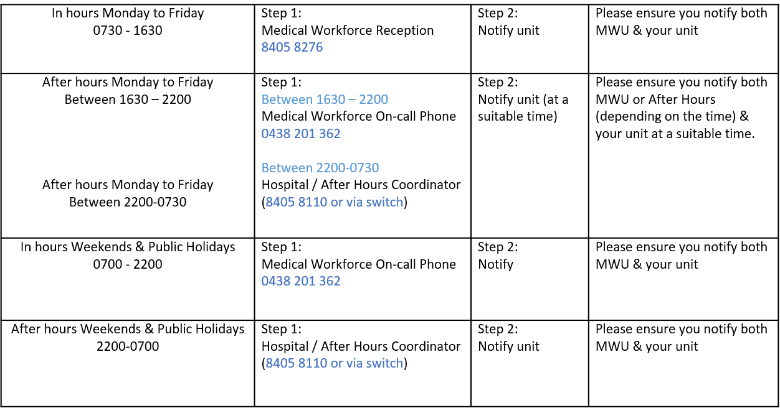
Overtime | All overtime should be submitted into the Overtime Portal  This can be accessed via the intranet whilst onsite at Northern Health  Please include the reason for your overtime- i.e. ward workload, delayed handover, include UR where relevant.

