ROTATION: NPU PSYCH TEAMS COMBINED


ROVER (Rolling handOVER) – I am a ‘living document’ that needs your care and attention
UPDATED BY: Jessica Kamphuis CONTACT: jessica.kamphuis@nh.org.au DATE: 01/08/2023

REVIEWED BY:

! Please update me as required and send me to susie.sangas@nh.org.au in week 8 of this rotation

CHECKLIST FOR NEW STARTERS
- Find a copy of the Medical Orientation to Psychiatry (‘Psychiatry Handbook’) online on Northern Doctors website. A lot of logistical questions will be answered in this ROVER, and there it contains good psych medications summaries.
- Email Vijay.Danivas@nh.org.au for access to shared drives and to be added to the NPU mailing list (ideally contact prior to your rotation as access to shared folders is very important)
- Revise the Mental Health Act terms AO, TTO, TO, ITO, CTO, CTTO, VTO. Revise the criteria for placing someone under an AO.
- Set up your desktop with shortcuts to the following:
- NAMHS NPU Handover folder – handover lists for NPU1 and NPU2 updated by the nurses (you don’t need to make your own list, just print these out for your team). To access the NAMHS NPU Handover folder go to:
Desktop folder ‘Shortcuts’ → North Western Mental Health users only → Shared Mental Health Program Folder → Click ‘Sdrives’ in the address bar at the top of the window → MHP → NAMHS NPU Handover
- Short Cut link to Handover folder: \\ssg.org.au\allfiles\SDrives\MHP\NAMHS NPU Handover
  - EPI shared folders - this is where you will find admissions, discharge summaries (aka Transition/Discharge Summary, TDS), and all past admissions for that consumer (useful for past hx etc.) To access EPI folders to desktop folder Shortcuts → North Western Mental Health users only → EPI shared folders
      - If the consumer has a known CMI number (a statewide mental health UR number) then search this within the relevant EPI folder
      - If the consumer does not have a CMI number, go to the ‘EPI Ax unregistered folder’ and search their last name +/- date of birth (DDMMYYYY)

STAFF
UNIT STAFF & KEY CONTACTS | CONTACT DETAILS
Director of Clinical Services: A/P Vinay LAKRA  Deputy Director of Clinical Services: Dr Vijay Danivas | 8468 3808
Consultants and team colours:  NPU1 (Ward 7):  Dr Akhil Abhijnhan (Blue)  Dr Abhinav Nahar (Green)  Dr Vijay Danivas (Pink)  NPU2 (Ward 8):  Dr Priya Lakshmanan (Yellow)  Dr Suresh Yadav (Purple)  Dr Ranjit Krishnadas (Red) | Mobile numbers are in the directory next to ANUM for consultants and registrars; they are also attached to the oncall roster which will be emailed to you regularly
NPU1 NUM: Erva and Carl  NPU2 NUM: Bec  NPU1 and NPU2 NICS: Change daily | NPU1 x 58910 NPU2 x 52961  They are all wonderful and very experienced so take their concerns seriously!
NPU Pharmacists: Karan (NPU2), Midya (NPU1) | x 58994 (NPU1)  x 52885 (NPU2)  The pharmacists are super helpful and friendly and welcome any questions about meds!
Discharge Co-Ordinator Priscilla

TOP TIPS
- Document, document, DOCUMENT! Even conversations you have in the hallway! All referrals and phone calls (Relatives, Community teams, GP, Private Psychiatrist) should be documented as well.
- Copy + paste is your friend – view and collate information from the client’s previous admission and community mental health documents. Make sure to update them after pasting if needed.
- Use the term ‘consumer’ instead of ‘patient’ – this is a recommendation from the royal commission to help assuage the dehumanisaiton of people in mental health. Even better – use their name!
- Prioritize phone calls and emails over paperwork – people are hard to get ahold of and this can be a barrier to discharge.
- Consumer folders: Med charts are located in each team’s coloured folder in the medication rooms. Everything else including obs charts, CRAAMs, legal paperwork etc is located in the (helpfully colour-coded) individual consumer folders in the nurses’ station.
- Prepare for the weekend – leave forms, legal forms, med chart, CRAAM, discharge sum/script for those being discharged. Make sure to email a handover for the weekend team before you finish on Friday.
- Currently, NPU teaching is in-person in NPU conference room on Thursday 12-1pm. It’s run by consultant Suresh and is fantastic.
- Though the pace of Psych is slower than surgical/medical rotations (especially during reviews), you will be busy. The rotation can become emotionally overwhelming at times. Your half days are a salve – take them.
- This rotation is truly what you make of it. This will be your only opportunity as an intern to have meaningful, daily contact with a consistent consultant. Get a reference.

GEOGRAPHY

ITEM | LOCATION
Home ward | NPU 1 (ward 7) or NPU 2 (ward 8) – note ward 23 is coming soon!
Morning meeting point | Meet in your team’s office by 0830.
Your pager lives here | NO PAGER <3  There is a Medtasker role (under ‘mental health’) for referrals, but the nurses will usually just find you directly
Consumer list | Green- 10 consumers, Red- 10 consumers, Blue- 10, Purple- 10, Yellow-5, Pink – 5  Print out a copy of the nursing handover for a list of your consumers. Most teams won’t have their own list.
Handover | Handover jobs (rarely) to after-hours admitting resident. For the weekend, handover is by email

WEEKLY TIMETABLE
Mon | Tue | Wed | Thu | Fri
08:30-08:45  Pre handover, prep for the day  0845 - 0915  Handover meetings  0915-0930  AM Discharge meeting  ~ from 0930h  Round/Jobs  1430-1445  PM Discharge meeting | 08:30-08:45  Pre handover, prep for the day  0845 - 0915  Handover meetings  0915-0930  AM Discharge meeting  ~ from 0930h  Round/Jobs  12:30-13:30  Intern teaching  TNH Lecture Theatre  1430-1445  PM Discharge meeting | 08:30-08:45  Pre handover, prep for the day  0845 - 0915  Handover meetings  0915-0930  AM Discharge meeting  ~ from 0930h  Round/Jobs  1430-1445  PM Discharge meeting | 08:30-08:45  Pre handover, prep for the day  0845 - 0915  Handover meetings  0915-0930  AM Discharge meeting  ~ from 0930h  Round/Jobs  12:00-13:00  NAMHS Education  OR  12:30 – 13:30  HMO 2/3 Teaching  TNH Lecture Theatre  1430-1445  PM Discharge Meeting | 08:30-08:45  Pre handover, prep for the day  0845 - 0915  Handover meetings  0915-0930  AM Discharge meeting  10:00-11:00  ICA review  ~ from 0930h  Round/Jobs  1430-1445  PM Discharge meeting
1-hour Clinical review (MDT) - time varies from team to team

Handover meetings and discharge meetings are online (Webex link in calendar or ask the team).
ICA review on Fridays 10AM and team MDTs are in the conference room between NPU1 and NPU2.

SHIFT STRUCTURE
You’ll work the hours you’re rostered and unrostered overtime is rare (claim it if you work it!). The pace of psych is slower than medicine and surgery, but there are lots of jobs and many of them are time consuming.
Teams discuss which day the reg and intern take their half days. HMOs currently have a day off each week instead of a half day as they rotate through the longer admission/afternoon shifts and night shifts.

DAY SHIFT STRUCTURE (INTERNS AND HMOS)
- Print the handover list for your team from the nursing handover sheet
- Morning handover starts at 8:45am (online). The NIC will hand over the consumers and request updates/changes to the plan. Allied health and psychology are often present at these huddles, so this is a good time to refer to them.
  - NPU1 and NPU2 both hold their morning huddles at the same time. Most of your consumers will be on the same ward so this shouldn’t be an issue.
- Discharge meeting starts at 9:15am after the huddle (also online). Here, each team discusses their upcoming discharges and their ICA
- 2nd Discharge Meeting at 2:30pm each afternoon, for any new updates to discharge dates that may have happened since the morning meeting.
- The rest of the day is filled with reviews and jobs
- At the end of the day, hand over URGENT JOBS ONLY to the admitting HMO

AFTERNOON (ADMITTING) SHIFT STRUCTURE (HMOS ONLY)
- Interns do not do these shifts
- 1100 – 2030, weekdays only
- On these shifts, your job is to admit new consumers on wards 7 and 8, irrespective of the team they are under. After 5, you are the medical cover for both wards – in addition to admissions, you’ll handle any medical issues/emergencies and seclusion reviews
- When you get in, identify yourself to the NIC on each ward and give them your number/medtasker role to contact you when a new admission comes in
- Help your usual team with jobs and reviews until the admissions roll in
- Handover anything urgent and any pending admissions to the night HMO at the end of your shift

NIGHT SHIFT STRUCTURE (HMOS ONLY)
- Interns do not do these shifts
- 2000 – 0830, includes weekends!
- Similar to the afternoon shifts, you cover both wards and handle medical issues, seclusion reviews and admissions. At this stage, you are NOT responsible for CL or EMH pts.
- When you get in, identify yourself to the NIC on each ward and give them your number/medtasker role to contact you when a new admission comes in
- Nights are usually very reasonable. There is a reg and consultant on-call (you’ll be emailed the roster) – never be scared to ask for help.

INTERN AND HMO ROLES & RESPONSIBILITIES
CONSUMER REVIEWS
- Consumers in ICA must be seen by a doctor every day. They must have 3 consultant reviews per week.
- Consumers in LDU must be seen by a doctor every 2 days. They must have 2 consultant reviews per week.
- All notes in MH are electronic. Your team will have COWs/a laptop.
- Set up a word document with your template for reviews, and then copy and paste for each review. It’s best to save your reviews on word or as an email draft rather than straight to CPF in case it times-out and you lose everything!
- Example of template:
  - CONSULTANT REVIEW on NPU1/2, LDU vs ICA
  - Present: Dr (consultant), Dr (reg/resident/intern), (nurse), (+/- family members)
  - On review – transcribe history here. It helps to break down further with sub headings, e.g. Re: medication, re: substance use, re: events leading to admission etc. Try to include direct quotes whenever pertinent. Try to write in sentences rather than dot points.
  - MSE
  - Impression (ask consultant for their impression if they don’t tell you)
  - Risk level CRAAM (low, medium, high)
  - Plan – make sure you solidify with consultant and include:
    - Legal status
    - LDU vs ICA (if ICA, ?for trials or transfer to LDU)
    - CRAAM Level (low, medium, high)
    - Medication changes
    - Investigations
    - Allied health
    - Any collateral from or update for GP/ PP/ family/ community team
- Upload your note in CPF admissions → current admission episode → add → ‘medical review – Mental Health’ → select NPU from the dropdown tab.
- Don’t forget to update the CRAAM (Risk assessment) form in the consumer folder! This must be done after every review. Note that if consumers are in ICA but for LDU trials, their CRAAM will have to be medium or lower.

ADMISSIONS
- Save admissions under ‘medical review – mental health’, as you would with regular reviews.
- Psych admissions are quite detailed, but EMH will usually have done most of the work already and you can copy-paste (their notes are in the consumer’s EPI folder or under the ‘emergency’ tab)
- Your admission note should include the following
  - BACKGROUND/EVENTS LEADING TO ADMISSION
  - ON REVIEW
  - MSE
  - PAST MH HX
  - MEDICATIONS
  - SOCIAL HISTORY (including forensic and AOD)
  - PHYSICAL HEALTH HISTORY
  - RISK ASSESSMENT
  - IMPRESSION
  - PLAN (Discuss with the consultant of the team the consumer is under, or if after hours, the on-call registrar. After-hours, the registrar will advise if you need to also call the on-call consultant)
- In addition to the admission note, you must also do the following (ask nursing staff to show you where all these forms are):
  - Request admission bloods (standard) and UDS + ECG
  - Fill out med chart including with adequate PRNs (see below)
  - Make sure to do a brief physical examination also and document any physical health concerns on the physical health sheet in the consumer’s folder
  - Initial CRAAM and sexual safety (on admission can only be medium/high risk before being modified by a consultant)
  - HONOS form (nursing will show you)

DISCHARGES
Discharge planning:
- If the consumer is itinerant, get SW involved early!!!
- For community mental health team (CMHT) follow-up/referrals:
  - Check http://www3.health.vic.gov.au/mentalhealthservices/ for the consumer’s catchment area and associated CMHT. The consultants and nurses also have helpful resources for finding the right community team.
  - Community teams are the equivalent of outconsumer psych. They can offer two services – ACIS (formerly known as a CATT team) or case management
    - ACIS is an acute service for short term monitoring. They offer services like medication supervision, monitoring of mental state and risks, linking in with a regular GP, etc.
    - Case management is longer-term outconsumer psych follow up. A person will be assigned a key clinician (usually a senior nurse or social worker) who will have regular contact with them and co-ordinate things like medical team reviews, social work input, NDIS and OT, etc.
  - Some consumers already have an ‘open case’ with a community team (check this in the mental health tab of CPF – does the person have an open episode?). If so, you will call the key clinician to refer them back on discharge
  - If the consumer is a new referral for a community team, contact the discharge coordinator (Priscilla), who will kindly do your referral for you!
  - You usually need to complete the TDS before you do the referral.
- Other services you may refer to include:
  - PARC (Prevention and Recovery Centre) - “step down” facility with plenty of allied health and group activities, designed to assist consumers with their transition back to community and re-establishment of routine. Northern PARC is an approx. 10 bed unit in Preston. This is not a locked facility, consumers handle their own medication, no drugs policy, and you must have clear goals for clients’ stay before making referral. Goals might be to establish a daily routine, establish medication routine, assistance to improve functioning with ADLs, monitoring of mental state, etc. Consumer must have a fixed address in the PARC’s catchment area for them to be accepted.
  - CCU – Community Care Unit – subacute ward, long term admission (months - years)
  - SECU – Secure Extended Care Unit - same as CCU, but secure. For consumers with forensic history or marked interpersonal risk at baseline

Discharge summaries:
- The TDS (transitional discharge summary) is used instead of the CPF Discharge Summaries. You can find the form either on PROMPT (Mental Health Transition Discharge – 400200) or using the ‘Template Chooser’ application on NPU desktops.
- Save the TDS in the consumer’s EPI folder
- Once completed, the consumer gets a copy of the front page of the TDS only. There is space on the front page for you to document their next appointment dates with community team and the date/time of upcoming MHT hearings
- A copy of the full TDS is given to your consultant to sign and then handed over to the ward clerk to upload to CPF.

Discharge scripts:
- Get your scripts to the pharmacist and they do the rest.
- Pharmacy prefers scripts before 12pm the day prior to discharge.
- Generally most consumers receive 2 weeks medication only. Full PBS quantities can be given for anyone with a webster pack or at an SRS.
- If the consumer is a high suicide/overdose risk, check with your consultant how much medication to prescribe – you may only do a couple of days’ worth, or a staged supply.

Legal paperwork:
- Lots of different forms for different circumstances – e.g. if under the MHA, the client will require a variation on discharge; some consumers have their TTOs revoked on discharge which is a separate form; if moving out of area the consumer will need a transfer of care form, etc.
- Get the right form to the consultant and they do the rest. Nursing will show you where the forms live on each ward.
- Only consultants can alter a consumer’s legal status

Other forms:
- You must complete a final CRAAM that states ‘for discharge’. People usually need to be on low CRAAM for discharge BUT NOT ALWAYS (some consumers have chronically elevated risk)
- You must complete a discharge HONOS form

DAMAs
- Unexpected discharges are quite complicated in psych as consumers commonly have impaired insight and judgement as well as elevated risk – which is what led to admission in the first place!
- Consumers under the mental health act often desperately want to be discharged. Though every effort needs to be made to discharge them as soon as this is safe and appropriate (least restrictive practice!), these consumers are unable to DAMA.
- If a consumer is voluntary and wants to discharge immediately (a common after-hours issue!) you need to do the following:
  - Full review with the consumer to establish their motivations for discharge, plans on discharge, why they feel they cannot wait til tomorrow when their home team is back, current risk level including of harm to self or others, who will be at home to supervise and support them, etc. As with all reviews, include an MSE and pay particular attention to the engagement of consumer in review, whether they appear distressed/agitated/emotionally heightened, and whether they are demonstrating appropriate planning
  - Discussion with the next of kin about their thoughts re: discharge, if they are able to support the person at home, what their concerns are, whether they think the person is at baseline, etc.
  - Discussion with at least the reg, but usually also the consultant. Allowing a consumer to DAMA in psych is a high-risk decision that should be made at the consultant level.

COLLATERAL HISTORIES
- You will pick up the phone at least once a day for this
- Document collaterals (from family, community teams, GPs, etc) in CPF under ‘Family Work’
- Ask what the consumer is like at baseline, how they are currently different from baseline, the timeline of deterioration and any possible precipitants, previous medications, screens including risk to self and others, etc. Ask families who else lives at home (especially concerned if children at home – may need to report to child protection if risk to them) and whether the family feel safe to have the consumer back home (screen for previous episodes of aggression/violence)

PHYSICAL HEALTH
Physical health concerns are predominantly handled by interns/HMOs. All consumers will need a routine physical examination on admission. Periop is available for any further concerns or advice. Never be afraid to call a MET call if you think it’s needed, especially after hours.
Be aware that the Psych ward is limited in what it can provide for acute medical care (e.g. IVCs, IV fluids) and consumers will need transfer to medical wards if they have any acute medical issues – so escalate earlier rather than later.

ECT
ECT scripts:
- Every consumer receiving ECT requires a prescription to be completed prior to each session. This needs to be signed by consultant and treating doctor who has reviewed consumer prior to ECT. Any consumer who is newly commenced on ECT will require the following:
- Consent form or ECT tribunal
- Initial ECT script
- ECT Medical review booklet (this is done before the first ECT and after every 6 ECT sessions. Includes physical exam, baseline bloods, ECG and CXR, and a MOCA)
- Email to ECT coordinators group (this is so they can be booked) or hand in in-person to the ECT suite
ECT Reviews
- As the interns and HMOs, you review outpatients post ECT on Monday, Wednesday and Friday. There is a roster for this outside the ECT room. The ECT team like you to be there by 11am because most of the consumers have transport booked for 11:30. The review is for medical clearance. Suggested:
Gait: check if baseline
Orientation: TPP, check if baseline
S/e: any headaches, dizziness, nausea/vomiting?
O/E: auscultate heart, lungs, feel the abdomen and legs
Neuro: PEARL, nystagmus, rigidity, tremor, grip strength?
Finish your notes off with ‘safe for transfer’ if that is the case.
- If there are any concerns during ECT, the anesthetist will review them, so most consumers come to you stable. If there is something wrong, escalate to anesthetics or your reg.

MENTAL HEALTH TRIBUNAL HEARINGS
Consumers under the Mental Health Act with TTOs or VTOs will have Mental Health Tribunal hearings scheduled. A person may also need a tribunal hearing to commence ECT if they need it and don’t have capacity to consent.
- There are regular emails sent out listing the consumers who have upcoming hearings.
- Speak to the NPU MHT team (in the office near the break room) to be added to the email mailing list for these schedules, and to get links for your team’s consumers’ hearings. The tribunal hearings are held online or by phone.
- For each hearing, you need to prepare a report to be given to the consumer at least 48 hours in advance. You will find report templates and writing guides at https://www.mht.vic.gov.au/forms-health-services. The report is in the format of a letter to the consumer, so most of the content should be addressed to the consumer (i.e. in 2nd person). Most consumers will have had previous reports from previous hearings, so you can gather some information from these, but update the information because the report is mainly about why they need a treatment order in their current admission/circumstances.
- The report needs to be checked and signed by the consultant. Make sure to keep the signed report for the MHT team and make a copy for the consumer.
- When you present the report to the consumer, ask them
- During a hearing, the tribunal members will usually start by asking the consumer some questions, then move on to asking the treating team. Usually it’s best if the person who wrote the report is also the person presenting at the hearing, as it helps to make sure you know the consumer’s history and management plan.

ICA REVIEW MEETING
Every Friday 10-11:00AM there is an ICA Review meeting. All consultants meet with lead MH nurses and pharmacy to discuss each ICA consumer and their weekend plan. One intern or HMO (rotating through the different teams each) needs to be there to scribe for the whole meeting. The most important part to document for each consumer is their plan. After the meeting, upload each consumer’s note into their CPF under ‘Clinical Review – Mental Health’.

SECLUSION REVIEWS
These are done as planned Code Greys. Check that the consumer is clinically stable, give medications/food/water, and see if they are safe to come out of seclusion (a balance of least-restrictive treatment and managing risk). A consumer needs to be reviewed at 1 hour after entering seclusion and then every 4 hours after that. The nursing staff are very experienced at these reviews – tell them it’s your first time and they will lead you. Call the on-call registrar if you have any concerns or questions.

COMMON CONDITIONS MANAGED BY UNIT
Most common:
- Psychotic disorders - Schizophrenia (SCZ), Schizoaffective Disorder (SAD), Drug-Induced Psychosis (DIP) First-Episode Psychosis (FEP) (an excellent learning opportunity for anyone interested in Psych)
- Bipolar Affective Disorder (BPAD) – will most commonly present in mania
- Personality Disorder in crisis - the most common are borderline personality disorder (BPD) and antisocial personality disorder (ASPD), but you may see other cluster B or C disorders. It is uncommon to see cluster A disorders.
- Depression with suicidal ideations (MDD/MDE – major depressive episode/disorder)
- Substance use disorders – alcohol and ICE are the most common

Less common, but occasionally encountered:
- Obsessive compulsive disorder
- Eating disorders – consumers who have acutely deteriorated due to an eating disorder are usually managed on the medical ward because of their medical instability. By contrast, on the inconsumer ward, you may meet stable consumers with chronic issues with feeding and weight/body image.
- PTSD
- Anxiety disorders (these are common, but not usually the reason for acute admission)

COMMON ISSUES
Behavioural issues:
- The nurses are amazing at handling these situations. You don’t need to do anything except make sure the appropriate PRNs are written up.
- If you are unsure about changing the PRNs, ASK SOMEONE. You will be dealing in doses of benzo’s and antipsychotics that would make even the most cavalier BPT3 sitting for their exams concerned, so do not be afraid to ask.
Consumers abscond:
- Amazingly common despite the NPU being a locked ward. People under stress can become extremely resourceful!
- Nurses usually manage this situation – if they are voluntary they will usually have their bed held for 24 hours before being marked as a DAMA and discharged. If they are under the MHA the nursing staff will contact Police to bring them back to the ward
Cannot get ahold of the community intake worker/KC
- Ask the receptionist for the intake worker’s email and send them the query and TDS. You will find that they end up calling you back

USEFUL RESOURCES

NPU Medical Orientation to Psychiatry Handbook

Queensland government information sheets on psychotropic medications. Given to consumers for information but very useful to anyone new to psych. Available on the ward.

RANZCP GP Guidelines

COMMON MEDICATIONS SPECIFIC TO UNIT

PRNS FOR ACUTE AROUSAL AND AGITATION
Every reg and consultant will have a different opinion about the best PRN regime, and every consumer is different. Below is a good basic PRN regime for new consumers.
ALWAYS CHECK TO SEE IF THE CONSUMERS ARE ON ANY OF THESE MEDICATIONS REGULARLY – if so, you may not be able to give them PRN as you’ll exceed the max doses.
Especially with your first few admissions, you can always check with your reg first.
First line | Lorazepam 1-2 mg PO Q2Hrly, Max 8mg/24 hours  Can also be given IMI if consumer refuses orals.  Lorazepam 1-2 mg Q2Hrly, Max 8 mg/24 hours  ***ALWAYS WAIT MINIMUM 60 MINS BETWEEN ADMINISTERING IM BENZOS AND IM OLANZAPINE DUE TO RISK OF RESPIRATORY DEPRESSION. WRITE THIS ON THE MED CHART!***  OR  Diazepam 5-10 mg PO Q2Hrly, Max 40 mg/24 hours  If benzodiazepines are not appropriate, offer:  Promethazine (25 to 50mg; 4 hourly; max 200mg in 24hours)
Second line | Olanzapine tablets or wafers 5-10 mg PO Q4Hrly; max 30 mg/24 hours  Can also be given IMI if consumer refuses orals.  Olanzapine 5-10 mg Q2Hrly, Max 20mg/24 hours. Give third injection after 6 hours only.  ***ALWAYS WAIT MINIMUM 60 MINS BETWEEN ADMINISTERING IM BENZOS AND IM OLANZAPINE DUE TO RISK OF RESPIRATORY DEPRESSION. WRITE THIS ON THE MED CHART!**  OR  Quetiapine 50-100mg PO Q4Hrly, max 200 mg/24 hours
Third Line | IMI Haloperidol 5-10mg + IMI Promethazine 25 to 50 mg Q4Hrly (max Haloperidol 20 mg and max Promethazine 200 mg in 24 hours)  These need to be charted separately on the PRN chart but should be given together.

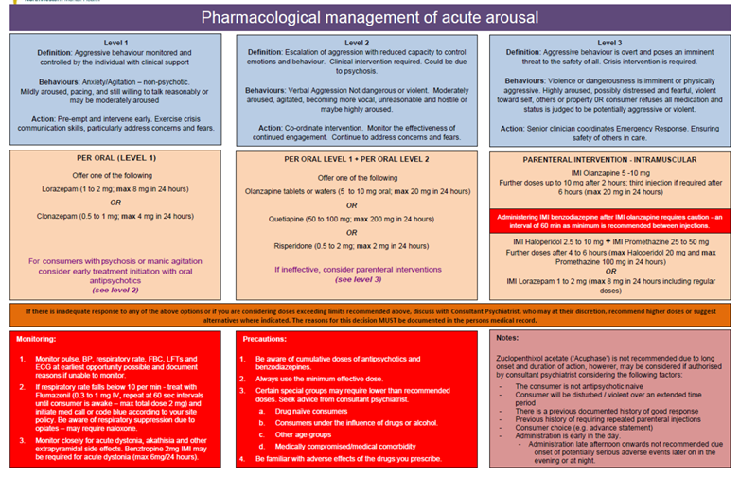
Another (similar) regime to consider:
PRNS NRT
Important to chart this on admission as consumers cannot smoke on the ward.

INFO ON COMMON PSYCHOTROPICS

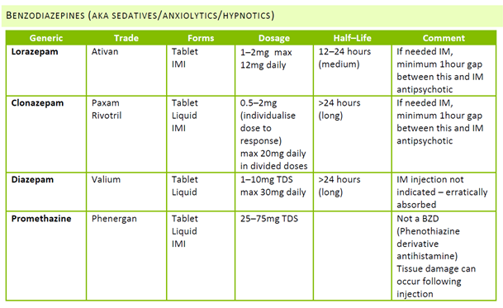

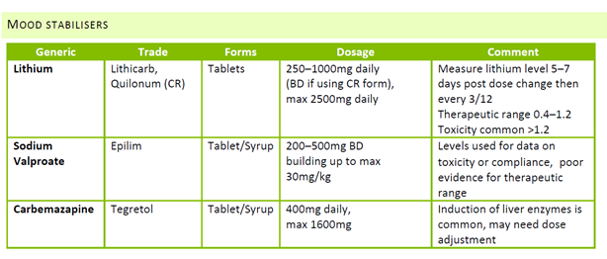
1st Generation Antipsychotics (Typical)
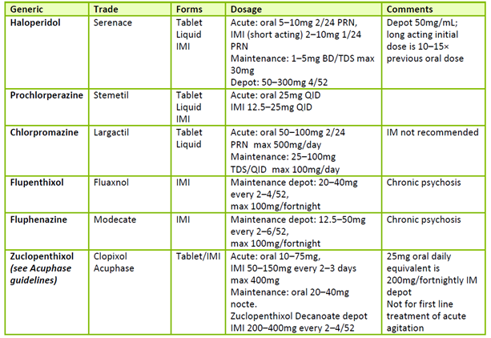
2nd Generation Antipsychotics (Atypical)
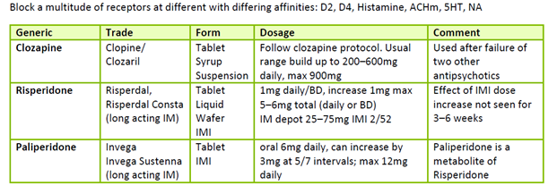
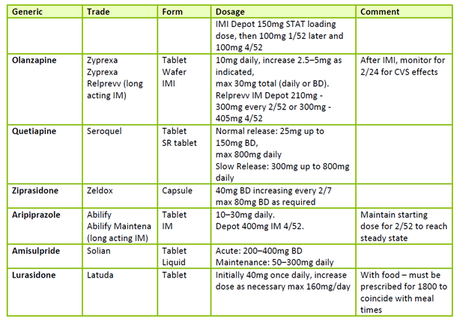
Clozapine
CLOZAPINE INITIATION
- Atypical antipsychotic, used only in refractory schizophrenia
- Follow initial workup investigations as per clozapine protocol (the ward Pharmacist is your friend):
  - FBE/UEC/LFT/bHCG/Cardiac enzymes/Fasting lipids/cholesterols/Fasting BSL/Blood group
  - ECG/Echo/Hip to waist ratio
  - TTE is done as per protocol – (cardiology will do ASAP with request)
  - BMI/Vitals
- Prescribe titrating dose on specific clozapine initiation medication chart
- Indicate on regular medication chart to see clozapine initiation medication chart
- If there has been an interruption of therapy (more than 48 hours since the last clozapine dose) re-titration of clozapine is necessary as per the Clozapine Titration Chart. Seek advice from the ward pharmacist or on-call pharmacist after hours.

CLOZAPINE ROUTINE INVESTIGATIONS
- As clozapine has significant potential to cause Cardiomyopathy/Myocarditis, Neutropenia/Agranulocytosis, Routine investigations as per clozapine protocol are mandated:
- Weekly FBE for 18/52 then monthly thereafter
- Day 7 and 14 ECG and Cardiac enzymes
- At 6/52 Echo and cardiac enzymes
- At 6/12 ECG/LFT/Lipids/TAGs/Fasting BSL/Serum Clozapine/BMI/Hip to Waist ratio/BP
- At 12/12 (annually) Echo/ECG/LFT/Lipids/TAGs/Fasting BSL/Serum Clozapine level/BMI/Hip to waist ratio

METHADONE/SUBOXONE/BUPRENORPHINE
- TALK TO THE PHARMACIST. Consumers discharging on methodone/suboxone require special paperwork and prescribing.
- If commencing a consumer on methadone, call DACAS for directions regarding dose. Make sure you have a thorough drug Hx before you call.
- If a consumer has missed their dose for more than 3 days, need to treat as methadone naïve

ADVERSE EFFECTS OF PSYCHOTROPICS

ANTIPSYCHOTICS
Occur with all agents
Traditional adverse effects associated with older agents appear less common or severe with newer agents.
The time for effect of antipsychotics may take up to several weeks, whereas side effects may occur quicker.
Common: sedation, anxiety, agitation, ESPE, orthostatic hypotension, tachycardia, blurred vision, mydriasis, constipation, nausea, dry mouth, urinary retention, weight gain, sexual adverse effects, hyperprolactinemia (galactorrhoea, gynecomastia, impotence, amenorrhea, infertility)
Infrequent: urticaria, Stevens–Johnson syndrome, corneal/lens opacities, SIADH, hyperthermia, hypothermia, neuroleptic malignant syndrome, anaemia, thrombocytopenia, agranulocytosis, VTE, prolonged QT, arrhythmia, cardiac arrest, sudden death, hepatic fibrosis, priapism, SLE, seizures, elevated BSL, dysarthria, dysphagia
EXTRA PYRAMIDAL SIDE EFFECTS (EPSE)
Highest with haloperidol, fluphenazine, trifluoperazine, percyazine
Reduce dose to avoid recurrent EPSE when possible
Anticholinergics (Benzatropine) used for prophylaxis in event
Dystonias: torticollis, carpo pedal spasm, trismus (lockjaw), perioral spasm, oculogyric crisis, medical emergencies – laryngeal spasm and opisthotonos
More common in children, typically occur within 24–48h of commencing or increasing dose, respond rapidly to anticholinergics
Akathisia: feeling of restlessness occurs 2–3/7 up to weeks after treatment. May subside spontaneously
Parkinsonism: tremor, rigidity, bradykinesia, usually develops after weeks or months. Usually reversible, consider reducing dosage or changing agent
Tardive Dyskinesias: involuntary movements of the face/mouth/tongue, sometimes head, neck trunk or limbs. Often after medium to long term treatment or sudden cessation of an agent. Incidence lower with atypical antipsychotics

NEUROLEPTIC MALIGNANT SYNDROME
Potentially fatal, autonomic, neurological reaction, likely due to DA2 blockade in hypothalamus and striatum
F fever
E encephalopathy (altered conscious state)
V vitals unstable (autonomic instability)
E elevated enzymes (CK – skeletal muscle origin)
R rigidity of muscles
Usually rapidly progresses over 24–72hrs, more often in younger men
Treatment: cease antipsychotic, supportive care including medical ICU as required

METABOLIC SYNDROME
People with schizophrenia have increased background risk of CV disease/T2DM
Antipsychotic medications increase risk, particularly clozapine, olanzapine, quetiapine associated with increased BSL, weight gain, dyslipidemia.

ADVERSE EFFECTS OF MOOD STABILISERS
Lithium: metallic taste, nausea, diarrhoea, epigastric discomfort, weight gain, tremor, acne, polyuria, hypothyroidism, t wave changes, diabetes insipidus, blurring vision, weakness, myoclonic jerks, hyperreflexia, seizures, coma – be aware of effects particularly with concurrent illness, excessive exercise or dehydration
Sodium Valproate: N+V, increased appetite, weight gain, tremor, paresthesia, drowsiness, elevated LFTs, hematological abnormalities (cell–penias), hyperammoniemia, ataxia, and rash
Carbamazepine: drowsiness, ataxia, dizziness, blurred vision, headache, rash, dry mouth, abdominal pain, N+V+D, anorexia, constipation, cytopenias, elevated LFTs, skin rash/reactions (SJS, TEN), SIADH, arrhythmia, orofacial dyskinesia

Clinical documentation queries in Medtasker
- Good documentation is critical to provide an accurate record of the consumer’s stay in hospital, decision making processes and rationale and handover between the multiple clinicians engaged in the consumer’s care. Remember - “if it is not documented, it didn’t happen”. Your documentation is also vital for ‘clinical coding’, which is necessary for Department of Health data reporting and hospital financial reimbursement.
- To ensure accurate and comprehensive documentation in real-time, the Clinical Documentation Specialist (CDS) will identify any deficiencies in documentation in the healthcare record and will query these via Medtasker. These will show up as “CDI Query”. Please action these queries by documenting in the healthcare record. This can be done by documenting:
• on the next progress note (paper format), or
• on an electronic progress note in CPF by noting “CDI query response”, and/or
• on the discharge summary in CPF

