
ROVER (Rolling handOVER) – I am a ‘living document’ that needs your care and attention

Rotation: Hospital In The Home (HITH)
Updated by: Dr Cian Carey
Contact: cian.carye@nh.org.au
Last updated: 1/11/2023
Reviewed by: Dr Rabin Sinnappu
Please update me as required and send me to fathimaijaza.lafeer@nh.org.au in week 11 of this rotation
CHECKLIST FOR NEW STARTERS
- Read through this ROVER
- Receive comprehensive unit orientation from unit supervisor/registrar within week 1
UNIT STAFF & KEY CONTACTS | CONTACT DETAILS
Head of Unit: Dr Rabin Sinnappu | rabin.sinnappu@nh.org.au
Consultants: HITH 1-35  - Dr Rabin Sinnappu – Geriatrician (Mondays & Thursdays)  - Dr Heng Cheok – Emergency Medicine Physician (Tuesdays)  - Dr Saliya Hewagama – Infectious Diseases Physician (Wednesdays)  - Dr Zi Lo – Geriatrician (Fridays)  HITH 36-70  - Dr Su Ann Ho – Infectious Diseases Physician (Mondays, Wednesdays & Thursdays)  - Dr En’en Tong – Geriatrician (Tuesdays & Fridays) | Via switch  Mobile numbers are available from the HITH office and on the keycard
1-35 Inpatient registrar | Phone x58957/ Mobile 0448 764 359
36-70 Inpatient registrar | Mobile 0460 626 151
Admissions registrar | Phone x58684 / Mobile 0448 843 113
1-35 HMO | Mobile: 0417 483 753
36-70 HMO | Mobile: 0460 624 429
HITH NUM (Ms Lynne Santamaria) | x58638
HITH Pharmacists | X52967 or x58689
HITH Social Worker | Healthpower x52213
Divisional Director of Ambulatory & Community: Dr Donald Campbell | Mobile 0421349201 or Pager 03 9387 1000
Northern Interpreter | X58188

What is HITH?
Our service provides care in the home that would otherwise be delivered in a hospital setting as an inpatient. It provides an alternative to a hospital admission or an earlier transfer home than would otherwise be possible

The Team
- One Registrar for Beds 1-35, one registrar for Beds 36-70, one registrar for admissions
- Three Registrars Mondays – Fridays. One registrar on the weekends. Four HITH HMOs. 3 HMOs on Mondays – Wednesdays & Fridays. 2 HMOs on Thursdays
- Flow nurse - Coordinates issues around admissions
- Admission nurse - Consents patients for HITH and handles home safety checks
- Clinic nurse
- Road nurses – Day &evening
- Pharmacists and Pharmacy Technician
- DNE
- Dietician
- Social work

HITH Catchment Areas
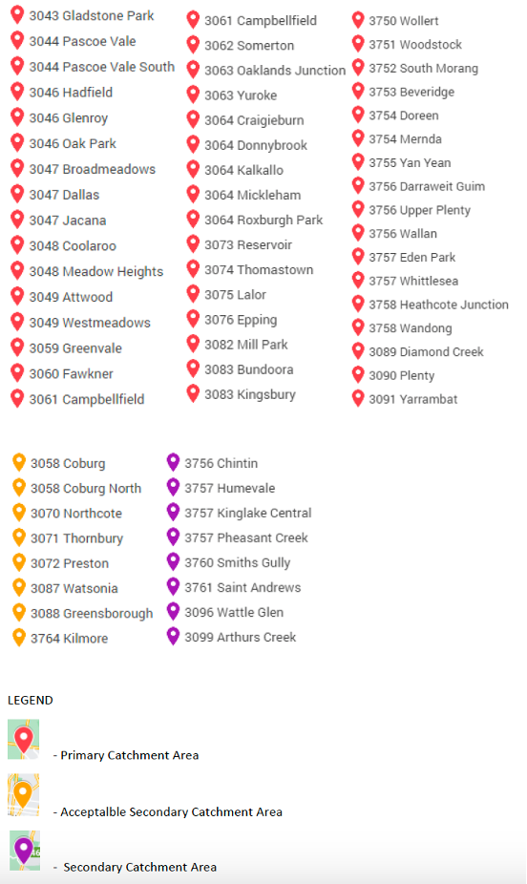
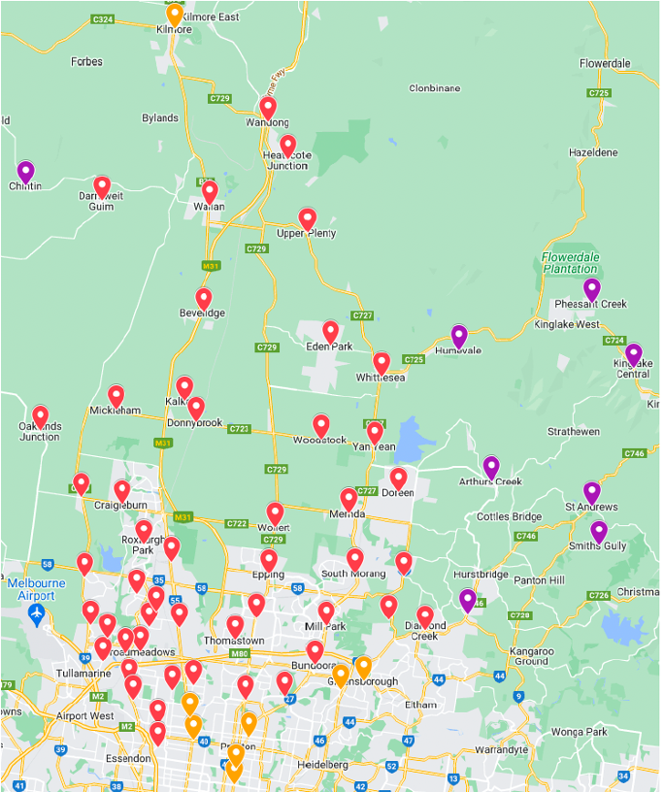

HITH Office Location:
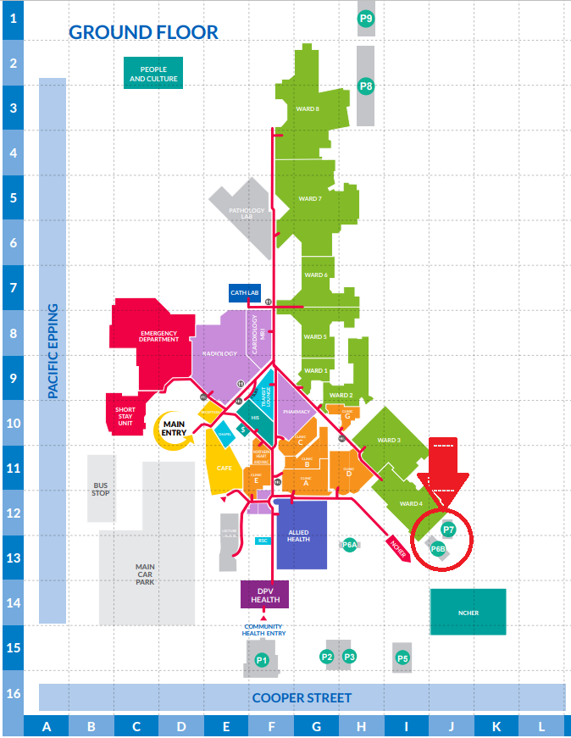

Summary of role and top tips:
- HITH patients
  - Heart failure management
  - Anticoagulation (Warfarin/bridging clexane)
  - Wound management/pressure dressings (VAC, SNAP, Prevena)
  - Drain tube management
  - Intravenous antibiotics
  - Chemo disconnects (direct day admissions )
  - Iron infusions/Infliximab infusions (direct day admissions)
  - IBD@Home
  - Paediatrics*
  - TOV@Home
  - Morning handover at 08:30 – Morning handover led by liaison nurse. Consultant attends either in person or via teams
  - Usually starts at 0900 on Thursday after grand rounds
  - HITH HMOs to print & manage handover lists on Teams folder

- Patients can also deteriorate at home and HITH staff should be proactive with assessing patients
  - Patients can be more vulnerable in their home environments. You will often change your management according to reviews by other staff members. Do not hesitate to call patients, bring them to HITH clinic, transfer them to the emergency department. Speak with HITH nursing staff about your patients. Communication is key on HITH. Be proactive with organising investigations for HITH patients - eg ordering CTPA for suspected PEs,

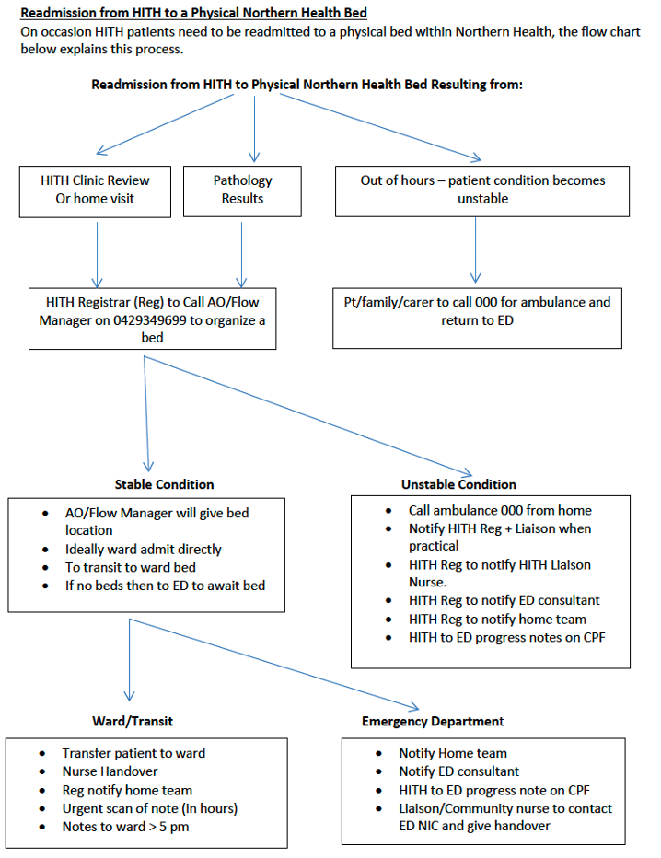
- If you have clinical concern about a potential emergency & potentially life-threatening situation for a patient I.e. Potential MI, PE, Haemorrhage, stroke, sepsis etc an ambulance should be called to the patients' residence. This can be called by the HITH doctor orr by the nurse on the road. Call emergency services on 000.Inform ED AO of incoming admissions. Complete HITH to ED handover note. Inform primary team of the need for admissions.

- VTE prophylaxis: HITH doctors should do VTE Padua Prediction Score (can be found below or on MDCalc) for HITH patients on admission to determine anticoagulation need. This should be performed on every patient on admission to HITH and be documented on the admission note. If a patient scores greater than 4, please liaise with the home team regarding the recommendation for VTE prophylaxis. If the home do not wish for HITH to commence the patient on DVT prophylaxis, document this clearly on the admission note. This is not applicable for patients already on anticoagulation. Padua scores are prediction scores. Clinical judgement should always be used for your patients with consideration of risk of bleeding (HAS-BLED score). VTE prophyalxis should be charted on a medication chart regardless of if this is being administered by HITH RN or self-administered. If a patient is self-administering clexane, this may be supplied on a script by the home team on discharge
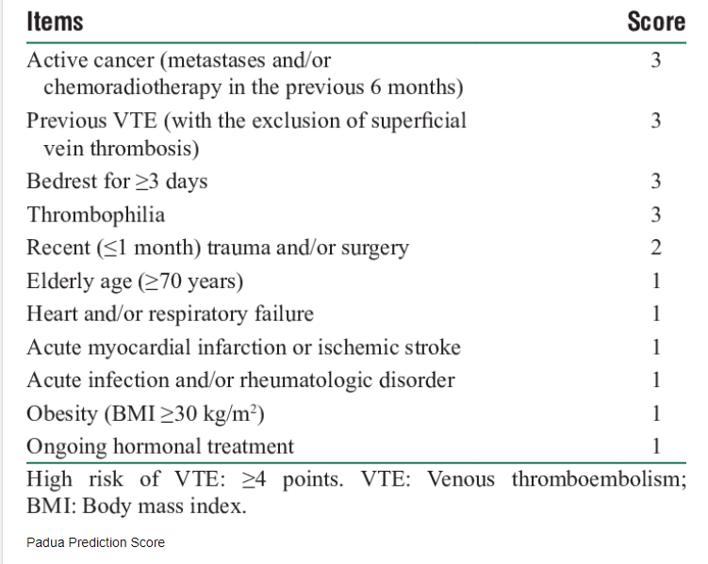

- For surgical patients, review need for VTE 4 weeks post-last surgery as Padua score can change significantly.
- Due to government funding, General Practitioners are not to be visited while patients are under HITH. HITH doctors will address most issues patients may have that are not related to their hospital admission. If you believe a patient needs to see their GP, discuss with liaison nurse +/- your consultant

Pathology Board/Doctors communication book
- Pathology board: Previously this was a white board in the HITH office with dates for patient’s next blood tests. Next date for bloods now on online handover list (see teams handover list)
  - Once a patient’s bloods are reviewed, please write a pathology slip for their next bloods (and left in the medical documents basket) and update the pathology board. Pathology board is used by HITH liaisons to make allocations for the following day. Make sure to write bed number of patient on pathology slip (in addition to BRAGMA)
  - PRN on the pathology bedcard is indicative of PRN bloods for your patient
- Doctors Communication Diary is a communication book used between nursing staff and medical staff. To be reviewed by HITH registrars daily
INTERVENTION | INCLUSION CRITERIA | EXCLUSION CRITERIA
Heart Failure Management | - Requiring diuresis (oral or IV) -encouraged to be converted to oral on admission to HITH  - Requiring fluid monitoring (daily weight etc)  - Requiring medication titration for uptitration of HFrEF medications  - Requiring monitoring of bloods - 2nd daily UEC usually unless we need to monitor electrolytes/urea  - Loss of weight as an inpatient. Medical patients (i.e. everyone not from CAHF Team) referred must to HITH should be discussed with HF fellow/NP prior to accepting  If patient not accepted by HF team but is straightforward, can accept and manage as HF but under HITH and not HF HITH | - Requiring new oxygen  - MET criteria obs  - Unable to manage independently if from home  - Clinically unstable or unwell
Bridging Clexane for Warfarin Anticoagulation (or Clexane only administration) | - Clexane education/administration (including monitoring anti-Xa levels)  - Bridging clexane while awaiting INR to be therapeutic  - Pre-operative patients requiring bridging clexane (requirement based on CHADs score) | - Suitable for NOAC  - If atypical request not in keeping with haematology protocol, ask home team to clarify with haematology consults registrar or anticoagulation stewardship pharmacist  - Just warfarin management without Clexane bridging can go to GP/Path service
Rapid warfarin reversal | - Following conditions eligible  - A Fib (depending on CHADs)  - Rheumatic valvular heart disease  - Recurrent VTE  - VTE last 3-12 months | - Thrombophilia  - MVR and AVR  - Stroke/TIA/VTE within last 3 months  - Known allergy or Adverse Drug reaction to Vitamin K (Phytomedadione)  - No elevated risk of thromboembolism identified  - Unstable INR two weeks prior to procedure
IV antibiotics | - Long course IV antibiotics [maximum bd dosing (tds by negotiation) – continuous infusions will depend on machine availability]  - Antibiotics will need to be confirmed with HITH pharmacist to ensure able to be given (need stability data)  - PICC completed for IV antibiotics  - Patients requiring intraperitoneal (IP) antibiotics  - ID input and guidance completed along with ID plan documented with clear end date | - Suitable for oral antibiotics  - IV antibiotics for cellulitis – referring team need to d/w ID
IV steroids | - Requiring IV steroids for medical condition (multiple sclerosis etc.)
Blood Test Monitoring | - Close monitoring of patient’s biochemistry, eg: liver function tests for patients on certain antibiotics  - UEC monitoring if plan in place for deterioration | - Requiring active intervention  - Monitoring able to be managed by LMO/ other service eg. DNE
Wound Care | - Wounds requiring VAC, SNAP or Prevena dressings  - Wounds >2 cm in depth  - Complex wound management | - Wound depth <2cm or wounds able to be managed by Bolton Clarke or PAC
Drain Tube Management | - Management of drain tubes  - Clear reportable parameters and removal parameters | - Drain tubes that can be managed by Bolton Clarke/LMO (i.e. capped tubes etc.)
Remdesivir Infusions | - COVID +ve  - Sufficiently High risk: Depends on Age, Vaccination Status, Comorbidities.  - Completion of Inpatient Remdesivir Course  - Doses 2 and 3 of Outpatient course. | - Must be off Oxygen  - Exertional Dyspnoea  - Drop in SpO2 on exertion  - No loading dose given (must be done in hospital)
IBD @ Home | - Referred and managed by IBD reg | - See escalation criteria below
Paediatrics | - Referred directly to HITH nurses by paeds  - No HITH doctor input. Can liaise with paediatric team if any concerns
Other | - Chemo disconnection (direct admissions from oncology ACC)  - Iron infusion (direct admissions from Gastro/Renal OPC)  - Infliximab infusion (strict criteria – discuss with HITH nurses)  - Blood transfusion in nursing homes

Warfarin / Clexane Bridge
Who is eligible?
    - Refer to the latest protocol on PROMPT (Haematology) 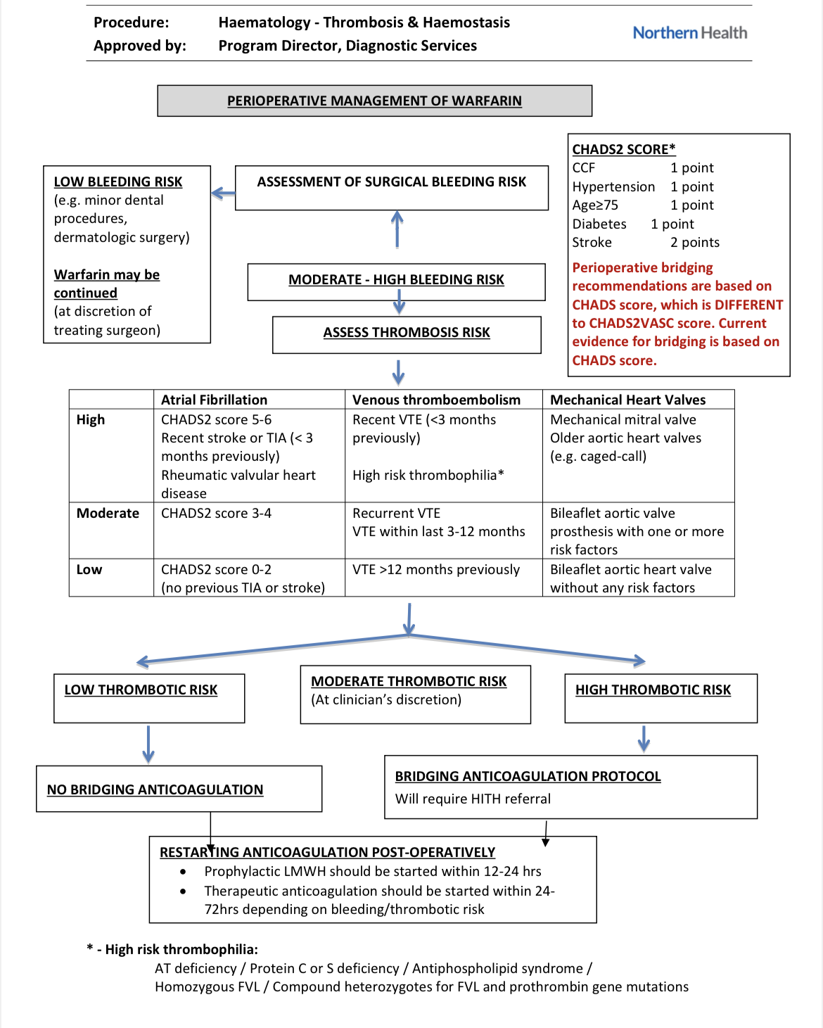
What happens…
    - Warfarin dosing chart completed including usual dose, pathology centre and target INR
    - If patient is new to warfarin then please try to find out who they would like to dose as this information is useful prior to discharge It is useful to have inpatient doses and INRs as a guide from the days leading up to HITH admission
    - Nurse takes morning INR and gives morning clexane
    - As per doctor’s decision, nurse calls pt to notify of warfarin dose then goes out for PM clexane if required
  - General protocol for Doctors
    - Step 1: Dose warfarin chart as per INR
    - Step 2: Complete pathology slip for next INR
    - Step 3: Give back to nurse who needs to notify patient of warfarin dosage OR Call patient yourself and document this
  - Details
    - INR is usually done every 2 days
      - Consider next day INR, particularly if INR is near target range, for faster discharge or supratherapeutic INR
    - INR isn’t known until PMs
      - This affects how you chart AM/PM clexane (examples below)
      - Nurses only carry patient drug charts, NOT WARFARIN CHARTS. So if clexane is on the chart then it will be given unless chart altered/nurse contacted
      - If making a change to clexane plan, document and update HITH liaison nurse. Once the folder is back in the office, amend drug chart and inform the pharmacist as well. (This is to ensure that there is enough supply of the clexane until we need to dose)
    - BD or Daily clexane?
      - BD for mechanical valves and active clots or as per Haem
      - Otherwise daily for everyone else (1.5mg/kg/day if renal function allows) unless high BMI and then for discuss with Haematology as may need bd
      - Check renal function and weight
- Dose of Clexane
  - 1mg/kg bd or 1.5mg/kg/day, dose reduced if CrCl<30
  - Use the patient’s weight and round the dose to the nearest 10mg where practicable
  - Criteria for doing Antixa level on patients:
- Age >80 years
- Obese patients (>100kg) or less than 50kg
- Patient has borderline renal function 30-40 gfr
- If patient is on clexane for greater than a week, the patient will have weekly antiXa to ensure it remains in range.
- Target Xa level for BD dosing 0.5-1.0 (preferred method), target Xa level for daily dosing 0.8-1.5 (less preferred method)
- Direct admits from PAC for pre-op clexane warfarin management can be challenging as patients not reviewed prior to admission to HITH.
  - Briefly document plan in outpatient tab - indication for anticoagulation and clexane dose. Often the patients directly referred from PAC clinic may not need bridging at all. Liaise with haematology or anticoagulation stewardship pharmacist if any concerns
  - Documentation makes things easier post operatively too as they will often come back to HITH for warfarin/clexane management.
  - HITH RN will chase latest INR and give you a template (filled out with weight and latest renal function) to chart the patient’s clexane dose on a medication chart and fill out the warfarin chart (write withhold in warfarin column)
  - Consider anti-Xa level (4 hours pre 3rd dose of clexane) if dosing high doses in context of obesity
- Be cognisant of any new medicines that may have been started during a hospital admission as warfarin has a narrow therapeutic index & interactions can be potentially lethal. If in doubt discuss with your friendly HITH pharmacists.

- Complications:
  - There may be many complications that can arise secondary to clexane administration. These can include rectus sheath haematomas and retroperitoneal haemorrhages.
  - In rectus sheath haematomas, a branch of the inferior epigastric artery is injured at its insertion into the rectus abdominis muscle. It is an uncommon but a well documented complication of anticoagulation therapy. An overall mortality of 4% and 25% for rectus sheath haematoma secondary to anticoagulation therapy has been reported. Patient usually gives a peculiar history of sudden, severe, unilateral abdominal pain which aggravates on movement. Ecchymosis may sometimes present as a late feature. On examination, tenderness may be present along with a palpable abdominal lump. There may also be unexplained tachycardia or hypotension, fall in haematocrit, peritoneal or bladder irritation, abdominal distension or abdominal cramping. A thorough history and examination are impeccable for diagnosis. Risk factors for the development of severe spontaneous hematomas include higher doses of LMWH, preexisting renal impairment, older age, and concomitant administration of medications that affect hemostasis. While Rectus sheath haematomas are typically self-limiting, clinicians should be aware of the most common presenting symptoms, including abdominal pain (84%–97%), palpable abdominal wall mass (63%–92%), and abdominal tenderness (71%).
  - Retroperitoneal bleeding caused by lumbar artery lesion is rare and mostly related to iatrogenic or trauma. Aneurysm or anticoagulation therapy is the most common causes of non-traumatic bleeding. Retroperitoneal haematomas can present clinically with groin, flank, abdominal or back pain and it has also been reported as inguinal hernia with appearance of groin swelling
  - Should a patient, nurse or HITH doctor have any concerns regarding any of the above symptoms, timely assessments should be organised in either HITH clinic (within 24 hours if clinically appropriate) or the emergency department depending on the patient’s symptoms and your clinical judgement. If there are any concerns, consider withholding anticoagulation until a medical review

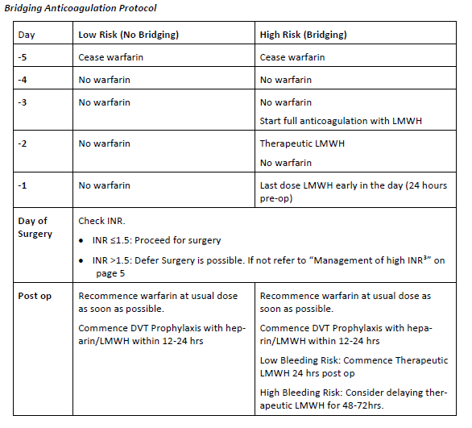
  - Usually warfarin and clexane plan as follows as per PROMPT protocol

- Warfarin Rapid Reversal
  - New protocol being trialled, needs close monitoring as open to near misses
  - Point of Care INR day before procedure, withhold warfarin. 3mg vit K IV administered
  - Day of surgery gets an INR in hospital

- Discharge Protocols for “New Warfarin” vs “Continuing Warfarin “
  - All discharges require
    - A warfarin discharge plan (Fax to pathology service) with previous INRs and Warfarin doses (For TNH path referral - no need to call haem reg as specified in form. It will suffice to email the TNH path warfarin referrals address provided with the discharge plan as well as the pathology slip)
    - Pathology slip for INR with Rule 3 exemption written on it (a stamp is also available) – this rule allows repeated INRs without path slips. Use the pathology brand path slips available (more so if new referral) eg. Clinical labs path slips for Clinical labs
  - New Warfarin
    - Requires 2 consecutive therapeutic INRs prior to discharge
      - If a patient is new to warfarin, 2 therapeutic results, a day apart, are required prior to discharging a patient. This patient will continue to have clexane after their first therapeutic dose and it will be ceased when the second therapeutic result is obtained. Discharge at home occurs the day after asecond therapeutic dose has been recorded. A copy of the discharge warfarin plan and pathology request slip is given to the patient upon discharge
      - Will need an additional day of admission post 2nd therapeutic INR for nurses to go and educate patient to do warfarin discharge paperwork
  - Continuing Warfarin
    - Can be discharged on day of 1st therapeutic INR if stable

Other reasons to be on HITH
- HF
  - HITH HF is a standard practice aiming to manage HF inpatients in their homes, reducing in-hospital stays and hopefully reducing re-admission rates
  - Heart failure protocol (on PROMPT):

HITH visit nurse:
Clinical assessment including
⦁ Vital signs
⦁ Weight
⦁ Oedema
⦁ Education
⦁ Pathology second daily or PRN
Telehealth with HF NP & Pharmacist

HF NP
⦁ Clinical advice including medication titration
⦁ Update on CPF under “Hearts at Home-HITH NP Progress Note

HF HITH Pharmacist
⦁ Medication reconciliation on admission and discharge
⦁ Medication reviews daily
⦁ Medication list updated daily on CPF under “HITH Pharmacist medication review”

  - HF HITH Virtual Ward Round Meetings
    - Occurs daily at 11am in ward 15 meeting room. HITH 1-35 registrar is expected to attend
    - Attendees: HITH Registrar, HF consultant, HF fellow, HF pharmacist, HF NP and HF physiotherapist
    - Management of the patients in their homes is decided by the team.
  - Aim for good diuresis (don’t be afraid to be aggressive) to prevent long admissions
  - Reasons for referral to HF HITH VW
1. Diuresis IV or oral
2. Monitoring of renal function & other path
3. Monitoring symptoms
4. Medication up titration HFrEF
5. HF education, support & self management
6. Discharge planning ie. OP & HARP f/u
  - Referral process to HF HITH VW (process currently being formulated by HF team)
  - Patients need to be deemed suitable by the HF fellow, HF NP or cardiology consults registrar for a HF HITH admission following a review. Referrals to be made via phone call or medtasker referral
  - Discharge scripts are organised by HF VW pharmacist who will also need to be informed of patient’s admission to HF HITH
  - Ensure you are aware of the patient’s base/aim weight and baseline renal function
  - Discharge template available to ensure adequate details re: weights/discharge plan etc
    - Patients need to be losing weight as inpatient prior to transfer to HITH
  - For Heart failure patients, we need as detailed as possible admissions for admissions. This will allow for a more streamlined discussion at 11am with the CAHF team. So details - eg BNP, CXR report, doses of diuretics - baseline and current as well as all HF meds, eGFR baseline and current, and TTE. Current sx - exercise tolerance, orthopnoea, etc. Weights on discharge .
  - If HFrEF – drugs with mortality benefit/should be on unless there are any contraindication:
    - Uptitration of medication → plan is to optimise HFrEF medications while with HF HITH VW instead of requesting GP to follow-up ACE-inhibitor/ARB/ARNI
      - if transitioning from ACE/ARB to ARNI needs 36hrs off ACE/ARB for washout
      - Avoid if hyperkalaemia and symptomatic hypotension
    - Mineralocorticoid receptor antagonist e.g. spironolactone/eplerenone
      - Avoid if hyperkalaemia
    - Beta-blocker (cardio-selective) – nebivolol/bisoprolol/carvedilol/metoprolol XR
    - SGLT2 inhibitor – dapagliflozin/empagliflozin
      - Avoid if recurrent UTI
    - Ivabradine – need to be in sinus rhythm with HR >75 and on maximal above therapy
    - Consider IV iron infusion on discharge from HITH especially if ferritin <100 OR ferritin 100-299µg/L and transferrin saturation <20%
  - Try to ensure there is a plan for managing all of the patient’s other issues if referred to HITH by HF service. HF management often ends up being combined with managing their other issues (diabetes, CKD etc).
  - HMO (on 1-35) – important to check HF VWR note each day to see pending jobs
    - Cardio Reg should ensure Cardio F/U is completed (e.g. referral for angiogram/TTE)
    - HITH HMO’s job to sort follow up for Cardiac Rehab, HF HARP (if required)
      - Rehab (cpf internal referral -> referral type (community access) -> Speciality (SACS) -> Subspecialty (cardiac rehab)
      - HF HARP (cpf internal referral -> referral type (community access) -> Speciality (HIP/HARP) -> Subspecialty (chronic heart failure outreach)
    - Medication changes from meeting need to be updated on EMR -> any new meds require script printed for HF pharmacist (can leave in their tray)
    - Iron infusions require phoning pt for consent and filling out paper iron transfusion order form and completing written iron prescription (leave in HF pharmacist tray, they will organise for pt to get on day of discharge from HITH)
  - Any HF HITH pt issues over weekend (i.e. worsening renal function or nursing concerns) need to be escalated to weekend cardiology reg on call for advice re management

- VAC / SNAP / PREVENA / Wound dressings
  - VAC and SNAP are different types pressure dressings for surgical wounds (SNAP has a manual function and is a down-step from a VAC dressing)
  - Prevena is another pressure dressing usually done for 7-10/7 post-LUSCS in high BMI females
    - Due to thrombosis risk in high BMI individuals, LUSCS also receive 5/7 of clexane either 40mg or 60mg depending on BMI
    - Prevena usually removed 1/52 post LUSCS and then discharged

- IV Antibiotics
  - Require weekly bloods
  - Note indication, end dates, and ID outpatient advice & ID guidance
  - Some antibiotics need to be made up in a special bag by an external company & delivered to TNH; this sometimes takes 48-hours which may affect admissions –liaise with HITH pharmacist ASAP once details confirmed upon receiving a referral
  - Vanc Levels in HITH are for continuous infusions, thus desired level is: 20-25
  - Always add UEC to Vanc level Path Slip

- Wound and Drain Tube Management
  - Track surgical outpatient advice and drain tube outputs
  - When admitting, make sure to have reportable drain output limits and when to remove and follow up plans
  - If drain tube capped & no reportable output, redirect to Bolton Clarke
- Iron infusions
  - Iron infusions are often given on day of discharge to HF patients if:
Ferritin <100, OR Ferritin <200 AND Transferrin Sats < 20%
  - Try to get Iron infusions done on discharge on the ward and then the patient doesn’t need HITH to insert IVC etc
  - HITH team to arrange all paperwork for iron infusions for patients referred from HARP, as of 2023
  - Emergency medications need to be charted on medication charts
- Remdesivir Infusions
  - High-risk COVID positive patients
  - Some patients in the community, referred by Medical teams (Renal, Gastro, ObsGyn etc).
  - Some stable inpatients for completion of inpatient courses.
  - There is a number of forms (can speak to pharmacist) needed in order to request Remdesivir/Paxlovid etc. Usually if referred from another team they will fill out these forms.
  - If the patients are current HITH patients and test positive then you will need to fill out these forms.
  - Loading dose (given by Inpatient team or in COMET clinic): 200mg
  - Doses for Days 2 & 3: 100mg
  - HITH Reg to chase baseline bloods (UEC & LFT)

- Blood Transfusion in Nursing Homes
  - Must be attended at nursing home by HITH HMO for first 30 minutes to ensure nil transfusion reactions

ROLE & RESPONSIBILITIES
Both HMOs and REGs must ask Dr Rabin Sinnappu to complete mid-term and end of term assessments
Admissions Reg
- Find out bed capacity each day. If at capacity then patients will need to be waitlisted Capacity is currently 70 patients
- ADMISSIONS
  - The flow liason nurse (also a useful resource if you are unsure whether a referral if feasible)
  - The bed management portal – get the nurses to show you how to use
- Things required for HITH admission
  - GOPC completed by home team – Try to get home team to do as isn’t HITH responsibility & HITH not the most appropriate to have these discussions. Will then fill out form as per home teams decision.
  - Script – this does NOT need to include supply of clexane (if self-administered by patiens upon discharge from the ward) or IV Abx as pharmacy will supply off our drug chart. It does however need adequate analgesia etc for patient to self-administer
  - Clear plans for follow-up especially whether ID needs to r/v prior to cessation of any IV Abx
  - Discharge summary
  - HITH Reg and nurse r/v PRIOR to discharge -> if simple i.e. prevena or wound admitting dpctprs may not have to review – check with HITH Liason Flow nurse.
  - Drug chart (we complete this) and it only needs medications we are managing eg. Abx/ Frusemide etc. Clexane needs to be charted on medication charts regardless of if it is being self-administered or by HITH nursing staff
  - Interim drug charts for NH patients
  - Must be in our catchment
  - Medicare ineligible patients need to be approved by medicare ineligible team (this comes up relatively frequently)

- Also helpful:
  - Review laboratory tests and scan results that were ordered during the admission to begin with – if abnormality is identified ensure that the home team are & that appropriate follow up has been arranged
  - Heart Failure: dry weight/current weight/fluid restriction/baseline & current diuresis
  - Abx: cease date/PICC insitu (make sure they have iGuidance approval before coming to HITH- this is the home team’s responsibility)
    - Confirm with home team
    - Follow up plans with ID
  - Drain tube: reportable upper limit/lower limit to remove
    - For patients post breast mastectomy and axillary clearance often
    - Follow up plans with home team
  - Obstetric patients: duration of clexane & dose (sometimes need HITH to administer)
- Patient’s need to pass the safety check– no current substance misuse /hx of violence / risk issues
- If the home environment is difficult, there is a potential option of patients coming into hospital via HITH clinic to see us
- Paperwork for admission
  - Admission in EMR within the current episode – print and put in folder
  - Warfarin chart if applicable
  - HF chart if applicable
  - GOPC completed
  - Med chart if needed

DIRECT ADMITS eg. Iron, blood transfusions, chemo disconnects, preop bridging clexane, remdesivir infusions
- Complete the relevant charts (i.e. iron infusion form + consent, warfarin chart, medication chart)
- GOPC forms – ideally home teams/ referrers should be completing otherwise use the legal tab in CPF or ring the patient/ NOK to have discussion where possible (this is last resort as we have not met the patient before).
- NEW: Admission note required now that HITH have transitioned to EMR for all direct admission)

All pending admissions are to be put on the admissions board in the office – tick box once reviewed

Inpatient Regs
If working the weekend – should be the 1-35 Reg on Friday before & Monday after
- Answer calls about HITH patients
  - If any changes/updates/significant info, to document in EMR (Progress note) AND print to put in folder so nurses can access these notes on the road
- Answer calls re: HF patients from road nurses if HF nurse not working.
- See patients in clinic
  - Usually for heart failure reviews or for pts with new symptoms that don’t require ED t/f
- Readmissions from HITH to hospital
  - Can readmit directly under home team if recurring issue (call AO for bed x58110),
  - Send to ED if patient is unstable or there are no ward beds available
    - Call the ED Consultant in charge to handover and document a progress note on EMR (call it HITH to ED handover)
    - Call home team to inform
- Attends 11:00 heart failure meeting to discuss all HF HITH patients. Attended by HF fellow +/- consultant, HF nurse, HF pharmacist.
- Be in the office from around 1330-1500 to review INRs and HF patients with the HMOs (the morning shift nurses go home at 1530 – this allows the nursing staff to communicate medication changes to the patients/pharmacy)
- Rewrite a new pathology slips for the next planned blood test & update pathology board (in teams list)– if not done by HMOs

On Call over Weekend
- Usually consultant who attends morning handover is on call after hours for any queries from HITH nurses
- Weekend registrar is on call for HITH over weekend (from Saturday 8am to Monday 8am)
- Usually receive phone calls from HITH on call nurse e.g. pathology result which comes back after hours, or if a patient contacts HITH on call nurse
- Weekend registrar is not expected to review patients at home or after hours UNLESS patient passes away expectedly in RACF – may need to certify death the next morning (very rare)
- Ensure you have remote access to document all discussions/outcomes after hours – Lynne (NUM) happy to approve/sign the remote access form. If no remote access available then document on EMR when you are physically in the next day
HMO
Main jobs include:
- Updating/printing the list. This includes removing discharged patients, making sure new pts are on the list, updating frequency of bloods (and next date due), dates for outpatient referrals, outcomes of outpatient reviews
- Discharge summaries - will be placed in tray next to HMO monitor by ward clerk (will also be medtasked so don’t tick off until complete so know which ones are outstanding), to be done same day if possible and then to put in tray next to Pharmacist for them to doublecheck medications on discharge if needed. All discharges to be
- Chasing up outpatient referrals and clinic times for patients, often will need to email or call clinic coordinators if appointment not scheduled after discharge / Check visits list on EMR
- Checking path and updating pathology board accordingly (remember when checking bloods inc UECs/INRs always rewrite a new slip for the next planned blood test!)
- Regs will often ask you to help out with admissions and clinic reviews when it gets busy
- Patient reviews over the phone re: any concerns, may get phone calls over HMO mobile phones if any issues, any concerns to escalate to reg. Document reviews in progress notes on EMR
- May need to attend nursing homes occasionally to supervise blood transfusions- mainly need to be present for first 30 mins and ensure nil issues and then can leave
- Documentation is done on EMR generally- create a progress note and label “HITH progress Note” in the current admission and then print off to be placed in patient’s file so road nurses have a copy
- Specialist team referrals as well as liaising with home team regs
- Chase up outpatient clinic notes from other teams about ongoing management plans (all outpatient notes will still be on CPF under outpatient’s tab)
- Completing warfarin discharge plan and paperwork (see above warfarin section for more information) if home visit needs to Fax to path company, also will need to call path company to book appointment for home visits, otherwise patient advised to present to pathology or GP for next INR following discharge
- NEW FOR EMR: Medication suspension when pt is discharged to HITH, it is vital that all the patient’s medications charted from inpatient stay are SUSPENDNED (right click an active medication and click suspend, reason other and in box say “HITH patient”). If a medication is not suspended, then EMR will keep giving notifications that the medication is due and needs to be signed off. All new meds charted (esp HF meds from VWR) need to be charted on EMR and then subsequently suspended afterwards (also make sure if it’s a dose change that the old previous dose medication is discontinued). Ideally admissions team would suspend medications when doing admission note. However, if pt is still on the ward then meds shouldn’t be suspended in case it needs to be given before discharge (if has been suspended then nurses on ward cannot give it). Therefore, important that 1-35 and 36-70 HMOs suspend their new patient’s meds daily. Pharmacy are a big help in identifying such patients.
- Other EMR advice
  - As HITH patients are at home, they require physical pathology slips to be filled out (and left in folder). Do not order path on EMR as nurses cannot access that then to take bloods.
  - Can order radiology on EMR as otherwise would for inpatient. Can tick outpatient box but then in special instructions, specify that pt is a HITH patient. If booking urgent Ix, important to ring radiography after booking scan on EMR and try finalise an appointment date and time.
  - HITH medications that the nurses are physically given (i.e. Clexane, Abx) need to be physically charted (on drug chart nurses can sign) but also on EMR (and subsequently suspended) to ensure accuracy of discharge summary

HITH logistics – important!
- Need to make sure any decisions or changes to treatment are relayed to the rest of the team inc other medical staff, nurses, nurse liaison, pharmacy
- Patients can come to HITH for IV abx, however most of the pumps are NOT compatible with normal IVCs and therefore need a PICC
  - If unsure about an IV antibiotic regimen, discuss with nursing staff and pharmacy, as there are lots of potential issues (continuous infusions often need to be ordered in, some antibiotics are not stable in a pump, HITH can generally only administer IV antibiotics twice a day, the duration of infusions have implications for nursing staffing)
  - Let pharmacy know of changes to medications. To reorder medications that pts have run out of:
    - In most cases you can just inform pharmacy
    - For medications that nurses need to sign of (IV Abx, clexane), you will need to rechart on the medication chart and give to pharm to dispense
- Warfarin to be dosed on the warfarin chart BUT also need to make sure that the medication chart is up to date with the clexane to be given/not given as the nurses on the road only have access to the medication chart
- Nursing home patients who have warfarin dosed need a form faxed to the nursing home each day with the warfarin dose
- It is the doctors responsibility to fax warfarin d/c plan and ensure that it goes through! If new to warfarin need path slip with “rule 3 exemption” stamp
- It is preferable for pts to be daily instead of BD clexane when possible, ask home teams prior to discharge!
- Blocked PICC lines can still be used if other lumen patent, but must be unblocked by 24 hours. Consider alteplase if required (can be done in clinic by nursing)
- Document, document, document – as you will have rotating regs and HMOs, its worth documenting discussions under HITH progress notes to ensure there is not duplication in jobs
Medication changes and Webster Packs
- Always check if patient has a webster pack as you need to let pharmacist know
- A webster pack may be a barrier to discharge over the weekend if medication changes are required, so always pre-empt the nursing home +/- webster pack discharges over weekends
- Update the MMP and drug charts with any medication changes
- It is good to have medication of interest ie Abx and diuretics written on a drug chart to track changes
- For nursing home drug changes: especially when titration of HF medications like furosemide -if the dose has been altered -HMO to write up an interim drug chart and fax it/email it to the nursing home AND liase with the pharmacist. The pharmacist will then make sure that the NH have received the fax. To also update the medication chart.

Roster
 | Monday | Tuesday | Wednesday | Thursday | Friday | Saturday | Sunday
HITH 1-35 A  (Reg 1) |  | HITH 1-35 A  08:00-17:00 | HITH 1-35 A  TT  12:00-17:00 |  | HITH 1-35 A  08:00-17:00 | HITH 1-35 A  08:00-18:00 | HITH 1-35 A  08:00-18:00
 |  |  |  |  |  | Phone OC | Phone OC
HITH 1-35 B  (Reg 2) | HITH 1-35 B  08:00-17:30 | HITH 1-35 B  TT  12:00-16:00 | HITH 1-35 B  08:00-18:00 | HITH 1-35 B  08:00-17:30* | HITH Admit  09:00-19:00
HITH 36-70  (Reg 3) | HITH 36-70  08:30-17:00 | HITH 36-70  08:30-17:00 | HITH 36-70  08:00-12:00  TT 12:00-17:00 | HITH 36-70  08:30-17:00 | HITH 36-70  08:30-17:00
HITH Admit  (Reg 4) | HITH Admit 09:00-19:00 | HITH Admit 09:00-19:00 | HITH Admit 09:00-18:00 | HITH Admit 08:00-18:00* | HITH Admit  TT  12:00-16:00
HITH HMO 1 | HITH 1-35 A  08:30-17:30 | HITH 1-35 A  08:30-17:30 | HITH 1-35 A  08:30-17:00 | HITH 1-35 A  08:00-17:00
HITH HMO 2 |  | HITH 36-70  08:30-17:00 | HITH Admit  08:30-17:00 |  | HITH 36-70  08:30-17:00 | HITH 36-70  08:30-16:00 | HITH 36-70  08:30-16:00
HITH HMO 3 | HITH 36-70  08:30-17:30 |  | HITH 36-70  08:30-17:30 | HITH 36-70  08:30-17:00 | HITH Admit  08:30-17:00
HITH HMO 4 | HITH Admit  08:30-17:00 | HITH Admit  08:30-17:00 |  |  | HITH 1-35  08:30-17:00 | HITH 1-35  08:30-16:00 | HITH 1-35  08:30-16:00
*1 hour of training time (grand rounds) from 08:00-09:00 for 1-35B Registrar and Admissions Registrar

Clinical documentation queries in Medtasker
- Good documentation is critical to provide an accurate record of the patient’s stay in hospital, decision making processes and rationale and handover between the multiple clinicians engaged in the patient’s care. Remember - “if it is not documented, it didn’t happen”. Your documentation is also vital for ‘clinical coding’, which is necessary for Department of Health data reporting and hospital financial reimbursement
- To ensure accurate and comprehensive documentation in real-time, the Clinical Documentation Specialist (CDS) will identify any deficiencies in documentation in the healthcare record and will query these via Medtasker. These will show up as “CDI Query”. Please action these queries by documenting in the healthcare record. This can be done by documenting:
• on the next progress note (paper format), or
• on an electronic progress note in CPF by noting “CDI query response”, and/or
• on the discharge summary in CPF

