9. Hospital Orientation
Hospital orientation occurs at the beginning of each term. Attendance is mandatory and paid non-clinical time.
This is separate to the unit orientation. Follow the link for details, password: NorthernDoctors
Location | NCHER, Northern Hospital – Epping | 185 Cooper Street, Epping 3076
Facilitator | Medical Education Unit | Email: MedicalEducationUnit@nh.org.au
Date | First day of each term
Start | 08:00

10. Unit Orientation
Unit Orientation occurs at the beginning of each term. Attendance is mandatory and paid time.
Orientation that occurs outside of your rostered hours should be submitted as overtime on the overtime reporting portal
Location | HITH Portables (Portables, 7)
Facilitator | Head of unit
Date | First week of rotation
Start | 08:30

11. Unit Overview
Department | Hospital in the Home
Location | Portables 6, 7
Inpatient Beds | 70 General HITH + 16 Paediatrics HITH
Outpatients Clinics | Daily – Outpatient clinic D, Room 22
Day Procedures | N/A
Virtual Unit | Heart Failure Virtual Ward Round (HF HITH, for beds 1-35)

12. Safety
Unit Specific Safety & Risks
- Safe medication prescribing for high-risk medications – anticoagulants, antimicrobials, opioids
- COVID screening
- Patient assessments and appropriate triage - Symptom assessment and management
- Discharge planning
- Interdisciplinary team and patients - communication skills
- Home visit safety - When admitting patients to HITH, important to consider safety of staff visiting homes: Patients need to pass the safety check – no current substance misuse/hx of violence/risk issues. If the home environment is difficult, there is a potential option of patients coming into hospital via HITH clinic for care

13. Communication
Medtasker | HMO and Registrar roles
WhatsApp | Nil
Pager | Nil
MS Teams | Daily handover sheets

14. Handover Process
Morning | 08:30 – Portable 6 (beds 1-35) and Portable 7 (beds 35-80)  Doctors communication diary – to be reviewed daily
Afternoon | N/A
Night | N/A

15. Shift Structure
 | Intern | HMO | Registrar
Day | - | 08:30 Handover (09:00 Thurs) | 08:30 Handover (09:00 Thurs)
Afternoon | - | No evening shifts | No evening shifts
Night | - | No night shifts | No night shifts
Weekend | -

16. Shift Roles & Responsibilities
 | Intern | HMO | Registrar
Day | - | Login to medtasker  Morning handover  Discharge summaries, warfarin plans  Outpatient referrals and appointments  Assist with HITH Admissions and Clinic  Patient phone reviews | Login to medtasker  Morning handover  HF VWR Meeting (beds 1-35)  HITH Admissions (Admissions Reg)  HITH Outpatient clinic reviews  Patient phone reviews  Admissions Reg:  - Find out bed capacity each day. If at capacity then patients will need to be waitlisted.  - Talk to the flow liaison nurse (also a useful resource if you are unsure whether a referral if feasible)  - Refer to the bed management portal – get the nurses to show you how to use
Afternoon | - | Update Pathology dates (Teams sheet)  Update handover sheet (Teams)  Chasing pathology results  Write pathology requests | Update Pathology dates (Teams sheet)  Update handover sheet (Teams)  Chasing pathology results  Write pathology requests
Night | - | - | -
Weekend | - | 2 HMOs rostered on weekends:  - Beds 1-35  - Beds 36-80 | Weekend registrar is weekend on-call (Saturday 8am to Monday 8am).  Weekend registrar is not expected to review patients at home or after hours UNLESS patient passes away expectedly in RACF – may need to certify death the next morning (very rare)

17. Common Conditions
- Heart failure management
- Anticoagulation management: Warfarin titration, bridging Clexane, or Clexane-only administration
- Rapid warfarin reversal
- IV antibiotics
- IV drug infusions (e.g. remdesivir, iron, steroids)
- IBD @ Home
- TOV @ Home
- Blood transfusions at nursing homes – require attendance/supervision by HMO
- Chemotherapy disconnects
- Drain tube management
- Surgical wound care + dressing management, including pressure dressings (VAC, SNAP, Prevena)

Specific challenges in HITH
- Patient assessments and appropriate triage: Patients can deteriorate at home and can be more vulnerable in their home environments. Do not hesitate to call patients, bring them to HITH clinic, transfer them to the emergency department. If you have clinical concern about a potential emergency & potentially life-threatening situation for a patient, an ambulance should be called to the patients' residence (000) and you should handover to ED and the primary team.
- Responding to requests for high-risk medications
- Communication with the treating team
- Documentation
Good documentation is critical to provide an accurate record of the patient’s stay in hospital, decision making processes and rationale and handover between the multiple clinicians engaged in the patient’s care. Remember - “if it is not documented, it didn’t happen”. Your documentation is also vital for ‘clinical coding’, which is necessary for Department of Health data reporting and hospital financial reimbursement
- Discharge planning – e.g. warfarin plans, medication changes, outpatient follow-up

18. Common Procedures
N/A

19. Clinical Guidelines
The My Favourite Links page on the intranet contains the links to a number of useful clinical guidelines https://intranet.nh.org.au/applications/
ETG- Electronic Therapeutic Guidelines
AMH- Australian Medicines Handbook
Up to Date
PROMPT- This site contains the hospital policy and procedure manuals. It can only be accessed from the intranet - https://intranet.nh.org.au/departments-and-services/prompt-policy-procedures-guidelines/prompt-policies-procedures-and-forms/
PADUA score
VTE prophylaxis: HITH doctors should do VTE Padua Prediction Score (can be found below or on MDCalc) for HITH patients on admission to determine anticoagulation need. This should be performed on every patient on admission to HITH and be documented on the admission note. If a patient scores greater than 4, please liaise with the home team regarding the recommendation for VTE prophylaxis. If the home do not wish for HITH to commence the patient on DVT prophylaxis, document this clearly on the admission note. This is not applicable for patients already on anticoagulation. Clinical judgement should always be used for your patients with consideration of risk of bleeding (HAS-BLED score).

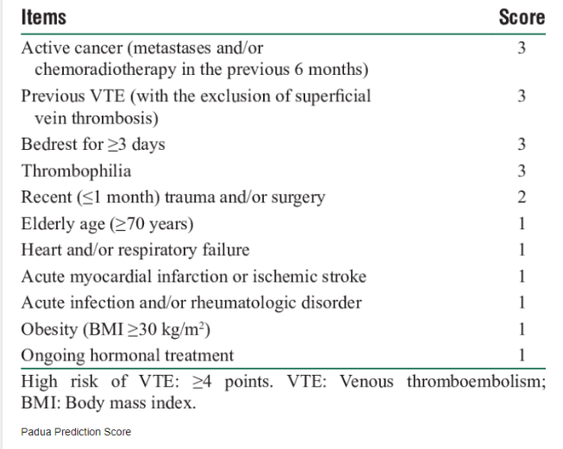

20. Routine Orders
Pathology | Not all patients need daily bloods. Assess need for bloods accordingly.  HITH uses hybrid EMR-paper system – blood tests are requested on paper. Do not order path on EMR as nurses cannot access that then to take bloods.  Make sure to write bed number of patient on pathology slip (in addition to BRAGMA).  Update the ‘Pathology Board’ on Teams with the date for each patient’s next blood test. . Pathology board is used by HITH liaisons to make allocations for the following day.
Radiology | Can order radiology on EMR as otherwise would for inpatient. Can tick outpatient box but then in special instructions, specify that pt is a HITH patient. If booking urgent Ix, important to ring radiography after booking scan on EMR and try finalise an appointment date and time.
Pharmacology | - HITH medications that the nurses are physically given (i.e. Clexane, Abx) need to be physically charted (on drug chart nurses can sign) but also on EMR (and subsequently suspended) to ensure accuracy of discharge summary  - EMR medications need to be SUSPENDED as the nursing staff administer HITH medications from paper charts. If a medication is not suspended, then EMR will keep giving notifications that the medication is due and needs to be signed off. All new meds charted (esp HF meds from VWR) need to be charted on EMR and then subsequently suspended afterwards (also make sure if it’s a dose change that the old previous dose medication is discontinued).  - Document any medication changes or new plans on EMR.  - Always check if patient has a Webster pack and let pharmacist know. A Webster pack may be a barrier to discharge over the weekend if medication changes are required, so always pre-empt the nursing home +/- Webster pack discharges over weekends  IV Antibiotics  - Require weekly bloods  - Note indication, end dates, and ID outpatient advice & ID guidance  - Some antibiotics need to be made up in a special bag by an external company & delivered to TNH; this sometimes takes 48-hours which may affect admissions –liaise with HITH pharmacist ASAP once details confirmed upon receiving a referral  - Vanc Levels in HITH are for continuous infusions, thus desired level is: 20-25  - Always add UEC to Vanc level Path Slip  Remdesivir infusions  - Loading dose (given by Inpatient team or in COMET clinic): 200mg  - Doses for Days 2 & 3: 100mg  - HITH Reg to chase baseline bloods (UEC & LFT)  Blood Transfusion in Nursing Homes  Must be attended at nursing home by HITH HMO for first 30 minutes to ensure nil transfusion reactions

21. IT Programs
EMR | The EMR is in use for documentation, medication ordering and radiology/pathology requests.  It is being used for all inpatients, as well as maternity clinics and pre-anaesthetic clinics.  Located in the intranet > My Favourite Links > EMR Live Environment  EMR Training courses are located on the LMS- https://mylearning.nh.org.au/login/start.php  Training is compulsory; you will need to complete the elearning within the first week of commencing.  Please contact medical workforce, or check the EMR website for more information on how to complete EMR training https://emr.nh.org.au/  When starting a new rotation, please reach out to Term Supervisor to ensure you are oriented to the EMR specific workflows for that unit as well.  EMR is NOT a primary communication system. Please use Medtasker and phones for referrals and communication.
CPF | The source of information for all outpatients’ clinics, investigations, GP referrals and scanned admission notes prior to September 2023.  Located in the intranet > My Favourite Links > CPF https://cpf.nh.org.au/udr/
PACS | XERO Viewer Pacs- https://nivimages.ssg.org.au/ or located in My Favourite Links, look for the CXR icon  This is where you can find radiology images
My Health Record | Centralised health record https://shrdhipsviewer.prod.services/nhcn
Safe Script | Monitoring system for restricted prescription medications https://www.safescript.vic.gov.au/

22. Documentation
Admission | Use the admission workflow on EMR  Info/Documents required for HITH admission:  - GOPC completed by home team – Try to get home team to do as isn’t HITH responsibility & HITH not the most appropriate to have these discussions. Will then fill out form as per home teams decision.  - Clear plans for follow-up especially whether ID needs to r/v prior to cessation of any IV Abx  - Home team Discharge summary  - HITH Reg and nurse r/v PRIOR to discharge -> if simple i.e. prevena or wound admitting doctors may not have to review – check with HITH Liaison Flow nurse.  - Drug chart (we complete this) and it only needs medications we are managing eg. Abx/ Frusemide etc. Clexane needs to be charted on medication charts regardless of if it is being self-administered or by HITH nursing staff  - Script – this does NOT need to include supply of clexane (if self-administered by patiens upon discharge from the ward) or IV Abx as pharmacy will supply off our drug chart. It does however need adequate analgesia etc for patient to self-administer  - Interim drug charts for NH patients  - Must be in our catchment area (refer to map)  - Medicare ineligible patients need to be approved by medicare ineligible team (this comes up relatively frequently)  - HITH Admission note in EMR within the current episode --> Print and put in folder  DIRECT ADMITS eg. Iron, blood transfusions, chemo disconnects, preop bridging clexane, remdesivir infusions  - Complete the relevant charts (i.e. iron infusion form + consent, warfarin chart, medication chart)  - GOPC forms – ideally home teams/ referrers should be completing, otherwise use the legal tab in CPF or ring the patient/ NOK to have discussion where possible (this is last resort as we have not met the patient before).  - HITH Admission note
Ward Rounds | Use the Handover sheet on Teams (“Pathology Board” = medical handover sheet)
Discharge Summary | Use the discharge workflow on EMR  Signing and submitting will send an electronic copy to the GP and upload to My health record
Outpatient Clinics | Correspondence from Outpatient clinics, prescriptions and investigations remain on CPF  HITH Outpatient clinic progress is documented on EMR
CDI Queries | To ensure accurate and comprehensive documentation in real-time, the Clinical Documentation Specialist (CDS) will identify any deficiencies in documentation in the healthcare record and will query these via Medtasker. These will show up as “CDI Query”. Please action these queries by documenting in the healthcare record. This can be done by documenting:  • on the next progress note (paper format), or  • on an electronic progress note in CPF by noting “CDI query response”, and/or  • on the discharge summary in CPF
Death Certificates | Death certificates are completed online.  https://www.bdm.vic.gov.au/medical-practitioners  Hard copies are to be printed out for the patient file/funeral director, in addition to the electronic submission. Print 2 copies, sign them, and save a PDF to the Teams folders (HITH Medical folder).
Coroners | Reportable deaths: Death certificates should not be completed if it is a Coroner’s case. This will require a phone call to the Coroner’s office followed by an e-medical deposition. It is important that the medical team identifies patients who will be reported to the Coroner ahead of time. Patients’ whose death is reportable will need to have a statement of identification completed by the next of kin, and attachments such as butterfly cannulas etc are left in situ. Any uncertainty about whether a death is reportable should be escalated to the consultant  https://www.coronerscourt.vic.gov.au/report-death-or-fire/reportable-deaths

23. Referrals
Internal | Referrals to specialist outpatient clinics are made electronically via e-referrals on CPF.  This includes HF HARP and HF Rehab – important to send these for relevant HF VWR patients (will be included in HF VWR plans).  Referrals to HF HITH need to be accepted by a HF team member – Registrar, NP, etc.  Referrals to General HITH (eg for vac mx, warfarin, etc) are sent to HITH Admissions Reg via Medtasker.
External

24. Clinical Deterioration
Escalation Process | Check GOPC
PreMet | Resident and registrar review
Code | Resident and registrar to follow standard procedures and discuss with consultant about transfer to acute medical unit

25. Night Shift Support
Unit | N/A
Periop | N/A
Take 2 @ 2 | N/A

26. Assessments: PGY1 & PGY2
All forms are located on the Northern Doctors website under the Assessments tab
Both HMOs and REGs must ask Dr Rabin Sinnappu to complete mid-term and end of term assessments
Beginning of Term | Meet with Term Supervisor to set learning goals for the term using the Term Description Learning Objectives as a basis for the discussion
Mid-Term & End of Term | To be completed at the mid and end of term meetings
EPAs | Minimum of x2 EPA assessments to be completed per term

27. Mandatory Training
- Mandatory Training is located on the LMS- https://mylearning.nh.org.au/login/start.php
- Mandatory training is compulsory and part of your contract with Northern Health and needs to be completed by the first month of your start date. If not completed you will come of the floor to complete.
- Hand Hygiene needs to be completed by the end of your first week.
- If you have completed the mandatory training elsewhere you may be able to apply for recognition of prior learning

28. Unit Education
- Grand Rounds - Thursday 8AM-9AM
- HITH education sessions – Will be informed of times/availabilities when booked (e.g. HF, warfarin, ECGs)

29. Unit Meetings
Morning handover: 08:30AM daily (including weekends).
- Beds 1-35 in Portable 6.
- Beds 36-80 in Portable 7 on weekdays, Portable 6 on weekends.

HF HITH handover: 11:00AM on weekdays, for Beds 1-35

HITH education: Will be informed of times/availabilities when booked, depending on staff availability

30. Research and Quality Improvement

31. Career Support
Discuss with head of unit

32. Medical Students on the Unit

33. Rostering
Shift Swap | The doctor initiating the roster swap is responsible for arranging with an appropriate colleague.  Once you have arranged a colleague to perform the swap, please email your MWU coordinator and cc in the colleague.  All swaps should be kept to within the pay period fortnight where possible. In exceptional circumstances where this cannot be achieved, please discuss with the MWU coordinator prior.  All shift swaps should be like hours for like hours.  Proposed shift swaps must be emailed to your MWU coordinator for approval.
Unplanned Leave- Notification and documentation process | Personal Leave documentation required:  For 3 single absences per year, the doctor will not be required to provide any supporting evidence to substantiate their personal leave.  For other days absent due to personal illness or injury the doctor is required to provide evidence of illness.  To be eligible for payment, the doctor is required to notify the Health Service two hours before the start of their shift, or as soon as practicable.  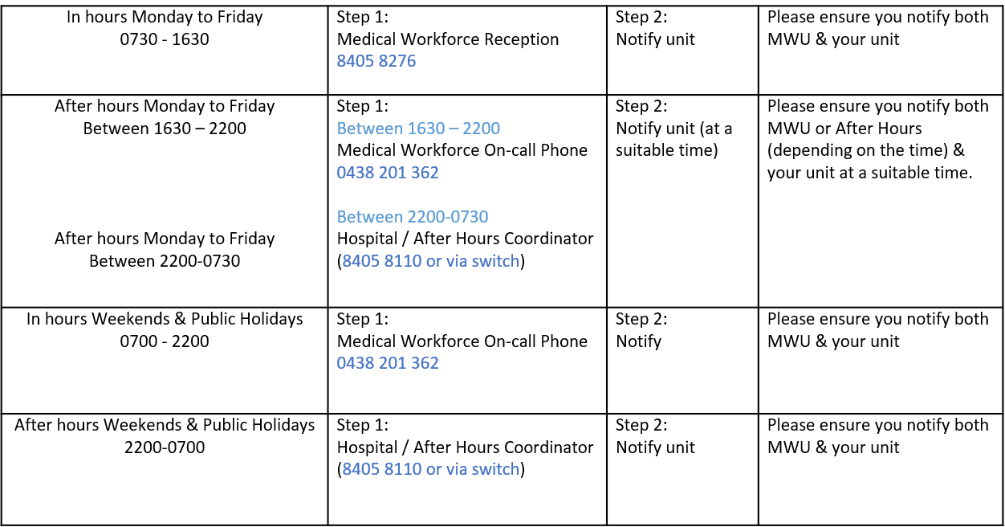
Overtime | All overtime should be submitted into the Overtime Portal  This can be accessed via the intranet whilst onsite at Northern Health  Please include the reason for your overtime- i.e. ward workload, delayed handover, include UR where relevant.

