9. Hospital Orientation
Hospital orientation occurs at the beginning of each term. Attendance is mandatory and paid non-clinical time.
This is separate to the unit orientation. Follow the link for details, password: NorthernDoctors
Location | NCHER, Northern Hospital – Epping | 185 Cooper Street, Epping 3076
Facilitator | Medical Education Unit | Email: MedicalEducationUnit@nh.org.au
Date | First day of each term
Start | 08:00

10. Unit Orientation
Unit Orientation occurs at the beginning of each term. Attendance is mandatory and paid time.
Orientation that occurs outside of your rostered hours should be submitted as overtime on the overtime reporting portal.
Location | Main Lecture Theatre, Microsoft Teams
Facilitator | Divisional Director, Senior Medical Registrar
Date | 1st or 2nd day of rotation  Given high turnover in HMOs, senior medical registrar or periop registrar will enquire if the resident is new to the role and provide a brief orientation
Start | 07:30 of first Tues

11. Unit Overview
Department | Medicine
Location | Various wards – Night cover HMO covers different zones (groups of wards)
Inpatient Beds | Variable, depends on each specially and general medicine unit
Outpatients Clinics | Nil
Day Procedures | Nil
Virtual Unit | Nil

12. Safety
Unit Specific Safety & Risks
Handover – ensure review of patients is documented on EMR and handed over to the day team where relevant. Ensure any outstanding tasks are handed over to the day time team via Medtasker. Attend the Take 2 at 2 meeting
Safe Prescribing
- Ensure all new patients’ usual medications are charted and refer to ‘Pharmacy Admission Note’ to check all medications are correctly charted
- seek help from registrar or pharmacist if uncertain.
- Look up all medications you are not familiar with
- Special consideration for the APINCH Medications; Antimicrobials, Potassium, Insulin, Narcotics (opioids) and sedative medications, heparin and other anticoagulants (chemotherapy not routinely prescribed in medicine)
- Ensure you use antibiotic guidance system for all restricted antibiotics
Falls – Identify patient with high falls risk, identify risk factor and implement high falls risk precautions
Delirium – Identify patients with delirium or at high risk of delirium, address the risk factors and ensure patients/staff safety
Pressure injuries – Identify the patient with high risk of pressure injuries
Infection prevention – ensure you follow all guidelines regarding isolation and wear appropriate PPE

13. Communication
Medtasker | Downstairs Med Wards HMO  Night Tower 1 HMO  Night Tower 2 HMO
WhatsApp | Night team AMT or periop registrar may create a group during the night shift
Pager | Downstairs HMO: pager 178  Tower HMO 1 Pager 236  Tower HMO 2 Pager 1316
MS Teams | This is not generally used by specialty night cover HMOs

14. Handover Process
Morning | Nigh cover handover tasks to the home team via Medtasker or phone  Also, for face to face handover:  - Downstairs HMO attends handover at 08:00 in AMT office  - Tower HMO 1 attends handover at 08:00 in ward 20 front office  - Tower HMO 2 attends handover at 08:00 in ward 20 front office
Afternoon | Not applicable
Night | Home team hands over tasks to night covers via Medtasker or phone  Also, for face to face handover:  - Downstairs HMO attends handover at 20:00 in AMT office  - Tower HMO 1 attends handover at 20:00 in ward 20 front office  - Tower HMO 2 attends handover at 20:00 in ward 20 front office

15. Shift Structure
 | HMO
Day | N/A
Afternoon | N/A
Night | 20:00-08:00
Weekend | 20:00-08:00

16. Shift Roles & Responsibilities
 | Downstairs HMO | Tower HMO 1 | Tower HMO 2
Day | N/A | N/A | N/A
Afternoon | N/A | N/A | N/A
Night | 20:00 login to Medtasker  Collect the pager  Handover from home teams in ward 3-4 office  Downstairs HMO covers the following:  renal admissions ward 4 + ED  renal ward cover - ward  ward 4 gen med cover  ward 3 pall care ward cover  heam /onc ward cover -ward 5  heam /onc ward cover admissions ward 5 + ED  ward 5 gen med ward cover  Assist with the workload of other night covers/AMT when possible  Handover to home teams at 08:00 via Medtasker, phone or face to face | 20:00 login to Medtasker  Collect the pager  Handover from home teams in ward 20 office  Tower HMO 1 covers the following:  resp ward cover - ward 20 + RCU  resp admitting - 20 and ED  neuro stroke ward cover - 21 + HDU  neuro stroke admitting  ward 20 gen med ward cover  ward 21 gen med ward cover  stroke calls  Assist with the workload of other night covers/AMT when possible  Handover to home teams at 08:00 via Medtasker, phone or face to face | 20:00 login to Medtasker  Collect the pager  Handover from home teams in ward 20 office  Tower HMO 2 covers the following  ward 22 gen med / COVID ward cover  COVID admitting if patient on COVID ward  gastro ward cover and admissions- ward 16 and ED  General medical ward cover - ward 16  Med outliers ward 18, 19, 13  Assist with the workload of other night covers/AMT when possible  Handover to home teams at 08:00 via Medtasker, phone or face to face
Weekend | Similar to weekdays | Similar to weekdays | Similar to weekdays

17. Common Conditions
You will see a great range of medical conditions in the general medical and other specialty patients. Many patients have multiple medical conditions. You will see lots of common conditions as well as some rarer ones in your term. Some common conditions you might see are:
● Exacerbation of CCF & its causes ● Other cardiac conditions AF NSTEMI
● Exacerbation of COPD, asthma and ILD
● Various Haematological conditions: Leukaemia, Lymphoma, Myeloma, cytopenia, post chemo complications
●Various Oncological conditions and post chemo complications
●Various neurological conditions such as stroke, Seizure/epilepsy, encephalopathies
● Various gastroenterological and hepatological conditions such as H&M, Hepatitis, H
● Diabetes and its complications
● Acute and chronic renal impairment ●Glomerulonephritis, Nephrotic and Nephritic Syndrome
● Delirium ● Falls and functional decline
● Respiratory infections including influenza and COVID 19 ● Fever in returned traveller
● Sepsis – Urinary, Cellulitis, Pneumonia, Prostatitis, Endocarditis, Epidural abscess, other
● Altered conscious state: Neurological: infection, stroke, post-ictal, Drugs, Metabolic, Accident/injury, Psychiatric, delirium
● Acute gout and other rheumatological conditions

18. Common Procedures
● Venepuncture/ IVC ● IDC ● ABG ● Lumbar puncture - done by Regs but HMOs can assist or perform if confident
● PICC lines - done by Radiology (always dual lumen!) ● Ascitic tap – done by registrar but can assist

19. Clinical Guidelines
The My Favourite Links page on the intranet contains the links to a number of useful clinical guidelines https://intranet.nh.org.au/applications/
ETG- Electronic Therapeutic Guidelines
AMH- Australian Medicines Handbook
Up to Date
“For Clinicians” Header on the intranet Home page – has a range of commonly used resources used by doctors
PROMPT- This site contains the hospital policy and procedure manuals. It can only be accessed from the intranet - https://intranet.nh.org.au/departments-and-services/prompt-policy-procedures-guidelines/prompt-policies-procedures-and-forms/

20. Routine Orders
Pathology | There are no routine order sets in general medicine/specialty medicine. Order sets will depend on the condition and the current patient assessment.  Check that bloods like TSH iron HBA1c has not been ordered recently prior to ordering them again
Radiology | CT should be discussed with registrar / consultant  MRI should all be discussed and approved by your consultant  Once you have submitted a CT/ US or MRI request please check the EMR Radiology Order Management System to check that the scan has been approved. If it states ‘for discussion’ then radiology needs more information and you will need to go down and discuss that test with the radiographer/ radiologist
Pharmacology | See - Safe prescribing section in Safety section of this handbook  Periop registrar or On call pharmacist is there to help you please check with them if you are uncertain  Look up all drugs that you are not familiar with and check doses if uncertain  Ask periop registrar, home team on call registrar or consultant if not sure if you should continue or withhold medications  Warfarin dosing should be done in consultation with your registrar  Please refer to the anticoagulation stewardship pharmacist or haematology team for patients with complex anticoagulant regimens

21. IT Programs
EMR | The EMR is in use for documentation, medication ordering and radiology/pathology requests.  It is being used for all inpatients, as well as maternity clinics and pre-anaesthetic clinics.  Located in the intranet > My Favourite Links > EMR Live Environment  EMR Training courses are located on the LMS- https://mylearning.nh.org.au/login/start.php  Training is compulsory; you will need to complete the elearning within the first week of commencing.  Please contact medical workforce, or check the EMR website for more information on how to complete EMR training https://emr.nh.org.au/  When starting a new rotation, please reach out to Term Supervisor to ensure you are oriented to the EMR specific workflows for that unit as well.  EMR is NOT a primary communication system. Please use Medtasker and phones for referrals and communication.
CPF | The source of information for all outpatients’ clinics, investigations, GP referrals and scanned admission notes prior to September 2023.  Located in the intranet > My Favourite Links > CPF https://cpf.nh.org.au/udr/
PACS | XERO Viewer Pacs- https://nivimages.ssg.org.au/ or located in My Favourite Links, look for the CXR icon  This is where you can find radiology images
My Health Record | Centralised health record https://shrdhipsviewer.prod.services/nhcn
Safe Script | Monitoring system for restricted prescription medications https://www.safescript.vic.gov.au/
Antibiotic Guidance | iGuidance in My Favourite links (Pharmacy will only supply one day unless this is done)  Some antibiotics you can get guidance by selecting the condition. Otherwise you will have to refer to ID, explain rationale behind ABx choice/ ask for their opinion and they do the guidance.
Other | Interpreter via phone: 84058188  Endoscopy results: on the CPF patient screen – endobase. Username: endobhs. Password: endobhs  Echo and angio results: Phillips Xcelera. Username and login same as CPF

22. Documentation
Admission | Use EMR admission form
Ward Rounds | Not applicable
Discharge Summary | EMR discharge summary workflow – please use this format as this will generate upload to Myhealth record and fax to GP when completed
Outpatient Clinics | referrals via referral on CPF (no EMR option for referrals)  Outpatient notes are all documented on CPF under the outpatient tabs
CDI Queries | Will be sent via Medtasker
Death Certificates | Discus with home team on call registrar/ consultant or periop registrar re if coroners’ case and if not then cause of death before completing, Link is direct via Births Deaths and Marriages. Link – Death Certificates on the Favourite links page or https://www.bdm.vic.gov.au/medical-practitioners
Coroners | Discuss every death with home team on call reg/ consultant or periop registrar to check if it should be coroners. If uncertain then call to speak to a delegate from the coroner’s office and document your conversation in EMR notes. Coroner deposition is done via - E Medical Deposition Form  https://coronerscourt.vic.gov.au/report-death-or-fire/how-report-death

23. Referrals
Internal | For specialty referral overnight first discuss with periop registrar and if necessary, periop registrar or HMO need to contact on call registrar/consultant  For surgical referrals: contact via communications. Please make referrals as early as possible in the day and know what question your unit is asking of them (if uncertain speak to your unit registrar)  Outpatient referrals – CPF – Summary tab – bottom right of the page is ‘Submit internal referral’ link
External | Ad hoc no frequently used pathways

24. Clinical Deterioration
Escalation Process | HMOs can escalate tasks to periop registrar (for patients in tower), AMT2 registrar (for patients in ED/downstairs) and or on call registrar/consultants.  Call MET call or code if patient meets these criteria and needs urgent review
PreMet | HMOs will answer these but seek advice from Periop/AMT2 registrars if necessary
Code | Attended by cover HMOs and periop registrars and wider hospital code teams

25. Night Shift Support
Unit | For Night Cover HMO: Periop/AMT 2 registrar assists with complex patients.  Ward Med patients: Consultant for Med 1-5 or Specialty med patients: call the Registrar/consultant on call for the specialty through switch  When unable to get through to above or extremely challenging situations – ask for Med Exec on call through switch
Periop | Contact 0418 428 781 or via Medtasker  Attends MET calls and codes.  AMT registrar attends MET Calls and codes for the patients under AMT bed card in ED
Take 2 @ 2 | Night HMOs and registrars attend this meeting. A brief huddle run by the ICU night clinical lead. Come along! Especially if you are busy (now a face to face meeting in ICU meeting room – Ward 17) idea is to flag if your busy and help redistribute workload. You can also flag patients you are concerned about at this meeting.

26. Assessments: PGY1 & PGY2
All forms are located on the Northern Doctors website under the Assessments tab
Beginning of Term | Meet with Term Supervisor to set learning goals for the term using the Term Description Learning Objectives as a basis for the discussion
Mid-Term & End of Term | To be completed at the mid and end of term meetings
EPAs | Minimum of x2 EPA assessments to be completed per term

27. Mandatory Training
- Mandatory Training is located on the LMS- https://mylearning.nh.org.au/login/start.php
- Mandatory training is compulsory and part of your contract with Northern Health and needs to be completed by the first month of your start date. If not completed you will come of the floor to complete.
- Hand Hygiene needs to be completed by the end of your first week.
- If you have completed the mandatory training elsewhere you may be able to apply for recognition of prior learning

28. Unit Education
General Medicine Journal Club Tuesdays 07:30 to 08:30
Medical Grand Rounds Thursdays 08:00- 09:00 – lecture theatre or Teams
Protected HMO teaching Thursdays 12:30-1:30 Lecture theatre or Teams
BPT registrar Education – 1300- 1400 Friday Conf room 4 and Teams
BPT consortium clinical/ written exam education lecture series – 1600- 1700 Wed
BPT clinical exam prep programme – see consortium website for more details

29. Unit Meetings
Nil

30. Research and Quality Improvement
If you are interested in research please speak to your unit head to see how you can get involved.

31. Career Support
Divisional Director Medicine Dr Yana Sunderland
Basic Physician training - Directors of Physician Training – Edwina Holbeach, Yana Sunderland, Mueed Main, Vinita Rane
Basic Physician training - Consortium Manager – Laura Ivins

32. Medical Students on the Unit
Medical students do not have night rotations

33. Rostering
Shift Swap | The doctor initiating the roster swap is responsible for arranging with an appropriate colleague.  Once you have arranged a colleague to perform the swap, please email your MWU coordinator and cc in the colleague.  All swaps should be kept to within the pay period fortnight where possible. In exceptional circumstances where this cannot be achieved, please discuss with the MWU coordinator prior.  All shift swaps should be like hours for like hours.  Proposed shift swaps must be emailed to your MWU coordinator for approval.
Unplanned Leave- Notification and documentation process | Personal Leave documentation required:  For 3 single absences per year, the doctor will not be required to provide any supporting evidence to substantiate their personal leave.  For other days absent due to personal illness or injury the doctor is required to provide evidence of illness.  To be eligible for payment, the doctor is required to notify the Health Service two hours before the start of their shift, or as soon as practicable.  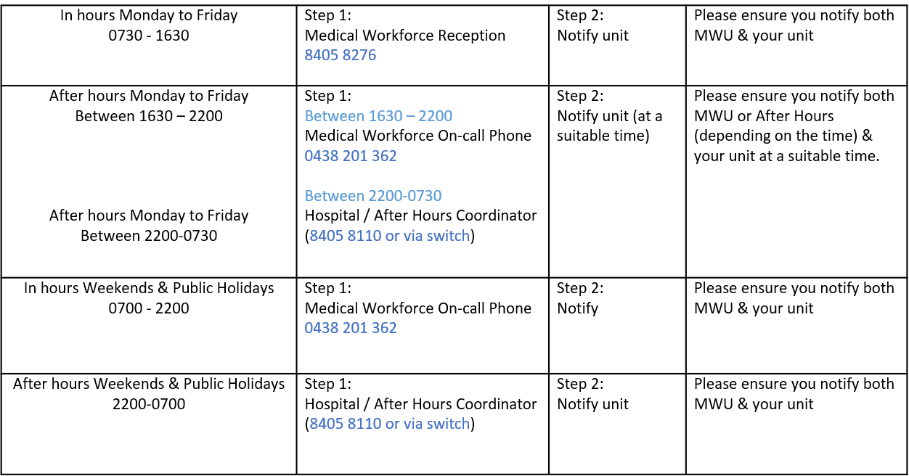
Overtime | All overtime should be submitted into the Overtime Portal  This can be accessed via the intranet whilst onsite at Northern Health  Please include the reason for your overtime- i.e. ward workload, delayed handover, include UR where relevant.

