
ROVER (Rolling handOVER) – I am a ‘living document’ that needs your care and attention

ROTATION: Emergency Department
UPDATED BY: Jess Kamphuis CONTACT: jessica.kamphuis@nh.org.au DATE: 11/01/23
REVIEWED BY: CONTACT
! Please update me as required and send me to fathimaijaza.lafeer@nh.org.au in week 8 of this rotation

Topics Covered in this ROVER
- Checklist for new starters and hot tips
- ED Allocations
- Using EDIS
- Staff in ED and Geography of ED
- JMO roles and responsibilities
- Common procedures
- Clinical Documentation in Medtasker
- Useful tips and resources

CHECKLIST FOR NEW STARTERS
- Obtain username and login for EDIS (see admin staff upstairs)
  - Enter your username on EDIS to identify which patients you have clerked so nurses & other staff know to find you if there are any questions regarding your patient
- Ensure you have swipe card access to ED upstairs (tearoom, lockers, bathroom)
  - See security outside ED in waiting area if not
- You will receive an ED orientation on the first day and there is prior online orientation that will be sent to you by email.
- You will receive an email from Dr Stefan Herodotou (ED Intern Supervisor) letting you know which consultant you’ve been assigned as your personal supervisor. Make yourself known to this consultant early in the term and get their contact info so you can get in touch with them for your intern assessment at the end of the rotation.
HOT TIPS
- Take breaks at regular meal times as it is your right, 30 minutes is usually the accepted amount of time. Let your consultant know when you are going and when you are back
- If any is giving you grief in the hospital e.g registrar not accepting a referral, let your consultant know early! They are usually very supportive and will back you up.
- It will take a good 2-4 weeks to feel comfortable in ED, don’t stress!
- DO NOT pick up a new patient in the last hour of your shift to make sure you get out on time! Tie up any loose ends and make sure CPF notes are up to date. Help nurses with bloods to fill the time if you are free – they will appreciate it
- Document every encounter with specialties on your CPF note including a time stamp and the name of the reg you spoke to
- At time of writing (11/01/23), SSU interns working the morning shift can usually leave a bit earlier than 1730 if it is not too busy
- This ROVER covers a lot, and you are not expected to remember it all! You will pick it up along the way ☺

Allocations
At the beginning of your shift you will be assigned to a particular area of ED. As an intern you will generally be assigned to Admissions (blue), Assessments (purple), Waiting Room (also purple – nurses station near the front of the ED), Fast track (green), or SSU. Most commonly you will be assigned to Assessments or SSU.

WAITING ROOM
Your work station is near the front of the ED, close to the triage cubicles.

Often nurses have already seen the patient, taken bloods +/- administered analgesia or antiemetics +/- completed an ECG/VBG, then placed the patient back into the waiting room. They will keep them in a cubicle if the patient looks very unwell or received a medication like diazepam. When you pick up a patient, check the patient folders on the wall to see the triage history, their obs, FWT, and what medications have been given, then check CPF to see if bloods have come back. Nurse initiated bloods often include FBE, lipase, LFTs, UEC, CRP. Sometimes they will add a troponin or D-dimer if the presentation is very suspicious, signed off by someone else.

When you pick up a patient from the waiting room, assess them in one of the nearby cubicles reserved for the waiting room staff. The triage notes in the patient folder will also guide your history and examination. Present your findings to a consultant or senior reg assigned to the waiting room and suggest your impression alongside any further medication/imaging/bloods/referrals needed. If the patient looks well enough, pop them back in the waiting room to await results to keep the cubicles free.

Waiting room patients are usually more straight-forward than Assessment or Admissions patients, and are more often discharged home with GP follow-up. If their length of stay will be >4 hours e.g. because you are waiting for a referral or radiology, consider referring them to SSU if they meet SSU criteria.

Your EMRG Summary is their discharge summary if they are going home. Print two copies – one for them, and one to leave in the patient folder. If they require outpatient clinic follow-up, you can do the referral on CPF as usual. Once the patient is discharged, leave the patient folder in the tray labelled “Discharges”.

Regardless of whether you are assigned to Waiting Room, Assessments, Admissions, or SSU, keep the patient’s nurse (seen on the EDIS screen) updated on the plan. Also flag major changes to the NUM for each area, who is often at the NUM computer in each area.

Assessments
Assessments are similar to Waiting Room, except that patients already have a cubicle in the ED (in the purple area) and are often more unwell than waiting room patients. Check the patient folders, which will be scattered across the nurse’s stations. Check CPF for investigations and previous presentations, take a history and examination, talk to the patient’s nurse, present to the consultant/senior registrar, and order bloods/imaging/referrals.

Note that it is often worth sending off a blood gas and a purple, blue and gold tube of blood early with a very simple request slip (FBE/UEC/CRP) to get these basic bloods back as soon as possible. This will help to expedite referrals – many teams will not appreciate you referring with basic bloods still pending. Try drawing the blood while you take the history to save time). You can add on anything else you need later.

The extensions/pager of many teams are on charts glued to the desks of every nurses station. Particularly relevant teams/staff in ED to make a referral to include AGSU for surgical presentations, Acute Medical Team (AMT), ED physiotherapist, ED pharmacist, Emergency Mental Health (EMH), and the discharge coordinator.

HOT TIP: download Med App which has a directory of all the important extension numbers at the Northern. You can also find a list of helpful phone extensions on the intranet homepage → Emergency Department Tab → Phone Directory

AMT - Any medical admissions onto the ward go through AMT. Sometimes, patients are referred directly to BHS medical units and do not go through AMT (ask your supervising consultant if you should refer AMT or directly to BHS – it depends on patient complexity and bed availability)

Discharge coordinator/ED nurse navigator (Felicity) – Extremely helpful when you are wondering if the patient is safe for discharge in terms of support at home. Often relevant for elderly patients with reduced ADLs, living alone, multiple comorbidities, polypharmacy, etc.

SSU – The numbers of the SSU consultant and SSU NUM are pasted above many computer monitors. If a patient is not acutely unwell and does not require an admission under medical/surgical/psych, they can often be referred to the Short Stay Unit (SSU) to await results, review by other teams etc. Call the number for the SSU consultant and if accepted, remember to make a bed request on EDIS for SSU. SSU can accept covid positive (well) patients, but does not accept patients who need contact isolation (e.g. diarrhoea)

EOU – contact numbers for this consultant and nurse in charge are also pasted on most of the computers. EOU patients are similar to short stay (need somewhere to stay while they await a result or receive a treatment) but are usually more complex. Patients with COVID cannot go to EOU, but EOU will accept patients who need contact isolation beds.

EMH – Most psychiatric presentations warrant an EMH referral. EMH consists of mental health staff members e.g. social workers and psychiatric nurses, who specifically assess ED patients presenting with mental health concerns. They are busy and may take some time to arrive. If the patient is low risk, they could be referred to SSU. Do not refer if you have concerns about risk to self or others.

Frequent ED presenter plans are helpful documents. If you can see multiple recent admissions under the Emergency tab, check the Emergency tab for a frequent presenter plan. This is a comprehensive document which guides management and includes a full history of the patient’s recurring presentations.

When a patient is accepted and admitted under a team, they may stay in Assessments/Admissions until a bed becomes available. You can still keep an eye on your patient, but if the admitting team has written an admission note, they should be contacted if the nurses have any questions or about investigation findings and management decisions.

Admissions
Admissions is again similar to Waiting Room and Assessments, with patients already assigned cubicles. They are sometimes more unwell and have been transported by AV or sent straight from triage.

Admissions includes Resus 1-5, which you will usually not be assigned to as an intern. These patients are often unstable, in isolation, or have an acute psychiatric presentation requiring sedation. If a code occurs, the ED resus team assigned during handover will arrive and the patient is transported to resus if required.

Note that in ED (except for SSU), you do not call 444 for a MET call. Just find the closest registrar/consultant (there will always be many present), or call the MET call over the loudspeaker. If you press the emergency buzzer in the patient cubicle e.g. for code blues or seizures, the ED resus team will arrive.

The patient folders for Admissions are at the desks outside each cubicle.

There is a formal handover at 8:30 AM and again at 11 PM, where the doctors will round across the admissions cubicles to handover to the new staff. If you have a patient in one of these cubicles, join the round to present your patient and their plan.

Short Stay Unit
The intern is assigned to the smaller half of SSU (beds 15-23). This section is intended for patients who are expected to have a shorter stay in SSU with simpler presentations and good flow (although it doesn’t always work that way!) Patients admitted to SSU should arrive with a plan, and your job as the SSU intern into implement the plan.

At the start of your shift, print a handover sheet of patients from the bed management portal and obtain a handover of each patient and a list of jobs.

If you start at 8 AM, there is a formal round from night cover to the consultant and you. A second intern will arrive at 2 PM for handover and any assistance with jobs.

If you start at 2 PM, you receive handover from the morning intern, then have a consultant ward round at 3PM when they change over, then handover in a formal round to night cover at 11 PM.

As the SSU intern, your role is to review the history/examination on the EMRG summary, complete jobs in the patient’s management plan, chase the outcome of referrals already made in ED, refer the patient to a team yourself, or discharge depending on findings. If a team accepts a patient for admission, inform the NUM and ward clerk, who will change the bedcard. If you’re unclear on any plan or follow-up, never be afraid to check with your consultant.

After they have been admitted under another bedcard, the patient’s management falls under that team and they only stay in SSU until a bed on the ward becomes available. The patient is primarily managed by that team and not you. In some cases it is best to advise the patient’s nurse to medtasker or page the team for any queries e.g. fasting and medications, because you will usually not receive a handover for patients who are no longer under the SSU bedcard.

Extended Observation Unit
Similar to SSU but for patients who are slightly more unwell/high risk. Can accept patients with diarrhoea/vomiting but does not accept covid patients. Interns do not work in EOU at the time of writing (Jan 2023).

EDIS OVERVIEW
To view the patients in your area on EDIS:
- Open EDIS
- Click on ‘patient tracking’
- At the top of the screen, select your area from the drop-down menu (e.g. ‘fast track’ or ‘assessment’)
- At the bottom of the screen, tick the box that says ‘all patients’
Note that SSU and EOU patients are not listed on EDIS -you can view these patients on CPF under the unit code ‘SSU’.

Other tips for navigating EDIS:
- Click ‘Dr/Rn Logon’ and enter your EDIS code to pick up a patient.
- Click ‘Handover’ to re-assign the patient to a new doctor when your shift is ending or take over a patient.
- Click ‘Clinical Comments’ to add brief patient updates to the EDIS screen e.g. ‘awaiting bloods’ or ‘admitted under AGSU’.
- Click ‘Bed Request’ when your patient is accepted by another team/bedcard – whether this is SSU, medical, surgical, BHS, etc. Click as soon as they are accepted. The hospital is penalized for ED patients with a LOS of >4 hours who are not discharged or placed under another bedcard. Patient safety is first priority, but try to click bed request or discharge from EDIS as soon as practical.

To discharge a patient, double click the row with the patient’s name on EDIS and a new screen will pop up (third image below).
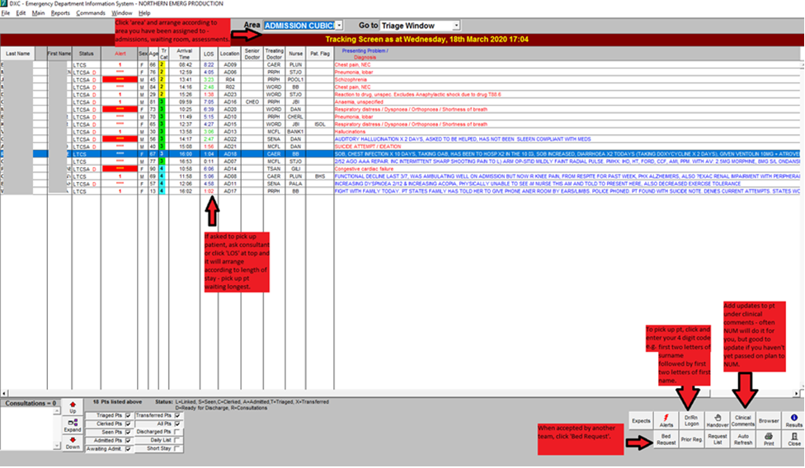

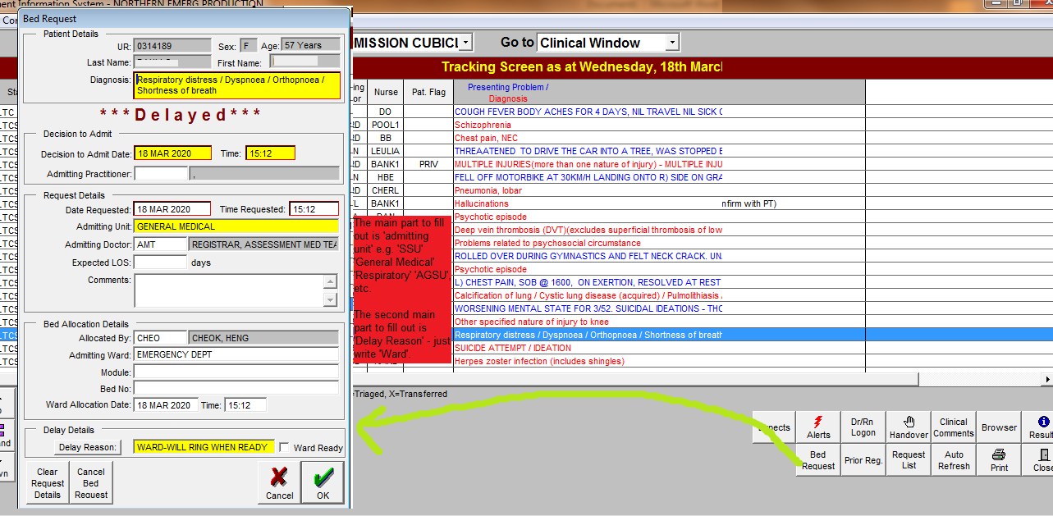

Below is the box which appears when you double-click the patient name to discharge. You only need to fill out the yellow boxes. For departure ready/actual departure, click ‘Now’. When you click ‘Close’ after filling all the boxes, the patient will disappear from the EDIS screen.
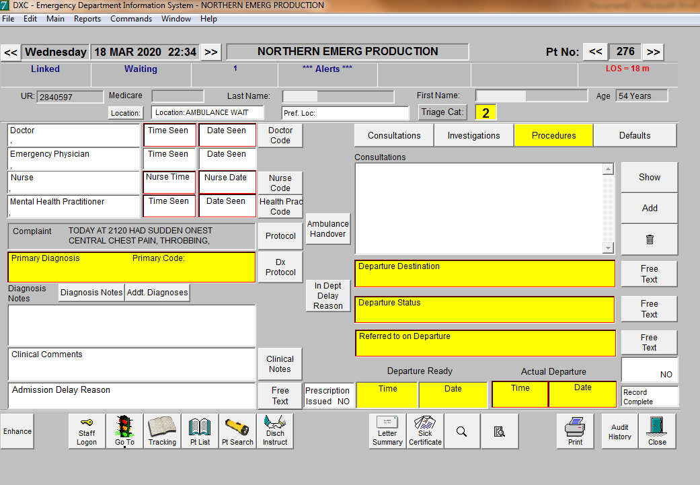

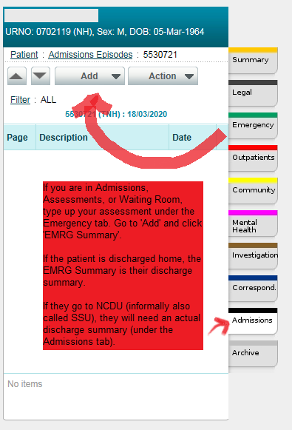

STAFF
UNIT STAFF & KEY CONTACTS | CONTACT DETAILS
Head of Unit: Nancy Sadka / Deputy: Heng Cheok | Office upstairs in ED
Consultants: changes every shift | N/A
Registrar: changes every shift | N/A
HMO/Resident: changes every shift | N/A
ED NIC: changes every shift | x52609
ED/SSU Pharmacist | x52696

GEOGRAPHY
ITEM | LOCATION
Home ward | Red – resus  Blue – complex admits (admissions)  Purple – complex assessments (assessments)  Green – simple assessments (fast track)  Yellow – paediatrics (no interns)  SSU (short stay unit)
Morning meeting point | Upstairs in teaching room or tea room for morning shifts to receive pod allocation for your shift  There are lockers upstairs above ED
Patient list | Interns do not get morning handover of patients from other doctors. You start seeing patients.  Registrars and Consultants do a morning handover of allocated areas (interns are not involved in this)  SSU ward lists are printed from Health Power (use your normal login & password as per followme or kindly ask you ward clerk/NIC)
Handover | If in Assessments, hand over to the new consultant or night cover with the plans. You are not allowed to handover to another intern or HMO, although occasionally after handing over to the consultant they will ask you to handover to an HMO to help complete any outstanding jobs.  It is not wise to pick up another patient in the last hour of your shift. Instead make sure your existing patients have plans, medications charted, and any transfer paperwork to SSU/OAU/inpatient team. Make sure you have completed your notes on CPF and checked any pending results.

WEEKLY TIMETABLE
Mon | Tue | Wed | Thu | Fri | Sat | Sun
0800  Handover  (Meet in tea room upstairs)  15:00 SSU Handover  23:00  Handover | 0800  Handover  1230-1330  Intern Education  LT  15:00 SSU Handover  23:00  Handover | 0800  Handover  15:00 SSU Handover  23:00  Handover | 0800  Handover  12:30-13:30  HMO Education  (mandatory for HMO2s and 3s)  LT  15:00 SSU Handover  23:00  Handover | 0800  Handover  15:00 SSU Handover  23:00  Handover | 0800  Handover  08:30  ED HMO teaching  15:00 SSU Handover  23:00  Handover | 0800  Handover  08:30 ED HMO teaching  15:00 SSU Handover  23:00  Handover

Handover/consultant ward round
- Handover in the morning starts in the upstairs tearoom at 08:00
  - Don’t be late! This may only take a few mins as consultants assign you to an area & then the formal handover/round occurs on the floor
  - Generally you will be assigned to purple, blue or SSU. But sometimes you will be asked to help out on green.
  - Morning consultant rounds vary depending on the consultant on for the shift, but they are usually pretty quick. You may be assigned some of the overnight patients however this is uncommon for interns
- Consultants changeover at 3.30pm and there is another handover between the consultants of the department
- Evening handover occurs at 23:00
  - Night shift staff will come and find the consultant on the floor.
  - Night staff consists of Registrars and HMOs
JMO ROLE & RESPONSIBILITIES
- Hours:
  - You will either work 8am – 5:30pm or 2pm – 11:30pm.
  - You work 4 shifts a week (38 hours) and have 3 days off per week.
  - You usually get out on time, but might have to stay back 15 mins to finish up handovers or make last minute referrals but they are pretty good at handovers.

- Start of shift:
  - Handover for morning shift is at 8am and afternoon shift hand over is at 2pm, both in the office upstairs. Make sure you are on time. You’ll receive allocations at this time
  - There is usually a printout of the allocations as well on the notice board near the printer room/behind the purple pod nurse desk.
  - Consultants are very happy to accommodate allocation swaps. There is no-one tracking how often you have been allocated to a particular area, so if you find you have been in the same area for several consecutive shifts just tell the consultant and they will try to vary things for you.

- Clerking patients:
  - Some consultants will tell you which patients to see, others will be happy for you just to pick up whoever has been waiting for the longest
  - After seeing your patient, discuss your assessment & plan with the consultant ALWAYS.
  - MRI forms need to be co-signed by a consultant
  - Keep your consultant and the NUM for your unit updated on your patients.
  - If your patient is in the waiting room, you can see them in the assessment cubicles (35 to 40), triage cubicle (remember to ask the triage nurse first!!), the plaster room or the procedure room → then bring them back to the waiting room once you have finished your assessment if they are stable. If you think the patient will need to be admitted/should have a bed, let the nurse in charge know so they can try to arrange it.

- Discharging patients
  - You will need to either write a discharge letter on EDIS OR print off your ED summary as a discharge letter (much easier)
    - In EDIS, double click on your patient → click ‘clinical’ tab → click ‘letter’ → click ‘edit’
    - Remember to type in the top box only, otherwise if you exit the window the changes will not be saved
    - alternatively, complete your ED summary on CPF with diagnosis, plan and letter to GP
    - ALWAYS PRINT OUT 2 COPIES - one for the patient and one for our records.
  - If you printout the ED notes to give to the patient as a discharges ummary, bear in mind that sometimes your notes will contain information you would ratherthe patient or theircarerdoesnotread (e.g. allegations regardingfamilyviolence). If you need to document thisinformation, you have two options:
    - Documentitinthe patient’s ED Summarynotesand, when theyaredischarged, writeadischargeletterinEDIS as above
    - Documentthesensitive information in aseparate’consultation note’ in the emergencytab in CPF, so that youcan still giveyour patientan ED summary printout asadischargeletter (again, much easier)
  - To discharge a patient, you need to fill in all the yellow boxes on theirclinical profile inEDIS (principal diagnosis, procedures, discharge destination, follow-up, discharge ready time andactual dischargetime)
    - Once all these sections are filled, your patient should disappear from the EDIS list when you press ‘close’

- SSU/CDU
  - Short stay unit – acts as an interim ward where patients from main ED go for things like awaiting results (second troponin, CTB, etc.), allied health review in the morning for vertigo patients, etc.
  - If patients are to be discharged in CDU, you will need to write a discharge summary on CPF, do discharge medications as well as organise any outpatient referrals and investigations.
  - In SSU you can use the emergency summary, edit it with short stay progress at the bottom and print out the letter
  - There will generally be one resident and one intern allocated to SSU per shift. The intern will take the patients in the smaller section of SSU (beds 15-23); usually (but not always!) your patients are a bit simpler than the other side
  - Try to keep your ED Summary up to date as things happen throughout each patient’s admission. You will be thankful in a few hours when you have multiple people ready for discharge at once

- Referrals
  - Psych pts: contact EMH (x52055) after taking a brief hx & assess suicide risk
    - They often have heaps of people to see so better to get your patient on their radar ASAP
    - - if a person has any suicidal intent, they MUST be reviewed by EMH before discharge
  - General medicine: contact acute AMT registrar on x
    - Once you have spoken with them make a bed request on EDIS
    - if the patient is in SSU then the medical referrals go to the Med3B registrars
  - Special medicine: contact the appropriate registrar
    - Page during normal hours or call the on-call registrar (or on-call consultant for some specialties – switch will know) if out of hours
    - If it is out of hours and the referral is accepted, contact special med cover (p284) to do the admission paperwork
  - General surgery: contact AGSU (x52628) during both normal & out of hours
  - Special surgery: contact appropriate registrar (through switch)
    - Neurosurgery referrals generally go to St. Vincent’s, though you can also ask for advice from RMH if the question is trauma-related. ENT and maxillofacial surgery referrals generally go to Austin. You will need to transfer images (Hub and Spoke) so that they can review them (radiographers can help you, even overnight)
    - Ophthalmology referrals go to the Royal Victorian Eye and Ear hospital
  - SSU: contact the SSU consultant (x52562) then fill out the relevant SSU pathway (folder found on desktop on ED computers or search in intranet for "SSU Adult" and click)
    - If medical pts fail SSU refer AMT
    - If surgical patients fail refer AGSU

- Teaching:
  - After morning handover every Thursday and Friday
  - Try and get to as many as you can because they are useful.
  - Sometimes if it is really busy and if staff have called in sick, you may not be able to go.

PRESENTATIONS COMMONLY ENCOUNTERED

- Chest pain +++++
- Shortness of breath ++++
- Abdominal pain +++
- Trauma/MVA
- Mental health +
- Lower back pain
- Falls +++
- Dizziness/vertigo
- Headache/migraine
- PV Bleeding + (esp in early pregnancy)

PROCEDURES COMMONLY ENCOUNTERED

- Cannula/venepuncture +++
- IDC
- Suturing +
- Plastering +
- Lumbar puncture
- Joint aspiration

INSIDER INFORMATION & MISCELLANEOUS TIPS

- If you need help with plastering, the physio that works in fast track can also help
- Investigations
  - During normal hours (8am - 7pm), drop x-ray requests at the ED x-ray room (near green). Out of hours x-ray needs to be dropped off at the main radiology department.
  - Bloods take ~1-2 hours to come back
  - Out of hours CT & MRIs are reported externally (Everlight or HIS radiology) → reports will be faxed through to the photocopier behind the purple waiting room nurse’s station Dictated/interim reports can be found on the program IRIS
    - Available on the computer next to the purple pathology chute or the SSU computer next to the telemetry screen
    - if the report is concerning the radiologist should call to deliver the report verbally
  - For interim ultrasound reports, find the sonographer’s worksheet in their office. The worksheet should also be scanned onto the radiology computers. Do not take the sonographer’s worksheet out of the office – photocopy it, and take only the copy with you
- Lists of useful numbers are stuck on the workstation desks everywhere

USEFUL RESOURCES
- Emergency Department Tab on the Intranet homepage
  - Particularly useful as it contains a Phone Directory for contacting different specialties
- ED Clinical Resources folder on the desktop of all ED computers
  - Contains fact sheets about common conditions encountered in ED
  - Created by our ED consultants, especially Dr James Hayes- they are awesome!
- ED registrars & residents
  - They are generally very friendly and happy to help you
- Life in the fast lane (online)
- ED consultants - just ask if you don't know!
- MDCalc – consultants love an EDACS, PERC, Wells, pneumonia severity score

