9. Hospital Orientation
Hospital orientation occurs at the beginning of each term. Attendance is mandatory and paid non-clinical time.
This is separate to the unit orientation. Follow the link for details, password: NorthernDoctors
Location | NCHER, Northern Hospital – Epping | 185 Cooper Street, Epping 3076
Facilitator | Medical Education Unit | Email: MedicalEducationUnit@nh.org.au
Date | First day of each term
Start | 08:00

10. Unit Orientation
Unit Orientation occurs at the beginning of each term. Attendance is mandatory and paid time.
Orientation that occurs outside of your rostered hours should be submitted as overtime on the overtime reporting portal
Location | ED, Level 1 offices
Facilitator | Keith Amarakone
Date | First Monday of each term
Start | Returning resident 0830 (after handover); New staff – after hospital orientation

11. Unit Overview
Department | Paediatric Emergency Department
Location | Emergency Department
Inpatient Beds | N/A
Outpatients Clinics | N/A
Day Procedures | N/A
Virtual Unit | N/A

12. Safety
Unit Specific Safety & Risks
- Identification of the sick patient – one of the core skills of emergency medicine is rapid identification of the seriously unwell patient. It is expected that when you recognize a sick patient that this escalated early to either the registrar or consultant (even if your history / examination is incomplete).
- Paediatric drug dosing - great care is required in prescribing and administering paediatric medications. It is expected that doses are checked against an approved resource when prescribing. You may administer simple oral medications to children (e.g. paracetamol / ibuprofen / ondansetron) during your term but even these require a double check with another staff member.
- COVID precautions – the ED (and other critical care areas) may have different COVID precautions to the rest of the hospital based on current epidemiology, and the processes are subject to change as new information arises. Please check with the ANUM / senior medical staff if you are unsure of what PPE you should be using or where COVID / SCOVID patients should be examined.
- Minimising patient distress / discomfort is one of the key priorities for the paediatric ED. This means you will be required to perform procedures (including IV access / venipuncture / NGT insertion / catheterization / application of a cast) under the supervision of a registrar / consultant at the commencement of your term.
- Clinician well-being – because there is always another patient waiting, it is sometimes easy to neglect your own well being. It is important every shift to take a break and have a meal, and if you are struggling to do so please let the consultant / registrar know so they can assist with your workload.

13. Communication
Medtasker | Paediatric medical team
WhatsApp | Other junior and senior medical staff in the Paeds ED (for non-urgent communication only)
Pager | Paediatric medical team (if not responding to Medtasker)
Phone | In patient surgical specialties (e.g. AGSU who manage paediatric surgical patients, ortho, plastics etc)
MS Teams | Teaching sessions

14. Handover Process
Morning | Initial meeting Level 1, ED offices, followed by Paeds ED handover in Yellow pod
Afternoon | N/A
Night | Yellow pod

15. Shift Structure
 | Intern | HMO | Registrar
Day | N/A | 0800 – 1730 | 0800 – 1730
Afternoon | N/A | 1400 – 2330 | 1400 – 2330
Night | N/A | 2300 - 0830 | 2300 - 0830
Weekend | N/A | As above | As above

16. Shift Roles & Responsibilities
 | HMO | Registrar
Day | - Attend handover  - Introduce self to resus team  - Airway trolley / checklist familiarisation in resus  - Assist with restocking of procedure room  - Review of new patients  - Seek senior input and review of all patients  - Ensure timely disposition of allocated patients and completion of notes | - Attend handover  - Identify shift preference (resus / procedures etc) and if need to complete any WBAs  - Introduce self to resus team  - Airway trolley / checklist familiarisation in resus  - Review of new patients  - Seek senior input where required  - Assist with supervision of HMOs / medical students  - Ensure timely disposition of allocated patients and completion of notes
Afternoon | - Review of new patients  - Introduce self to resus team  - Seek senior input and review of all patients  - Ensure timely disposition of allocated patients and completion of notes | - Identify shift preference (resus / procedures etc) and if need to complete any WBAs  - Introduce self to resus team  - Review of new patients  - Seek senior input where required  - Assist with supervision of HMOs / medical students  - Ensure timely disposition of allocated patients and completion of notes
Night | - Attend handover  - Introduce self to resus team  - Review of new patients  - Seek senior input and review of all patients  - Ensure timely disposition of allocated patients and completion of notes | - Attend handover  - Introduce self to resus team  - Take over care of patients in department  - Review of new patients  - Escalate to on-call consultant as required  - To attend neonatal / paediatric Code Blues on ward as well as in ED (must ensure ED senior is aware – and will need to return to ED if any unwell child in ED).  - Ensure timely disposition of allocated patients and completion of notes
Weekend | As above | As above

17. Common Conditions
Viral infections
Wheeze / asthma
Croup
Gastroenteritis
Abdominal pain
Testicular torsion
Fractures
Lacerations
Head injury
Rashes – paediatric and neonatal
Seizures
UTI
Febrile neonate

18. Common Procedures
Venepuncture
IVC insertion
Fracture reduction and splinting
FB removal (from ears / nose)
Laceration repair
Use of paediatric sedation techniques (nitrous / ketamine)

19. Clinical Guidelines
The My Favourite Links page on the intranet contains the links to a number of useful clinical guidelines https://intranet.nh.org.au/applications/
ETG- Electronic Therapeutic Guidelines
AMH- Australian Medicines Handbook
Up to Date
PROMPT- This site contains the hospital policy and procedure manuals. It can only be accessed from the intranet - https://intranet.nh.org.au/departments-and-services/prompt-policy-procedures-guidelines/prompt-policies-procedures-and-forms/

The RCH Clinical Practice Guidelines are appropriate for use at the Northern Hospital Paediatric ED. These can be found here: https://www.rch.org.au/clinicalguide/about_rch_cpgs/welcome_to_the_clinical_practice_guidelines/

Prescribing in emergency situations is based on the Monash Drug Book – copies of this are available in the resus area of the ED.

20. Routine Orders
Pathology | Not routinely required for most paeds ED patients – check with registrar / consultant prior to taking bloods
Radiology | Routinely used for MSK injuries, but not for LRTI
Pharmacology | Most emergency medications should be checked against the Monash Drug Book or an RCH clinical practice guideline

21. IT Programs
EMR | The EMR is in use for documentation, medication ordering and radiology/pathology requests.  It is being used for all inpatients, as well as maternity clinics and pre-anaesthetic clinics.  Located in the intranet > My Favourite Links > EMR Live Environment  EMR Training courses are located on the LMS- https://mylearning.nh.org.au/login/start.php  Training is compulsory; you will need to complete the elearning within the first week of commencing.  Please contact medical workforce, or check the EMR website for more information on how to complete EMR training https://emr.nh.org.au/  When starting a new rotation, please reach out to Term Supervisor to ensure you are oriented to the EMR specific workflows for that unit as well.  EMR is NOT a primary communication system. Please use Medtasker and phones for referrals and communication.
CPF | The source of information for all outpatients’ clinics, investigations, GP referrals and scanned admission notes prior to September 2023.  Located in the intranet > My Favourite Links > CPF https://cpf.nh.org.au/udr/
PACS | XERO Viewer Pacs- https://nivimages.ssg.org.au/ or located in My Favourite Links, look for the CXR icon  This is where you can find radiology images
My Health Record | Centralised health record https://shrdhipsviewer.prod.services/nhcn
Safe Script | Monitoring system for restricted prescription medications https://www.safescript.vic.gov.au/

22. Documentation
Admission | Use the ED documentation in FirstNet
Ward Rounds | Generally not required however, ED consult notes can be used to add extra information
Discharge Summary | Use the ED Discharge Summary in First Net
Outpatient Clinics | N/A
CDI Queries | Liaise with senior staff
Death Certificates | Liaise with senior staff
Coroners | Liaise with senior staff

23. Referrals
Internal | Inpatient referrals for admission are made to:  - Paediatrics (via Medtasker or pager 161)  - AGSU – who review paediatric surgical cases and discuss their management with the paediatric surgeons – contact via phone for admission / review  - Ortho / Plastics – contact via phone for admission / advice / review  Outpatient referrals are to be made via CPF
External | Common external referrals include:  PIPER – this is the paediatric retrieval service for children requiring HDU or ICU level care. They are contacted via 1300 137 650. The consultant PEM must be informed about all children being discussed / retrieved by PIPER (this includes the on-call consultant on night shifts).  Other paediatric subspecialties can be contacted via RCH switchboard, or an outpatient referral sent.

24. Clinical Deterioration
Escalation Process | Caregivers and nursing staff may escalate any concerns – all require review by resident / registrar – discuss with consultant if during AM / PM shift
PreMet | Review by resident / registrar – discuss with consultant if during AM / PM shift
Met | Review by registrar / consultant – consultant to be aware if during AM / PM shift, consultant to be contacted on night shift if required
Code | Registrar to attend all Code Blues in the ED (with consultant during AM / PM shift). Consultant to be contacted in the event of a Code Blue in the ED overnight.  Consultant will attend Code Blues (paediatric / neonatal) on the wards or in theatre out of hours  Registrar may attend Code Blues (paediatric / neonatal) on the wards or in theatres overnight IF it is safe to leave the department  Code Trauma (Paediatric) – see PROMPT guidelines for attendance

25. Night Shift Support
Adult ED | There is always a senior ED trainee available on the adult side of the ED who can assist with clinical and non-clinical issues
On-call consultant | There is a PEM on call 7 nights a week to assist with clinical and non-clinical issues
Paediatrics | The in patient paediatric registrar may also be able to assist

26. Assessments: PGY1 & PGY2
All forms are located on the Northern Doctors website under the Assessments tab
Beginning of Term | Meet with Term Supervisor to set learning goals for the term using the Term Description Learning Objectives as a basis for the discussion
Mid-Term & End of Term | To be completed at the mid and end of term meetings
EPAs | Minimum of x2 EPA assessments to be completed per term

27. Mandatory Training
- Mandatory Training is located on the LMS- https://mylearning.nh.org.au/login/start.php
- Mandatory training is compulsory and part of your contract with Northern Health and needs to be completed by the first month of your start date. If not completed you will come of the floor to complete.
- Hand Hygiene needs to be completed by the end of your first week.
- If you have completed the mandatory training elsewhere you may be able to apply for recognition of prior learning

28. Unit Education
HMO Education – there is a dedicated HMO supervisor who is tasked with running education with the HMOs. You may also be able to attend some of the Adult ED HMO education. Late stage ACEM trainees are given the opportunity to assist HMOs with bedside clinical skills during double staffing times

Registrar education: 4 hours of paid protected teaching time is available each week. 1 hour of paid time is provided for self study.

29. Unit Meetings
Monthly M&M meetings held conjointly with paediatrics

30. Research and Quality Improvement
Research Lead in the Department (Dr Mark Corden) may be able to provide information on current trials, as well as audits / QI initiatives

31. Career Support
Mentoring program offered as an opt in program. Otherwise Head of Unit (Dr Keith Amarakone) can provide advice.

32. Medical Students on the Unit
MD3 students are present – typically will follow a registrar

33. Rostering
Shift Swap | The doctor initiating the roster swap is responsible for arranging with an appropriate colleague.  Once you have arranged a colleague to perform the swap, please email your MWU coordinator and cc in the colleague.  All swaps should be kept to within the pay period fortnight where possible. In exceptional circumstances where this cannot be achieved, please discuss with the MWU coordinator prior.  All shift swaps should be like hours for like hours.  Proposed shift swaps must be emailed to your MWU coordinator for approval.
Unplanned Leave- Notification and documentation process | Personal Leave documentation required:  For 3 single absences per year, the doctor will not be required to provide any supporting evidence to substantiate their personal leave.  For other days absent due to personal illness or injury the doctor is required to provide evidence of illness.  To be eligible for payment, the doctor is required to notify the Health Service two hours before the start of their shift, or as soon as practicable.  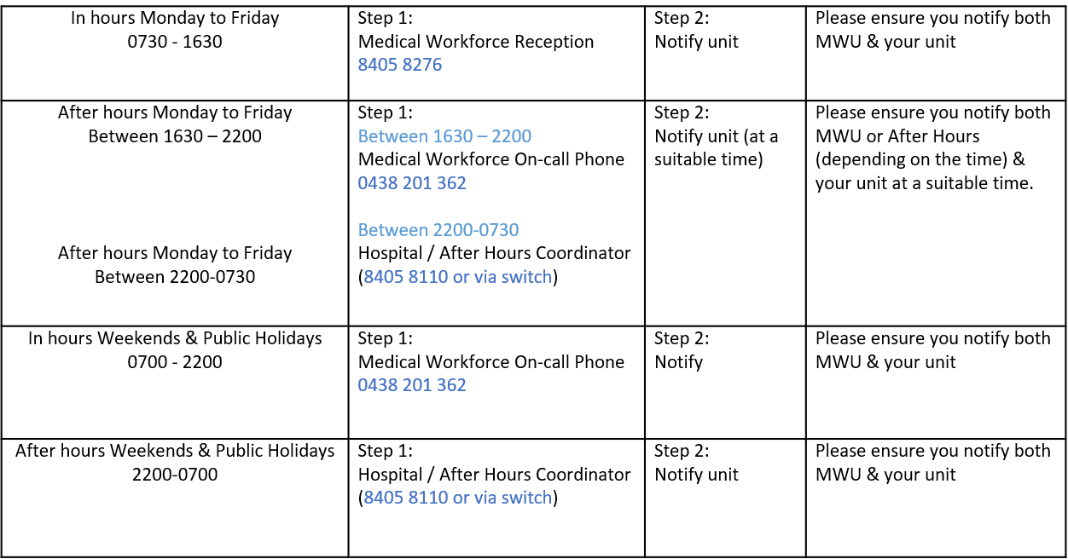
Overtime | All overtime should be submitted into the Overtime Portal  This can be accessed via the intranet whilst onsite at Northern Health  Please include the reason for your overtime- i.e. ward workload, delayed handover, include UR where relevant.

