Broadmeadows Hospital - General Surgery, Endoscopy, ENT, Ophthalmology, Orthopaedics, Vascular, Urology & Gynaecology |  | Unit 1/Surgicentre – Head of Surgical Services  Mr Chiu Kang  Chiu.Kang@nh.org.au x58814 | 0400423 437 737  Anaesthetic Lead – Dr Jason Ma jasonma78@gmail.com
Unit 1 NIC 8345 5203 |  | Supervisor of Training – HMO3 & non accredited registrars  Mr Chiu Kang
Ward Numbers/ Helpful Contacts
NHE Surgery Bookings Manager | Jeramie Carson - Jeramie.carson@nh.org.au
BH Floor Coordinator | 8345 5228
BH Anaesthetist in Charge | 8345 5899

If you cannot reach AGSU (52628), the Broadmeadows registrar, or the consultant looking after the patient switch should be able to put you through to Director of Surgery.

Unit Structure:

At present, the BHS surgical unit consists of one general surgery registrar and three HMOs. The Rosters are as follows:
- Week 1: Friday 11.30-21.30, Saturday 7.30-21.30, Sunday 7.30-21.30
- Week 2: Monday 1200-2200, Tuesday 12-2200, Wednesday 12-2200, Thursday 1400-2200 (7 days on total, then 3 off before starting morning shifts)
- Week 3: Monday-Friday 0700-14.30/1500
- Then 6 days off, then return for the weekend shifts (7 days on)
The roster is to accommodate weekend surgical lists, which are one HMO + consultant who are paid fee for service. There are not always lists on at BHS, so medical workforce may re-deploy you to TNH. There is usually at least one general surgery list on Saturdays – if there are more than one, medical workforce will find another surgical cover HMO to attend. There are currently no surgical lists on Sundays.
On the weekends, round on the patients and update the specialty teams/consultants that operated. If you are not at BHS on the weekend and have been re-deployed, the crit care HMO will see the patients. Make sure you give them handover on Friday afternoon.

Technically, the specialty teams should be rounding on their patients, doing paperwork, and then updating you, however most teams (mostly ortho) expect you to do their referrals, discharge summaries, scripts and review their patients.

Clinical documentation queries in Medtasker
- Good documentation is critical to provide an accurate record of the patient’s stay in hospital, decision making processes and rationale and handover between the multiple clinicians engaged in the patient’s care. Remember - “if it is not documented, it didn’t happen”. Your documentation is also vital for ‘clinical coding’, which is necessary for Department of Health data reporting and hospital financial reimbursement.

- To ensure accurate and comprehensive documentation in real-time, the Clinical Documentation Specialist (CDS) will identify any deficiencies in documentation in the healthcare record and will query these via Medtasker. These will show up as “CDI Query”. Please action these queries by documenting in the healthcare record. This can be done by documenting:
• on the next progress note (paper format), or
• on an electronic progress note in CPF by noting “CDI query response”, and/or
• on the discharge summary in CPF

After Hours

The HMO on in the afternoon also covers the rehab ward (Unit 2) after hours Tuesday-Friday. HMO covers GEM/Unit 3 on a Monday. The rehab/unit 3 team will handover any expected admissions or things that need to be chased. Besides this, you will have some run of the mill tasks like pre-METs for BSLs, patients requiring analgesia, or review of medications. At the end of your shift, patients should be handed over to the BHS Night Critical Care HMO.

Workload

The BHS Surgical HMO rotation gives you a good chance to attend a wide variety of elective surgeries. Aim to be in theatre with the registrar for general surgery lists, you will have many opportunities to scrub. On days that there are multiple lists, you should work out with the registrar which list you will go to. At times, specialty surgical units may request your assistance. Make your phone number available to theatre to facilitate this (go to PACU on the first day and the nurses there will have a sheet for your information).
The patients that are admitted to ward are generally low acuity and you may find yourself with significant time free of duties to surgical patients. In this time, help the medical teams if needed. They are excellent colleagues and part of this rotation is aimed at getting to know the medical management of patients better.

Important note: there is currently an audit underway re: lap chole patients. Talk to your registrar about it. It is being run by Mr Russell Hodgson. Please ensure that if you are the first assistant for any lap choles (including on the weekend, or if there are multiple lists running) that you record the following details:
- Operative time in minutes (check the computer in theatre which shows start & end times for the surgery)
- ASA score (on the computer & on the anaesthetic notes)
- Pneumoperitoneum pressure (ask the consultant or theatre tech)
- If clexane was given post-op later that day

General guide to the day:
If you’re not needed for the morning lists, you can take your time with your ward round. If you are needed in theatre, you’ll have to review all of the patients beforehand so be quick and efficient.
- 0700 – pre-round on gen surg patients (collect folders, prep progress notes, check obs/analgesia use/bowel chart etc). If you’re expecting a busy day, review some specialty surg patients while you wait for the gen surg registrar
- 0730-0800 – gen surg ward round with the registrar
- 0800 onwards – round on the remaining surgical patients, and/or go to theatre
- Go to theatre + attend to tasks as needed between cases
- Day 1 post op lap chole calls (new protocol in 2023):
  - For lap chole patients who are discharged home same-day, we need to review them over the phone the day after their procedure. Find time during the day to call them and conduct your usual day 1 post op review. Make sure to rediscuss the plan with them (e.g. GP review 1 week, no heavy lifting for 6 weeks etc) and safety net re: reasons to attend ED. Add a note to the outpatient tab of CPF. Update the surg reg re: the patient’s progress.
- During the day/after hours:
  - Admit post-op patients to the ward – basically just making sure reg meds are charted, +/- clexane if indicated, and ordering any bloods/imaging needed (e.g. ortho day 1 post op XRs)
  - Prep discharges for the morning HMO – summaries, scripts, referrals, med certs
Weekends
- Round on surgical patients in the morning before theatre, assist in theatre, cover until night team comes
- Saturday: assist in theatre all day. Let the NIC know that you will be in theatre & will be slow to answer medtasks – tell them to escalate anything urgent to the crit care HMO
- Get the list on the Friday from ward clerks at theatre front desk. Alternatively you can find it on iPM:
Select Theatre Overview:
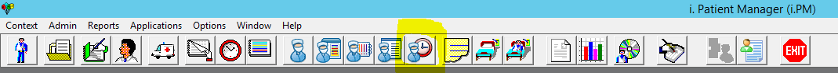
Select B Main Theatre Suite and adjust the date at the bottom:
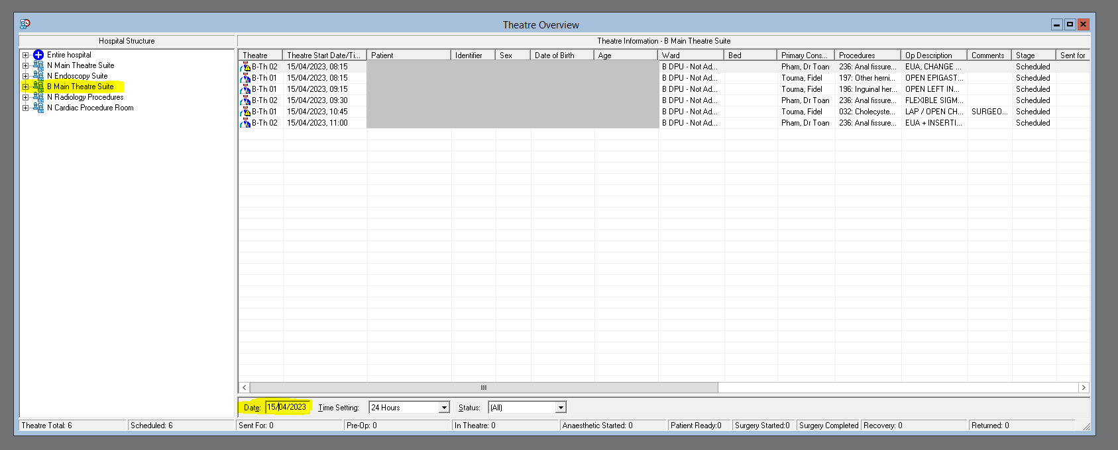
Key Tips
- Be contactable
- Bring study material for when you have downtime and the medical teams don’t need help
- Attend any METs or Code Blues while you are on the wards
- Do at least the ALS online component before you get to BHS (it’s mandatory to have ALS training there)
- Leave your name and phone number with the Unit 1 NUM and ward clerk
- Go to theatre, there will be many opportunities to scrub
- There is BHS teaching with the medical teams, usually on Tuesday at 12.30pm
- Check the theatre schedule to get an idea of what other units might be doing, patients to expect, and of course plan where you need to be in a given week: http://dsuselfrequest.nh.org.au/internal/SessionSchedule/index.php
- You will need to get access to Theatre, Unit 3, and the Mental Health wards, the admin office near the front of the building can help you get this
- Temporary access to changerooms and theatre can be obtained at the surgical centre front desk in exchange for your keys
- Prepare discharge summaries and scripts in theatre for straightforward cases that can be criteria led discharges
- Have a read of the general surgery guidebook and BHS guidebook for more general information (common conditions, protocols etc)
- For useful templates, go to S: drive (‘Shared on TNH Office’) -> Medicine -> BHS -> BHS SURG
  - Surgical handover template: print this, fill out with patient details, locations etc, and tick off tasks so the afternoon/next day team know what has already been done
  - Surgical discharge template: copy & paste into the Discharge Plan in the discharge summary and amend as needed
  - Surgical phone review template - day 1 lap choles: copy & paste into an outpatient note on CPF for your day 1 lap chole phone reviews
- BHS does not have on-site pathology. It can take many hours for blood results to hit the system as they all need to be couriered to TNH. However, there is a VBG machine in the Unit 1 medication room – very helpful for checking a quick post-op Hb if needed to clear someone for discharge home

- Ortho tips (technically they should be doing their scripts, summaries, referrals but they don’t)
  - There is an unwritten “protocol” for ortho patients, but if unsure ask ortho team on Whatsapp or call ortho at TNH
  - Clexane – 2 weeks for total knee replacements (TKR), 5 weeks for total hip replacements (THR)
    - Upper limb joint replacements don’t need clexane
  - Aspirin – for ACLs
  - Vitamin C 1 g BD for Mr Samuel Bewsher patients
  - Bloods – day 1 post op FBE, UEC for joint replacements
  - X-rays and repairs – X-ray day 1 post op, fax to 9309 8741 and put original in folder
    - NOTE: there is no on-site radiology on the weekend (there is an on-call radiographer for emergencies/urgent scans)
    - Therefore, if there are any ortho cases on Friday who need post-op XRs it is MUCH better to have them done on Friday before the radiographer goes home
  - Celecoxib for joint replacements 100mg bd until wound review + PPI unless otherwise specified
  - Do not change the dressing without blessing from ortho, they like it to stay on for 2 weeks
  - Check neurovascular supply and wound dressing when reviewing
- Gynae (usually their paperwork is done by whoever is in theatre)
  - Most of the time report back the review to gynae on x52521 / Medtasker
  - If O&G reg is at BHS they MAY review at some point in the day and leave a note – do not assume this is the case
  - Some days there are not O&G at BHS so then they definitely need an update
- Urology (usually the TURPs that stay, and they also forget to do their summaries/scripts but the referral is usually done)
  - TOV as per their instructions which is usually when the urine is clear after continuous bladder washout (CWB) or slightly rose, call urology before removing IDC
  - If they TOV great, if they don’t call urology but usually go to Craigieburn 4 weeks for formal TOV
- Occasionally ENT, opthal or endoscopy but rarely, more often asked to review in recovery for bleeding wound or something minor, if in doubt call the person who did the surgery
  - IF you are discharging an ENT patient from the ward, tell them to present to AUSTIN HEALTH ED if any complications/concerns. Northern Health do not have ENT cover so all cases are discussed with Austin Health anyway

