ANAESTHETICS INTERN ROVER (see also HMO ROVER)
UPDATED BY: Dylan Cornish CONTACT: dylan.cornish@nh.org.au DATE: 31/05/2024


ROVER (Rolling handOVER) – I am a ‘living document’ that needs your care and attention

Please update me on Teams in week 8 of this rotation. Link here.
Any questions, contact Ijaza via fathimaijaza.lafeer@nh.org.au

TOP TIPS!
- The weekly roster is posted in the Anaesthetic Department every Monday - you are also emailed a copy the Thursday before. Theatre changes may occur on the day - check theatre lists in the morning.
- There is also a ‘TNH Anaesthesia’ App where the roster can be found, as well as contact details of all the consultants – very handy! Holly in the Anaesthetic office will help you set it up at start of rotation.
- If you are not rostered to be with anyone in theatre: i) speak to anaesthetist in charge to help find you a good spot – best option a theatre without a trainee in it ii) go on pain rounds.
- Check the daily list to see what procedures you will be doing. See the patient beforehand, read their EMR and CPF files, make notes and fill in the preop anaesthetic EMR note. Find the anaesthetist and briefly present the case – come up with as best a plan as you can. If you do this, you are far more likely to get involved – e.g. “I think a rapid sequence induction is necessary because of… and I think it should be a relatively easy airway as their last anaesthetic record sheet showed a grade 1 airway.”
- Very useful resource - Developing Anaesthesia Textbook by A/Prof David Pescod – available on the Anaesthesia network drive (S: Drive/Medical/Anaesthetics ) or free download - Google “Developing Anaesthesia Textbook David Pescod”
- If there is an issue in PAC – call the BHS anaesthetist in charge (AIC) phone (55899) - always happy to help. If you can’t get a hold of BHS AIC call TNH AIC phone (88 555)
- Clinic has now been changed so that endoscopy PAC is on consistent days (used to be on a rotating schedule). Clinic will be on Monday – Wednesday afternoons and Friday morning. Most clinics now overlap with ANAPAC (anaesthetic PAC), so there will be anaesthetists to talk to if you are lost. Can either do that or call the BHS AIC. Generally, the preference is to call BHS AIC first.

STAFF
UNIT STAFF & KEY CONTACTS | CONTACT DETAILS
Head of Unit: Jake Geertsema
Consultants: > 50 Different consultants, you will rarely work with the same boss twice | Contact list in Anaesthetic Office
Anaesthetist in Charge TNH | 88555 (always happy to help)
Anaesthetist in Charge BHS | X55899 (call first if need assistance in PAC)
PAC Nurse Phone | 0447020692

WEEKLY TIMETABLE
Theatre in the mornings from 8am (Usually arrive around 15 minutes early to see patients in the morning)
Pre-Admission clinic typically in the afternoon and sometimes in the mornings – first patient will be booked for 1:30 or 8:30. Located in DPV. You can find it by walking towards and past the specialist clinics and following signs for pre-admission clinic.
GEOGRAPHY
ITEM | LOCATION
Home Ward | Anaesthetic Department / Theatre
Morning Meeting Point | Anaesthetic Office / Designated OT
Patient List | EMR “Perioperative tracking → NH GOT → NH OT (your allocated theatre)
Outpatient clinic | PAC in DPV

INTERN / JMO ROLE & RESPONSIBILITIES
Anaesthesia is split into two specific roles – junior anaesthetic trainee in Theatre, and Endoscopy PAC Intern.
THEATRE

- Try to see as many of the patients on your list in DPU/Wards/Anaesthetic bay before theatre as you can. When you arrive, see your patient before the Anaesthetist; take an anaesthetic history and brief examination. Briefly present to the anaesthetist – background, key worrying issues, airway and brief plan (LMA vs ETT. If ETT rapid sequence? Likely difficulties e.g., previous airway grade) if you do this you WILL get involved. Generally, the boss is happy if you see the first patient, prior to them getting in, and they will then let you see subsequent patients in the holding bay while they are finalizing the current case.

- Further duties are at anaesthetic consultant’s discretion. This usually includes cannulation, bag/mask ventilation, administration of medications, note taking in the anaesthetic record. As you become more experienced, you may be asked to perform more advanced procedures. Be enthusiastic! Many of the consultants are happy to talk you through a wide range of procedures.

- If you want to get involved, you can and will do a lot. Depending on the list, you have the opportunity to do lots of bag masking, multiple cannulas, LMAs and intubations each day. Towards the end of the rotation some consultants may also be comfortable supervising you to do spinals/art lines on appropriate patients
PAIN ROUNDS

- This happens daily with Nicole or Victoria (the Pain Nurses), a consultant and a registrar. Meet at 8am in the pain office. The patient list will be in EMR. Nicole and Victoria are amazing and on the ball! Your main job is to follow with the WOW, take notes, update drug charts/orders for PCAs. You can learn a lot on these rounds and they are definitely worth going on. You may not be formally rostered, but definitely try and jump on one or two rounds if your consultant on the day or the in-charge anaesthetist is happy for you to do so. You can also specifically ask to be rostered on - it is an excellent opportunity to learn and strengthen your understanding of the key principles of acute pain management.

ENDOSCOPY PREADMISSION CLINIC (ENDOPAC)

- S: Drive/Medicine/Preadmission/PAC results follow up for doctors/endo – results to follow up; Folder containing prepared notes, Excel spreadsheet to keep track of investigations to chase + Handy resources for clinic (such as PROMPT guidelines for endoscopy + medications, this ROVER, etc.)

- You are responsible for the pre-admission assessment of all patients booked for endoscopy (colonoscopy, gastroscopy, ERCP etc.)
- Typically up to 4 patients are booked per PAC session.

- Your job is to ensure that patients are fit for endoscopy. It is a low-risk procedure, and it is very rare for a patient to be refused endoscopy. Having said this, it means people you see in clinic will be very co-morbid and often quite complex.

- Patient lists for the day can be accessed via CPF, iPM or EMR (see pictures below).

- To create a note on EMR, open up your patients file, hover over documentation and click “Add +”. Under new note select the following

  - Type: Anaesthetic Review
  - Date: Prefilled
  - Title: Endoscopy PAC Anaesthetic Review

- From catalog, select perioperative notes from the drop down bar, followed by Anaesthetic Review* *2G Anaesthetic Review Note.
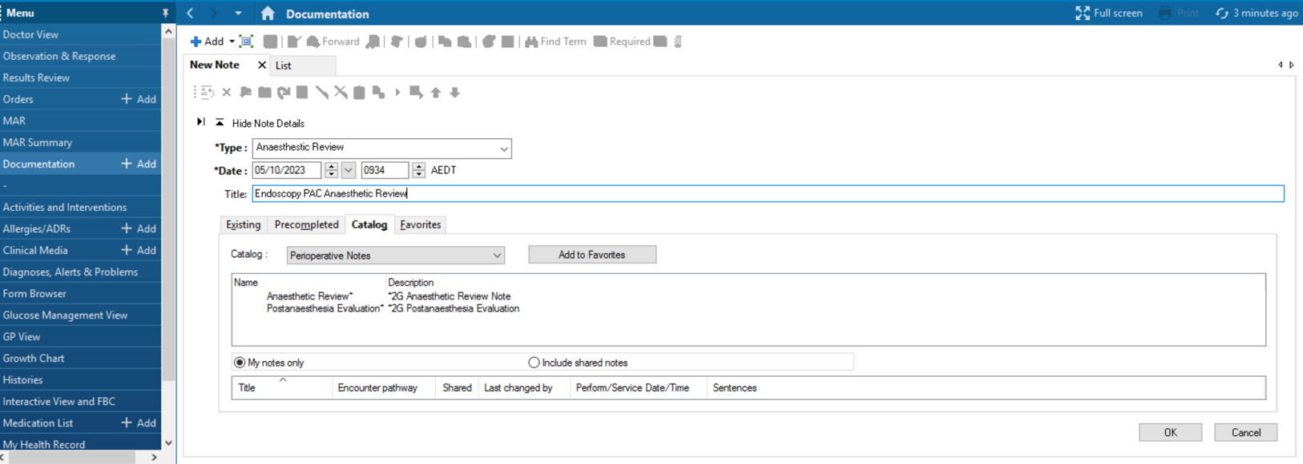
  - This will give you a general template to follow and you can include relevant things such as current medications, allergies and problem list by ticking the tick box. Alternatively, if you do not want info in the auto populated document, untick the relevant box.

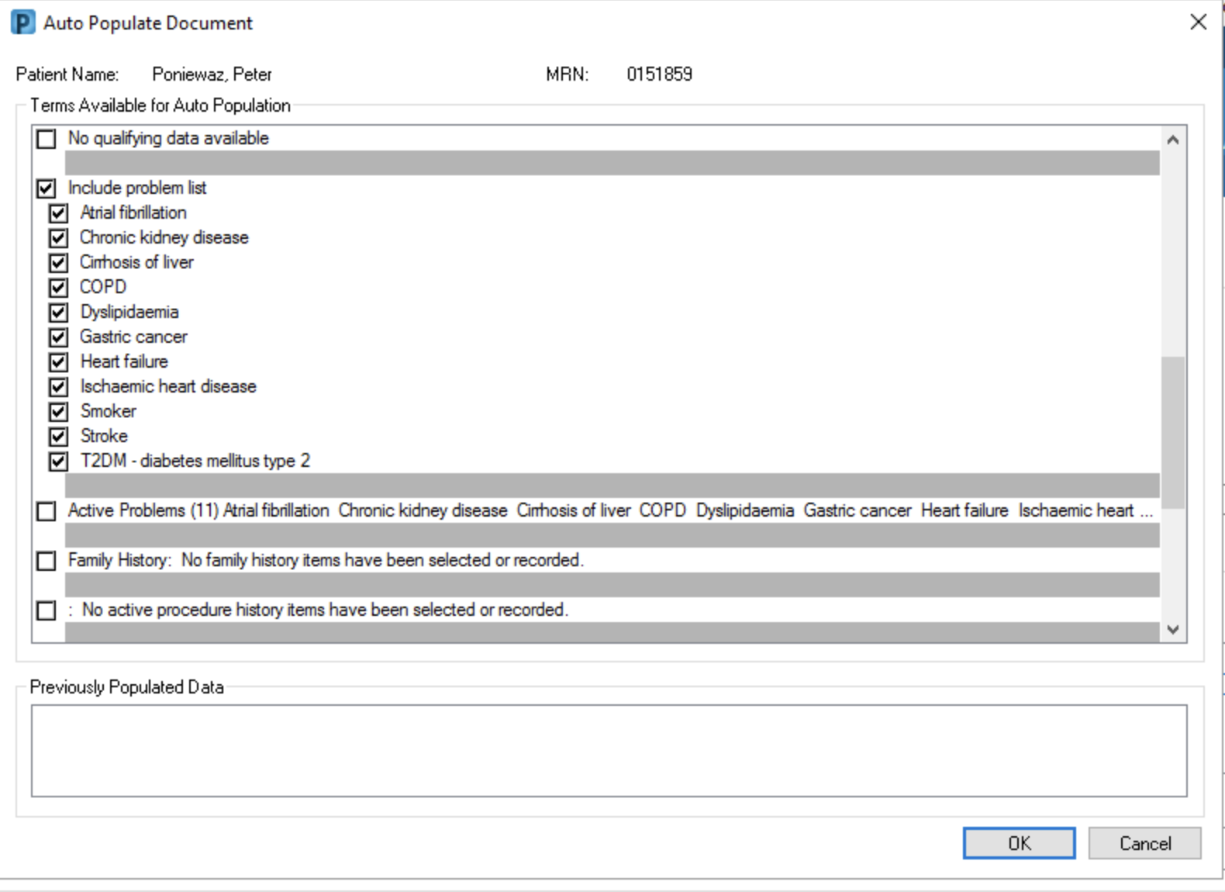

- Generally the documents adhere to the following template:
  - History of presenting illness
  - A line about what procedure and why. E.G. 66M for Cat 1 C’scope for positive FOBT
  - Preoperative information
  - Category
  - Previous anaesthetics and any issues
  - E.g. Cat 1, Anaesthetic History: Previous lap chole – nil issues. Previous hernia repair PONV, difficult airway
  - Review of Systems
  - Can either use the template in EMR or Charlie Harding’s link (below) and copy paste as free text. I preferred the latter as this could include social history.
  - Health Status
  - Under the list of medical conditions, I would use the free text option to delve into relevant medical conditions further
  - E.g. 1. Asthma
  - Uses Ventolin PRN only, no regular puffers
  - No recent hospital admissions
  - Physical Examination
  - Used the prefil template, but also added things such as MO </>4cm, TM,</>6cm, JP normal/abnormal
  - Review and Management
  - Include recent TTEs, RFTs, sleep studies, bloods, any pertinent info
  - Assessment and Plan
  - Include the anaethetist you discussed with, if necessary, and plans. Geerally I followed this template.
- Proceed/Delay
- Bowel prep/fasting as per PAC nurse
- ECG/Bloods today
- Medication plan
- Diabetes meds, b. anticoagulants c. antihyperternsives
- Other relevant info
- There are a variety of ways to document the pertinent information. This format is not gospel and if you find a more efficient method then by all means go for it. The most important thing is that all the relevant information is present somewhere on the review. ☺

- Label notes as ‘Endoscopy PAC Anaesthetic Review’ in EMR under their outpatient anaesthetics record.

- Generally speaking, endoscopy is only delayed when the reason for the endoscopy is not urgent, or the patient is imminently unwell (i.e., end stage respiratory disease, active infection)

- Take a thorough anaesthetic history, and a brief anaesthetic examination. If you have any concerns at this point, call the BHS Anaesthetist in Charge on X55899
- Generally need bloods within last 3months (Hb, eGFR (and HbA1c if poorly controlled diabetes)). ECG within last 3months. If don’t have these, arrange from clinic.

- Occasionally, the Anaesthetist in Charge will request deferral of the procedure to allow investigation of e.g. cardiac function or medical optimization. This may be an investigation you order yourself or pending an investigation by a different specialty. In this case, you’ll need to keep an eye out for the investigation/review when it happens. From there advise the PAC nurse whether proceeding/further deferring or if patient needs to be re-booked for PAC.

  - It is very important that any investigations that are pending or ordered are chased and the outcome documented on EMR prior to the procedure. You can do this by doing an addendum on the anaesthetic review. Using the excel spreadsheet (called “Investigations to chase”) in the PAC folder in S: Drive is a good way to keep track of what has been followed up.

  - If you are unsure about the implications of the findings of an investigation, call to discuss it with the AIC prior to documenting on EMR

- Occasionally, a patient will appear to be fit for endoscopy, but will have outstanding specialist correspondence that needs to be confirmed prior to procedure. In such cases, the patient keeps their procedure date - but make sure you chase/eyeball the relevant consult/investigations and document before procedure goes ahead.

- It often helps to review outpatient notes/previous admissions and anaesthetic notes/correspondence for risks and complications of previous procedures, medical history as well as how well optimised a patient is prior to a procedure.

- You may need to request anaesthetic reports from other hospitals if there is concern about previous anaesthetic reactions. You may need to phone GPs/specialists to get further information about someone’s optimization, or chase investigations not on file at Northern. If in doubt, call the Anaesthetist In Charge.

- Check the investigations and review the ECG if available, comment on them in your documentation. If the ECG looks suspicious, compare it to old ones on CPF to see if the abnormalities are longstanding.

- For the very co-morbid patients, ask yourself: “Is this as good as they’re ever going to get?’ If they are as optimised as they can be, they can usually proceed given the scopes are indicated. (In rare instances you may have to touch base with the team ordering the scopes (usually gastro or surg) to check whether scopes are still warranted/indicated if patients are very high risk)

- You may notice/pick up things that have been missed and whilst not strictly an anaesthetic issue, it is a perioperative medical issue that needs sorting prior to, or in parallel with, the patient having their scopes.

- Anticoagulation/antiplatelet/hypoglycaemic agents: There is an endoscopy guideline on prompt that details how to deal with these medications. A PDF copy of this can also be found in the S: Drive folder. The Haemostasis guideline on PROMPT is also very useful for warfarin/DOAC management peri-operatively.

- Find what works for you in terms of preparing for clinic. As stated, some of the patients can be very complex and require a bit of pre-reading!

- Other things to note in PAC (call Anaesthetist about anyone you think may need to be deferred):
  - Someone with a Pacemaker has to have had their PM checked within the last 6 months. If so, complete a cardiac investigation form and give it to the PAC nurses. They are wonderful and will organise a check on the day of procedure.

  - As a general rule, any new or worsening symptoms (esp. cardiac or respiratory) may warrant follow-up prior to scopes. (Check CPF or ask the patient if the patient has already had recent investigations or OPC regarding these.)
  - Often patients will require admission prior to the procedure because they require monitoring during bowel prep/fasting. This can be for a number of reasons including perioperative BSL management, fluid balance monitoring (for patients with CKD/CCF/fluid restriction) or poor functional status/incontinence. The PAC nurse will organize the logistics of the bed, but it’s your job to chat with the relevant team to organise preadmission.
  - BSL monitoring – usually only for T1DM who are poorly controlled or have poor literacy/risk of hypos (see PROMPT guideline). Run all T1DM patients by endo via Medtasker with an initial plan > they will advise whether patient can manage at home or should be admitted.
  - CKD – As a general rule, patients on dialysis will be admitted the day before and reviewed by renal. Send them a Medtasker referral for them to advise a plan (sometimes renal want the patient to be admitted under renal, sometimes they will consult with an admission under the home team). PAC nurse will organize logistics of dialysis peri-procedure. For patients who are CKD III, pre-admission can depend on what type of bowel prep they’re having (Moviprep usually fine, extended prep - chat with renal.)
  - Functional or other types of monitoring – Usually it suffices to advise that pre-admission will be needed in your documentation, and to alert the home team via Medtasker that this will be the case. The home team will then make a plan when admitting the patient.
ANAPAC now runs pretty much every day. There will be an anaesthetic consultant and registrar in clinic too. There may be days you (and occasionally the PAC resident) are the only doctors in clinic, but the Anaesthetist in charge is always happy to help you out over the phone/are happy for you to run up to the office with an ECG or other results you may need to show them.

How to access PAC Lists
Option 1: CPF > Patient Lists > Outpatients tab > Filter: Clinic Code: nppacendint (= Northern PAC Endoscopy Intern)
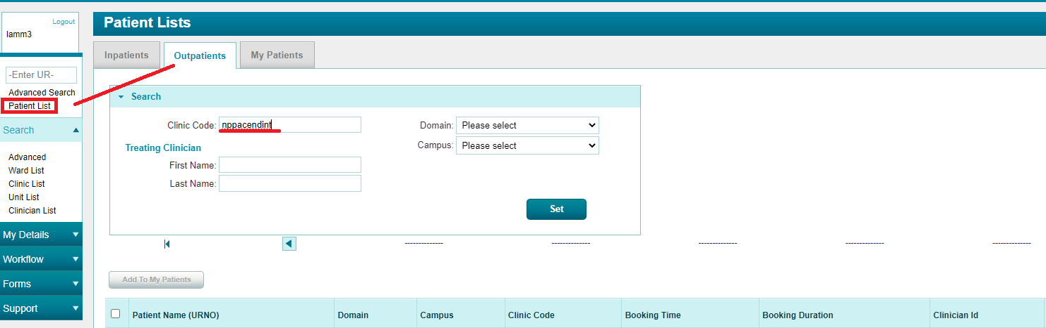
Option 2: IPM → search for outpatient day clinic lists (NPPACENDINT)
Option 3: EMR → Schedule → Resource: NPP – Intern Endoscopy Clinic
A patient list for the day will be present underneath this.
Clinical documentation queries in Medtasker

- Good documentation is critical to provide an accurate record of the patient’s stay in hospital, the decision-making processes and the rationale and handover between the multiple clinicians engaged in the patient’s care. Remember - “if it is not documented, it didn’t happen”. Your documentation is also vital for ‘clinical coding’, which is necessary for Department of Health data reporting and hospital financial reimbursement.

- To ensure accurate and comprehensive documentation in real-time, the Clinical Documentation Specialist (CDS) will identify any deficiencies in documentation in the healthcare record and will query these via Medtasker. These will show up as “CDI Query”. Please action these queries by documenting in the healthcare record. This can be done by documenting:
• on the next progress note (paper format), or
• on an electronic progress note in CPF by noting “CDI query response”, and/or
• on the discharge summary in CPF

COMMON MEDICATIONS SPECIFIC TO UNIT
**Medication doses must be in accordance with the Pharmacy-approved booklet distributed at intern orientation. If you do not have a copy you can find it on the NorthernDoctors website: http://northerndoctors.org.au/wp-content/uploads/2019/12/Pharmacy-Medication-Guide-2020.pdf
Common Analgesic Medications Encountered
Paracetamol | Paracetamol 1g QID PO/IV max 4mg
NSAIDs  Beware: renal failure, diabetics, elderly, brittle asthmatics | Ibuprofen 400mg TDS/Q8hrly PO max 1200mg  Celebrex 100mg BD PO max 200mg  Diclofenac 25-50mg TDS/Q8hrly max 150mg

Opioids | Tramadol IR 50-100mg QID/Q6hrly PO/IV PRN max 200mg (avoid in elderly and epileptic pts)  Tapendatol IR 50-100mg QID/Q6hrly PO/IV PRN max 200mg  Oxycodone IR 5-10mg Q3hrly PO PRN max depends on patient  Fentanyl (generally you will only write up as PACU protocol) ”APP – PACU ONLY – IV.” Commonly used intraoperatively  Tip: if using oxycodone for intraoperative analgesia, rule of thumb is for oxycodone protocol in recovery. Fentanyl as intra-operative analgesia = fentanyl protocol in recovery.
Intraoperative Antibiotics:
- Usually cephazolin 2g IV (give slowly – can be very nauseating!)
Antiemetics:
- Ondansetron 4-8mg TDS/Q8hrly PO/IV
- Droperidol 0.625mg IV (PONV in recovery)
- Cyclizine 50mg TDS IV

COMMON ISSUES
I have arrived in DPU but where is my patient?? They may be in the main waiting room or sub-waiting room of DPU. Their notes can be found outside of the sub-waiting room in a pigeonhole for their allocated theatre. You can see the patient in one of two interview rooms until their bed is prepared. If in doubt, ask the DPU nurses where a patient is.

PAC - The main issue will be when you are unsure if a patient can proceed with their endoscopy due to a severe/worsening medical issue. If in doubt, call the BHS AIC. As you spend more time in PAC, you will be able to manage more and more of these patients without deferring to the AIC. Other issues are now addressed by the endoscopy guidelines on PROMPT.
Any issues, please contact Suzy Cook or Neil MacDonald (anaesthetic intern supervisors).
PROCEDURES COMMONLY ENCOUNTERED

- Bag and mask ventilation
- Intubation
- Laryngeal Mask Placement
- Cannulation
- Spinal anaesthesia

MED TIPS FOR PAC
- There has been a subtle change in injectables for T2DM. I.e. Ozempic, Trulicity (dulaglutide).
- There have been multiple cases cancelled as these meds have been shown to delay gastric emptying therefore increase the risk of aspiration. The new advice is that a dose should not be taken within 7 days of a procedure. This is controversial but is the best way to avoid your patient being cancelled on the day.
- Generally, withhold antihypertensives day of scope. Anaethetists would rather a high BP than low as most sedatives drop BP.
- Other diabetes meds and anticoagulant protocols can be found below. If in doubt, you can always call the home team/referring gastroenterologist for what they want for these meds.
TAKING AN ANAESTHETIC HISTORY
Focus on ABC:
- What procedures are we doing for you and why?
- Cardiovascular issues e.g. IHD, CCF, cardiomyopathy, exercise tolerance
  - Angina, SOBOE, can they climb stairs
- Respiratory issues e.g. COPD, asthma, OSA
  - Medical management, recent infections, hospitalisations/frequency of reliever use in asthma/COPD. Compliance with CPAP
- General comorbidities/PMHx e.g. Diabetes, CKD, GORD
  - Are they optimised for surgery, review OPC notes, check investigations, ask the patient
  - GORD is important because patients with poorly controlled GORD will likely have to be intubated
- Medications, allergies, previous anaesthetic complications
  - Check previous anaesthetics notes, ask the patient, ?FHx of anaesthetic complications
- Other – loose teeth or denture
- Previous issues with anaesthetics (patient or family member)

ANAESTHETIC EXAMINATION
Focus on cardiovascular system, respiratory system, airway examination:
- Cardiovascular
  - Pulse – regular vs irregular
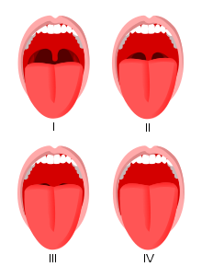
  - Heart – heart sounds? Murmurs? New or old?
  - CCF signs
- Respiratory
  - Wheeze/crackles? Good air entry? CCF signs
- Airway assessment
  - Cervical spine flexion and extension – how easy will they be to intubate?
  - Mouth opening
  - Thyromental distance - > 6cm
  - Jaw protrusion
  - Dentition
  - Mallampati Score (right) - Grade I, II, III, IV

A ROUGH PROFORMA TO HELP YOU IN PAC
Endoscopy Pre-Admission Clinic
Anaesthetic Intern: …

UR:
Name:
Age:
Gender:

Surgery:
Indication:

Date of Op:
Time of Op:

Medical Hx:

Systems review:
- Denies CP at rest or OE
- Denies dyspnoea at rest or OE
- Denies palpitations
- Denies dizziness/ syncope
- Denies wheeze/cough
- Denies orthopnoea/PND – sleeps on 1 pillow
- Denies peripheral oedema
- Denies reflux symptoms
- OSA screen: denies snoring. Gets a good night’s sleep, no excessive daytime sleepiness

Denies: CVD, CVA, COPD/Asthma, Diabetes, VTE, GORD, Renal disease, OSA, Thyroid, Stoma

Allergies:

Medications:

? Fluid restriction

? Diabetic medications
? Anti-coagulants – Include CHADSVASc

No / Recent medication changes

Previous anaesthetic:
Previous anaesthetic issues:
No FHx anaesthetic issues

Social History:
Lives with
?I ADLs
Work:
Smoker:
EtOH:

METs:
- Able to dress yourself 2-3 METs
- Able to shower 3-4 METs
- Able to walk up 2 flights of stairs >4 METs

Exercise tolerance: able to walk ____
Walking aids:

Weight:
Height:
BMI:

Examination findings
Obs: Nurse to perform, please notify if issues
MO: >4cm
Mallampati Score: Class I, II, III, IV
Thyro-Mental Distance: >6.5cm
Jaw protrusion: Class A, B, C
Neck flex/extension:
Dentition:
Neck:

Cardio:
Resp:
Calves:

Investigations:

Issues:

Discussed anaesthetic risks with patient – happy to proceed

Plan:
1) Proceed with ____ as planned
2) Bowel prep as instructed by PAC nurse
3) Bloods: _____
4) Medication plan
Diabetic medication:
- Insulin
- OHGs
- SGLT2 inhibitors
Anticoagulation/antiplatelet:
5) Admission letter given

Dr …
Anaesthetic Intern

*Alternatively – Charlie Harding, Anaesthetic Consultant, has created a webpage/program that allows you to take a comprehensive anesthetic assessment as prompted by drop-down menus and check-boxes. The program will then allow you to create a text version of the assessment you can paste into CPF. Have a play around and see if it fits your style a little better, or if you want to incorporate parts of it into the template above. It can be found at: https://anaestheti.st/nh/

QUICK SUMMARY OF MEDICATION MANAGEMENT
These are a guide only. Please see PROMPT protocols from which these are developed for more detailed information.

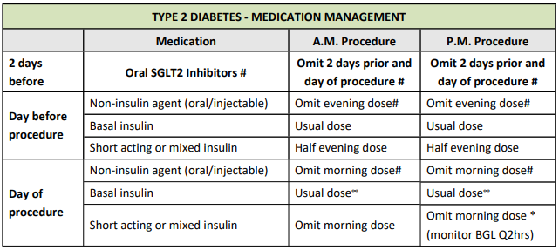

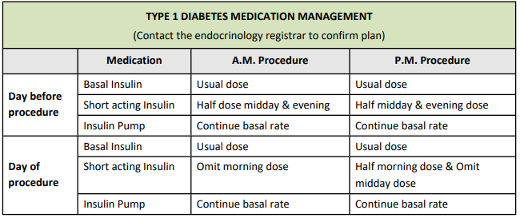
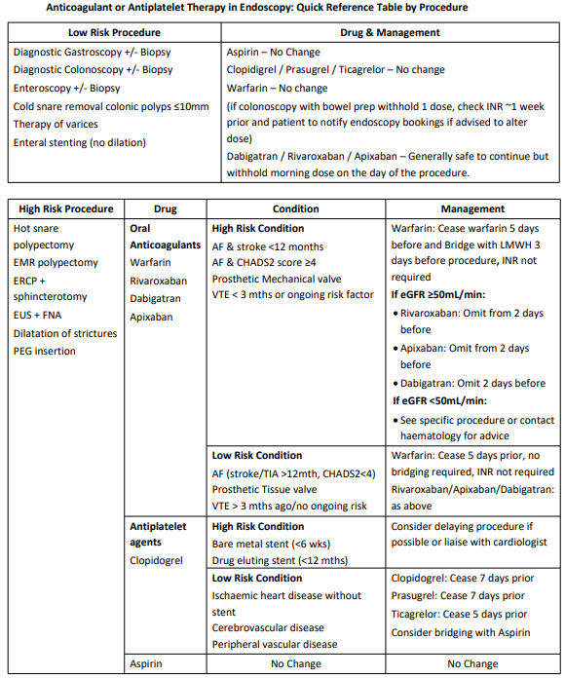
Common medications to continue DOS:
- B-blocker
- Anti-arrhythmic
- PPI and anti-reflux medications
- Antiepileptics
- Psychiatric medications
- Benzodiazepines - especially if regular
- Bronchodilators
- Frusemide (consider renal function – if high risk AKI may need preadmission)
- Corticosteroids or immunosuppressants
- Consider stress dose steroids if on equivalent of >5mg/day in 6 months prior to surgery
- Thyroxine
- Opioid analgesia
- CPAP machine
  - Bring to hospital on day of surgery

Common medications to withhold DOS:
- ACE-inhibitors
- ARB
- NSAIDs

INSIDER INFORMATION & MISCELLANEOUS TIPS

There is an Anaesthetic Department meeting on MS Teams every week alternating Tuesdays, Wednesdays and Thursdays from 5-6pm that you are welcome to attend (dates and times listed in anaesthetic office).

How to Document a Spinal (adapted from C. Harding)
- Aseptic technique: cap, gown, sterile gloves, mask, drape
- Left lateral / sitting position
- Awake
- Skin prep: Chlorhexidine 0.5% and left to dry
- L3/L4 space
- Lignocaine 1% 2mL to skin
- 25G pencil point needle
- First pass
- Midline
- Clear CSF
- Heavy bupivacaine 0.5%: 2.3 mL
- 100 mcg morphine
- 15 mcg (0.3 mL) fentanyl
- No pain or paraesthesia on insertion or injection
- Adequate block
- No immediate complications

USEFUL RESOURCES

- Oxford Handbook of Anaesthesia

- Developing Anaesthesia Textbook – David Pescod (digital copy online/shared file on S: Drive/Medical/Anaesthetics), library also has a hard copy.
- MDCalc- For calculating METs.

