9. Hospital Orientation
Hospital orientation occurs at the beginning of each term. Attendance is mandatory and paid non-clinical time.
This is separate to the unit orientation. Follow the link for details, password: NorthernDoctors
Location | NCHER, Northern Hospital – Epping | 185 Cooper Street, Epping 3076
Facilitator | Medical Education Unit | Email: MedicalEducationUnit@nh.org.au
Date | First day of each term
Start | 08:00

10. Unit Orientation
Unit Orientation occurs at the beginning of each term. Attendance is mandatory and paid time.
Orientation that occurs outside of your rostered hours should be submitted as overtime on the overtime reporting portal.
Location | NHE Ward 19
Facilitator | Aged Care Registrar
Date | First day of rotation
Start

11. Unit Overview
Department | Aged Care
Location | NHE Ward 19
Inpatient Beds | Automatic referral from Orthopaedic unit
Outpatients Clinics | N/A
Day Procedures | N/A
Virtual Unit | N/A

12. Safety
Unit Specific Safety & Risks
- Acutely unwell patients
Peri-op patients can be acutely unwell and require timely support and intervention. This can require escalation.
- Delirium
OGS patients have a high rate of delirium and can become agitated. Care in management and prescribing in delirium is required.
- Falls
- Pressure injuries
- Consent and capacity
Many patients under the care of OGS have cognitive impairment and capacity issues mean that there is a high rate of substitute decision makers. Care is needed in the identification of a need for a MTDM and the appropriate person to act in this role.

13. Communication
Medtasker | Yes
WhatsApp | Ortho-Geriatrics Group Chat (OGS AT, OGS RMO, Ortho Reg/RMO/Interns)
Pager | ?
MS Teams | N/A

14. Handover Process
Morning | Direct hand over from overnight cover and direct communication with Ortho unit
Afternoon | Direct communication with ortho team and hand over to afterhours Peri-op as needed
Night | N/A

15. Shift Structure
 | Intern | HMO | Registrar
Day | N/A | M-F 08:00 – 17:00 | M-F 08:00 – 16:30
Afternoon | N/A | N/A | N/A
Night | N/A | N/A | N/A
Weekend | N/A | N/A | N/A

16. Shift Roles & Responsibilities
 | Intern | HMO | Registrar
Day | N/A | Ward round + tasks | Ward round + tasks  Review referrals
Afternoon | N/A | N/A | N/A
Night | N/A | N/A | N/A
Weekend | N/A | N/A | N/A

17. Common Conditions
#NOF
#SNOH
# ankle
Complications
- Renal impairment
- Post op pneumonia
- Hypotension
- VTE
- Delirium

18. Common Procedures
IVC
IDC insertion

19. Clinical Guidelines
The My Favourite Links page on the intranet contains the links to a number of useful clinical guidelines https://intranet.nh.org.au/applications/
ETG- Electronic Therapeutic Guidelines
AMH- Australian Medicines Handbook
Up to Date
PROMPT- This site contains the hospital policy and procedure manuals. It can only be accessed from the intranet - https://intranet.nh.org.au/departments-and-services/prompt-policy-procedures-guidelines/prompt-policies-procedures-and-forms/
Some (but not all) relevant PROMPT guides are listed below:
- Diabetes Management – Adults
- GEM at Residential Care
- Falls Prevention and Management
- Blood – Administration of Blood/Blood Products (Adults)
- Dementia, delirium, and Cognitive Impairment Management

20. Routine Orders
Pathology | Pre-op investigations are usually managed by the ortho team but include:  - FBE, U&E, LFTs, Ca/Mg/PO4, coags, G&H  Osteoporosis investigations:  - Vit D, TSH  ECG pre-op
Radiology | DEXA scan may be required for osteoporosis management and planning on discharge
Pharmacology | A decision must be made about analgesia for every patient even if a decision NOT to prescribe is made.  Clexane 20-40mg SC daily should be prescribed for every patient UNLESS ortho indicate otherwise.

21. IT Programs
EMR | The EMR is in use for documentation, medication ordering and radiology/pathology requests.  It is being used for all inpatients, as well as maternity clinics and pre-anaesthetic clinics.  Located in the intranet > My Favourite Links > EMR Live Environment  EMR Training courses are located on the LMS- https://mylearning.nh.org.au/login/start.php  Training is compulsory; you will need to complete the elearning within the first week of commencing.  Please contact medical workforce, or check the EMR website for more information on how to complete EMR training https://emr.nh.org.au/  When starting a new rotation, please reach out to Term Supervisor to ensure you are oriented to the EMR specific workflows for that unit as well.  EMR is NOT a primary communication system. Please use Medtasker and phones for referrals and communication.
CPF | The source of information for all outpatients’ clinics, investigations, GP referrals and scanned admission notes prior to September 2023.  Located in the intranet > My Favourite Links > CPF https://cpf.nh.org.au/udr/
PACS | XERO Viewer Pacs- https://nivimages.ssg.org.au/ or located in My Favourite Links, look for the CXR icon  This is where you can find radiology images
My Health Record | Centralised health record https://shrdhipsviewer.prod.services/nhcn
Safe Script | Monitoring system for restricted prescription medications https://www.safescript.vic.gov.au/

22. Documentation
Admission | Patients are admitted under the orthopaedic bed care. OGS sees all patients >50 with a lower limb fracture, all patients >60 with and upper limb fracture, elective ortho patients who have been seen in complex and high-risk pre-op clinics and any orthopaedic patient on the request of the ortho team for medical review.
Ward Rounds | Tues/Fri consultant round. Other days with Geriatric Medicine Advanced Trainee
Discharge Summary | Edit and contribute to Ortho unit DCS.
Outpatient Clinics | N/A
CDI Queries
Death Certificates | These should be completed by the ortho unit. https://www.bdm.vic.gov.au/medical-practitioners
Coroners | Referral made in conjunction/consultation with the ortho unit. https://coronerscourt.vic.gov.au/report-death-or-fire/how-report-death

23. Referrals
Internal | Made via EMR/Medtasker as appropriate
External | As needed

24. Clinical Deterioration
Escalation Process | Escalate to OGS Registrar (except Thursday afternoon when escalation should be to OGS consultant directly)
PreMet | As per hospital protocol
Code | As per hospital protocol

25. Night Shift Support
Unit | N/A
Periop | Out of hours support is via Peri-op.
Take 2 @ 2

26. Assessments: PGY1 & PGY2
All forms are located on the Northern Doctors website under the Assessments tab
Beginning of Term | Meet with Term Supervisor to set learning goals for the term using the Term Description Learning Objectives as a basis for the discussion
Mid-Term & End of Term | To be completed at the mid and end of term meetings
EPAs | Minimum of x2 EPA assessments to be completed per term

27. Mandatory Training
- Mandatory Training is located on the LMS- https://mylearning.nh.org.au/login/start.php
- Mandatory training is compulsory and part of your contract with Northern Health and needs to be completed by the first month of your start date. If not completed you will come of the floor to complete.
- Hand Hygiene needs to be completed by the end of your first week.
- If you have completed the mandatory training elsewhere you may be able to apply for recognition of prior learning

28. Unit Education
HMO teaching

29. Unit Meetings
HMO is welcome to attend Complication meeting on Thursday morning (0700) in person or via Teams but this is not considered mandatory.

30. Research and Quality Improvement
NH OGS and Orthopaedic unit participate in the Australian and New Zealand Hip Fracture Registry.

31. Career Support
Direct discussion with Head of Unit (Dr Rohan Wee).

32. Medical Students on the Unit
On an ad hoc basis

33. Rostering
Shift Swap | The doctor initiating the roster swap is responsible for arranging with an appropriate colleague.  Once you have arranged a colleague to perform the swap, please email your MWU coordinator and cc in the colleague.  All swaps should be kept to within the pay period fortnight where possible. In exceptional circumstances where this cannot be achieved, please discuss with the MWU coordinator prior.  All shift swaps should be like hours for like hours.  Proposed shift swaps must be emailed to your MWU coordinator for approval.
Unplanned Leave- Notification and documentation process | Personal Leave documentation required:  For 3 single absences per year, the doctor will not be required to provide any supporting evidence to substantiate their personal leave.  For other days absent due to personal illness or injury the doctor is required to provide evidence of illness.  To be eligible for payment, the doctor is required to notify the Health Service two hours before the start of their shift, or as soon as practicable.  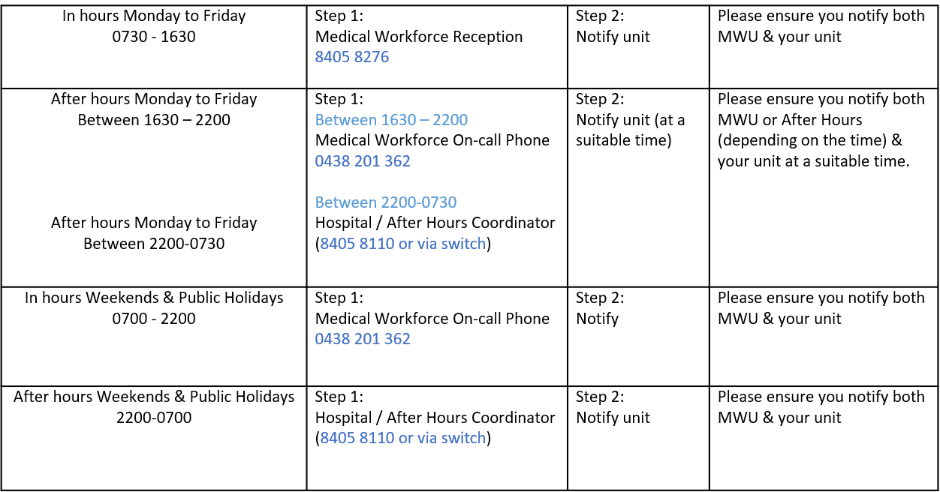
Overtime | All overtime should be submitted into the Overtime Portal  This can be accessed via the intranet whilst onsite at Northern Health  Please include the reason for your overtime- i.e. ward workload, delayed handover, include UR where relevant.

