9. Hospital Orientation
Hospital orientation occurs at the beginning of each term. Attendance is mandatory and paid non-clinical time.
This is separate to the unit orientation. Follow the link for details, password: NorthernDoctors
Location | NCHER, Northern Hospital – Epping | 185 Cooper Street, Epping 3076
Facilitator | Medical Education Unit | Email: MedicalEducationUnit@nh.org.au
Date | First day of each term
Start | 08:00

10. Unit Orientation
Unit Orientation occurs at the beginning of each term. Attendance is mandatory and paid time.
Orientation that occurs outside of your rostered hours should be submitted as overtime on the overtime reporting portal.
Location | Kilmore hospital
Facilitator | Unit Consultant, GEM Allied Health staff and nurse in-charge
Date | First day of rotation
Start | 08:30

11. Unit Overview
Department | Continuing Care
Location | Northern Health Kilmore District Hospital
Inpatient Beds | 10 GEM, 2 Bed Based Transitional Care Program
Outpatients Clinics | N/A
Day Procedures | N/A
Virtual Unit | N/A

12. Safety
Unit Specific Safety & Risks
Unit Specific Risks
- Safe medication prescribing (high opioid dose medications)
Use of opioid medication is common in our patients, great care should be taken in their prescribing, and you are encouraged to seek advice from the consultant.
When a syringe driver is commenced, in most cases long-acting oral opiates will be ceased. Refer to Palliative Care service for advice.
All opioid rotations should be discussed with and confirmed by consultant. Please ensure that you check to confirm all medications are correctly prescribed.
- Falls
Ensure appropriate screening and prevention strategies in place for falls, and ensure timely review, documentation and communication with Medical Treatment Decision Maker post falls.
- Pressure injuries
- Delirium
- BPSD
- Deteriorating patients
Given the absence of after hours on site medical cover, and limited access to pathology and radiology, please ensure adequate handover of plan to nurse in charge and on call consultant, clear discussion and documentation for goal of patient care, and if patient is for transfer to acute hospital, ensure this occurs in a timely manner. Please email updated ward-list to on-call consultant every Friday.

13. Communication
Medtasker | N/A, but can be used to contact specialty registrars for advice at TNH
WhatsApp | N/A
Pager | N/A
MS Teams | Used for scheduling of unit meetings

14. Handover Process
Morning | Nurse station at 9am - multidisciplinary
Afternoon | ~1600 – update NIC re: clinical concerns
Night | N/A

15. Shift Structure
 | Intern | HMO | Registrar
Day | N/A | 08:30 – 17:00 | N/A
Afternoon | N/A | Half day 08:30-12:00 (ideally Wednesday) | N/A
Night | N/A | N/A | N/A
Weekend | N/A | N/A | N/A

16. Shift Roles & Responsibilities
 | Intern | HMO | Registrar
Day | N/A | HMO WR or CWR | N/A
Afternoon | N/A | Ward jobs and follow-up | N/A
Night | N/A | N/A | N/A
Weekend | N/A | N/A | N/A

17. Common Conditions
Falls and balance
Fracture and osteoporosis
Delirium
Dementia with BPSD
Frailty
Wound care
Pain management
Rehabilitation post-acute medical conditions or post op
Assessment of cognition
Common medical condition of elderly e.g. heart failure, COPD, pneumoniae, UTI, diabetes, pressure injury
Legal aspects of aging e.g. capacity assessments, VCAT and surrogate decision maker process, elder abuse issues
End of life care
D/C planning and use of services

18. Common Procedures
NGT insertion
IDC insertion
IVC insertion +/- venesection
Venepuncture
Wound care

19. Clinical Guidelines
The My Favourite Links page on the intranet contains the links to a number of useful clinical guidelines https://intranet.nh.org.au/applications/
ETG - Electronic Therapeutic Guidelines
AMH - Australian Medicines Handbook
Up to Date
PROMPT- This site contains the hospital policy and procedure manuals. It can only be accessed from the intranet - https://intranet.nh.org.au/departments-and-services/prompt-policy-procedures-guidelines/prompt-policies-procedures-and-forms/

20. Routine Orders
Pathology | KDH is serviced by Austin pathology, most patients don’t require routine pathology. Results usually available by 3pm.  Requires organisation of Austin Auscare portal access prior to commencing rotation -> can be organised via Austin laboratory website (ideally register for Auscare at least a week prior to commencing).  Pathology order forms are behind the nurse station.  iStat for urgent troponin / INR / VBG (ask nursing staff for help organising iStat).
Radiology | Capital radiology – limited access to USS and CT, consider transferring to TNH if urgent radiology indicated. XR can usually be booked on the same day.  Requires organisation of capital radiology portal access prior to commencing rotation -> can be organised via Capital radiology website
Pharmacology

21. IT Programs
EMR | The EMR is in use for documentation, medication ordering and radiology/pathology requests.  It is being used for all inpatients, as well as maternity clinics and pre-anaesthetic clinics.  Located in the intranet > My Favourite Links > EMR Live Environment  EMR Training courses are located on the LMS- https://mylearning.nh.org.au/login/start.php  Training is compulsory; you will need to complete the elearning within the first week of commencing.  Please contact medical workforce, or check the EMR website for more information on how to complete EMR training https://emr.nh.org.au/  When starting a new rotation, please reach out to Term Supervisor to ensure you are oriented to the EMR specific workflows for that unit as well.  EMR is NOT a primary communication system. Please use Medtasker and phones for referrals and communication.
CPF | The source of information for all outpatients’ clinics, investigations, GP referrals and scanned admission notes prior to September 2023.  Located in the intranet > My Favourite Links > CPF https://cpf.nh.org.au/udr/
PACS | XERO Viewer Pacs- https://nivimages.ssg.org.au/ or located in My Favourite Links, look for the CXR icon  This is where you can find radiology images
My Health Record | Centralised health record https://shrdhipsviewer.prod.services/nhcn
Safe Script | Monitoring system for restricted prescription medications https://www.safescript.vic.gov.au/

22. Documentation
Admission | Most GEM admissions are from other Northern Health campuses. Some GEM admissions are direct from community or transfer from Kilmore Acute Medical team. Some GEM admissions are from GEM@Resi or BBTCP if they now have GEM goals.  All BBTCP admissions are from Kilmore GEM or other Northern Health campuses. They are predominantly for patients awaiting permanent residental care placement  Document admission note on CPF, print off hard copy and include in folder.
Ward Rounds | Currently paper based documentation
Discharge Summary | Use CPF template
Outpatient Clinics | N/A
CDI Queries | N/A
Death Certificates | Print 2 copies, sign them and put them in the file  The discharge summary should still be completed in a timely fashion, as should any communication required with outside providers. Death certificates are completed online. https://www.bdm.vic.gov.au/medical-practitioners  Hard copies are to be printed out for the patient file/funeral director, in addition to the electronic submission.  Funeral directors may contact HMO for copies of death certificates to be emailed.
Coroners | Reportable deaths: Death certificates should not be completed if it is a Coroner’s case. This will require a phone call to the Coroner’s office followed by an e-medical deposition. It is important that the medical team identifies patients who will be reported to the Coroner ahead of time. Patients’ whose death is reportable will need to have a statement of identification completed by the next of kin, and attachments such as butterfly cannulas etc are left in situ.  Any uncertainty about whether a death is reportable should be escalated to the consultant, and advice can be sought from Coroner’s office.  https://www.coronerscourt.vic.gov.au/report-death-or-fire/reportable-deaths

23. Referrals
Internal | All GEM referrals for admission go through the ARC process. These referrals will have been triaged and approved by a Geriatrician. The ARC nurse coordinator Andrew Lang 0409716315 (Andrew.Lang@nh.org.au) emails the referrals to NUM, GEM Consultant and GEM team.  All BBTCP referrals will have been approved by ACAS and TCP team. These referrals will be emailed to GEM Consultant and GEM team to ensure suitability for Kilmore BBTCP.  Kilmore acute medical patients who may be suitable for GEM may be referred by ward staff to GEM medical team. Suitability is to be assessed by GEM consultant.
External | As above

24. Clinical Deterioration
Escalation Process | Check GOPC, and discuss with Unit Consultant or Consultant on Call
PreMet
Code

25. Night Shift Support
Unit | On Call Geriatrician
Periop | N/A
Take 2 @ 2 | N/A

26. Assessments: PGY1 & PGY2
All forms are located on the Northern Doctors website under the Assessments tab
Beginning of Term | Meet with Term Supervisor to set learning goals for the term using the Term Description Learning Objectives as a basis for the discussion
End of Term | To be completed at the end of term meetings with GEM consultant.
EPAs | Minimum of x2 EPA assessments to be completed per term

27. Mandatory Training
- Mandatory Training is located on the LMS - https://mylearning.nh.org.au/login/start.php
- Mandatory training is compulsory and part of your contract with Northern Health and needs to be completed by the first month of your start date. If not completed you will come of the floor to complete.
- Hand Hygiene needs to be completed by the end of your first week.
- If you have completed the mandatory training elsewhere you may be able to apply for recognition of prior learning

28. Unit Education
Ground Round - Thursday 8am via TEAMS
HMO Education - Thursday 12.30-1.30 via TEAMS
Medical Education - Friday 1-2 via TEAMS
Ward based education throughout the week.

29. Unit Meetings
Weekly MDT – date and time to be determined by AH staff and GEM consultant.

30. Research and Quality Improvement
Discuss with Ward Consultant.

31. Career Support
Discuss with Ward Consultant or HMO Supervisor.

32. Medical Students on the Unit
N/A

33. Rostering
Shift Swap | The doctor initiating the roster swap is responsible for arranging with an appropriate colleague.  Once you have arranged a colleague to perform the swap, please email your MWU coordinator and cc in the colleague.  All swaps should be kept to within the pay period fortnight where possible. In exceptional circumstances where this cannot be achieved, please discuss with the MWU coordinator prior.  All shift swaps should be like hours for like hours.  Proposed shift swaps must be emailed to your MWU coordinator for approval.
Unplanned Leave- Notification and documentation process | Personal Leave documentation required:  For 3 single absences per year, the doctor will not be required to provide any supporting evidence to substantiate their personal leave.  For other days absent due to personal illness or injury the doctor is required to provide evidence of illness.  To be eligible for payment, the doctor is required to notify the Health Service two hours before the start of their shift, or as soon as practicable.  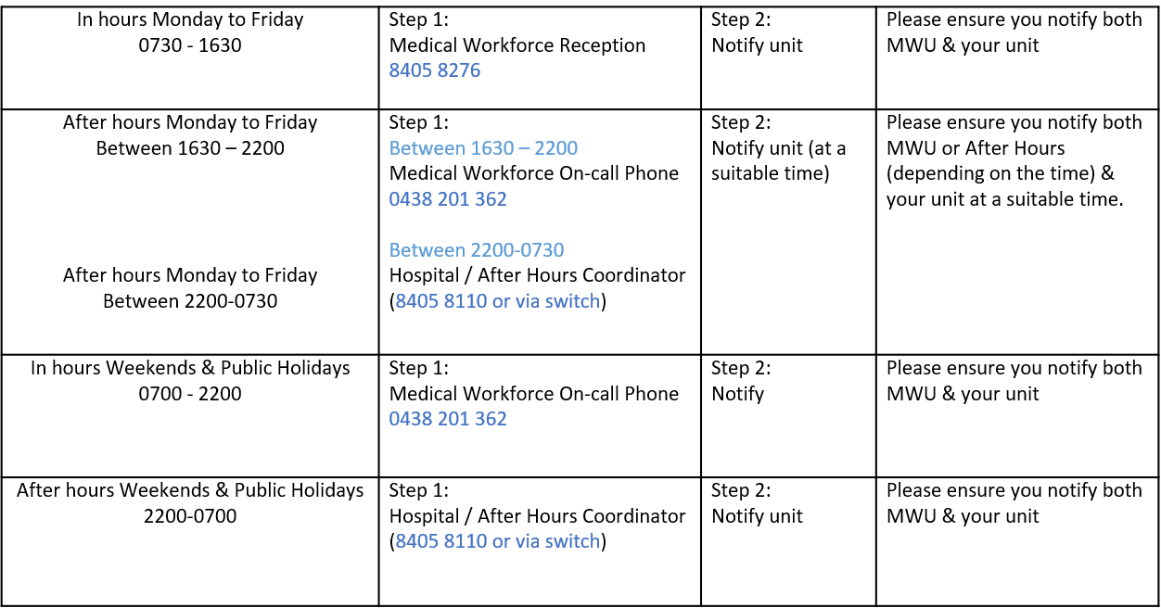
Overtime | All overtime should be submitted into the Overtime Reporting Portal  This can be accessed via the intranet whilst onsite at Northern Health  Please include the reason for your overtime- i.e. ward workload, delayed handover, include UR where relevant.

