THE NORTHERN HEALTH
SURGICAL EDUCATION 2019

TEACHING SCHEDULE FOR 31/07/2019
VENUE: NCHER BUILDING, LEVEL 3

CONVENER:

MR KRINAL MORI
GENERAL SURGEON

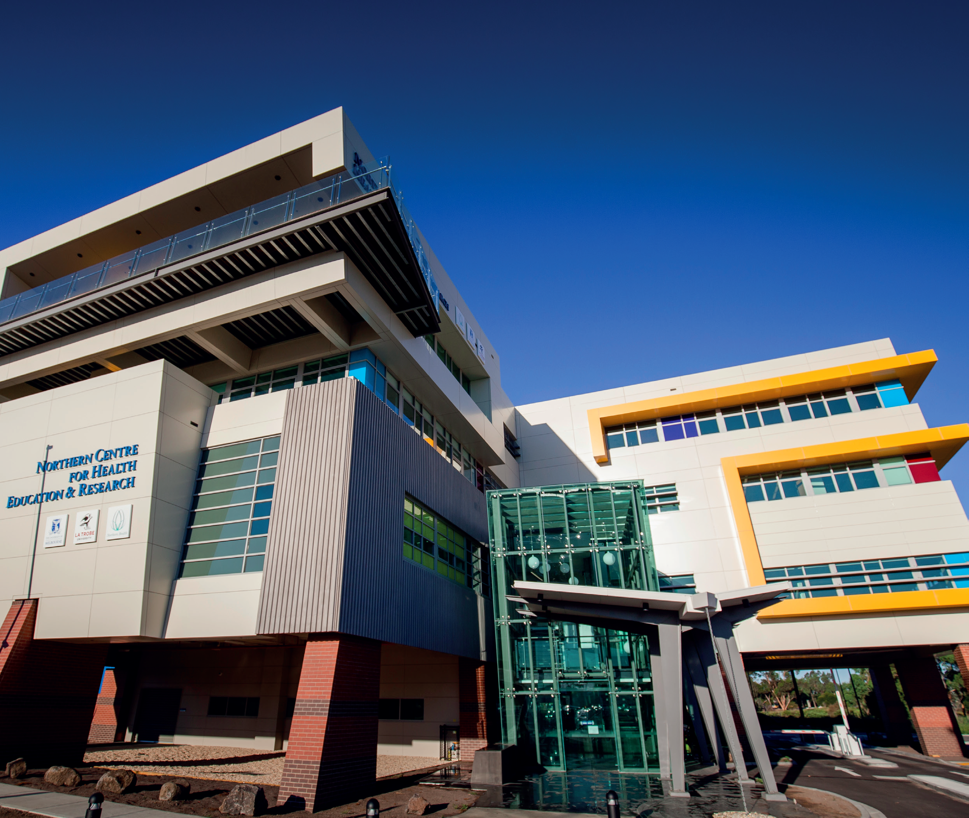

TNH TEACHING SCHEDULE
31st JULY 2019

Due to low theatre activity 31st of July is an education day for Northern Health.
Junior doctors interested in acquiring and augmenting technical skills are encouraged to attend workshops and education sessions organized on the day.

Two Sessions:
AM = 9:30am to 1:30pm
PM = 12pm to 4pm

SESSION | TIME | TOPIC | MODERATOR - Sponsor
AM | 9:30 am to 10:00 am | Introduction and basics of laparoscopic surgery | Krinal Mori  [Applied Medical]
AM | 10:00 am to 12pm | Laparoscopic skills workshop | Fidel Touma, David Bird and Krinal Mori  [Applied Medical]
AM + PM | 12pm to 1:00pm | Wound management and VAC dressings | KCI
AM + PM | 1:00pm to 1:30 pm | Hernia Mesh and fixation | Bard
PM | 1:30pm to 2:00 pm | Introduction and basics of laparoscopic surgery | Krinal Mori  [Applied Medical]
PM | 2:00pm to 4:00pm | Laparoscopic skills workshop | Fidel Touma and David Bird and Krinal Mori  [Applied Medical]
Twilight | 5:15 to 7:00 pm | Basic Suturing Workshop | Fidel Touma and Krinal Mori

Note:
Session on VAC dressings and Hernia Meshes are for both the AM and PM groups.

Basic and Advance Laparoscopic skills workshop will be run at the Northern Hospital – NCHER Building level 3 on WEDNESDAY 31ST JULY 2019. There will be a team of Consultant Surgeons and Fellows who will be happy to guide, assist and teach you various laparoscopic skills throughout both the sessions.

Both the sessions will be similar and light refreshments will be provided.

Basic Laparoscopy: Sessions will cover basic knowledge about laparoscopy, instrument handling and plenty of opportunities for hands on practice of basic laparoscopic tasks.
Highly recommended for Interns and HMOs interested in surgery

Advanced Laparoscopy: There will be exposure to various tasks which will benefit trainees at all levels as well as senior HMOs. There will be an advanced laparoscopic simulator, which will give opportunity to practice major intra-abdominal operations as well as other Lap-Sims on which minor surgical procedures can be simulated. Senior registrars will get exposure in Laparoscopic Suturing and Knot tying. Intra-corporeal and extra-corporeal suturing techniques will also be covered.
Highly recommended for Accredited and Non-accredited Registrars and HMOs

Please RSVP on the following email by 29TH JULY and also inform the session you will attend (AM or PM)

Susie.Sangas@nh.org.au

